Tab 1
Dream Fallen

Game Design Document



Overview

Game Overview

Game Concept
This is a first-person shooter and puzzle adventure game.
The player takes the role of a researcher who accidentally enters an unfinished, dream-based experimental stress intervention system. The player explores unstable dream environments, engages in combat, solves puzzles, and tries to find the exit to escape.

Theme
- Increasing and unbearable pressure in modern society
- Capital-driven commercialization and the pursuit of profit, with disregard for risk and life
- Individuals trapped in systemic oppression, sinking deeper with no easy escape

Genre & Player Experience
Fps / Puzzle / Adventure
Players explore environments that appear calm but feel unsettling, face sudden dangers, recurring pressure, and constant threats. The overall pacing cycles between tension and short moments of relief.

Game Plillar
- FPS Combat Under Pressure
- Survival-Oriented Resource Management
- Puzzle-gated progression
- Environmental narrative

Narrative Delivery
The narrative is mainly delivered through environmental details, inner monologue, and in-game text. Story elements are closely integrated with gameplay.

Core Gameplay Mechanics Brief
- Evade and attack enemy, surviving in environments with limited resources
- Search the environment for resources to restore health
- Solve puzzles to progress and gain weapon upgrades
- Interact with environmental objects to gradually piece together story information
- Advance through levels to get to the exit of the dream experiment

Targeted platforms
PC

Monetization model
Monetization Type
Premium, single-purchase title (Full Release)
Monetization Plan
Dreamfallen is designed as a premium, single-player experience with a complete narrative and mechanic arc delivered at purchase. The project does not include advertisements, subscriptions, or microtransactions, as these would conflict with the game’s themes of systemic pressure and psychological control.
The design emphasizes clarity, mastery, and replayability through learning, rather than content gating or progression monetization. Additional monetization options (such as a future expansion or director’s cut) may be evaluated only after a complete and stable core experience is delivered.

Project Scope

Game Time Scale
Estimated playtime: 1-2 hours
Linear progression with limited backtracking
Replay value driven by mechanic mastery rather than branching content

Team Size
Small student production team

Core Team
Designers:
Tony Shen
Boss Design：
Designed the core boss mechanics, including multi-phase behavior and player interaction logic
Created the boss puzzle mechanics, integrating environmental and combat-based solutions
Defined the damage system, including weak points, damage conditions, and player feedback
Designed the boss skill set, attack patterns, and phase transitions
Weapon Design
Designed player weapons and their core mechanics
Balanced weapon damage, usage conditions, and combat roles
Ensured weapon design supports both combat encounters and boss puzzle mechanics

Zhiyun Yu：
Level Design: layout, player pathing (flow), pacing, and the implementation of encounters and interactions.
World Design: large-scale map/region planning and ecosystem/resource distribution.
Narrative Design:
Puzzle design for in-game Level 2 and Level 3.
UI sfx
UI design：if Jun do not have time

Bailu Xu：
System design:
Player health and damage handling
Inventory/backpack system
Player interaction systems for puzzles and exploration
Puzzle state logic and condition tracking
Game progression, checkpoints, and save/load systems
UI system architecture and gameplay UI logic
Puzzle design: Designed puzzle mechanics and gameplay flow for Level 1 and Level 4.

Artists:
Rain Wang (Corresponding Sound Effects)
1.Characters Design:
2.Characters Rigging & Animation :
Regular Enemies x 2 （Drone）
Elite Enemies x 2 （Tank Robot）
Final Boss Enemy x 1 （Boss Robot）

3. Environment
Level Factory
Level LAB - JUN (Corresponding Sound Effects)
Level HALLWAY - JUN (Corresponding Sound Effects)
Props Modeling - JUN, Paul
4.Props
Grenade Launcher - JUN (Corresponding Sound Effects)

Paul Shin
Environment design:
Factory (Warehouse)
City street
Prop design:
Weapon (Pistol, Rifle X2, Bolt action)
Props for factory & City
Corresponding Sound Effects

Programming:
Sriraj Katkuri
Core Game Systems & Features:
Combat Mechanics: Implementation of multiple weapons and shooting systems.
AI Systems: Development of multiple enemy types with distinct AI, culminating in a complex boss enemy encounter.
Player Interaction: Logic and systems governing player actions and interactions within the game environment.
Progression & Navigation: System for handling transitions between different game levels.
Puzzles: Integration of various puzzle mechanics.
Smart Armor System: Refining an existing armor system.
User Interface (UI):
Complete UI implementation, including the Main Menu, Pause Menus, and the Player Heads-Up Display (HUD).

Licenses / Hardware / Other Costs
- Unreal Engine: Free (educational use)
- Audio assets: Free or student-licensed libraries
- Software:
  - Unreal Engine 5
  - Blender / Substance / Maya / Photoshop (student licenses)
- Hardware:
  - Personal development PCs
Total Estimated Cost
Low-budget academic project
Primary cost is time investment, not direct financial expenditure

The Elevator Pitch
Dreamfallen is a tense FPS puzzle-escape built around a White Room “buffer hub,” where each completed layer of pressure pushes you deeper—from school to lab to street to factory—until the system’s threat forces you to fight your way out.

Project Description

Brief
Dream Fallen places the player inside a research prototype that was rushed toward commercialization before it was ready. What was presented as a breakthrough in mental health becomes an unstable dream environment shaped by control, pressure, distorted memory, and emotional suppression. The tone is calm on the surface but deeply unsettling, with sudden threats and recurring oppression.
Gameplay combines exploration, combat, and puzzles in a structured flow. Players navigate each dream layer to find resources (health items, ammo, and upgrade parts), solve puzzles that unlock access, activate mechanisms, or reward upgrades and resources, and improve their weapon through attachments. After completing a level, the player transitions into the White Room—a buffer space that acts as the hub and checkpoint—then uses an exit door to proceed to the next dream, pushing toward the final escape.

Detailed
In Dreamfallen, the player is a researcher working under extreme pressure inside a major institution. Leadership prioritizes market readiness and investor-facing success, deploying an unfinished dream-based intervention system despite internal warnings. As a result, the dream becomes unstable and harmful: pressure is suppressed rather than healed, and the player experiences distorted environments that reflect systemic demands rather than personal recovery.

The game is structured around escalating “pressure layers”: Education Pressure (School) → Work Pressure (Laboratory) → Daily Life Pressure (Street) → Pressure Production (Factory). Between layers, the player returns to the White Room, a quiet backend-like buffer that provides the player a place to stay awake, rest, and adjust parameters, serves as the checkpoint space, and reinforces the idea that the system is still “running” even when the player tries to stop or escape.

Core systems support a survival-forward loop. Health ranges from 0–100, with clear damage feedback and a Game Over state when health reaches 0. Inventory is capacity-limited and supports stacking for identical consumables, with full-inventory messaging and optional drop-to-world behavior. Puzzles run in a dedicated Puzzle Screen: entering the screen locks normal gameplay inputs, and solving a puzzle automatically exits back to gameplay. Puzzle completion can trigger progression effects and rewards (such as unlocking a path or granting weapon attachments).

Each level emphasizes a distinct gameplay pillar while staying within the same loop. The School Pre-Level establishes pressure as something the player cannot revolt directly through a chase, followed by a safe zone puzzle that grants the first weapon and leads into a low-risk first combat encounter. The Laboratory introduces multi-floor navigation and pathway switching, giving players freedom to choose routes while rewarding exploration with a weapon attachment rather than a full weapon upgrade. The Street presents daily-life pressure as ambient and repetitive, using branching routes and reconnection to push progress. The Factory frames pressure as a continuous production process, where running conveyor belts feed dense black fog into the space; shutting down the system stops the belts, clears the fog, unlocks the electrical room, and leads the player into the final preparation and ending.
Narrative is delivered through environmental composition, inner monologue, and short in-game text tied to key moments—entry, puzzle completion, major encounters, and transitions back to the White Room. Story information is discovered in parallel with gameplay actions, so that progression through the space also reveals the system’s truth, the cost of “stability”.

Market Reference Research
This project references first-person shooter titles that emphasize mechanic-driven encounters, structured combat rules, and high-pressure execution, rather than relying solely on reflex-based shooting. Of particular importance are FPS designs that use invulnerability states, conditional damage windows, and clearly defined success and failure conditions to guide player behavior.
Mechanic-driven boss encounters found in games such as Destiny 2 serve as a primary reference. These encounters demonstrate how combat can be structured around explicit mechanical rules, including shielded phases, execution-based damage opportunities, and wipe conditions that reset the encounter when requirements are not met. Such structures create clarity and tension, reinforcing learning through repetition rather than gradual attrition.
In addition to combat structure, the project draws inspiration from puzzle-oriented games that focus on rule clarity and execution under pressure. Titles such as Portal 2 and The Witness highlight how strict rule enforcement, clear feedback, and reset-based failure states can support strong learning loops without relying on complex instructions or random outcomes. In these experiences, success is determined by understanding and correctly executing mechanics rather than experimentation through trial and error.
Time-loop–based puzzle experiences like Outer Wilds further demonstrate how limited execution windows and forced resets can generate tension while maintaining fairness. Failure does not represent lost progress, but instead reinforces player understanding of the system. These principles directly inform the project’s approach to mechanic-driven boss encounters, where wipe conditions function as clear rule boundaries rather than punitive setbacks.
While many mechanic-driven encounters are traditionally designed for cooperative play or pure puzzle contexts, this project adapts these principles for a single-player FPS experience. Mechanics are simplified, challenges are sequenced rather than simultaneous, and objectives are presented with clear spatial and temporal constraints. This approach preserves the authority and tension of mechanic-driven systems while ensuring readability and manageability for solo players.
Overall, the project situates itself at the intersection of FPS combat, puzzle execution, and structured pressure systems, emphasizing clarity, rule-based challenge, and psychological tension over constant action or mechanical complexity.

Market Positioning Summary
This project positions itself as a single-player, mechanic-driven first-person shooter that emphasizes structured encounters and psychological pressure over constant action or weapon variety.
While many FPS titles focus on sustained combat flow or cooperative coordination, this project adapts raid-inspired mechanic structures into a solo experience. Encounters are built around clear rules, limited execution windows, and decisive success or failure states, allowing players to engage with complex mechanics without the cognitive load of multiplayer coordination.
The project further differentiates itself by integrating puzzle-like execution into combat scenarios. Rather than separating combat and puzzles into distinct modes, mechanics are embedded directly into high-pressure encounters. Players are required to interpret spatial rules, manage timing, and make deliberate positioning decisions while under threat, reinforcing tension through system-driven constraints rather than scripted sequences.
Additionally, the use of wipe and reset mechanics functions as a learning tool rather than a punishment. Failure states are designed to be clear and informative, encouraging iteration and mastery instead of slow attrition-based progression. This approach supports a focused, high-stakes gameplay loop where understanding the system is as important as mechanical skill.
Overall, the project occupies a space between action-oriented FPS combat and rule-based puzzle execution, offering a tightly structured, single-player experience that rewards clarity, execution, and adaptability under pressure

Gameplay Mechanics & Systems

3C(Character, Camera, Controls)

Character
The player controls a first-person character with standard FPS movement.
Movement includes walking and sprinting.
Jumping is supported for basic navigation, while climbing and complex traversal are out of scope.
The player uses a standard collision capsule and cannot interact through walls or blocking geometry.

Camera
The game uses a first-person camera.
Camera feedback is used to communicate pressure and damage, including light camera shake and screen-edge vignette effects.

Controls
Input Method & Rules
Mouse + keyboard is the primary input method.
Gameplay inputs are context-locked during the Puzzle Screen (no movement/aim/shoot; UI-only).

View & Movement (FPS Standard)
Mouse: camera look
WASD: movement
Shift: sprint
Space: jump

Combat
LMB: Fire

Interaction Input
E: interact / open / confirm interaction
Tab: open/close Inventory (backpack)

Core Gameplay Loop
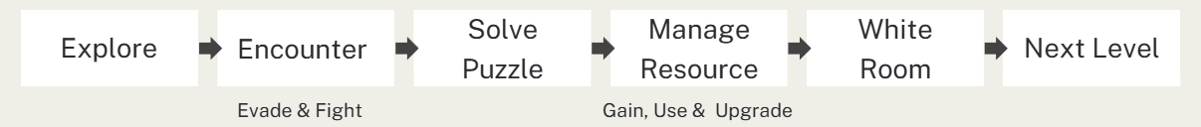
This game follows a repeating loop across all levels:
Explore the environment to locate objectives, puzzle triggers, and resources.
Evade or fight enemies under pressure (chase or combat encounters).
Solve puzzles to unlock access, activate mechanisms, or earn rewards.
Manage limited resources including health items, ammo, and upgrade parts..
Complete the level and return to the White Room as a checkpoint, then proceed to the next layer.

Player Interaction Rules

Interaction Input
E: interact / open / confirm interaction
Tab: open/close Inventory (backpack)

Target Selection
Interactable detection uses a crosshair line trace from the camera.
Interaction is valid only if:
- the target is within InteractionRange (300cm as a starting point TBD)
- Interaction is blocked if the line trace hits any other geometry before the interactable

Interaction Feedback
When the crosshair is on a valid interactable:
- object highlights (outline or emissive)
- on-screen prompt text “Press E to Interact” (ONLY FOR PRE-LEVEL)

Priority Rules
If multiple interactables overlap, pick the closest valid hit along the trace.

Combat vs Interaction Conflict
While enemies are actively engaging the player, interaction is still allowed only for quick pickups, but puzzle entry is blocked.
Exact “enemy nearby” lock rules can be tuned after combat tuning.

Health & Damage System

Health Range
MaxHealth = 100
CurrentHealth clamped to [0, MaxHealth]

Damage Sources
Only enemy attacks deal damage.

Healing Items
Consumable healing items restore health by fixed amounts:
Each +30 health points

Full health usage rule:
Cannot use healing at full health (show a toast message)

Cooldown
Healing has a short cooldown (1.0s TBD)

Hit Feedback
UI: health bar updates immediately
Audio: hit sound + low health warning (TBD)
Visual: red screen edges on damage
Camera: light camera shake on hit (stacking behavior TBD)

Death & Game Over
If CurrentHealth ≤ 0 → trigger Game Over Screen
Game Over UI buttons:
- Restart Level (respawn at White Room checkpoint and reload target level flow)
- Return to Main Menu

Checkpoint
Respawn/checkpoint hub is White Room

Inventory System (Backpack)

Capacity & Slots
Inventory has 10 slots.
Identical consumables can stack in one slot (MaxStack per item type TBD).
Non-stackable items: weapon parts/attachments.

Pickup Rules
Press E to pick up items in the world.
If inventory is full and cannot stack: pickup is blocked and shows a toast: “Inventory Full”.

Item Categories
- Consumables: healing items (Small/Medium/Large)
- Ammo: ammo packs
- Upgrades: weapon parts/attachments

Use / Drop UX
Inventory UI supports selecting an item, then:
- Use (for consumables; disabled in Puzzle Screen)
- Drop (spawns the item into the world so it can be picked up again)
Dropping a stacked item drops the entire stack.

Quick Use
Quick-use for healing is supported (key TBD).
Opening Inventory uses Tab and does not conflict with quick-use.

Restrictions
During Puzzle Screen: cannot use items, cannot open inventory.

Equipment Slot (Weapon)
The player has one Primary Weapon slot.
Attachments/parts modify the primary weapon state.

Puzzle System

Puzzle Entry
Interacting with a puzzle trigger opens a dedicated Puzzle Screen.
Background gameplay is paused (lock player movement/aim/shoot while puzzle UI is active).

Puzzle Interaction
Puzzle Screen uses mouse interaction and contains:
- the puzzle UI
- Back button (returns to gameplay without solving)

Solve Condition & Exit
On success: puzzle automatically exits the Puzzle Screen and triggers its results.

Puzzle Outcomes
- Progression outcomes: unlock route, activate mechanism, enable exit, etc.
- Reward outcomes: grant attachment/part, spawn resources, etc.

State Tracking (Runtime Only)
Each puzzle has a PuzzleID and a simple state: NotStarted / InProgress / Solved
Solved puzzles remain solved for the current session (no save/load).

Game Progression & Level Flow

Level Order (Pressure Layers)
Pre-Level (School) → Level 1 (Laboratory) → Level 2 (Street) → Level 3 (Factory)

White Room Hub Rules
White Room is the hub/checkpoint/transition space.
After completing a level, the player transitions to White Room automatically.
Transition to the next level is triggered automatically when the player enters the exit zone in the White Room. (supports loading).

Restart / Return to Menu
- Restart Level: reload current level flow from the White Room checkpoint.
- Return to Main Menu: resets progression variables; New Game only.

Session Persistence
Progress is tracked only during the current play session (no save/load in initial scope).
Save/Continue can be evaluated later if feasible.

UI / Game Shell

Required Screens
- Start Menu (Start Game / Player Zoo / Options / Help / Exit)
- Pause Menu (Continue / Options / Quit to Main Menu)
- Help Screen (controls + core mechanics)
- Options Screen (basic settings)
- HUD (health bar, weapon state, ammo, interaction prompt/toast)
- Game Over Screen (Restart Level / Return to Main Menu)
- Inventory Screen (Tab)
- Puzzle Screen (mouse-only + Back button)
- Loading Screen (level transitions, especially door → next level)

Input Support
UI must function with mouse and keyboard

Narrative

Global Premise
You are a researcher at a major institution developing an experimental system for dream-based stress intervention. Publicly, the program is framed as a breakthrough: Everyone who enters will have a dream suited to them for healing. And the effect can improve sleep quality, reduce anxiety, and make a new direction for mental health research—faster and less burdensome than traditional care.

Inside the institution, the priority is different. The board of directors wants a product they can sell immediately. They are pushing for rapid commercialization, “market readiness,” and a clean success story that can be packaged for investors and partners. The technology, however, is not finished.

The prototype can suppress symptoms quickly, but it does so by forcing the mind into a narrower emotional range. Early internal reports flag serious side effects: emotional dulling and flattened affect, memory distortion and false recall, heightened fear responses and “dream residue”: intrusive images that bleed into waking perception. Despite these warnings, leadership accelerates deployment. The official line is that the benefits outweigh the risks and refinement can happen later—after approval, after sales, after the first contracts are signed.

The researcher knows the system is unstable, but they are also over-responsible: the type who absorbs pressure, works late, and believes they can prevent harm by personally holding the project together.

On a night of overtime—under an impossible schedule and the looming board report—the researcher fell asleep in the lab from exhaustion and accidentally entered the test.

That is when the dream begins.

Locations

White Room
This is a “dream buffer layer” designed early by researchers. Whenever a dream ended, it would automatically appear to help subjects stay awake, rest, and adjust parameters. Now it is the only place that still maintains order: an empty, clean, low-noise room, like a “system backend.”

School (Pre Level)
A corridor stretched to an impossible length. The space presents a “cognitive distortion from being overworked to the extreme.”

Lab (Level 1)
The clean and tidy laboratory is where the protagonist usually works. It symbolizes the protagonist’s rationality and need for control—everything must be “right.”

Street (Level 2)
City blocks are covered by a “commercialized filter,” with billboards displaying highly commercial slogans, and “BUILD: UNFINISHED” hide in it. It symbolizes the convergence of external promotion and internal exploitation: everything is showcased, evaluated, and sold.

Factory (Level 3)
The factory’s production line shows pressure gauges, stacked containers, cold valves, conveyor belts, and more. It metaphorically turns stabilization into a production line—input pressure, output suppressed and controlled anxious emotions.

In-Game Text

White Room
While entering
- “Where am I?”
After moving a little bit
- “It seems... uh, it seems like the dream buffer layer we developed before. Am I in a dream?”

Hallway (Pre Level)
At the beginning
- “Run! it doesn’t listen to any explanation.”
When running (inner voice, faint)
- “We built a dream-based stress intervention system.”
- “The board wanted it sellable—immediately.”
- “They pushed an unfinished build forward!”
- “Fixing. Testing. Rewriting the same report.”
- “I am so tired…”

Lab (Level 1)
While entering
- “I cannot make any mistakes, otherwise…”
When finishing puzzle
- “You can't stop me from perfecting the research.”
When elite enemy first appears
- “Every outcome had to be clean. Immediate. Presentable.”

Street (Level 2)
While entering
- “They don’t care anything, they just watch to sell…”
After moving a little bit (ads)
- “Better Sleep, Faster.”
- “Try and Enjoy your dream”
When finishing puzzle
- “Now Available, Just do it!”

Factory (Level 3)
While entering
- “The truth layer, stability is not healing, pressure is still here…”
When finishing puzzle
- “You can't stop me from perfecting the research.”
When boss appears
- “Variance detected. Increase pressure…”

Ending
Ending Text
- “Back to reality.”
- “The side effects would still be real.”
- “It finally stopped… it is not victory.”

End Scenes

End Scene 1
The player suddenly wakes up at the desk in the laboratory. The lab is empty, and the monitor shows unfinished research data, with the time indicating early morning.
A notification window opens:
Board Review: 09:30

Back to reality.

End Scene 2
The player wakes up on the floor of the White Room. Everything feels the same as usual. Ahead, the usual door stands where it always has. Above the frame, the label reads “EXIT.”
The label flickers and distorts, then changes to “ERROR.”
The player opens the door.
Beyond it is the hallway.

Level Design

Level Structure Overview
This level progression functions as layered pressure escalation:
Education Pressure (School) → Work Pressure (Lab) → Daily Life Pressure (Street) → Pressure Production (Factory)

Pre Level – School

Narrative & Thematic Rationale
The Pre-Level is set in a school corridor because it represents the earliest source of pressure in the protagonist’s subconscious. Before work and life, pressure began in school—through evaluation, expectation, comparison, and the fear of falling behind.

Narrative
You wake up in a familiar place. It's the hallway of your old high school. Long, silent, and stretching so far that you can't see the end. You recognize it instantly. The pressure starts here—before work, before everything else.
An unsettling feeling creeps up behind you. The air turns cold. The space distorts, and a giant face emerges, expressionless and relentlessly approaching you.
You are unarmed and must escape.
You sprint forward. The hallway seems endless. A door appears. You push it open and slip inside.
The fear vanishes.
Inside, a handgun sits on the table. A drone monitors the room. A computer connects to lockers. You must shoot the drone.
Solving the puzzle unlocks the storage cabinet. Inside are medical supplies and weapon parts. You assemble them, modifying the handgun into a rifle.
You leave the safe zone. Hostile drones block your path.

Design Goals
- Introduce pressure as something the player cannot confront directly
- Introduce the final boss as a looming threat
- Teach movement, interaction, puzzle-solving, weapon acquisition, and basic combat
- Emotional transition: fear → agency → understanding

Layout
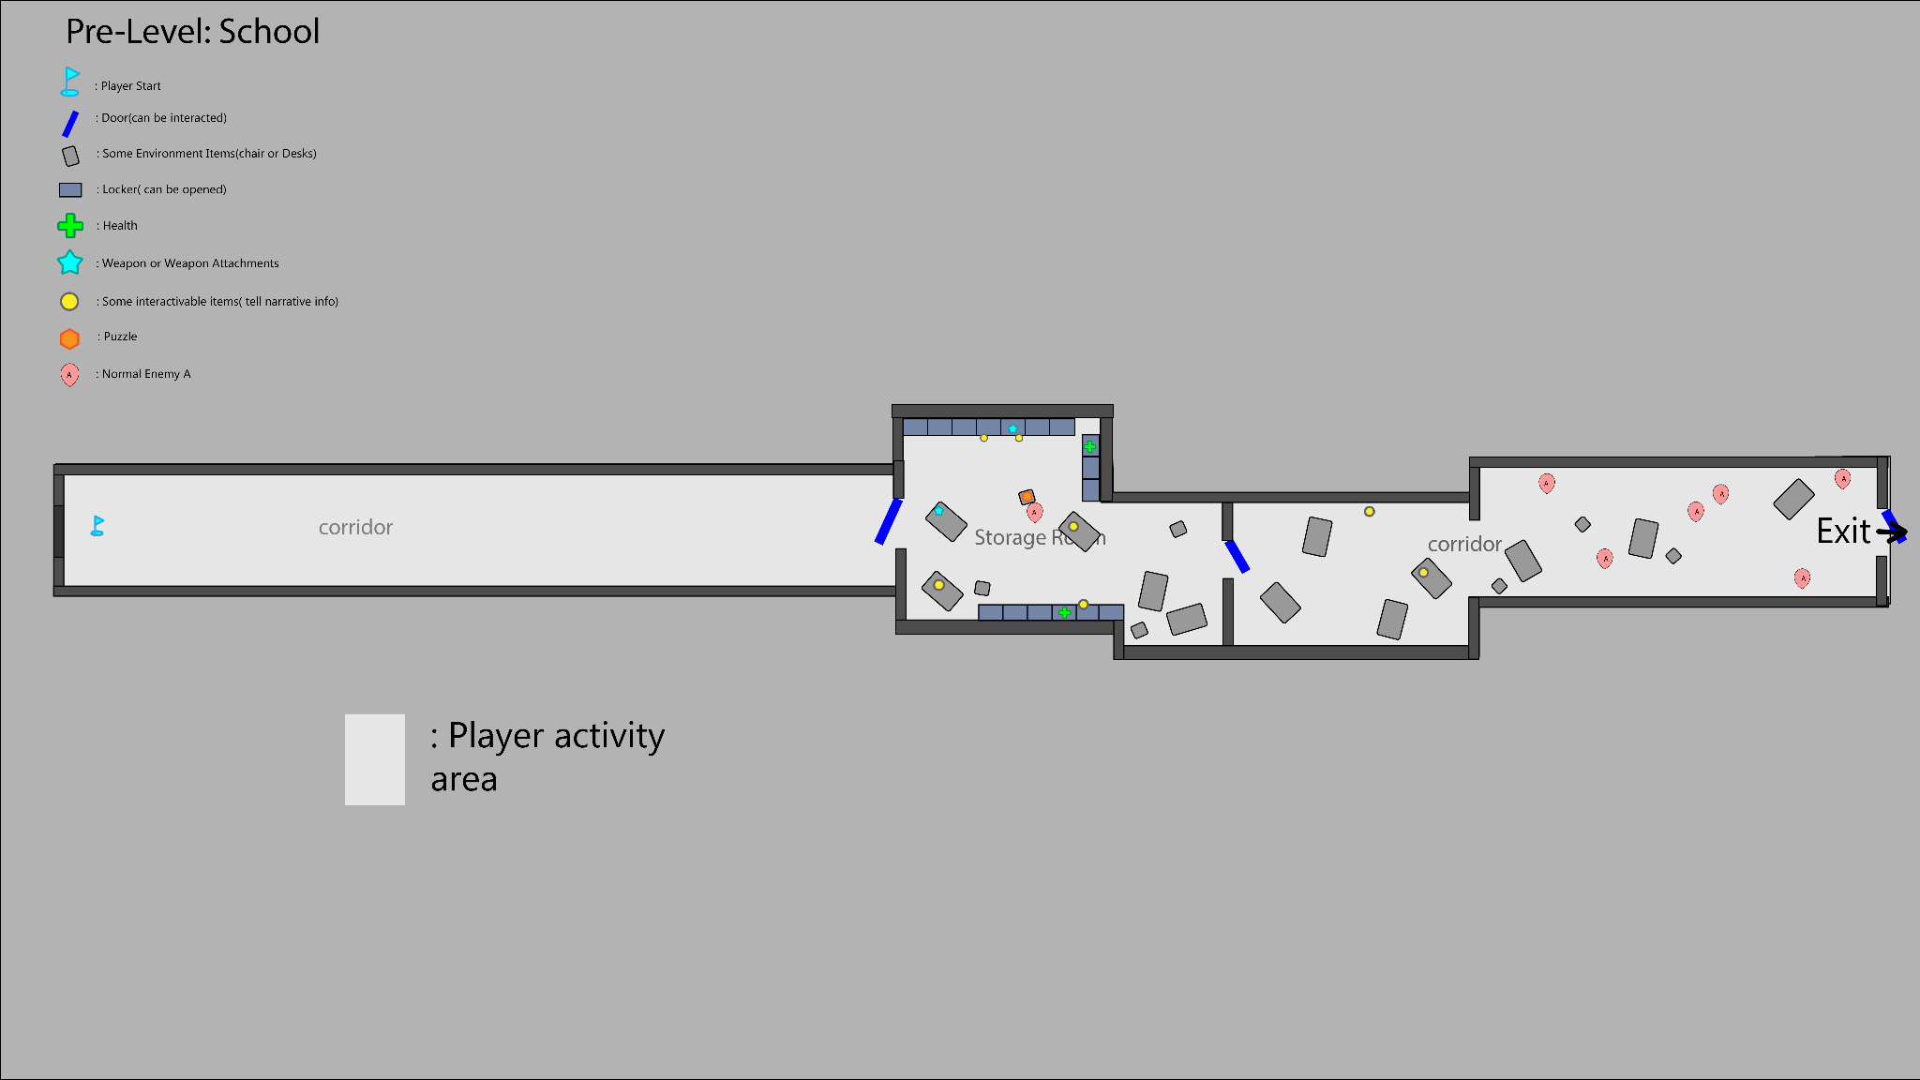

Gameplay Flow & Events

Event 1 _Player Entry

Player spawns in a long, empty school corridor

No weapon available
- Ambient audio is low and distant
- Movement is unrestricted but forward-facing

Event 2_Boss Appearance
- The giant face of the final boss suddenly appears at the far end of the corridor
- The boss begins moving toward the player
- No damage can be dealt to the boss
- Audio intensity increases rapidly

Event 3 — Chase Sequence (No Combat)
- Player is forced to run forward through the corridor
- Doors along the corridor are non-interactive
- The boss remains in pursuit but does not instantly kill the player
- Visual distortion increases as distance closes

Event 4 — Storage Room Reached

Player reaches the Storage Room entrance
- The boss immediately stops pursuing
- Audio drops sharply
- The player closes the door.

Event 5 — Investigation Phase
- Player finds a pistol on the table while get in the room
- Player explores the Storage Room and find a device（computer）connects with all the lockers and has a Normal Enemy A nearby
- Player uses the pistol to kill Normal Enemy A

Event 6 — Puzzle Resolution, First Weapon Acquisition)
- Player resolves the puzzles and all the lockers can be opened
- Player opens the lockers
- Get the first weapon attachment and the player can assemble the pistol into a rifle（ammunition is unlimited）
- Continue searching for other resources (health)

Event 7 — Narrative Buffer (Rest Space)
- Player enters a small adjacent room for a rest
- Interactable items provide narrative context

Event 8 — Combat Encounter
- Player step into the second corridor
- several Normal Enemy A appear and attack
- Combat space is wide and low-risk
- Player enters combat

Event 9 — Level Completion
- Defeat all enemies
- Exit becomes available
Transition to the White Room

Interactive Items
Computer: there are some puzzles needed to be solved(Wiring Panel.）
Trashbin: if you interact with it, you will see some torn exam papers
Health: a box of medicine
small notes:
（stick on the locker）I put my medicine here
（stick on the locker）hehe, my secret weapon! fight !!
（put it on the table） “Urban legends：a well-known company has created a monster through its research.”Urban legends
（put it on the table）“Didn't they say that taking this medicine would relieve stress? Why do I feel like my stress is getting worse?”
Poster:
“Academic ranking”
“Biological research, searching for the next generation of geniuses.”

Level 1 – Laboratory

Narrative
You seem familiar with the environment. Offices, desks, and workstations are still running, as if the work never stopped. Combat here feels routine, almost secondary.
What draws attention are the incubation tanks. Biological tissue—brain matter and organic samples—floats inside them, kept active and responsive. Pipes and conduits connect these tanks to a large machine at the center of the space. From the first floor, its purpose isn’t clear, only that everything seems to feed into it.
Through scattered notes and terminals, it becomes apparent that the system relies on biological responsiveness to maintain output. The samples aren’t being treated—they’re being used, but all the research is on the second floor, so you should find the way to floor2.
On the second floor, the machine is fully revealed. A large rotating mechanism draws energy directly from the incubation system, converting biological activity into power. To progress, you must unlock and operate this mechanism, aligning the rotating pathway to reach the room on the other side.
Inside is the rest of the research and a weapon attachment—an upgrade that improves efficiency rather than granting freedom.
When you leave the lab, the system continues running unchanged. The tanks pulse, the machine turns, and the work goes on as you enter the White-Room.

Design Goals
Gameplay Goals
- Introduce multi-floor spatial awareness
- Reward exploration with a weapon attachment
- Introduce pathway switching
- Reinforce procedural compliance
Pacing Goals
- Floor 1: Moderate combat
- Floor 2: Elite enemy and puzzles
- Final descent: Low tension exit

Layout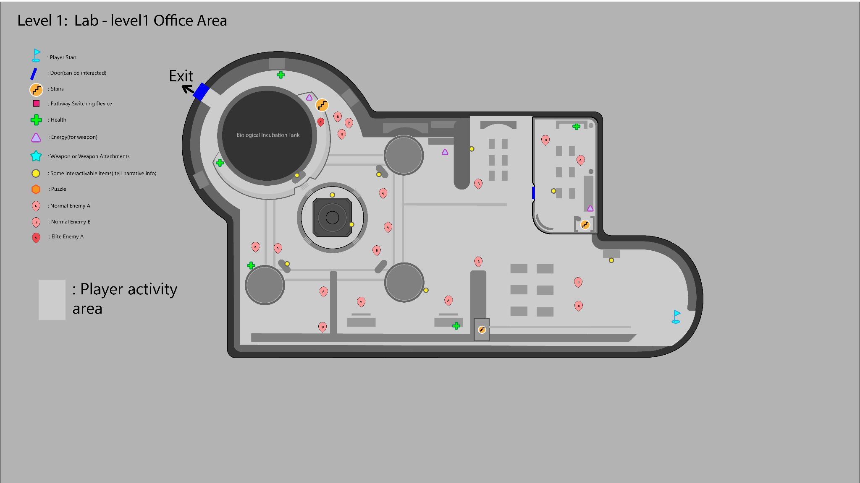
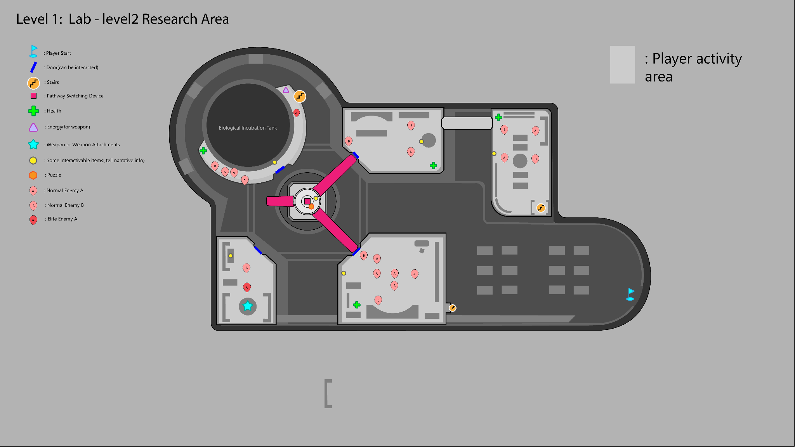

Gameplay Flow & Events

Event 1 — Level Entry (Office Area / Floor 1)
- Player enters the laboratory through an office area
- Normal Enemy A and Normal Enemy B are lightly scattered
- Combat is optional at first; enemies can be engaged gradually

Event 2 — Environmental Observation (Biological Research Space)
- Player encounters biological incubation tanks containing（ examples）:
  - Biological samples
  - Brain tissue
  - Organic-looking growth containers
- These elements are non-interactive but visually prominent
- The central machine on the floor is visible, but its function is unclear

Event 3 — Information Gathering
- Player interacts with terminals, notes, or devices in the office area
- Interactions provide fragmented information about:
  - Energy extraction
  - Biological resources
  - The need to access the upper floor
- Objective clarity shifts from exploration to progression

Event 4 — Find the way to Floor2
- Player identifies a route or access point leading to Floor 2
- Enemy density slightly decreases during the transition
- Visual focus shifts upward toward the large machine

Event 5 — Machine Reveal (Floor 2)
- Player arrives at the floor 2, find and observe the machine
- The machine resembles a large fan and rotating mechanism, player needs to rotate it and go to the other side.

Event 6 — Locked Mechanism (Pathway Switching Device)
- Player approaches the rotating pathway device
- The control interface is locked and cannot be activated
- Visual cues or some interactive items indicate that a prerequisite puzzle must be solved

Event 7 — Puzzle Resolution and Unlock the Device
- layer completes a simple puzzle to unlock the mechanism
- The device becomes operable
- The rotating pathway can now be controlled

Event 8 — Pathway Rotation
- Player rotates the pathway
- The rotation creates a new connection to a previously inaccessible room
- Environmental motion reinforces the scale and weight of the machine

Event 9 — Reward Room Access (Weapon Attachment)
- Player crosses the newly aligned pathway
- The hidden or isolated room becomes accessible
- Player acquires the new weapon attachment that enhances current weapon performance

Event 10 — Return Path & Descent
- Player returns to Floor 1
- Remaining enemies are cleared or bypass

Event 11 — Level Exit (White-Room Access)
- Player reaches the exit on Floor 1
- Transition to the White Room occurs
- The level concludes

Interactive Items
Floor 1
KPI Dashboard：
“review reminders”
“Countdown, production curve ”
Workstation computer：
“Meeting Transcript:The board of directors demanded "immediate marketability," a shortened timeframe, and a disregard for side effects.”
“Some experimental tables indicate that the specific research data is on the computer which is located on the second floor.”
Lab Notes：A brief record of the brain's response to the medication and any unusual side effects.
Control Console：Display “Locked – Control it on the 2nd floor”
Biological Incubation Tank：
（small1）Specimen Tags，Sample source, batch number, status, and signature of the person who processed the sample.
（small2）Specimen Tags，Sample source, batch number, status, and signature of the person who processed the sample.
（big）Shift the camera slightly upwards. VO “The full structure of the biological incubation tanks isn’t visible from here”
Machine Status Display：Disconnected status.
Warning Sign：Do not cut the power！It will interrupt the extraction cycle.

Floor 2
Biological Incubation Tank：
switch the camera that focuses on the big Biological Incubation Tank and VO “It looks like human tissue.“
Small Notes:
“The robots assisting with the work developed their own consciousness, and I had to hastily devise a shotgun to control their rebellion.”
“These drones are so annoying; it feels like I'm being monitored at work every day, and it's too exhausting.”
Work station computer：
Test Environment: Controlled Laboratory Setting
System Status: Active
Biological samples remain viable under continuous stimulation.
Neural responsiveness is successfully maintained through regulated extraction cycles.
Energy output has stabilized following recent system adjustments.
Control Console：Display “Locked – Connect the Electric circuit first” and show the wiring panel

Level 2 – Street

Narrative
The surroundings looked like the route home from get off work. Everything seemed outwardly normal, yet felt dull and oppressive. The air was heavy, and thick fog hung low between the buildings, blurring distance and depth. The city was quieter than it should have been.

As you moved forward, billboards along the street flickered with bright commercial slogans—advertisements about efficiency, productivity, better sleep, and increased focus. They sounded reassuring, but felt out of place here, echoing in the empty city.The streets branched and reconnected in an unnatural way. The city's layout began to resemble an organism rather than a typical urban structure, taking on the shape of a brain—the roads like neural connections, the intersections like pressure points. This wasn't just a place the protagonist was passing through, but something reconstructed from memory and habit.

Combat occurred along the way, but these encounters felt less deliberate than before, as if the pressure here stemmed from accumulation rather than intentional design.

Continuing walking, the side road was blocked. The road ahead was clearly visible but impassable, forcing you to explore outwards, activating mechanisms to reconnect the streets. Only after completing a simple puzzle did the central road open, allowing you to proceed.

When the player left this street, it no longer felt like a place they were simply passing through—it felt like something you had seen many times before.

Design Goals
- Present pressure as ambient
- Encourage exploration
- Reinforce subconscious/brain imagery
- Introduce Elite Enemy B

Layout
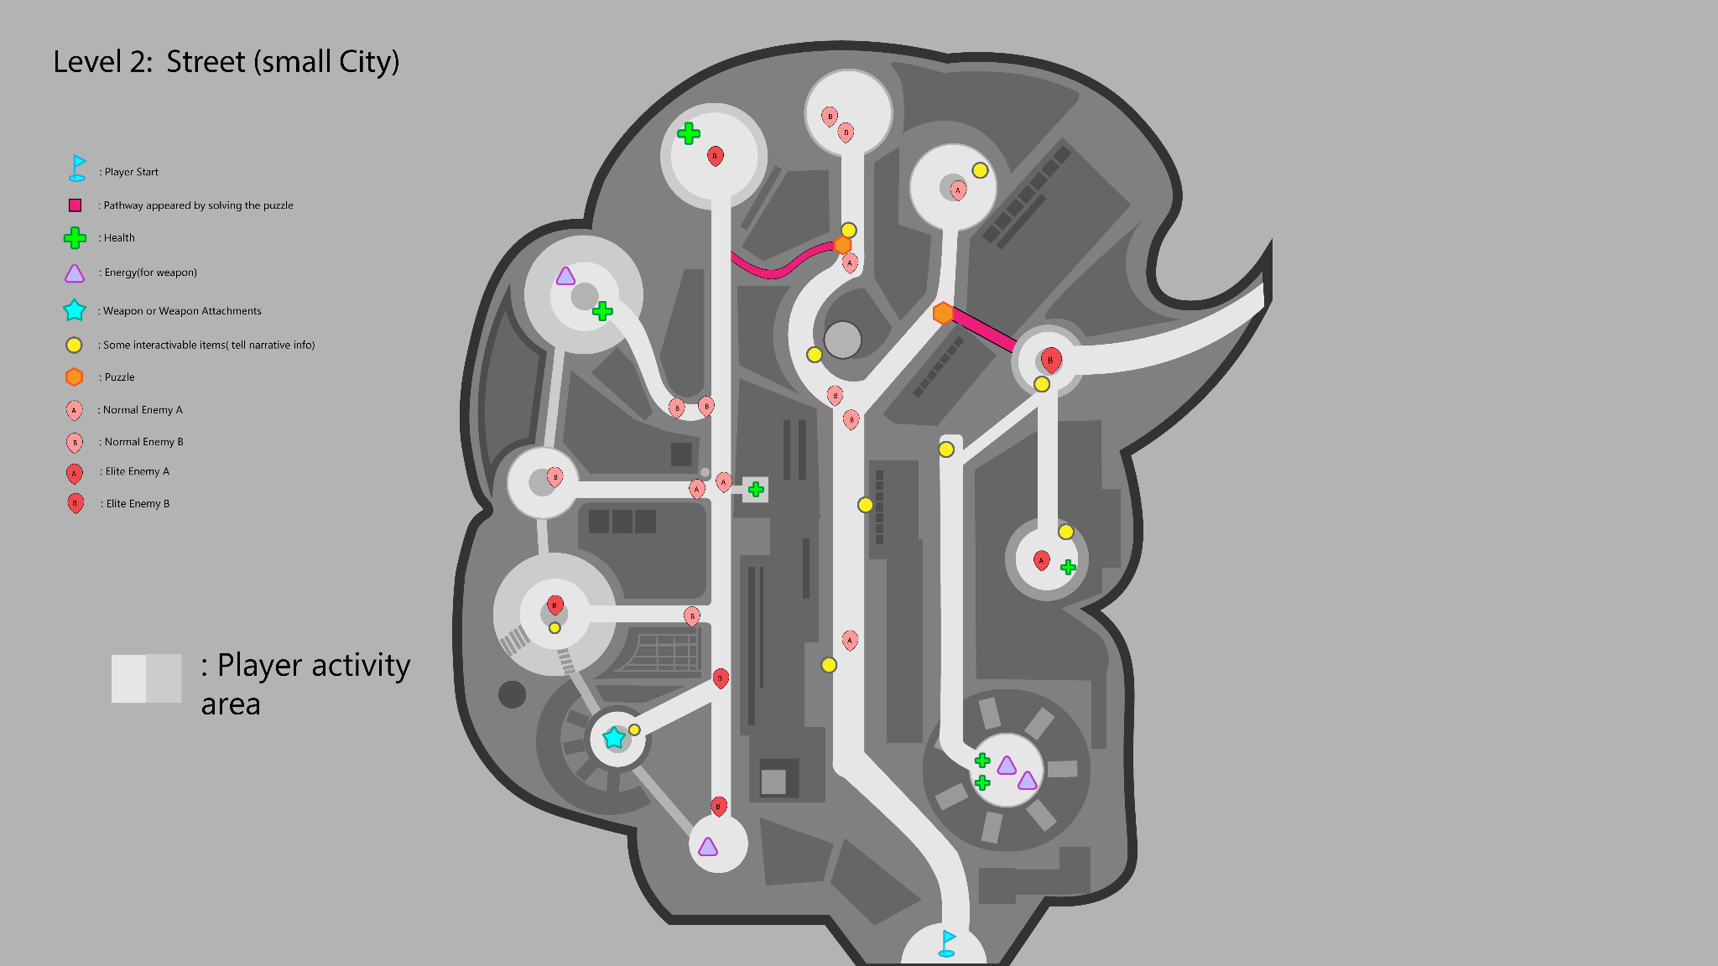

Gameplay Flow & Events

Event 1 — Level Entry
- Player spawns at the edge of the town
- Fog limits visibility and softens silhouettes
- No immediate combat

Event 2 — Initial Street Exploration
- Player follows the main road forward
- Side streets branch into circular nodes
- Normal Enemy A and B appear in small groups

Event 3 — Environmental Messaging
- Player encounters billboards and signs with commercial slogans
- Interactable points provide short narrative fragments
- The town begins to feel artificial and repetitive

Event 4 — Side Path Blocked
- Player reaches the blocked the side road
- Forward progress is clearly visible but inaccessible
- Puzzle objective becomes readable

Event 5 — Puzzle Resolution via Side Routes
- Player explores side streets to activate puzzle elements
- Normal enemies and Elite Enemy B guard key nodes
- Solving the puzzle causes a new pathway to appear

Event 6 — Exploration
- Explore both two sides beside the central road
- Find resources and New Weapon Attachment
- Find the exit according to the info

Event 7 — Level Exit
- Player reaches the exit at the far end of the street
- Transition to the white room

Interactive Items
Billboard：“BETTER SLEEP. BETTER FOCUS. ” Now preparing for public release.+ company logo
Poster：Urban trial phase ongoing. Welcome to the participants.
It‘s time to move on, feel the warmth like home.
Map Poster：This city looks so familiar.
Killed First enemy voice：“I don’t feel tired anymore. I just… don’t feel much at all.”
Graffiti：Down with the evil corporation！
Puzzle Device：Turning off the entire roadblock seems to allow access to the other side.
Near the Weapon Attachment：It looks like there's something sparkling here, a hidden secret weapon!

Level 3 – Factory

Narrative
Looking around, the conveyor belts were constantly running, pushing an unknown gaseous substance forward, and the factory floor was filled with stacked containers. Elite enemies patrolled between the containers, making the entire space feel oppressive, and the pressure never truly subsided. Every step forward was exhausting.
There were some small platforms with ladders extending upwards, allowing you to climb up. Climbing onto the high platforms and the tops of the containers offered a clear view, with only a few enemies visible. With limited remaining ammunition and supplies, a thick black fog loomed at the end of the conveyor belt, dense enough to completely obscure vision. As long as the conveyor belt was running, the fog would continue to pour in.
In the center of the factory was a conveyor belt controller.
After the controller was shut down, the factory settings changed. The belts slowed down, then stopped. The black fog gradually thinned and finally dissipated, and the electrical room became accessible. Finally, the hidden truth was revealed; you saw it, the thing that had been chasing you from the beginning!

Design Goals
- Present pressure as continuous production
- Encourage vertical strategy
- Use environment as narrative mechanics
- Prepare player for final confrontation

Layout
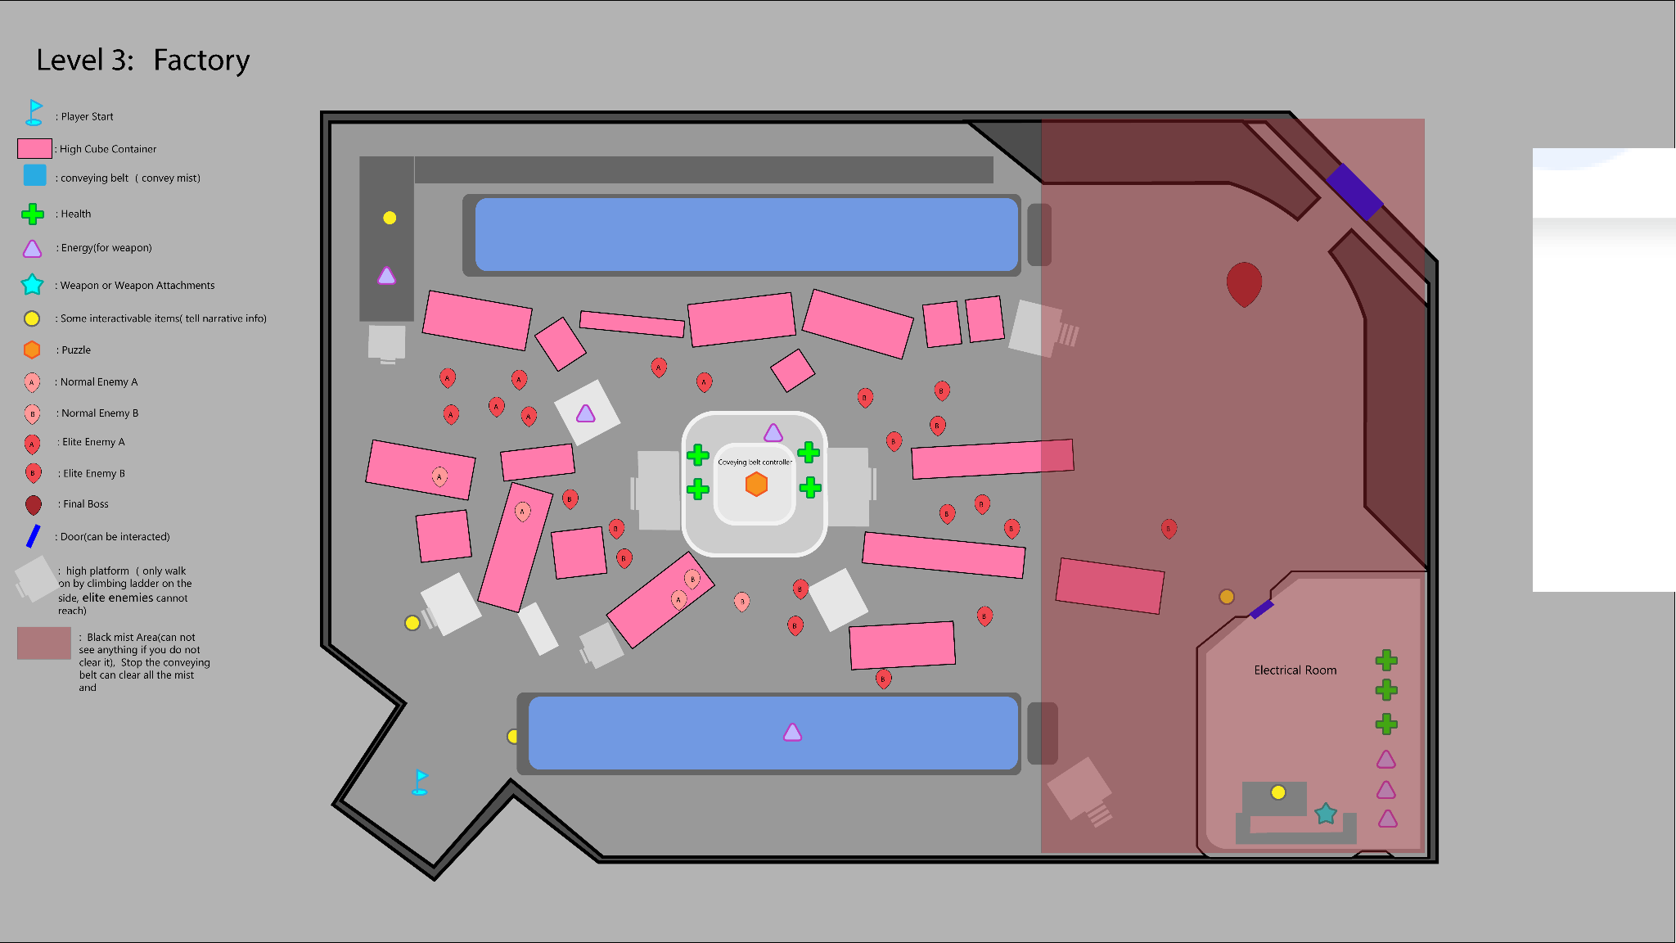

Gameplay Flow & Events

Event 1 — Factory Entry
- Player enters the factory interior
- Conveyors are active
- Immediate visual focus on stacked containers and vertical space

Event 2 — Ground-Level Pressure
- Elite enemies dominate the factory floor
- Movement is restricted and costly
- Staying on the ground feels intentionally punishing

Event 3 — High Platform Discovery
- Find ladders
- High platforms and container tops become accessible
- Enemy density drops significantly above

Event 4 — Resource Scavenging Above
- Small ammo and supply pickups appear on high platforms
- Player gains positional advantage for ranged combat
- Encourages vertical play and planning

Event 5 — Black Mist Area Revealed
- Right-side conveyor feeds thick black mist into part of the factory
- Visibility is nearly zero in the misted zone
- Area is inaccessible while the conveyor is active

Event 6 — Central Controller Objective
- Player identifies the conveyor belt controller at the factory center
- Two viable approaches:
  - Platform traversal from above
  - Ground-level push followed by side access
- Elite enemies protect the area

Event 7 — Conveyor Shutdown
- Player deactivates the controller
- Conveyors stop
- Black mist begins to clear

Event 8 — Electrical Room Access
- Newly cleared path opens to the electrical room
- No enemies present
- Player collects: Energy，Health and Final weapon attachment
- Interactive items provide final context

Event 9 — Final boss
- Fight with the final boss
- End

Interactive Items
Ladder：There's a ladder here; you can see further if you stand higher. Let me climb up and take a look.
Coveybelt:
CONVEYOR SYSTEM: ACTIVE
Output flow stable.
Visibility impairment reported in Sector R.
Do not enter without shutdown.
Central Coveybelt Controller:
CONTROL LOCKED
Manual override requires physical access.
Small Notes: They want to cover up the truth! The black mist…
Small Notes: The source can’t hide anymore. It’s a confrontation. Face it
Near the Final Boss：（The camera reveals the monster in its entirety） Oh…gosh. This is my final battle, right?

Combat Design

Weapon System Overview
The weapon system is designed to balance accessibility, efficiency, and player decision-making through a shared energy-based resource model. The system emphasizes combat efficiency, time-to-kill, and situational weapon choice through differentiated energy consumption.
Players are equipped with a single adaptive weapon platform capable of shifting between multiple weapon modes. These modes vary in power and tactical role, and are balanced through energy cost rather than ammunition scarcity.
The energy system ensures that players always retain access to combat tools, while higher-impact weapon modes introduce meaningful decision-making through limited energy availability.

Adaptive Weapon Platform & Mode Switching
Rather than equipping multiple separate weapons, the player is designed to wield a single adaptive weapon platform. Throughout progression, the player acquires weapon modules, components, or upgrades that allow this weapon to transform into different combat modes.
Each weapon mode fulfills a distinct combat role and is balanced through energy consumption or energy-free operation, while remaining fully integrated into the shared energy system. This approach preserves mechanical simplicity while expanding tactical depth through on-demand transformation.
Weapon mode switching can be performed during combat, allowing players to dynamically respond to different enemy types and encounter conditions. The design encourages situational decision-making rather than long-term loadout commitment.

Standard Weapons
Standard weapons represent the player’s baseline combat tools and do not consume energy. Their primary role is to ensure that players can always engage in combat without being blocked by resource scarcity.
These weapons deal relatively low damage but provide consistent and predictable performance. Against common enemies, standard weapons can eliminate targets within a small number of successful hits under normal conditions. However, against elite enemies, standard weapons require sustained fire across multiple reload cycles, significantly increasing engagement duration.
Boss encounters are intentionally designed so that standard weapons alone are technically viable but highly inefficient. Prolonged time-to-kill is used as a soft pressure mechanism, encouraging players to seek more effective combat solutions rather than relying exclusively on standard weapons.

Heavy Weapons(Energy-Consuming Weapon Modes)
Heavy weapon modes consume energy and represent the player’s most efficient combat options. Energy is primarily acquired through enemy drops, reinforcing active engagement and moment-to-moment decision-making.
When used against common enemies, heavy weapons are expected to eliminate targets immediately. Against elite enemies, heavy weapons significantly reduce combat time, often resolving encounters within only a few successful hits. Precision-based heavy weapons reward accurate play and can eliminate elite enemies with a single well-placed shot.
In boss encounters, heavy weapons are designed to deal substantial damage without fully replacing encounter mechanics. Under ideal conditions, a precision-focused heavy weapon may be capable of defeating a boss through optimal use of all available energy. Area-of-effect heavy weapons, by contrast, are intended to rapidly reduce boss health while remaining insufficient as a standalone solution.

Design Intent
The core intent of this weapon system is to create meaningful player choice without overwhelming complexity. Energy-free standard weapons guarantee accessibility and progression, while limited energy introduces efficiency, urgency, and tactical decision-making.
By balancing encounters around combat efficiency and time investment, rather than strict damage values, the system encourages players to adapt their weapon usage based on enemy type, encounter structure, and long-term resource considerations.

Standard Weapon Core Mechanics
Standard weapons represent the player’s primary and most reliable combat options and do not consume energy. Their core mechanical role is to provide consistent baseline performance while maintaining continuous combat flow through energy-free operation.
At a mechanical level, standard weapons emphasize sustained fire, stable handling, and predictable output rather than burst damage or high efficiency. Reloading remains a core part of their operation, reinforcing pacing and positioning without introducing energy-based constraints.

Standard Weapon Forms
At the start of the game, the player is equipped with a pistol as the initial standard weapon. The pistol deals relatively low damage and is designed to be effective against small numbers of common enemies. While reliable and easy to use, its damage output and rate of fire limit its effectiveness in situations involving larger enemy groups, where engagement duration and exposure to risk increase significantly.
As progression continues, the standard weapon transitions into a general-purpose rifle form, which serves as the baseline reference for player combat expectations. The rifle prioritizes versatility, mid-range effectiveness, and consistent performance across a wide range of encounters, offering higher sustained damage output and improved crowd-handling compared to the pistol.

Combat Role Across Enemy Types
Against common enemies, standard weapons are designed to be effective and dependable. Under normal conditions, a small number of successful hits is sufficient to eliminate standard targets, allowing players to engage confidently without hesitation or resource anxiety.
When facing elite enemies, standard weapons remain viable but intentionally inefficient. Extended engagement duration, multiple reload cycles, and sustained exposure to danger create natural pressure, signaling to the player that alternative solutions may be more appropriate.
In boss encounters, standard weapons function as a fallback option rather than a primary solution. While they are technically capable of defeating a boss, prolonged time-to-kill transforms sustained use into a strategic disadvantage, encouraging players to engage with higher-impact weapon modes and encounter mechanics.

Player Behavior & Design Intent
The mechanical design of standard weapons prioritizes accessibility and reliability over optimization. By ensuring that standard weapons do not consume energy, the system guarantees that players are never prevented from progressing due to resource scarcity.
At the same time, efficiency is deliberately constrained through engagement duration rather than raw damage output. This balance allows different standard weapon forms to coexist as situational tools while preserving overall combat parity over long time spans.
Standard weapons are not designed to be the optimal solution for every encounter, but they are always a valid one.

Heavy Weapon Core Mechanics

Heavy Weapon Core Mechanics
Heavy weapons represent the player’s most powerful combat options and are defined by high energy consumption and high-impact performance. Their core mechanical role is to provide decisive solutions in high-pressure situations, where efficiency and damage output are prioritized over sustainability.
Unlike standard weapons and low-cost energy weapons, heavy weapons are not designed for continuous use. High energy cost introduces deliberate decision-making, encouraging players to evaluate when and where their use will produce the greatest impact.

Energy-Consuming Shotgun Form
The shotgun is introduced as the player’s first energy-consuming weapon mode, serving as a transitional step between energy-free standard weapons and higher-cost heavy weapon modes. Compared to later energy weapons such as grenade launchers or railguns, the shotgun consumes a relatively small amount of energy per use and is not classified as a heavy weapon in terms of resource commitment.
The shotgun is designed to deliver high close-range burst damage, allowing players to quickly eliminate nearby threats and regain control in confined spaces. However, its effectiveness is highly dependent on positioning. To achieve full damage potential, the player must engage enemies at close range, introducing increased risk and reinforcing aggressive, proximity-based play.
This design allows the shotgun to outperform standard weapons in short, close-quarters encounters while remaining constrained by both energy consumption and positional commitment, preventing it from functioning as a universal solution.

Heavy Weapon Roles
Heavy weapons are designed to fulfill two primary roles: area control and precision damage. These roles address different combat scenarios while remaining unified under the same heavy ammo economy.
Area-of-effect heavy weapons focus on controlling space and managing clustered threats. Their primary strength lies in rapidly eliminating groups of enemies or creating temporary openings during intense encounters. While highly effective against common enemies and capable of significantly reducing elite enemy pressure, their efficiency diminishes against single high-health targets.
Precision-focused heavy weapons prioritize concentrated damage and reward accuracy. When used effectively, they can dramatically shorten encounters with elite enemies and apply substantial damage to bosses. Their performance is highly dependent on player skill, positioning, and timing.

Combat Role Across Enemy Types
Against common enemies, heavy weapons are designed to provide immediate and decisive results. Their use allows players to quickly resolve overwhelming situations or regain control of the battlefield.
When facing elite enemies, heavy weapons significantly reduce engagement duration. Precision-based heavy weapons can eliminate elite targets with optimal execution, while area-of-effect options provide efficient crowd management and pressure relief.
In boss encounters, heavy weapons are intended to accelerate progress rather than replace encounter mechanics. Precision heavy weapons may, under ideal conditions, be capable of defeating a boss through optimal use of all available ammunition. Area-of-effect heavy weapons, by contrast, are designed to remove supporting threats and reduce boss health without functioning as a standalone solution.

Player Behavior & Design Intent
The mechanical design of heavy weapons emphasizes commitment and consequence. High energy cost transforms their use into a strategic choice rather than a default action, reinforcing moments of tension and reward.
By offering distinct roles within the same ammo category, heavy weapons support multiple play styles while preserving clarity and balance. Their purpose is not to trivialize encounters, but to provide players with meaningful tools to resolve critical moments efficiently.
Heavy weapons are powerful by design, but their scarcity ensures that power is exercised thoughtfully.

Weapon Types & Damage Reference

Standard Ammo Weapon Forms
Weapon Type | Magazine Size | Damage vs Common Enemy | Damage vs Elite Enemy | Notes | Energy Cost
Standard Rifle | 30 | ~20% per hit | Low efficiency (multiple reloads required) | Baseline sustained-fire weapon | None
Pistol | 7 | 15% per hit | low efficency |  | None

Energy-Consuming Weapon Forms
Weapon Type | Magazine Size | Damage vs Common Enemy | Damage vs Elite Enemy | Notes | Energy Cost
ShotGun | 10 per round/50 total | Instant kill with in 8m | 25% per hit within 8m |  | 2%/Shot
Grenade Launcher | 5 per round/25 total | Instant kill | ~35% per hit | 2 shots insufficient, 3 shots inefficient | 4%/Shot
Long range RailGun | 5 per round/20 total | Instant kill | 100% on headshot / ~30% on body hit | Precision-rewarded heavy weapon | 5%/Shot

Enemy system:

Enemy：

Normal Enemy A — Sentry Shooter (Stationary, Range-Triggered)
Trigger Radius: 18m
Effective Range: 6–18m
Attack Pattern: 3-round burst (fires as soon as the player enters its trigger range)
Damage: 6 per bullet (18 per burst)
Cadence: 1.3s between bursts

Normal Enemy B — Chaser Shooter (Vision-Triggered Pursuit)
Detection (Vision) Range: 22m
Effective Range: 8–20m
Movement: pursues the player (moves 10–15% slower than the player so it can be outplayed, but still pressures positioning)
Attack Pattern: mobile semi-auto / controlled fire
Damage: 4 per shot, 3 shots/sec (theoretical DPS 12; practical DPS lower due to movement and cover)

Elite Enemy A — Mortar Tank (Mortar)
Engage/Trigger Distance: 24m
Minimum Firing Distance: 8m（If the player is closer than 8m, the elite attempts a short reposition/hesitation, creating a flanking window.）
Single Attack: Mortar (with ground indicator)
Wind-up: 0.9s (clear ground red-circle telegraph)
Damage:Direct hit: 30
Inner splash: 22 (radius 3m)
Outer splash: 14 (radius 5.5m)
Cooldown: 4.5s

Elite Enemy B — Wide Sweep Tank (Horizontal Sweep)
Detection Range: 20m
Effective Range radius: 24m
Single Attack: Wide Horizontal Sweep
Wind-up: 0.75s (colored warning area)
Sweep Duration: 2.4s
Sector Angle: 160°
Damage Model: 3 damage per 0.2s tick (12 ticks total; 36 if fully exposed)
Cooldown: 4.0s
Key Rule: locked facing during the sweep (sweeps a sector), then 1s overheat recovery (reliable flanking window).

Back-Weakpoint Rules (Balance Anchor)
Weakpoint Zone: a 120° rear cone behind the enemy. Hits only count as “back weakpoint” when the player is clearly inside this rear arc.
Weakpoint Damage Multiplier: ×1.6
Front/Non-Weakpoint Damage Reduction
  - Elites: ×0.70 (forces flanking/backshots to be the primary solution, not face-tanking)
  - Normals: ×0.85
Turn-Rate Caps (required—otherwise the rear weak point is meaningless)
  - Normal enemies: 90°/sec
  - Elite enemies: 60°/sec
Attack Facing Lock (No Instant Tracking)
  - Elite A (Siege Mortar): locks facing 1s before firing, and cannot instantly 180° turn for 0.5s after the shot.

Elite B (Wide Sweep): locks facing during the entire sweep (it sweeps a sector; it does not track the player’s lateral movement).

Final Boss Design – Core Framework
The boss encounter is designed as a mechanic-driven combat experience tailored for a single-player game. Rather than relying on raw damage output, the encounter emphasizes player execution, spatial awareness, and time-based decision-making.
From the start of the encounter, the boss occupies a central position within the arena and is protected by an invulnerable shield. While the shield is active, the boss is fully immune to damage unless the player has obtained a specific damage-enabling buff, establishing mechanics as the primary method of progression.

Offensive Pressure & Survival Context
While shielded, the boss applies offensive pressure only when the player enters close proximity. If the player approaches within a short range of the boss, the boss initiates direct attacks that deal significant damage.
This behavior establishes a clear danger zone around the boss and prevents players from using the boss as safe cover during mechanic execution. Players are required to maintain awareness of their positioning while completing encounter objectives.
Survival, movement, and objective execution occur simultaneously, reinforcing basic spatial awareness throughout the encounter without introducing constant pressure.

Failure Conditions & Wipe Mechanic
The encounter includes a hard failure condition to enforce pacing and execution. If the player fails to complete required mechanics within a designated time window or encounter cycle, the boss triggers an instant-kill event, resulting in a forced restart.
This wipe mechanic discourages passive play and ensures that progress is tied to timely and intentional action rather than attrition. The encounter also includes limited tolerance to reduce frustration in a single-player context, providing an additional opportunity before a full wipe occurs.

Boss Mechanic Structure – Two-Phase Encounter
The boss fight is structured into two distinct phases. Each phase introduces a different type of challenge while maintaining clarity and manageable cognitive load for a single player.

Phase One – Elite Buff Acquisition & DPS Check
During the first phase, the boss remains shielded and is immune to all damage unless the player has an active damage-enabling buff. At the beginning of this phase, the boss summons two elite enemies that each carry the same buff.
Defeating an elite enemy causes it to drop the buff, which temporarily enables the player to damage the boss. The buff has a limited duration, encouraging immediate engagement. The goal of this phase is to reduce the boss’s health to approximately half within the available buff windows.
If the player fails to push the boss into the next phase within the duration provided by the initial two buff drops, the encounter provides a clear warning message indicating that the boss is about to become enraged. After this warning, the boss summons one additional elite enemy of the same type, which drops the same buff and provides a final damage window.
If the player still fails to meet the phase transition requirement after this additional opportunity, the boss triggers an instant-kill wipe, forcing a restart.

Phase Two – Shield Regeneration & Generator Destruction
Upon reaching the health threshold, the boss enters the second phase and regenerates its shield. Unlike the first phase, this shield is fully invulnerable and cannot be bypassed by buffs or weapon damage.
In this phase, the boss no longer summons elite enemies. Instead, two shield generators appear at fixed locations within the arena. These generators serve as structural components maintaining the boss’s shield.
The player must destroy both generators while avoiding ongoing boss attacks. Once both generators are destroyed, the boss’s shield is permanently disabled, allowing the encounter to conclude through direct combat.

Shield Behavior Across Phases
The boss’s shield serves different mechanical purposes across the two phases:
- Phase One: The shield functions as a strict damage gate. Without the buff, the boss is immune to all damage; with the buff active, the boss becomes damageable for a limited window.
- Phase Two: The shield functions as a structural defense that must be permanently dismantled through environmental interaction.
This distinction reinforces phase identity and provides clear feedback on how player objectives evolve throughout the encounter.

Design Intent
This two-phase structure separates combat efficiency and spatial execution into sequential challenges. The first phase emphasizes damage optimization and timing under pressure, while offering limited tolerance through an additional buff window before enforcing a wipe. The second phase shifts focus toward movement, positioning, and environmental interaction.
By limiting the number of simultaneous objectives and presenting mechanics in a clear sequence, the encounter delivers the depth and tension of a mechanic-driven boss fight without overwhelming a single player.

Boss Encounter (Simplified)

Phase One – Elite Buff & DPS Check
- The boss is invulnerable and summons 2 elite enemies carrying damage-enabling buffs.
- Player defeats the elite enemies to obtain the buff, allowing temporary damage to the boss.
- Player attempts to reduce the boss's HP below 50%:
  - ✅ Success → Transition to Phase Two
  - ❌ Failure → Boss issues a warning ("Enrage Imminent") and summons 1 more elite enemy
    - Player picks up the buff again and attempts a second DPS check
      - ✅ Success → Transition to Phase Two
      - ❌ Failure → wipe

🔷 Phase Two – Shield Regeneration & Generator Mechanic
- The boss regenerates an invulnerable shield
- Two shield generators spawn in the arena
- Player must destroy Generator 1 ➝ Generator 2
- Once both are destroyed, the shield is permanently disabled
- Boss becomes vulnerable → Player finishes the fight

Puzzle Design

Purpose：
This circuit-rotation puzzle is integrated into the level as a power / connection Device. Certain devices in the environment start in an offline and unconnected state until the player restores power by completing the circuit.

Components：
- Start Point (Black Node): The power source / input terminal that marks where electricity begins to flow.
- Nodes (Hollow Node): Target points that must be powered and lit.
- Modules (Geometric Tiles): Each module contains one or more wire segments. Modules connect to each other through edge connectors to form a complete circuit network.
- Fixed Modules (Thick-Outlined Shapes): These tiles are fixed structures and cannot be rotated. They constrain the solution space and define the main routing structure.
- Rotatable Modules (Thin-Outlined Shapes): These tiles can be clicked to rotate, changing wire orientation and connection relationships.
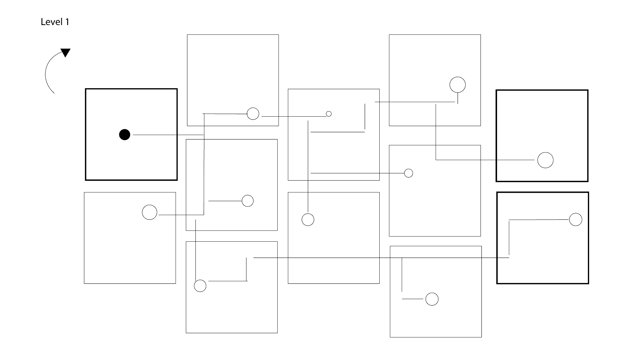
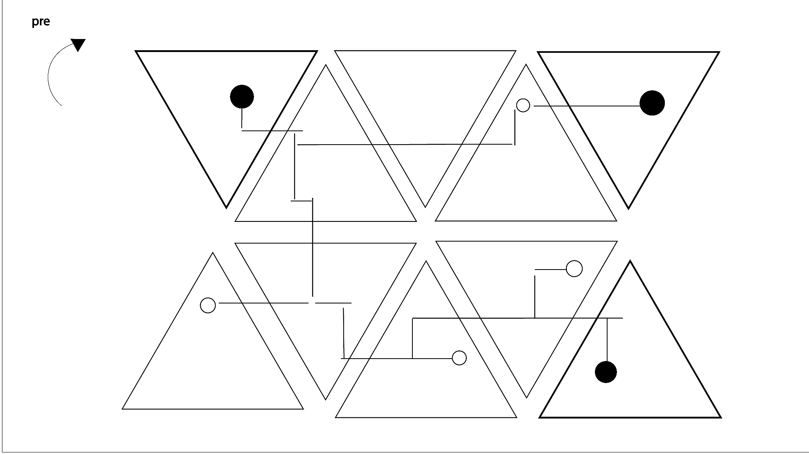

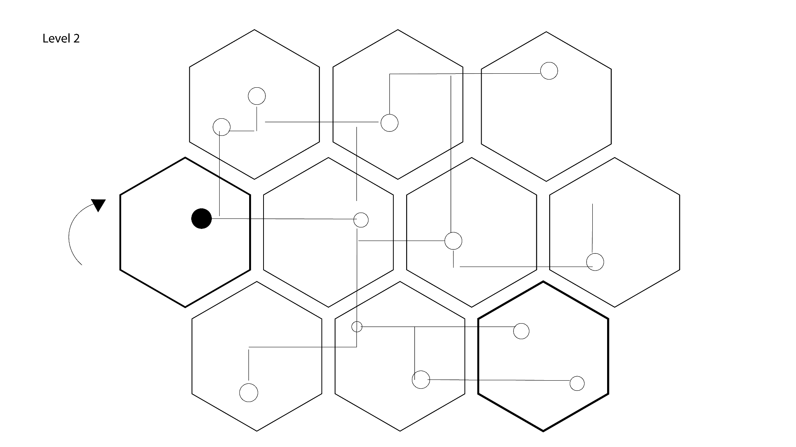
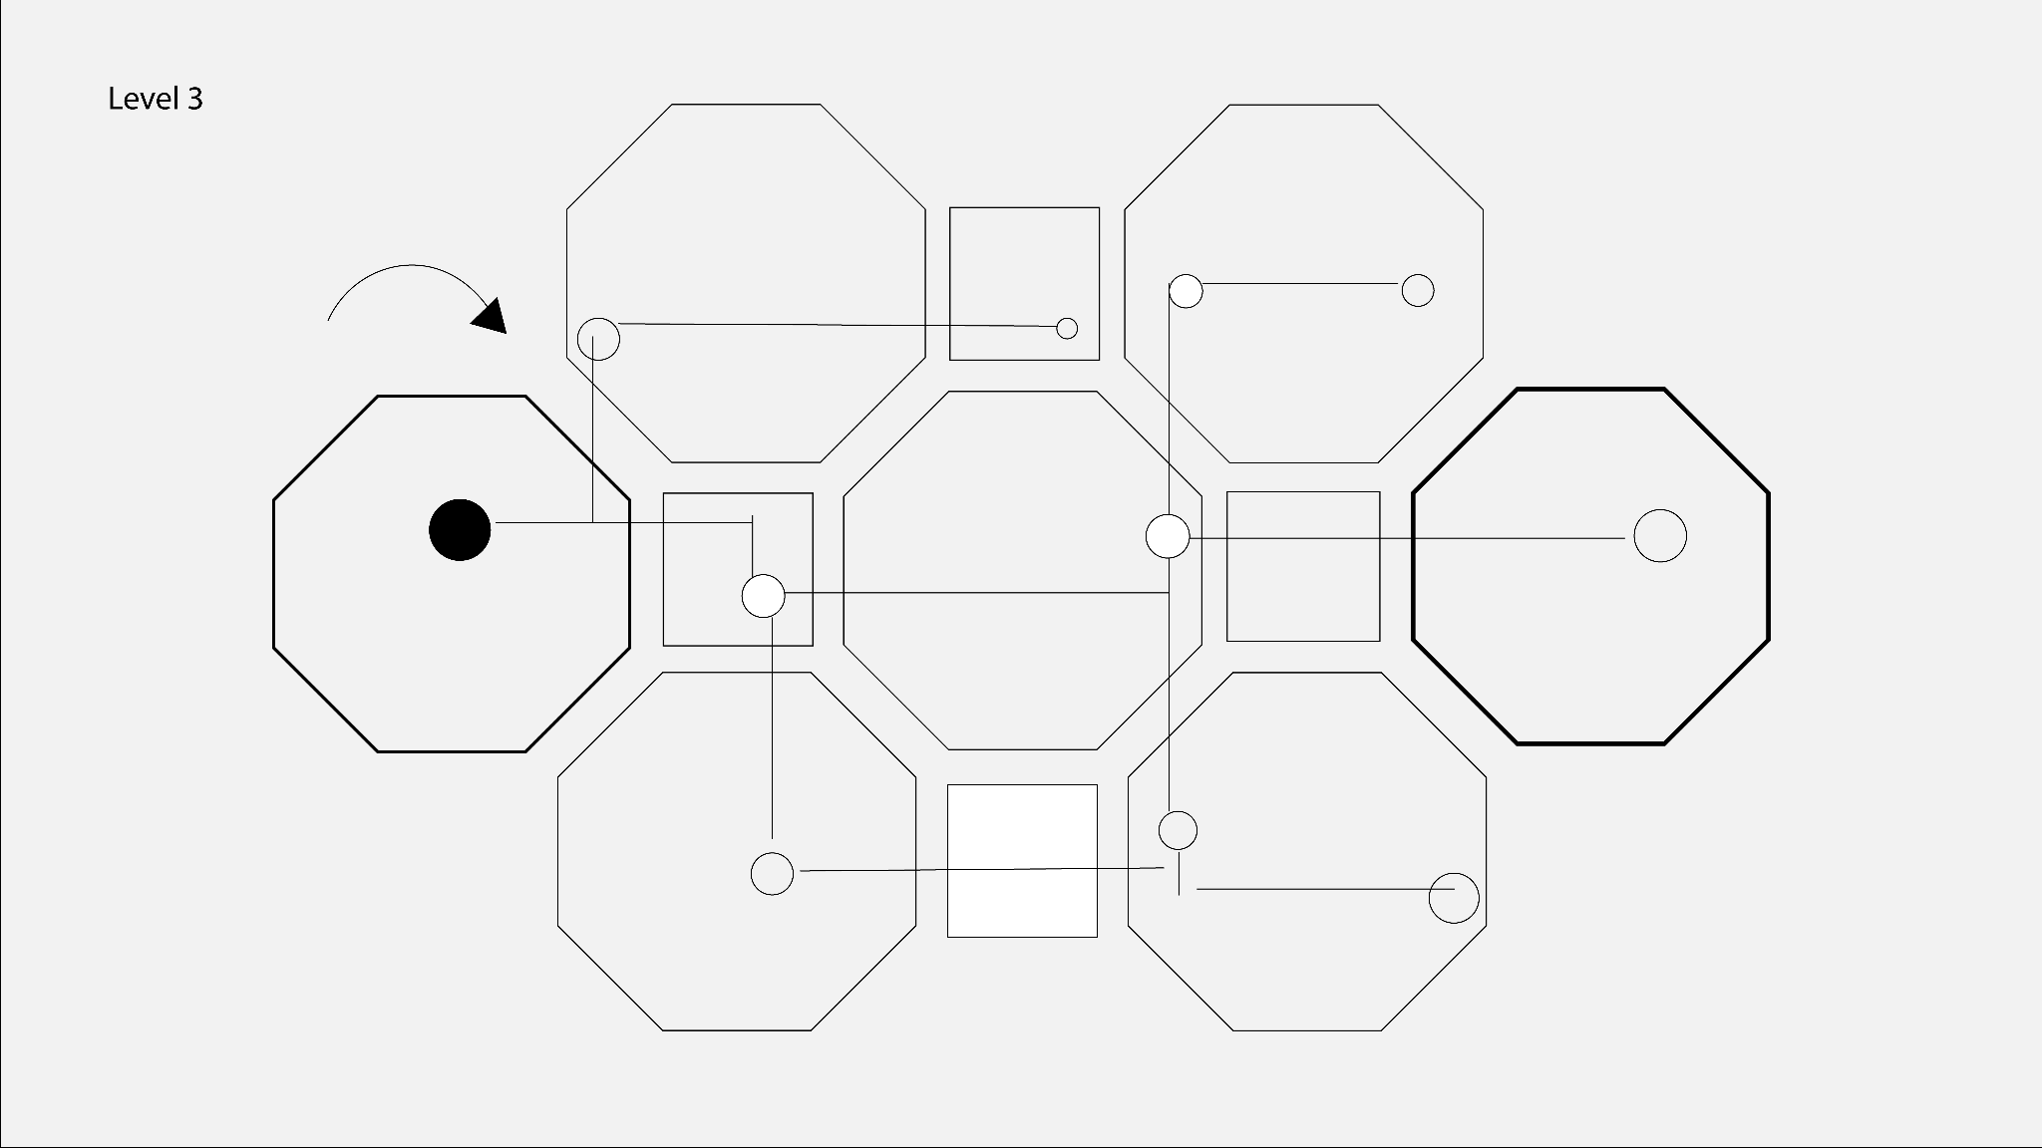

Controls：
- The player clicks any rotatable module, and the tile rotates by a fixed angle (typically 90° or 120°, depending on the tile shape).
- Rotation changes the direction of the module’s wire exits, which affects how it connects to adjacent modules.

State Changes：
When electricity flows from the start point and a module’s wiring is correctly aligned with its neighbors, that module is considered powered.
Nodes on powered modules will light up as progress feedback.

If rotation breaks the circuit, the affected section will lose power and stop lighting up, nodes turn off when disconnected.

Gameplay Kit
The Gameplay Kit defines the core interactive elements that are repeatedly used throughout the game.
These kits are designed to support level designers in building moment-to-moment gameplay experiences, including combat, interaction, and environmental challenges.

Kit 1: Pickup Kit

Description
Pickups are interactive items placed in the environment that support player survival, progression, combat and game narrative.

Elements
- Health Pickup
- Ammo Pickup
- Interactive objects Pickup
- Weapon and Attachment Pickup

Player Interaction
The player collects pickups through direct interaction.
Pickups are removed from the world after collection.

Design Usage
Used to reward and narrative exploration.
Supports pacing and difficulty balance in combat-heavy areas.

Kit 2: Door Kit

Description
Doors act as simple spatial transitions between areas or levels.

Elements
- Unlocked Door
- Open Door

Player Interaction
The player walks through the door to enter the next space.
No additional interaction or conditions are required.

Design Usage
Used to transition between gameplay spaces.
Supports clear and uninterrupted level flow.

Kit 3: Puzzle Kit
Description
Puzzle elements act as progression gates and pacing breaks between combat encounters.

Elements
- Puzzle Trigger Object
- Puzzle Screen (UI-based interaction)
- Puzzle Completion State

Player Interaction
The player interacts with a puzzle object in the environment.
Gameplay pauses and a dedicated Puzzle Screen is displayed.
The player solves the puzzle through UI interaction.
Solving the puzzle exits the Puzzle Screen and returns the player to gameplay.

Design Usage
Slows down pacing between action segments.
Acts as a narrative gate: failing to complete all puzzles leads the player toward a bad ending.
Reinforces player choice and consequence without adding combat difficulty.

Kit 4: Combat Encounter Kit

Description
Combat encounters define the core FPS gameplay loop.

Elements
- Enemy units
- Enemy spawn triggers
- Combat arenas

Player Interaction
- The player aims, shoots, and eliminates enemies.

Design Usage
Primary source of tension and challenge.
Used across all levels with increasing complexity.

Feature Set

Core Gameplay Features
- First-person movement and camera (FPS standard)
- Mechanic-driven combat encounters
- Limited-resource survival loop (health, ammo, attachments)
- Puzzle progression using a dedicated Puzzle Screen
- Environmental narrative through interactive objects
- White Room hub as checkpoint and transition space

Combat Features
- Single primary weapon with modular attachments
- Normal enemies, elite enemies, and boss encounters
- Chase-based pressure sequences (non-combat)
- Clear success/failure conditions for encounters
- Wipe/reset logic for mechanic-driven encounters

Puzzle Features
- UI-based Puzzle Screen (mouse-only interaction)
- Puzzle-triggered progression (unlock paths, mechanisms)
- Puzzle-triggered rewards (weapon attachments, resources)
- Puzzle states tracked per session (NotStarted / Solved)

Interaction Features
- Inspectable narrative objects (UI inspect screen)
- Pickups for health, ammo, and upgrades
- Environmental interaction (consoles, switches, controllers)
- Interaction feedback via crosshair trace and prompts

Progression Features
- Level-based progression through pressure layers:
  - School → Laboratory → Street → Factory
- Automatic transition back to White Room after level completion
- Automatic level entry triggers (no manual door interaction)

Assets List

Assets Overview

Environment Assets
- Modular environment geometry:
  - School corridor modules
  - Laboratory interior modules
  - Street building blocks
  - Factory industrial structures
- Basic architectural elements:
  - Ramps, stairs, slopes
  - Straight and curved walls
  - Archways
- Environmental props:
  - Consoles, lockers, desks, containers
  - Conveyors, pipes, machinery

Interaction Assets
- Puzzle devices (wiring panels, rotating mechanisms)
- Interactive props (computers, notes, trash bins)
- Inspectable object visuals
- UI elements for interaction prompts

Enemy Assets
- Normal Enemy A
- Normal Enemy B
- Elite Enemy A
- Elite Enemy B
- Final Boss
- Enemy VFX (attacks, hit effects, death)

Weapon & Item Assets
- Base weapon model
- Weapon attachment models
- Ammo pickups
- Health item pickups
- UI icons for inventory items

UI Assets
- HUD (health bar, ammo, prompts)
- Puzzle Screen UI
- Inventory UI
- Inspect Screen UI
- White Room UI elements
- Menu screens (Start, Pause, Game Over)

Audio Assets
- Ambient environment audio per level
- Enemy sound effects
- Weapon sound effects
- UI interaction sounds

Supporting Documents
The following documents support and expand upon the systems outlined in this GDD:
- System specifications
https://docs.google.com/spreadsheets/d/1yBzjOr3GBio27yFyWiqE7NphppyYjqe0qJwhPkoNSVw/edit?gid=508056687#gid=508056687
- Narrative and Level Document
https://docs.google.com/document/d/1qYYEPQdUe0986NuAP0n6VOLJ7NX1rXQJGL1QhuqR33E/edit?tab=t.0#heading=h.wk9sn6b56rmu
- Gameplay Kit Document
https://docs.google.com/document/d/1FaKhewOzCtEN4jFy_sw5_WRUk8Bfbv9kMS6xoMWa9CM/edit?tab=t.0#heading=h.qu51c6w7ssom
- Puzzle Design Document
https://docs.google.com/document/d/1Oz8Q0xW6Q1ttF-u8ad7ewJ-eQFVhjAmjN-Jpk8jaEFU/edit?tab=t.0#heading=h.ct3l2ua11v1o.
- Enemy Design Document
https://docs.google.com/document/d/14DgOy22COKKO5TMalesAV-IgxQJ5iMy4Cmvwz8VaFyY/edit?tab=t.0#heading=h.37nlsb29j0qr
https://docs.google.com/document/d/1IjQZeAIYt9TKCTCPKLmbM-TjhJTtjD7VSeUwVgBZJhU/edit?tab=t.0#heading=h.agst4mq162f1
- Weapon System Document
https://docs.google.com/document/d/1p-LlBVcdgKATFH0vutWVUi82XuFQONgFdQ1gwGi0QgU/edit?tab=t.0#heading=h.yogpk9i9mws4

