Level Design Document：

Overview:
Dream Fallen is a narrative-driven FPS structured around a sequence of dream spaces, each representing a different layer of psychological pressure. The level design focuses on translating abstract emotional states—fear, control, repetition, and exploitation—into readable spaces, player flow, and gameplay systems.
Each level represents a layer of pressure, escalating from personal memory to systemic exploitation: School (Education Pressure) → Lab (Work Pressure) → Street (Daily-Life Pressure) → Factory (Pressure Production). Each level escalates pressure not only through enemy difficulty, but through spatial structure, system complexity, and the player’s relationship to control.
Level layouts are designed with clear main routes supported by optional side paths, loops, and vertical layers. These structures allow encounters, puzzles, and resource placement to shape player decision-making rather than relying on scripted sequences. Pacing is managed through alternating zones of tension and release, ensuring that combat, exploration, and narrative beats reinforce one another.
Puzzles are intentionally lightweight and context-driven. Instead of complex logic challenges, they function as spatial or systemic gates—unlocking access, reconnecting routes, or revealing hidden spaces—so that momentum is preserved and focus remains on traversal and combat.
Enemy and encounter design is tightly integrated with level geometry. Standard and elite enemies are positioned to control sightlines, force movement, and apply pressure over time rather than create sudden difficulty spikes. Verticality, cover, and route choice play a key role in how encounters unfold, especially in later levels.
Overall, the level design aims to create a coherent experience where story, space, puzzles, and encounters operate as a single system. Each level teaches the player how pressure functions in that environment, gradually preparing them for the final confrontation where pressure is no longer hidden, but fully exposed.

Locations:
- White Room: This is a 'dream buffer layer' designed early by researchers. Whenever a dream ended, it would automatically appear to help subjects stay awake, rest, and adjust parameters. Now it is the only place that still maintains order: an empty, clean, low-noise room, like a 'system backend.’
- School (Pre Level): A corridor stretched to an impossible length. The space presents a 'cognitive distortion from being overworked to the extreme.’
- Lab(Level1) : The clean and tidy laboratory is where the protagonist usually works. It symbolizes the protagonist's rationality and need for control—everything must be 'right’.
- Street(Level2) : City blocks are covered by a 'commercialized filter,' with billboards displaying highly commercial slogans, and “BUILD: UNFINISHED” hide in it. Here, it symbolizes the convergence of external promotion and internal exploitation: everything is showcased, evaluated, and sold.
- Factory(Level3): factory’s production line , you can see pressure gauges, stacked containers, cold valves, conveyor belts, and so on. It metaphorically turns stabilization into a production line—input pressure, output suppressed and controlled anxious emotions.

Level：
This level functions as the first layer of the dream, setting the emotional baseline for all subsequent spaces: Education Pressure(School) → Work Pressure(Lab) → Daily Life Pressure(Street) → Pressure Production (Factory)

Pre level: School

Narrative & Thematic Rationale
The Pre-Level is set in a school corridor because it represents the earliest source of pressure in the protagonist’s subconscious.(Before work and life, people’s pressure began in school—through evaluation, expectation, comparison, and the fear of falling behind. )

Narrative：
You wake up in a familiar place. It's the hallway of your old high school. Long, silent, and stretching so far that you can't see the end. You recognize it instantly. The pressure starts here—before work, before everything else.
An unsettling feeling creeps up behind you. The air turns cold. The space begins to distort, bending in an unnatural way, and then it appears—a giant face emerges from the distorted space, expressionless and relentlessly approaching you. It fills the entire hallway, leaving you nowhere to run.

You are unarmed and must escape! You sprint forward, the hallway seemingly endless, the pressure behind you closing in. Just as you feel you're about to break, you see a door at the end of the hallway. You push it open and slip inside.

You close the door. The fear vanishes; whatever was chasing you didn't follow. The room is quiet. On a table in front of you sits a handgun. Beside it, a drone-like surveillance device hovers near a computer, monitoring the space. Cables connect the computer to a storage cabinet against the wall. You must shoot the drone.

The computer boots up, displaying a simple circuit connection puzzle on the screen. Solving the puzzle unlocks the storage cabinet. Inside are medical supplies and weapon parts. You assemble them, modifying the handgun into a rifle. Outside this room is a brief safe zone. Items are scattered around the space, hinting at information about this dream and the entity that chased you in the hallway. Nothing directly explains everything, but the truth is gradually unfolding.

Leaving the safe zone, hostile drones block your path. You now have the means to fight back. Eliminate them, and the exit is just ahead.

Design Goals:
- Introduce pressure as something the player cannot confront directly
- Introducing the final boss lets you know what you might ultimately face, putting pressure on and motivating the player
- Teach movement, spatial awareness, interaction(get narrative info), solve the puzzle, get the weapon and first weapon attachment, then experience basic fight.
- Transition the player from fear → agency → understanding

Layout:
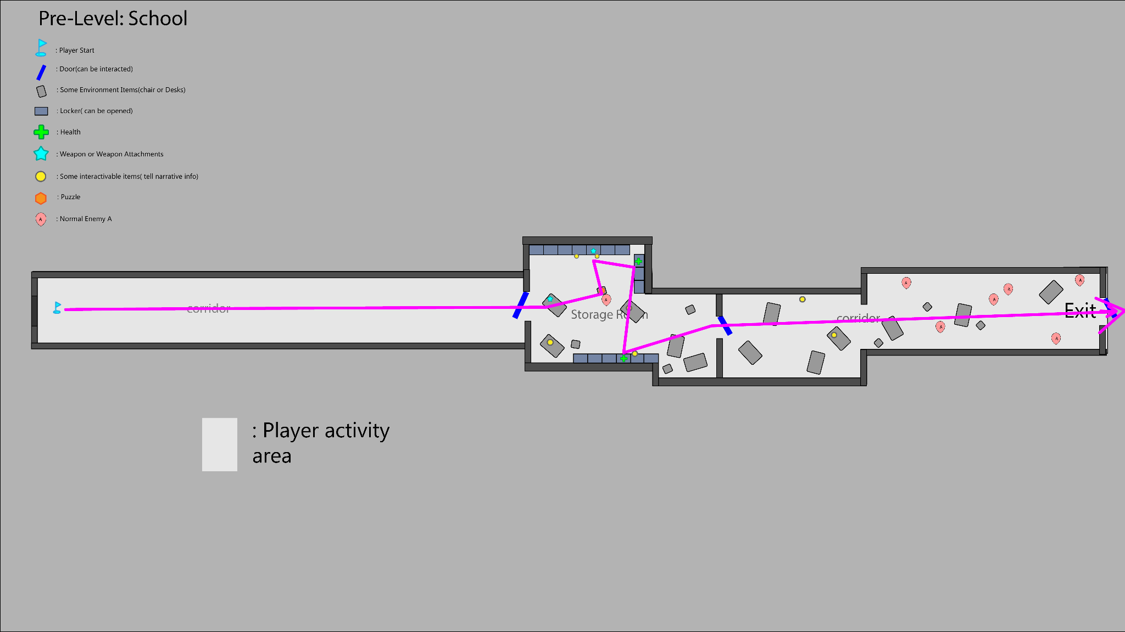

Gameplay Flow & Event&Beat Chart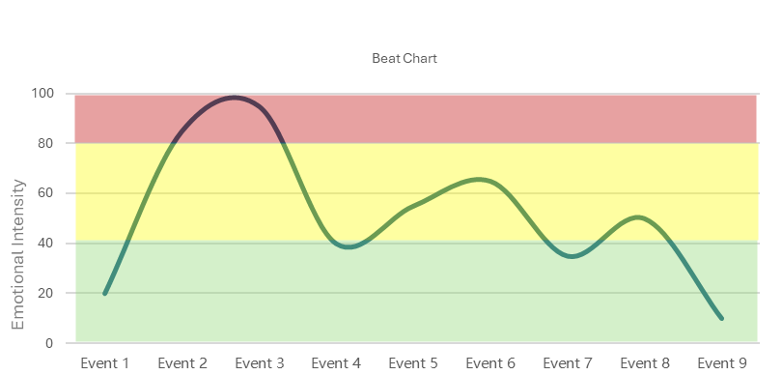

Event 1 _Player Entry

Player spawns in a long, empty school corridor

No weapon available
- Ambient audio is low and distant
- Movement is unrestricted but forward-facing

Event 2_Boss Appearance
- The giant face of the final boss suddenly appears at the far end of the corridor
- The boss begins moving toward the player
- No damage can be dealt to the boss
- Audio intensity increases rapidly

Event 3 — Chase Sequence (No Combat)
- Player is forced to run forward through the corridor
- Doors along the corridor are non-interactive
- The boss remains in pursuit but does not instantly kill the player
- Visual distortion increases as distance closes

Event 4 — Storage Room Reached

Player reaches the Storage Room entrance
- The boss immediately stops pursuing
- Audio drops sharply
- The player closes the door.

Event 5 — Investigation Phase
- Player finds a pistol on the table while get in the room
- Player explores the Storage Room and find a device（computer）connects with all the lockers and has a Normal Enemy A nearby
- Player uses the pistol to kill Normal Enemy A

Event 6 — Puzzle Resolution, First Weapon Acquisition)
- Player resolves the puzzles and all the lockers can be opened
- Player opens the lockers
- Get the first weapon attachment and the player can assemble the pistol into a rifle（ammunition is unlimited）
- Continue searching for other resources (health)

Event 7 — Narrative Buffer (Rest Space)
- Player enters a small adjacent room for a rest
- Interactable items provide narrative context

Event 8 — Combat Encounter
- Player step into the second corridor
- several Normal Enemy A appear and attack
- Combat space is wide and low-risk
- Player enters combat

Event 9 — Level Completion
- Defeat all enemies
- Exit becomes available
- Transition to the White Room

Interactive Items:
Computer: there are some puzzles needed to be solved(Wiring Panel.）
Trashbin: if you interact with it, you will see some torn exam papers
Health: a box of medicine
small notes:
（stick on the locker）I put my medicine here
（stick on the locker）hehe, my secret weapon! fight !!
（put it on the table） “Urban legends：a well-known company has created a monster through its research.”Urban legends
（put it on the table）“Didn't they say that taking this medicine would relieve stress? Why do I feel like my stress is getting worse?”
Poster:
“Academic ranking”
“Biological research, searching for the next generation of geniuses.”

Level 1: Laboratory

Narrative:
You seem familiar with the environment. Offices, desks, and workstations are still running, as if the work never stopped. Combat here feels routine, almost secondary.
What draws attention are the incubation tanks. Biological tissue—brain matter and organic samples—floats inside them, kept active and responsive. Pipes and conduits connect these tanks to a large machine at the center of the space. From the first floor, its purpose isn’t clear, only that everything seems to feed into it.
Through scattered notes and terminals, it becomes apparent that the system relies on biological responsiveness to maintain output. The samples aren’t being treated—they’re being used, but all the research is on the second floor, so you should find the way to floor2.
On the second floor, the machine is fully revealed. A large rotating mechanism draws energy directly from the incubation system, converting biological activity into power. To progress, you must unlock and operate this mechanism, aligning the rotating pathway to reach the room on the other side.
Inside is the rest of the research and a weapon attachment—an upgrade that improves efficiency rather than granting freedom.
When you leave the lab, the system continues running unchanged. The tanks pulse, the machine turns, and the work goes on as you enter the White-Room.

Design Goals：
Gameplay Goals：
- Introduce multi-floor spatial awareness，player have free to choose their own way to pass the level
- Reward exploration with a weapon attachment, not a full weapon upgrade
- Introduce pathway switching as a core interaction concept
- Reinforce the idea that:
  - Tools and systems are locked behind procedural steps
  - Access must be earned through compliance and problem-solving

Pacing Goals：
- Floor 1:Moderate, fragmented combat；Emphasis on observation and interpretation, introduce Normal Enemy B
- Floor 2:Let the players fight Elite Enemy A；Increased focus on puzzle-solving and spatial manipulation
- Final descent:Lower tension；allowing the player to exit with a sense of control

Layout：(Open world exploration）
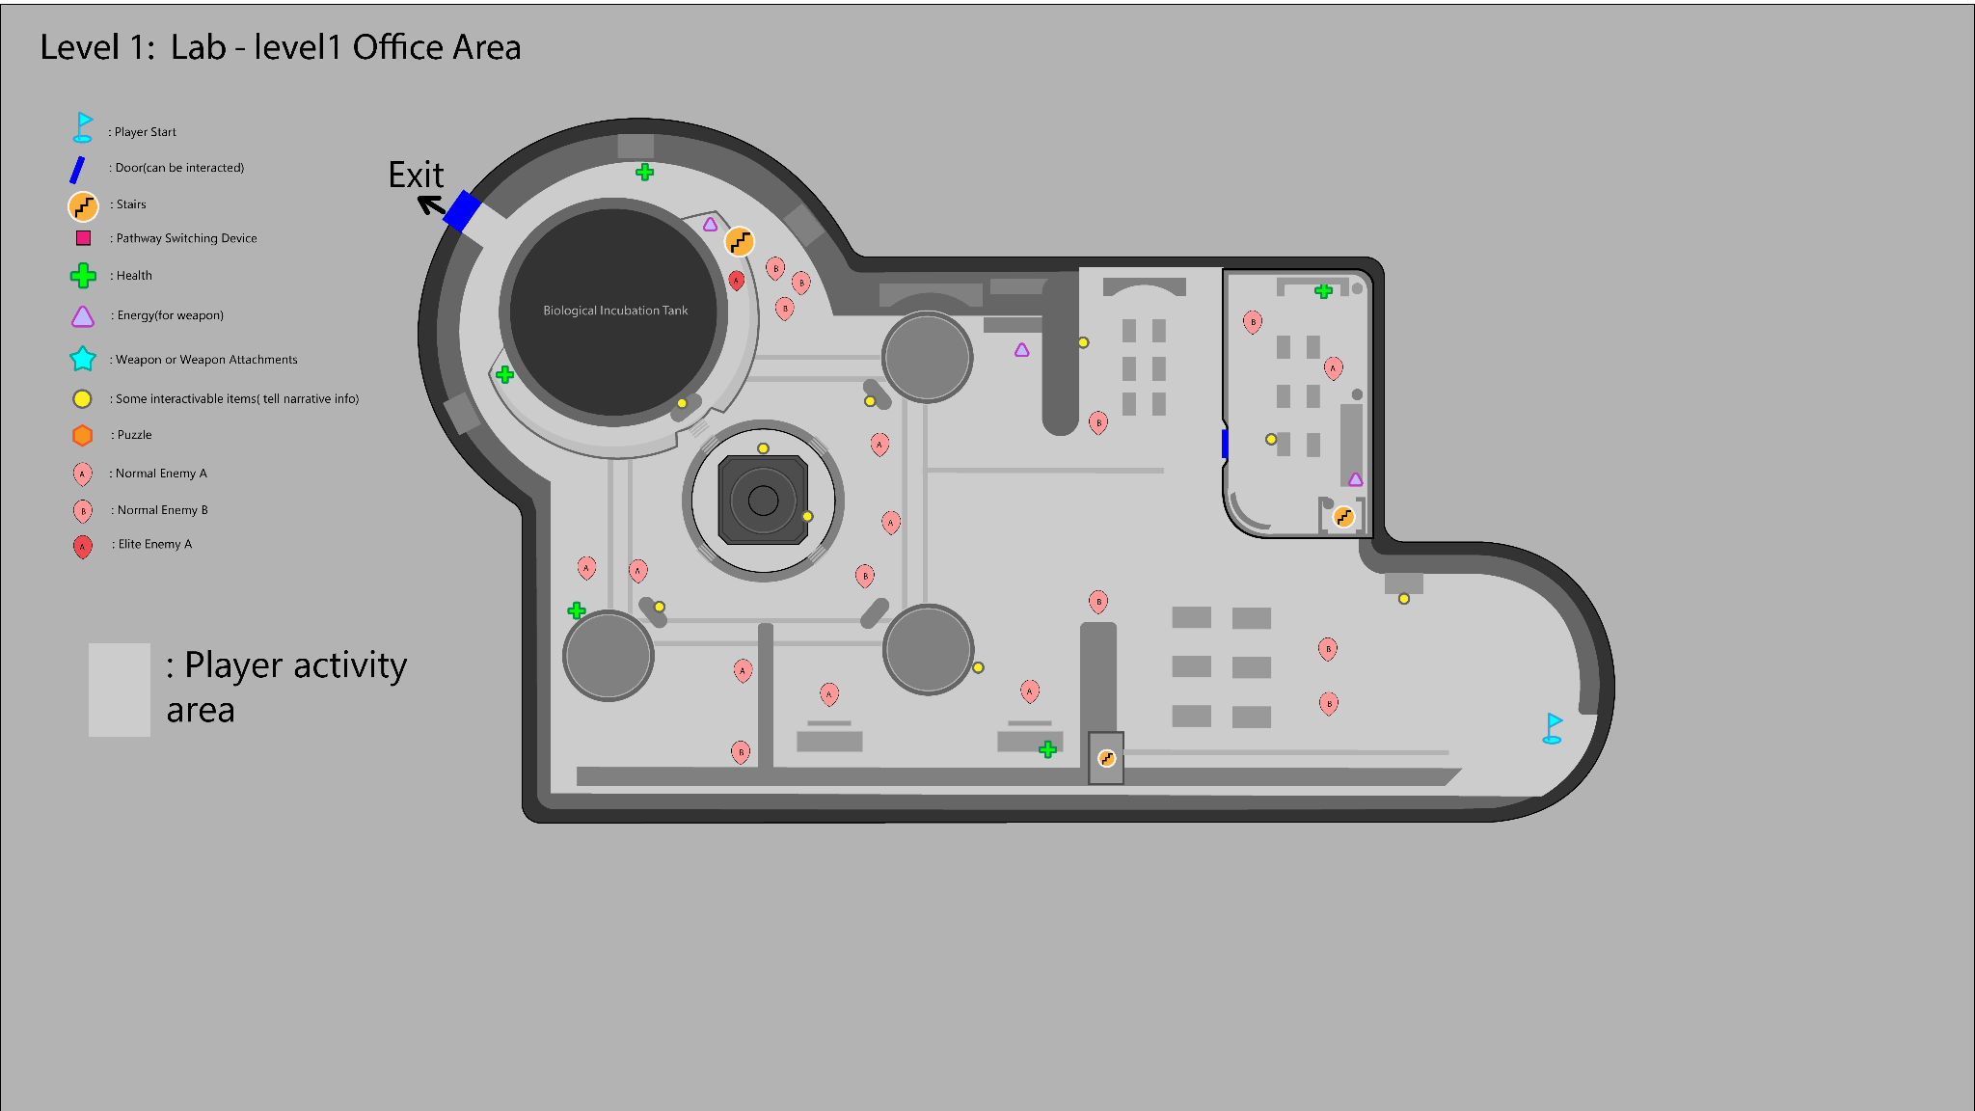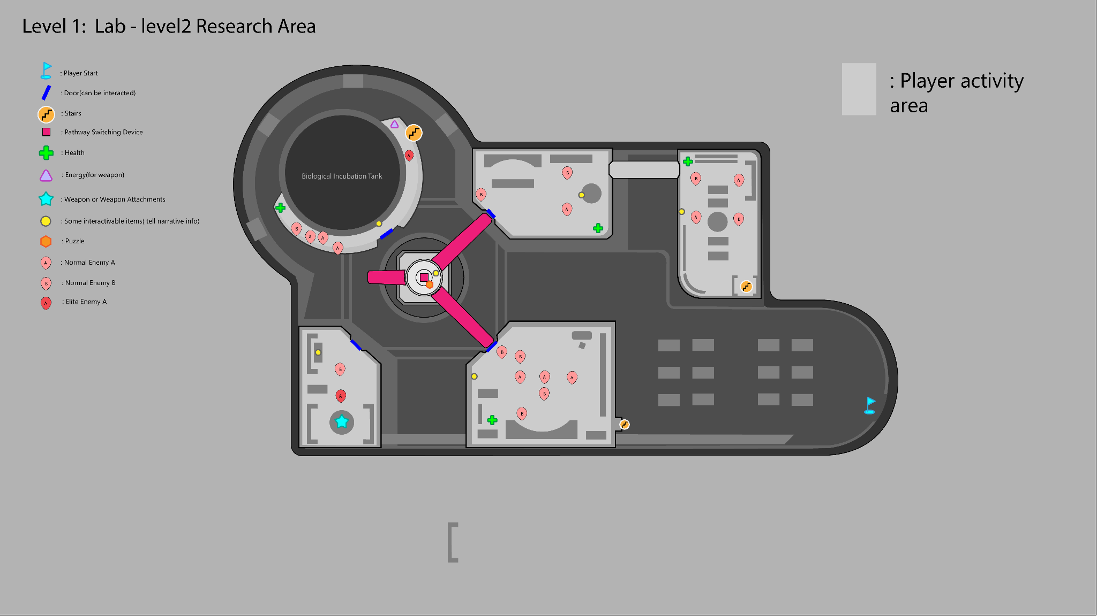

Gameplay Flow & Event & Beat Chart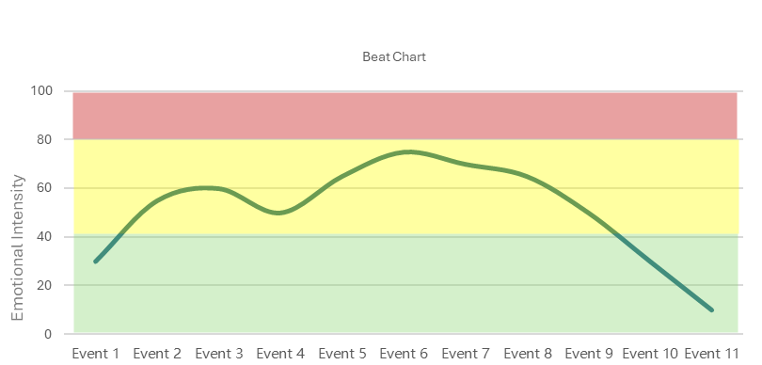

Event 1 — Level Entry (Office Area / Floor 1)
- Player enters the laboratory through an office area
- Normal Enemy A and Normal Enemy B are lightly scattered
- Combat is optional at first; enemies can be engaged gradually

Event 2 — Environmental Observation (Biological Research Space)
- Player encounters biological incubation tanks containing（ examples）:
  - Biological samples
  - Brain tissue
  - Organic-looking growth containers
- These elements are non-interactive but visually prominent
- The central machine on the floor is visible, but its function is unclear

Event 3 — Information Gathering
- Player interacts with terminals, notes, or devices in the office area
- Interactions provide fragmented information about:
  - Energy extraction
  - Biological resources
  - The need to access the upper floor
- Objective clarity shifts from exploration to progression

Event 4 — Find the way to Floor2
- Player identifies a route or access point leading to Floor 2
- Enemy density slightly decreases during the transition
- Visual focus shifts upward toward the large machine

Event 5 — Machine Reveal (Floor 2)
- Player arrives at the floor 2, find and observe the machine
- The machine resembles a large fan and rotating mechanism, player needs to rotate it and go to the other side.

Event 6 — Locked Mechanism (Pathway Switching Device)
- Player approaches the rotating pathway device
- The control interface is locked and cannot be activated
- Visual cues or some interactive items indicate that a prerequisite puzzle must be solved

Event 7 — Puzzle Resolution and Unlock the Device
- layer completes a simple puzzle to unlock the mechanism
- The device becomes operable
- The rotating pathway can now be controlled

Event 8 — Pathway Rotation
- Player rotates the pathway
- The rotation creates a new connection to a previously inaccessible room
- Environmental motion reinforces the scale and weight of the machine

Event 9 — Reward Room Access (Weapon Attachment)
- Player crosses the newly aligned pathway
- The hidden or isolated room becomes accessible
- Player acquires the new weapon attachment that enhances current weapon performance

Event 10 — Return Path & Descent
- Player returns to Floor 1
- Remaining enemies are cleared or bypass

Event 11 — Level Exit (White-Room Access)
- Player reaches the exit on Floor 1
- Transition to the White Room occurs
- The level concludes

Interactive Item:
Floor 1
KPI Dashboard：
“review reminders”
“Countdown, production curve ”
Workstation computer：
“Meeting Transcript:The board of directors demanded "immediate marketability," a shortened timeframe, and a disregard for side effects.”
“Some experimental tables indicate that the specific research data is on the computer which is located on the second floor.”
Lab Notes：A brief record of the brain's response to the medication and any unusual side effects.
Control Console：Display “Locked – Control it on the 2nd floor”
Biological Incubation Tank：
（small1）Specimen Tags，Sample source, batch number, status, and signature of the person who processed the sample.
（small2）Specimen Tags，Sample source, batch number, status, and signature of the person who processed the sample.
（big）Shift the camera slightly upwards. VO “The full structure of the biological incubation tanks isn’t visible from here”
Machine Status Display：Disconnected status.
Warning Sign：Do not cut the power！It will interrupt the extraction cycle.

Floor 2
Biological Incubation Tank：
switch the camera that focuses on the big Biological Incubation Tank and VO “It looks like human tissue.“
Small Notes:
“The robots assisting with the work developed their own consciousness, and I had to hastily devise a shotgun to control their rebellion.”
“These drones are so annoying; it feels like I'm being monitored at work every day, and it's too exhausting.”
Work station computer：
Test Environment: Controlled Laboratory Setting
System Status: Active
Biological samples remain viable under continuous stimulation.
Neural responsiveness is successfully maintained through regulated extraction cycles.
Energy output has stabilized following recent system adjustments.
Control Console：Display “Locked – Connect the Electric circuit first” and show the wiring panel

Level2: Street in the city

Narrative:
The surroundings looked like the route home from get off work. Everything seemed outwardly normal, yet felt dull and oppressive. The air was heavy, and thick fog hung low between the buildings, blurring distance and depth. The city was quieter than it should have been.

As you moved forward, billboards along the street flickered with bright commercial slogans—advertisements about efficiency, productivity, better sleep, and increased focus. They sounded reassuring, but felt out of place here, echoing in the empty city.The streets branched and reconnected in an unnatural way. The city's layout began to resemble an organism rather than a typical urban structure, taking on the shape of a brain—the roads like neural connections, the intersections like pressure points. This wasn't just a place the protagonist was passing through, but something reconstructed from memory and habit.

Combat occurred along the way, but these encounters felt less deliberate than before, as if the pressure here stemmed from accumulation rather than intentional design.

Continuing walking, the side road was blocked. The road ahead was clearly visible but impassable, forcing you to explore outwards, activating mechanisms to reconnect the streets. Only after completing a simple puzzle did the central road open, allowing you to proceed.

When the player left this street, it no longer felt like a place they were simply passing through—it felt like something you had seen many times before.

Design Goals：
- Present daily-life pressure as something ambient rather than aggressive
- Encourage exploration through branching paths and reconnection
- Use the city layout to subtly reinforce Company and brain or subconscious theme
- Let the players fight Elite Enemy B
Layout：(Open world exploration）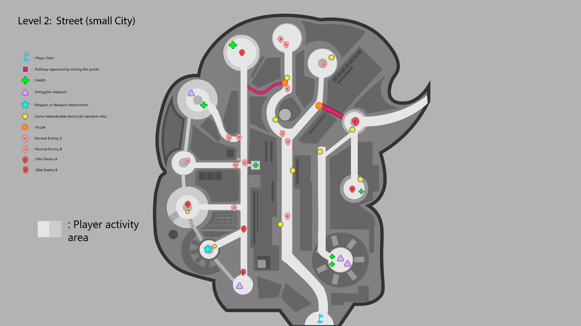

Gameplay Flow & Event & Beat Chart
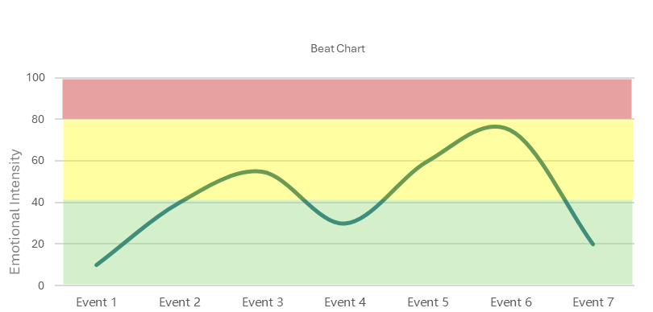

Event 1 — Level Entry
- Player spawns at the edge of the town
- Fog limits visibility and softens silhouettes
- No immediate combat

Event 2 — Initial Street Exploration
- Player follows the main road forward
- Side streets branch into circular nodes
- Normal Enemy A and B appear in small groups

Event 3 — Environmental Messaging
- Player encounters billboards and signs with commercial slogans
- Interactable points provide short narrative fragments
- The town begins to feel artificial and repetitive

Event 4 — Side Path Blocked
- Player reaches the blocked the side road
- Forward progress is clearly visible but inaccessible
- Puzzle objective becomes readable

Event 5 — Puzzle Resolution via Side Routes
- Player explores side streets to activate puzzle elements
- Normal enemies and Elite Enemy B guard key nodes
- Solving the puzzle causes a new pathway to appear

Event 6 — Exploration
- Explore both two sides beside the central road
- Find resources and New Weapon Attachment
- Find the exit according to the info

Event 7 — Level Exit
- Player reaches the exit at the far end of the street
- Transition to the white room

Interactive Item：
Billboard：“BETTER SLEEP. BETTER FOCUS. ” Now preparing for public release.+ company logo
Poster：Urban trial phase ongoing. Welcome to the participants.
It‘s time to move on, feel the warmth like home.
Map Poster：This city looks so familiar.
Killed First enemy voice：“I don’t feel tired anymore. I just… don’t feel much at all.”
Graffiti：Down with the evil corporation！
Puzzle Device：Turning off the entire roadblock seems to allow access to the other side.
Near the Weapon Attachment：It looks like there's something sparkling here, a hidden secret weapon!

Level 3: Factory

Narrative:（Looking at the problem from a different perspective might make everything clearer.）
Looking around, the conveyor belts were constantly running, pushing an unknown gaseous substance forward, and the factory floor was filled with stacked containers. Elite enemies patrolled between the containers, making the entire space feel oppressive, and the pressure never truly subsided. Every step forward was exhausting.

There were some small platforms with ladders extending upwards, allowing you to climb up. Climbing onto the high platforms and the tops of the containers offered a clear view, with only a few enemies visible. With limited remaining ammunition and supplies, a thick black fog loomed at the end of the conveyor belt, dense enough to completely obscure vision. As long as the conveyor belt was running, the fog would continue to pour in.

In the center of the factory was a conveyor belt controller.

After the controller was shut down, the factory settings changed. The belts slowed down, then stopped. The black fog gradually thinned and finally dissipated, and the electrical room became accessible. Finally, the hidden truth was revealed; you saw it, the thing that had been chasing you from the beginning!

Design Goals：
- Present pressure as a continuous production process rather than a sudden threat.
- Allow players to use multiple path strategies to reach the central objective.
- Utilize environmental mechanisms (conveyor belts, fog) as obstacles and narrative elements.
- Design the acquisition of the final weapon upgrade as a preparation phase leading to the ending.

Layout：
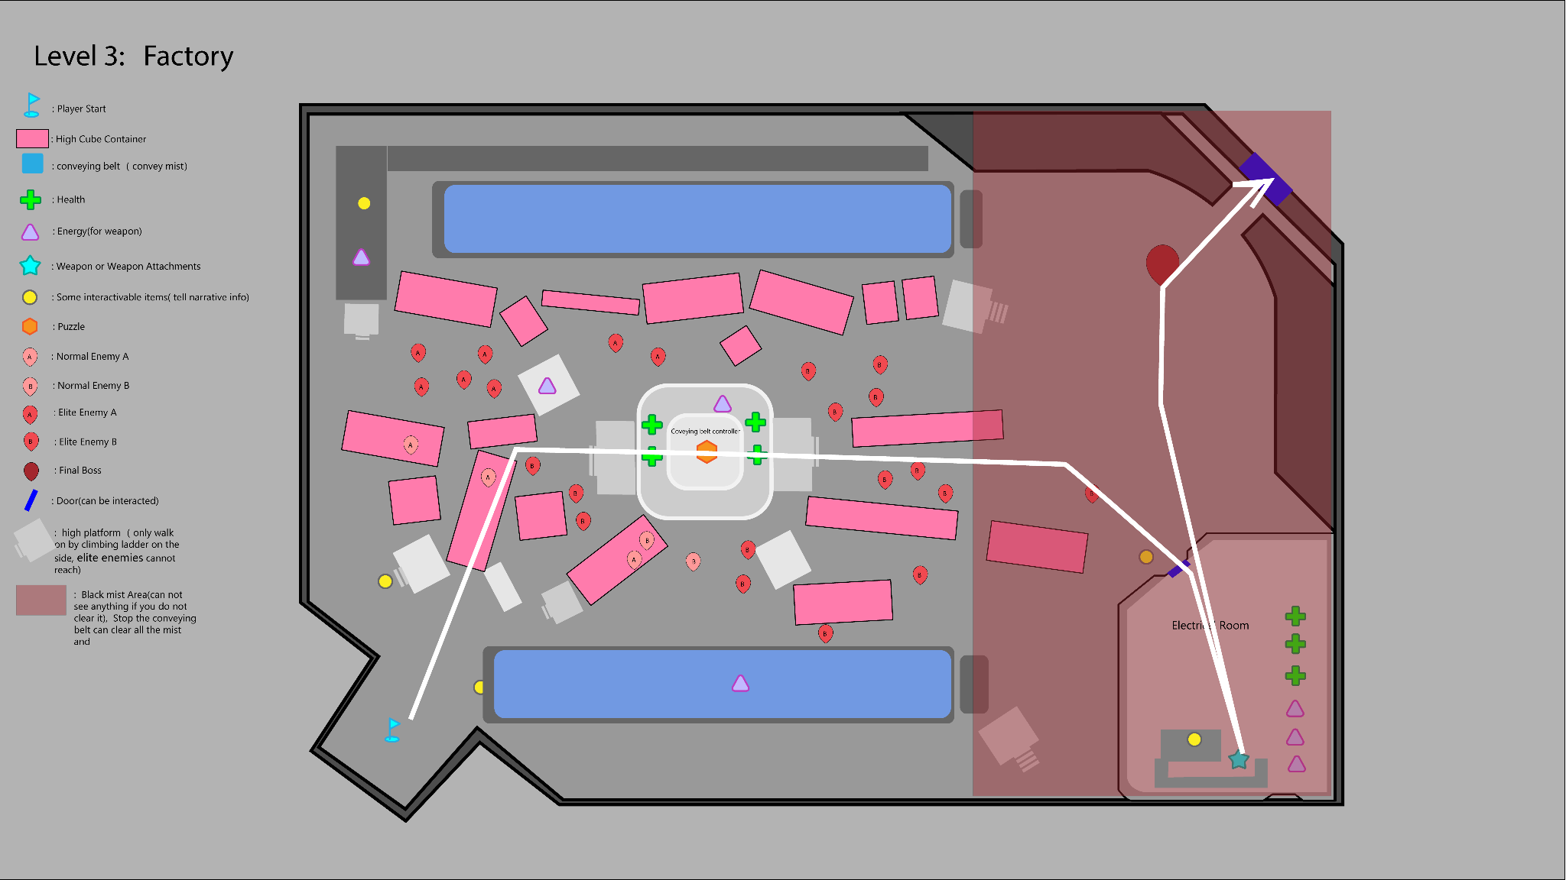

Gameplay Flow & Event & Beat Chart
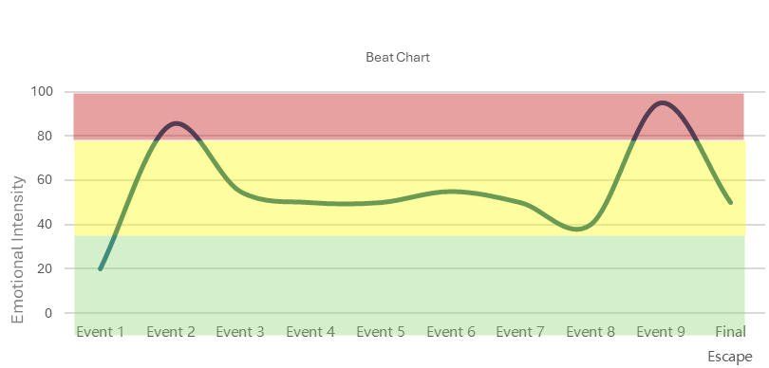

Event 1 — Factory Entry
- Player enters the factory interior
- Conveyors are active
- Immediate visual focus on stacked containers and vertical space

Event 2 — Ground-Level Pressure
- Elite enemies dominate the factory floor
- Movement is restricted and costly
- Staying on the ground feels intentionally punishing

Event 3 — High Platform Discovery
- Find ladders
- High platforms and container tops become accessible
- Enemy density drops significantly above

Event 4 — Resource Scavenging Above
- Small ammo and supply pickups appear on high platforms
- Player gains positional advantage for ranged combat
- Encourages vertical play and planning

Event 5 — Black Mist Area Revealed
- Right-side conveyor feeds thick black mist into part of the factory
- Visibility is nearly zero in the misted zone
- Area is inaccessible while the conveyor is active

Event 6 — Central Controller Objective
- Player identifies the conveyor belt controller at the factory center
- Two viable approaches:
  - Platform traversal from above
  - Ground-level push followed by side access
- Elite enemies protect the area

Event 7 — Conveyor Shutdown
- Player deactivates the controller
- Conveyors stop
- Black mist begins to clear

Event 8 — Electrical Room Access
- Newly cleared path opens to the electrical room
- No enemies present
- Player collects: Energy，Health and Final weapon attachment
- Interactive items provide final context

Event 9 — Final boss
- Fight with the final boss
- End

Interactive Item：
Ladder：There's a ladder here; you can see further if you stand higher. Let me climb up and take a look.
Coveybelt:
CONVEYOR SYSTEM: ACTIVE
Output flow stable.
Visibility impairment reported in Sector R.
Do not enter without shutdown.
Central Coveybelt Controller:
CONTROL LOCKED
Manual override requires physical access.
Small Notes: They want to cover up the truth! The black mist…
Small Notes: The source can’t hide anymore. It’s a confrontation. Face it
Near the Final Boss：（The camera reveals the monster in its entirety） Oh…gosh. This is my final battle, right?

Asset List

Pre level：

Department | Asset Type | Asset Name | Blueprint Needed | Interaction Type
Design | Actor | Normal Enemy A Drone | Yes | Combat
Design | Actor | Giant Face Boss | Yes | Boss Combat
Design | Actor | Storage Locker | Yes | Unlock Container
Weapon | Actor | Pistol Weapon | Yes | Weapon Fire
Weapon | Actor | Rifle (Upgraded Pistol) | Yes | Weapon Fire
Art | Model | Drone Enemy Model | No | Visual
Art | Model | Giant Face Boss Model | No | Visual
Art | Model | School Corridor Modular Set | No | Environment
Art | Model | Storage Room Props Set | No | Environment
Weapon | Model | Pistol FP Model | No | Visual
Weapon | Model | Rifle FP Model | No | Visual
Tech | Blueprint | Wiring Puzzle BP | Yes | Puzzle Logic
Tech | Blueprint | Pickup Base BP | Yes | Pickup
UI | UI Widget | Puzzle Wiring UI | Yes | Puzzle UI
UI | UI Widget | Interaction Prompt UI | Yes | Interaction
VFX | VFX | Space Distortion Effect | No | Trigger FX

Level 1:

Department | Asset Type | Asset Name | Blueprint Needed | Interaction Type
Design | Actor | Normal Enemy A | Yes | Combat
Design | Actor | Normal Enemy B | Yes | Combat
Design | Actor | Elite Enemy A | Yes | Combat
Design | Actor | Pathway Rotation Machine | Yes | Mechanic
Design | Actor | Circuit Puzzle Device | Yes | Puzzle
Weapon | Actor | Weapon Attachment L1 | Yes | Upgrade
Weapon | Model | Shot Gun | No | Visual
Art | Model | Lab Modular Kit | No | Environment
Art | Model | Incubation Tank Large | No | Environment
Art | Model | Incubation Tank Small | No | Environment
Art | Model | Central Machine | No | Environment
Tech | Blueprint | Pathway Rotation BP | Yes | Mechanic Logic
Tech | Blueprint | Lab Terminal Interaction BP | Yes | Interaction
UI | UI Widget | Terminal Reading UI | Yes | Narrative UI

Level 2

Department | Asset Type | Asset Name | Blueprint Needed | Interaction Type
Design | Actor | Normal Enemy A | Yes | Combat
Design | Actor | Normal Enemy B | Yes | Combat
Design | Actor | Elite Enemy B | Yes | Combat
Design | Actor | Street Puzzle Node Device | Yes | Puzzle
Weapon | Actor | Weapon Attachment L2 | Yes | Upgrade
Weapon | Model | Generade Launcher | Yes | Visual
Art | Model | City Building Modular Kit | No | Environment
Art | Model | Street Props Set | No | Environment
VFX | VFX | Fog Volume System | Yes | Environment FX
Tech | Blueprint | Street Puzzle Controller BP | Yes | Puzzle Logic
UI | UI Widget | Puzzle Activation UI | Yes | Interaction

Level 3

Department | Asset Type | Asset Name | Blueprint Needed | Interaction Type
Design | Actor | Elite Factory Enemy | Yes | Combat
Design | Actor | Final Boss | Yes | Boss Combat
Design | Actor | Conveyor Belt System | Yes | Environment Mechanic
Design | Actor | Conveyor Controller | Yes | Objective Interaction
Weapon | Actor | Final Weapon Attachment | Yes | Upgrade
Weapon | Model | Pulse Rifle | No | Visual
Pickup | Actor | Energy Pickup | Yes | Pickup
Pickup | Actor | Health Pickup | Yes | Pickup
Art | Model | Factory Modular Kit | No | Environment
Art | Model | Factory Container Stacks | No | Environment
Art | Model | Conveyor Belt Model | No | Environment
VFX | VFX | Black Mist Volumetric FX | Yes | Environment FX
Tech | Blueprint | Conveyor Control BP | Yes | Mechanic Logic
UI | UI Widget | Boss Health UI | Yes | Combat UI

