Tension through Surveillance Restriction: Designing Strategic Gameplay in Pet Simulation

May 2025

Savannah College of Art and Design

Acknowledgments

This project was developed by Yu Zhiyun. All game logic, UI interactions, and prototype scripts were implemented independently using Unreal Engine 5.5.

I would like to thank:
All volunteer testers who provided valuable feedback during the initial prototyping phase.
Mei Wanzhen, who contributed visual assets to the game.
Figma: Core Loop, Timeline Gantt Chart
ChatGPT: Assist in Translation, Grammar Checking
Google Form: Testing Feedback
Photoshop: Concept Design, Before-Game Comic, Pet and Character
Adobe Illustrator: UI
After Effects: Animation
Maya, Substance 3D Painter: Environment Model

TABLE OF CONTNETS

LIST OF FIGURES 2
LIST OF TABLES 3
ABSTRACT 4
INTRODUCTION 5
Research Focus Statement 5
Research Gap and Evidence 6
Theoretical Framework: Theory of Constraints (TOC) 7
Literature Review 8
Historical-Technical Survey 10
1. Five Nights at Freddy’s (Scott Cawthon, 2014) 10
2. Talking Ben (Outfit7, 2011) 10
3. Tamagotchi (Bandai, 1996) 11
Artifact Overview 11
Design Methods 12
Design Artifact 13
Pre-Production 14
Development 17
Prototype Overview 17
Second Prototype: Spatial Surveillance Restriction 24
Validation Methodology 26
Research Design Overview 26
Phase 1: Temporal Surveillance Restriction 27
Phase 2: Spatial Surveillance Restriction 28
Phase 3: Integrated Constraint Validation 29
Survey Results and Analysis: 30
Results 39
Phase 1: Results of the Self-Selected Temporal Constraint Test 39
Phase 2: Results of the Spatial Surveillance Restriction Test 41
Phase 3: Results of the Final Integrated Constraint Test 42
Conclusion 44
Limitations and Future Directions 46
Limitations 46
Future Directions 47
Development Team: 48
Appendix 49
Questionnaire 1: Post-Play Test 49
Questionnaire 2: Temporal Constraint Test 50
Questionnaire 3: Spatial Constraint Test 51
Questionnaire 4: Final Complex Constraint Test 52
Bibliography 53

LIST OF FIGURES

Figure 1: From “MDA: A Formal Approach to Game Design and Game Research” by R. 8
Figure 2: Core Loop 16
Figure 3: UI Sketch 17
Figure 4: Narrative Comic Storyboard (introducing the background) 17
Figure 5: Visual Style Confirmation 18
Figure 6: Screenshot from the Paper Prototype 20
Figure 7: In-Game Screenshots (Main Menu, Work Menu) 22
Figure 8: Temporal Restriction Blueprints 23
Figure 9: Result Menu and Time-Record Stamp Blueprint 24
Figure 10: In-Game Screenshots (Camera Menu, Pause Menu) 26
Figure 11: Spatial Constraints Blueprint (Camera Movement) 27
Figure 12: Results of Prototype Testing Feedback Questionnaire 33
Figure 13: Results of Temporal Constraints Test 33
Figure 14: Results of Spatial Constraint Test 35
Figure 14: Results of Final Integrated Constraint Test 38

LIST OF TABLES

Table 1: A systematic analysis of 20 commercially successful mobile pet simulators 13
Table 2: Destructive Event Rate (DER) Across Work Durations 41
Table 3: Perceived Tension and Pressure Metrics Under Spatial Restriction 43

ABSTRACT

Tension through Surveillance Restriction: Designing Strategic Gameplay in Pet Simulation

Zhiyun Yu

May 2025

This thesis explores how restrictions on surveillance can create psychological tension and encourage strategic decision-making in pet simulation games. While many pet simulation games emphasize comfort, emotional attachment, continuous control, and immediate feedback, this project investigates how limiting access to surveillance can shift pet care from passive observation to active prediction, risk assessment, and prioritization. Using the Theory of Constraints as a framework, the study identifies limited surveillance access as the primary system bottleneck. A playable prototype developed in Unreal Engine was created to test three forms of restriction: temporal restriction through work-time absence, spatial restriction through limited camera visibility, and integrated restriction through the combination of both systems. This research proposes surveillance restriction as a constraint-based design approach for enhancing strategic gameplay in pet simulation games without relying on punishment or moral consequences.

Keywords: pet simulation, surveillance game, restricted visibility, strategic gameplay, psychological tension, risk management, constraint-based design

INTRODUCTION
The global virtual pet simulation market is expanding rapidly, with forecasts projecting growth from $326.14 million in 2025 to more than $525.05 million by 2030 (Research and Markets, 2025). Despite this strong commercial performance, a systematic analysis of 20 leading mobile pet simulation games reveals a consistent design tendency: approximately 90% of these titles rely on continuous control loops, immediate feedback, and unrestricted visibility to support relaxation and emotional engagement (Sensor Tower, 2024). Although these approaches effectively promote accessibility and user attachment, they also reveal a notable design limitation within pet simulation games. In particular, the genre largely lacks systems that use mechanical constraints to introduce cognitive challenge or strategic complexity.
To address this limitation, the present study draws on the Theory of Constraints (TOC), which conceptualizes system behavior as primarily shaped by its most restrictive element (TOC Institute, n.d.). Within this framework, the principal constraint is defined as monitoring time bandwidth, namely the limited capacity players have to observe system states and intervene while managing concurrent tasks in pet simulation gameplay. By introducing spatial limitations alongside temporal bottlenecks, the project examines how deliberately imposed restrictions can reorganize player behavior under conditions of uncertainty.

Research Focus Statement
This study explores how mechanical surveillance constraints can be intentionally used in simulation games to create psychological tension and promote strategic decision-making. Set within a remote pet monitoring scenario, the game requires players to manage an active, disruptive pet through limited surveillance tools and teleoperated gadgets, responding selectively to prevent harm. Unlike traditional pet simulation games that emphasize relaxation and emotional connection, this project transforms passive observation into an active, tension-driven strategy system. By embedding systemic constraints into the core mechanics, the game demonstrates how constraints can focus attention, encourage more strategic play, and increase engagement without relying on punishment or moral consequences.

Research Gap and Evidence
Despite strong commercial growth, virtual pet simulators rarely use constraint-driven mechanics. Using Sensor Tower data from 2024, this study evaluated two design elements: mechanical constraints (e.g., limited monitoring range, limited interaction, or delayed feedback) and stress-inducing mechanics (e.g., resource scarcity, risk of failure, or strategic ambiguity).
The analysis showed that 18 of the 20 games relied on continuous control loops (e.g., feeding, customization, or care), continuous visibility, and immediate feedback. None implemented systematic constraints such as limited viewing angles, intervention caps, or action delays. The remaining two games used only a small number of restrictive mechanisms. Happy Pet Story includes intervention cooldowns, with some tools requiring players to wait several minutes before using them again. Talking Ben includes a limited number of “punishment” mechanisms and caps the number of times players can intervene in undesirable pet behavior. The former supports time-rhythm management and payment guidance, while the latter enhances character performance and humor. Neither produces sustained strategic decision-making pressure or cognitive challenge. Overall, these games remain relaxation-oriented rather than strategy-oriented experiences.
According to Research and Markets (2025), the global virtual pet simulator app market is expected to grow from $326.14 million in 2025 to $525.05 million in 2030, reflecting strong user demand and market saturation. The report notes that “strategy-oriented simulators emphasize progression mechanisms that reward careful planning,” but it does not identify commercial precedents for restriction mechanisms that induce tension and increase strategic gameplay. This points to a clear market and design gap: while the genre continues to grow in revenue and user base, its gameplay remains largely unrestricted. This study addresses that gap by intentionally embedding restriction mechanisms into the core design, transforming pet simulation into a site of conscious cognitive challenge and strategic play.

Theoretical Framework: Theory of Constraints (TOC)
This research is informed by the Theory of Constraints (TOC), which proposes that system behavior is primarily shaped by its main limiting factor. Rather than optimizing all system components equally, TOC emphasizes identifying the primary constraint that governs overall system performance.
In this study, the primary system constraint is monitoring time bandwidth, defined as the amount of time players can devote to observing surveillance information. Rather than directly limiting player abilities or action mechanics, the system restricts access to real-time environmental information by requiring players to allocate time to work tasks. As work occupancy increases, available monitoring bandwidth decreases.
This reduction in monitoring time bandwidth increases informational uncertainty. Players must make decisions based on incomplete or delayed knowledge of system states. Within this framework, Work-In-Progress (WIP) is reinterpreted as cognitive and informational workload: the number of system states players must mentally track while away from surveillance. As monitoring interruptions increase, WIP accumulates cognitively rather than physically.
The conceptual model can therefore be expressed as the following causal chain:
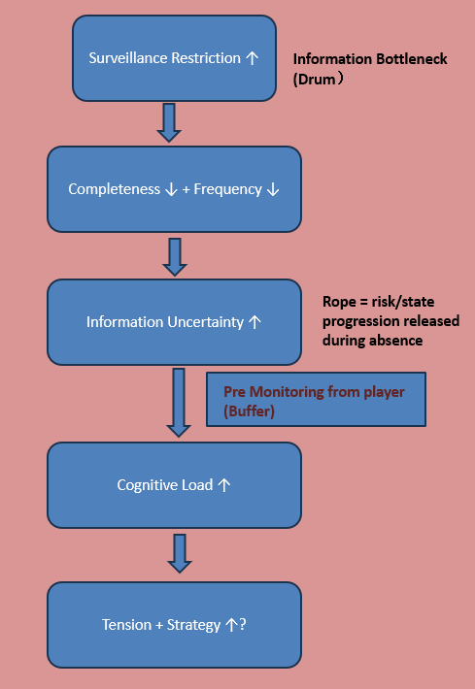
Figure 1: From “MDA: A Formal Approach to Game Design and Game Research” by R.
By manipulating monitoring-time restrictions, the system regulates informational throughput, cognitive pressure, and, ultimately, strategic adaptation. Surveillance restriction functions not as a deprivation of agency, but as a structural bottleneck that reorganizes player behavior under uncertainty.

Literature Review
1. TOC Institute. (n.d.). Theory of Constraints
According to the TOC Institute, “a constraint limits the output of every system, whether we acknowledge it or not. When properly identified and managed, constraints provide the fastest route to significant improvement and form the bedrock for continuous growth. When ignored, the constraint may lie idle, squandering system capacity. An out-of-control constraint may also wreak havoc on delivery schedules and cause unpredictable delays” (TOC Institute, n.d.).
This perspective reframes constraints not as weaknesses to be eliminated, but as structural determinants of system performance. In interactive systems such as games, this logic suggests that a deliberately designed bottleneck can reorganize player behavior and redirect strategic focus. In this study, surveillance restriction functions as the primary constraint governing informational throughput. By structuring when and how players access monitoring information, the system reorganizes decision-making behavior under uncertainty.
2. Finn Atkinson and Laura Pruszko. 2025. Player Agency Under Constraint: A Pilot Study on the Forced-Choice Effect in Narrative Difficulty Design. In Proceedings of the 2025 Conference on Creativity and Cognition (C&C ’25). Association for Computing Machinery, New York, NY, USA, 404–408.https://doi.org/10.1145/3698061.3735326 https://doi.org/10.1145/3698061.3735326
This article describes the “forced-choice effect” observed in a study of constrained decision-making in Elden Ring, where players facing limited options tended to focus on dominant strategies. The authors note that “players converged toward dominant strategies—with variation in how they interpreted them.” In the proposed game, similar constraints, such as limited camera access and restricted intervention opportunities, push players to prioritize actions and develop adaptive strategies under pressure. This supports the idea that intentional mechanical limitation can sharpen decision-making and increase psychological engagement, even when player freedom is reduced.
3. Spiliopoulos, L., Ortmann, A., & Zhang, L. (2018). Complexity, attention, and choice in games under time constraints: A process analysis. Journal of Experimental Psychology: Learning, Memory, and Cognition, 44(10), 1609–1640. https://doi.org/10.1037/xlm0000535 https://doi.org/10.1037/xlm0000535
This article shows that when players face time pressure, they tend to focus attention, simplify decision-making, and rely on faster strategies without reducing performance. In the proposed game, players are not placed under strict time pressure; instead, they face limited spatial and tool-based agency. The fixed number of cameras and restricted use of intervention tools, such as toys or distractions, require players to attend selectively to the most relevant cues and prioritize actions carefully. This aligns with Spiliopoulos et al.’s observation that constraints reshape player cognition, encouraging deliberate strategic action and heightened engagement even in the absence of temporal urgency.

Historical-Technical Survey

1. Five Nights at Freddy’s (Scott Cawthon, 2014)
This game relies on static surveillance cameras, limited energy, and delayed action feedback to generate stress and fear. Players must balance limited resources with fragmented visual information in order to survive nighttime threats. Its effectiveness lies in forcing players to make decisions under incomplete information and time-sensitive constraints.
The proposed game draws on its surveillance interface and constraint mechanisms, including limited visibility and limited intervention, but removes terror and punishment as incentive structures. Instead, it applies these systems to a care-based setting, transforming fear into focused engagement. The game retains the strategic tension of FNAF while replacing fear with cognitive urgency, making the experience suitable for nonviolent simulation while maintaining emotional intensity.

2. Talking Ben (Outfit7, 2011)
Talking Ben is part of the Talking Tom series and is primarily designed as a casual entertainment app. Although most interactions are open-ended and humorous, the game introduces a limited-use “scold” feature that allows players to briefly interrupt Ben’s behavior a few times per day. This mechanic suggests intervention scarcity, but it is designed to create comedic timing rather than to challenge player decision-making.
The proposed game draws from this idea of limiting player interaction, but recontextualizes it as a strategic decision-making system rather than a novelty feature. A limiting mechanic built around emotional feedback is replaced by a delayed, meaningful intervention system that encourages players to think strategically, making each action cognitively meaningful rather than purely entertaining.

3. Tamagotchi (Bandai, 1996)
Tamagotchi pioneered virtual pet care by offering a minimalist interface with only a small number of options. Despite its simplicity, the system creates deep emotional attachment through lasting consequences: if users neglect their pet, it may become sick or die. This is one of the earliest digital examples of limited control generating substantial psychological investment.
This project extends the principle of “consequences for inaction” by positioning the player as a surveillance agent with incomplete information, increasing tension through visual constraints and time delays.

Artifact Overview
This thesis explores how constrained mechanical systems, such as limited monitoring, delayed actions, and limited interventions, can create psychological tension and cognitive engagement in a remote pet monitoring simulation. Built for PC using Unreal Engine 5, the prototype enhances the playability and strategic depth of the casual pet simulation genre through a decision-making perspective grounded in partial information.
The game places players in the role of a pet owner who is away from home for work and monitors their pet through a network of fixed cameras accessed via a smartphone interface. Gameplay revolves around switching camera views, detecting destructive behavior, such as knocking over objects or chewing furniture, and responding through limited interventions, such as voice commands or virtual toys. Interventions are governed by cooldowns and delays, requiring players to think carefully and prioritize their actions.
A pet status interface is displayed before the monitoring phase begins. The interface presents key indicators, such as mood, hunger, and destructive drive. These values are updated over time and affect the likelihood that the pet will engage in destructive behavior. Players must interpret these indicators and determine in advance when to intervene or switch cameras. This mechanism adds a layer of prediction and resource management to the system, encouraging players to combine real-time monitoring with strategic foresight.
Unlike traditional pet simulators, this system intentionally deprives players of full autonomy. The goal is not constant interaction, but strategic inaction and anticipation. In “Thesis I,” the pet’s behavior is driven by a random script; in Thesis II, this system could be extended into a finite state machine or lightweight AI. The emphasis is on the player’s ability to manage uncertainty and allocate limited attention, especially in later stages when background distractions, such as work-related tasks, are introduced.

Design Methods
Content analysis: A systematic review of 20 commercially successful mobile pet simulators (Table 1, 2025) examined industry tendencies toward unrestricted interaction and immediate feedback. These findings highlighted a gap in research on constraint-based systems within the genre and guided the decision to pursue mechanisms that increase cognitive engagement. Theory-driven framework: The design draws on the MDA framework to structure how mechanical constraints, such as fixed viewpoints and input delays, create dynamic changes in priority, tension, and focus. The theory supports the core hypothesis that constraints, rather than freedom alone, can enhance psychological immersion.
Table 1: A systematic analysis of 20 commercially successful mobile pet simulators

Design specifications: The HUD adopts a retro anime and candy-colored visual style, similar to Muse Dash, and includes the following elements:
- A fixed-room monitoring layout with a single active camera feed at a time
- A scripted pet behavior timeline that randomly selects events from a limited pool, such as knocking over or chewing objects
- A limited-use intervention system, such as “throw toy” or “activate sound,” with cooldowns and delayed effects
- A UI overlay that includes both surveillance controls and passive background tasks, such as event-planning pop-ups
These specifications translate abstract design theories into executable gameplay elements suitable for testing.
The worldbuilding and narrative primer use a short opening comic to establish the scene: the player is about to leave for work, connect to a surveillance system, and balance daily responsibilities with real-time pet care. This opening comic not only outlines the player’s emotional trajectory but also reinforces the theme of “limited control.”
Optional research: Informal player interviews and digital surveys are planned to collect feedback on game tension, interface clarity, and emotional reactions to missed interventions.

Design Artifact
Phase I (Paper I):
Build and test a minimum viable prototype focused on the core loop:
- Three-room monitoring system
- Two scripted pet behavior types
- Three intervention methods with cooldowns and delays
- Visual feedback through screen flashes or object shaking
- Basic interruption task
- Optional pet status UI panel showing real-time values for emotion, hunger, and destructive drive

Phase II (post-MVP/Thesis II):
Extend pet behavior logic using AI or behavior trees
Introduce dynamic task interruptions, such as emergency calls or scheduling requests
Add a scoring or feedback system to reflect player success and failure rates
Develop a performance summary screen, such as an “end-of-day” report

Pre-Production
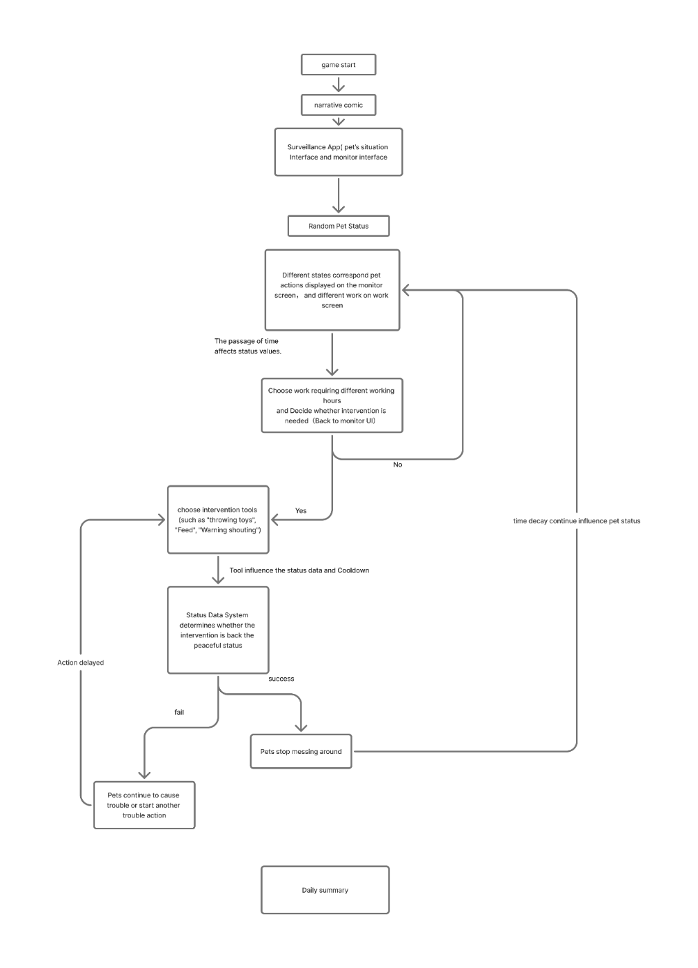
Figure 2: Core Loop

UI Framework:

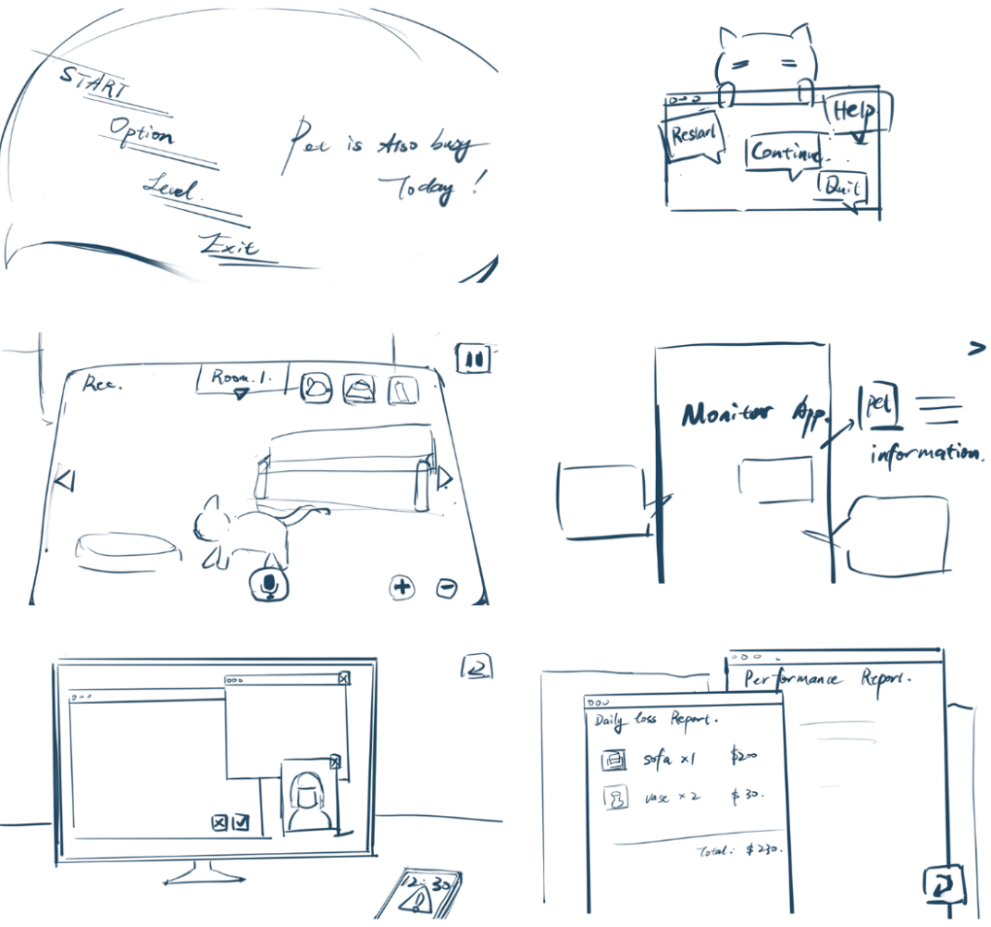
Figure 3: UI Sketch
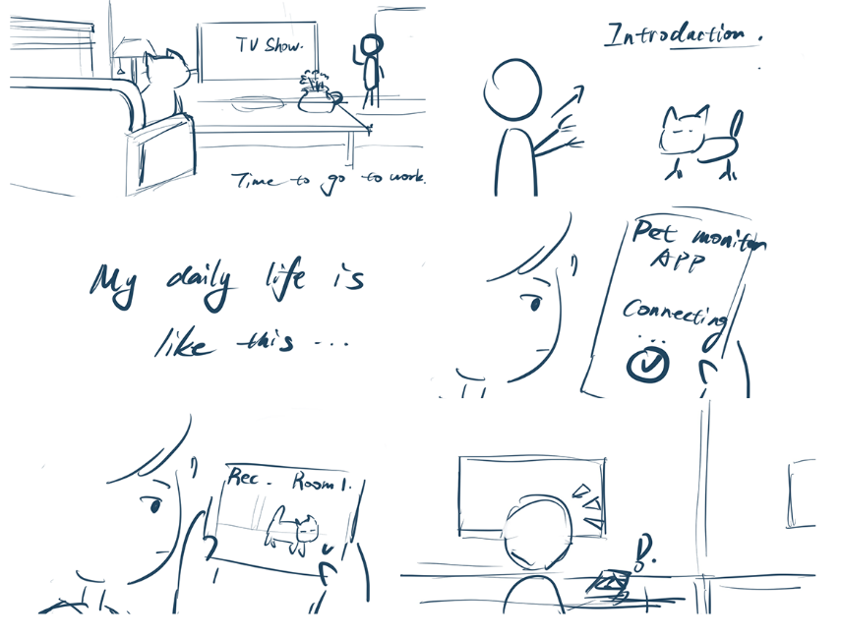
Figure 4: Narrative Comic Storyboard (introducing the background)

Visualization:
A simple sketch collage (Figure 11, 2025) establishes the general visual and color style, which is dominated by candy colors because the overall emotional tone of the game is playful and intended to convey the cute emotional connection between pets and people.

Figure 5: Visual Style Confirmation

Development

Prototype Overview
The main goal of the prototype is system testing. Built in Unreal Engine, the prototype evaluates the core UI system and the functional relationship between pet behavior states and player actions. Specifically, it explores how players respond to dynamic changes in three interrelated pet status values: happiness, hunger, and destructiveness. Players are given three behavioral intervention tools—feeding, throwing toys, and shouting—and must choose the most appropriate action based on the pet’s current state.
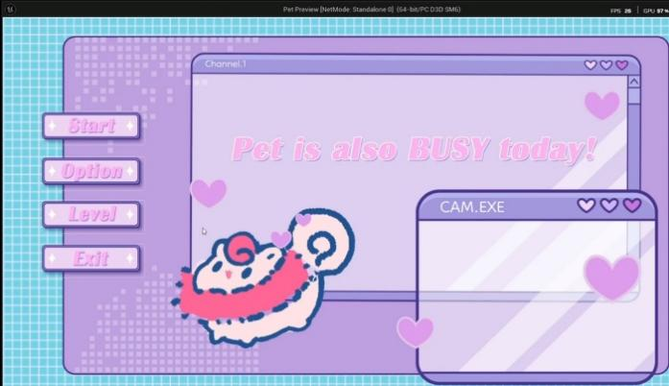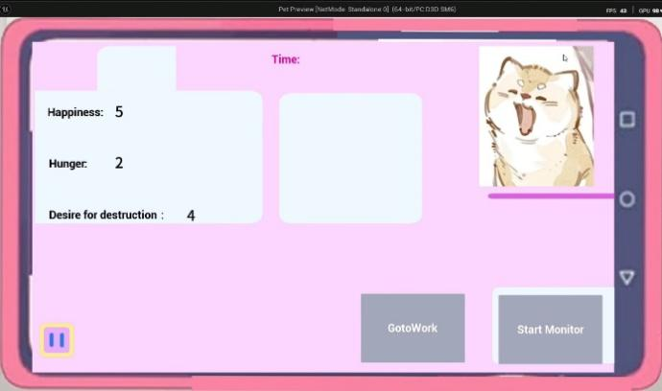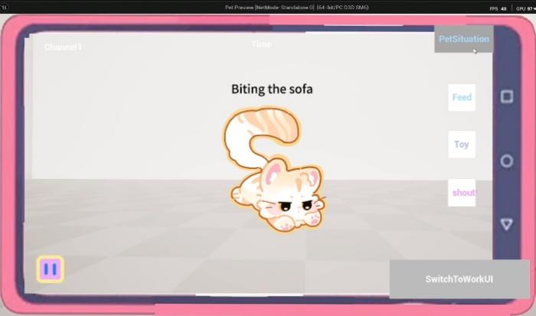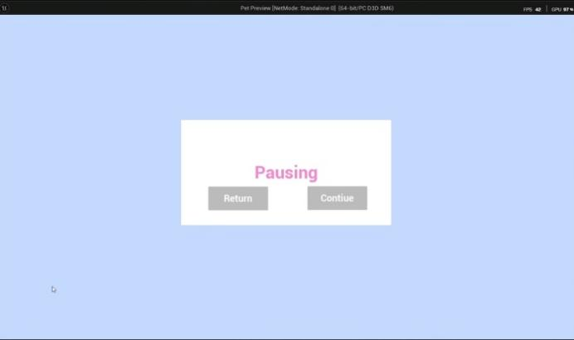
Figure 6: Screenshot from the Paper Prototype
A key design principle behind the prototype is that the three values are initially random, yet they do not exist independently; instead, they dynamically interact with and influence one another. For example, feeding reduces hunger, and when hunger reaches a certain threshold, it increases the pet’s happiness. Conversely, if the pet is not fed for a certain period and hunger rises to a specific level, happiness decreases while destructiveness increases. Similarly, although shouting can immediately suppress destructive behavior, it may significantly reduce happiness and thereby trigger further negative reactions. This interdependency is central to the test, requiring players to observe, interpret, and balance multiple constantly changing values in order to make the best decision.
The purpose of this prototype was therefore twofold: to assess whether players could manipulate the user interface effectively and intuitively, and to determine whether the game features functioned properly and successfully created a sense of strategic tension. To succeed, players must explore how their interventions affect the logic of interrelated state values and manage the balance between the pet’s emotions and behaviors over time.
Third Prototype: In this phase, I introduced temporal restrictions by adding a work interface system.
In this system, players are periodically required to remain on the work interface for a short duration. During this time, they cannot monitor the pet or perform any actions, such as feeding it or stopping disruptive behavior.
This creates a temporal surveillance constraint in which players temporarily lose access to both information and control. As a result, they must make decisions in advance and anticipate potential risks before losing access.
In addition, I implemented a results system that records player actions and summarizes performance at the end of each session, providing a clearer overview of player decisions.
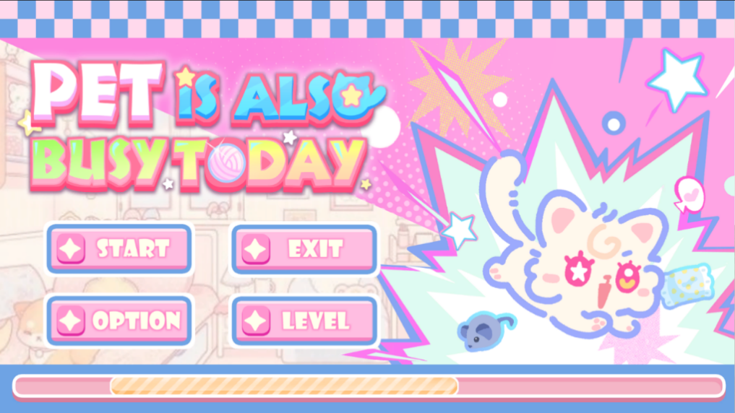
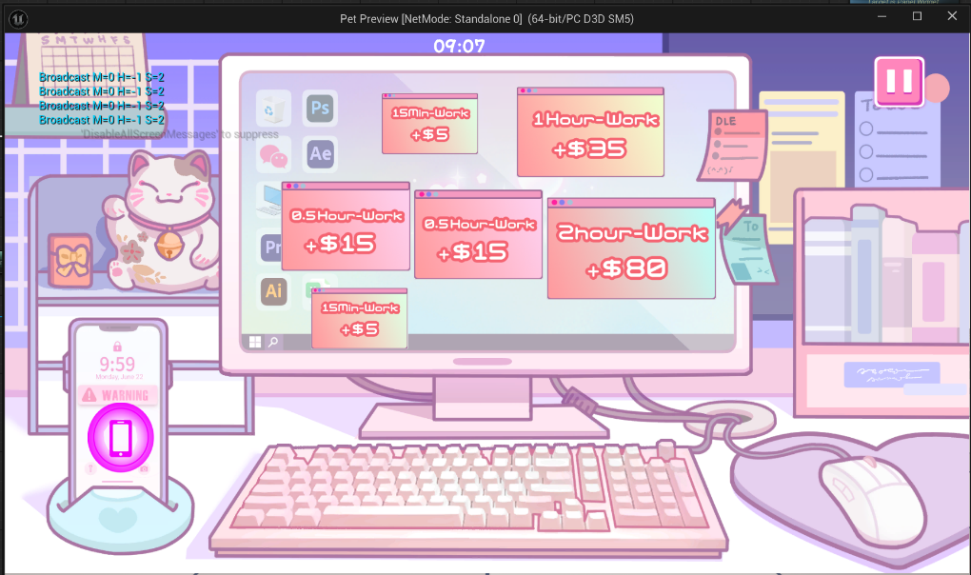
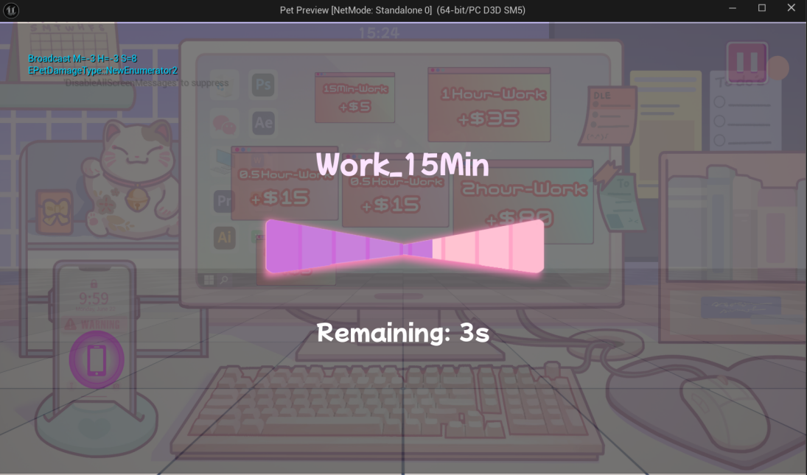
Figure 7: In-Game Screenshots (Main Menu, Work Menu)
A work-menu restriction was added so that players cannot return to the pet menu for several rounds.
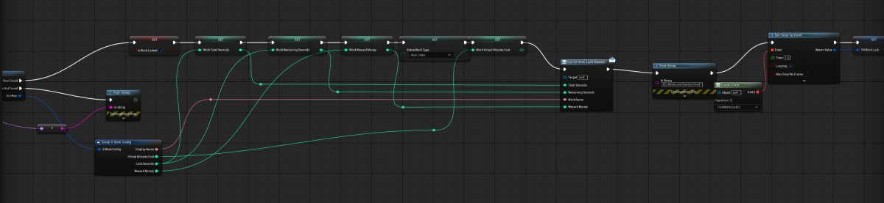
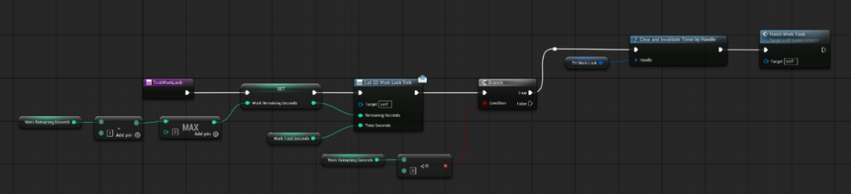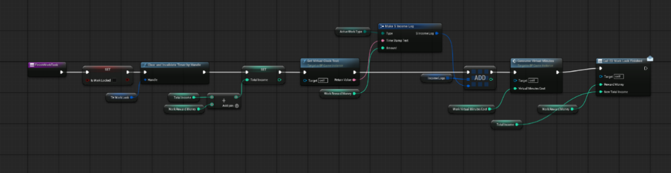
Figure 8: Temporal Restriction Blueprints
A time-record stamp was added to the result menu to support easier monitoring and prepare for subsequent data calculations:
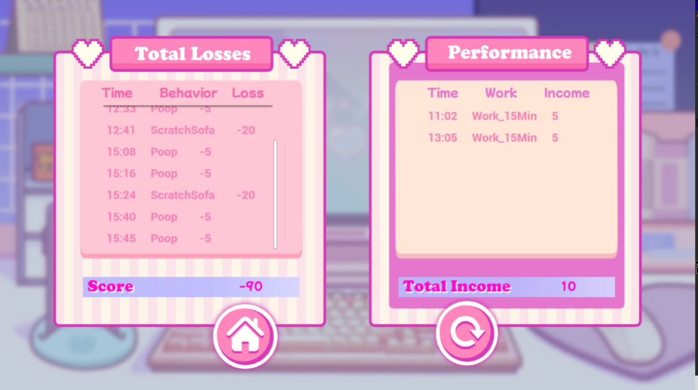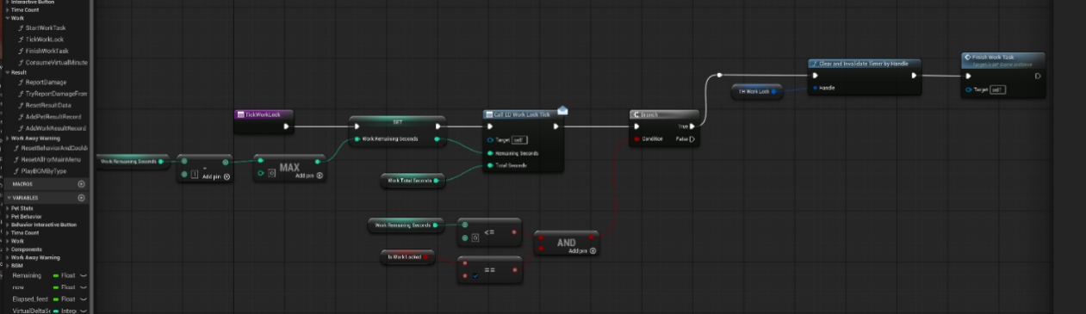
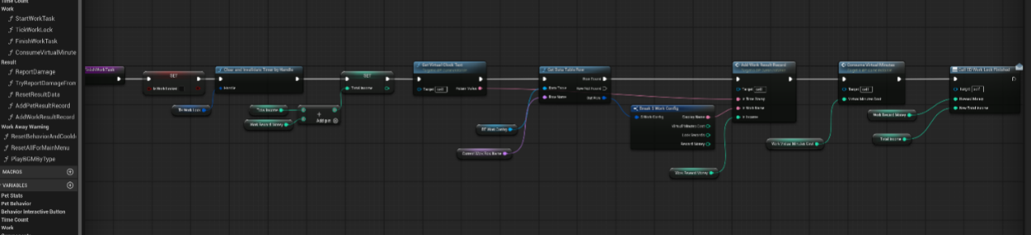
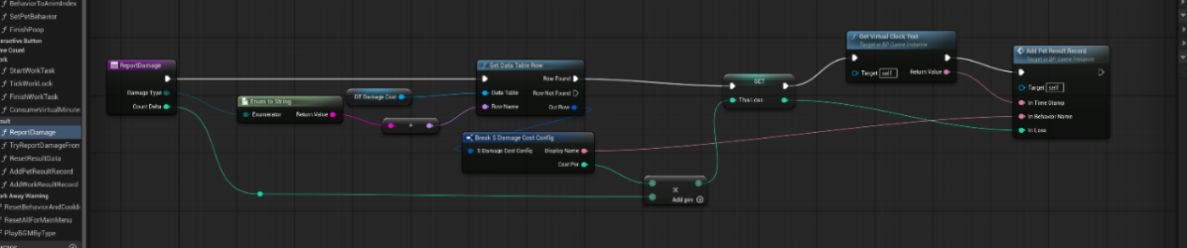
Figure 9: Result Menu and Time-Record Stamp Blueprint

Second Prototype: Spatial Surveillance Restriction
In this phase, I focused on implementing spatial restrictions within the monitoring system.
Players are required to move the camera actively (left, right, up, and down) to locate the pet rather than seeing the entire room at once. In addition, they must switch between the monitoring interface and the pet status panel to understand the pet’s condition.
These mechanics prevent players from accessing all information at the same time. Instead, they must search for the pet, check its status, and piece together what is happening.
Together, these interactions create a spatial surveillance constraint in which limited visibility and fragmented information force players to actively gather information and make decisions.

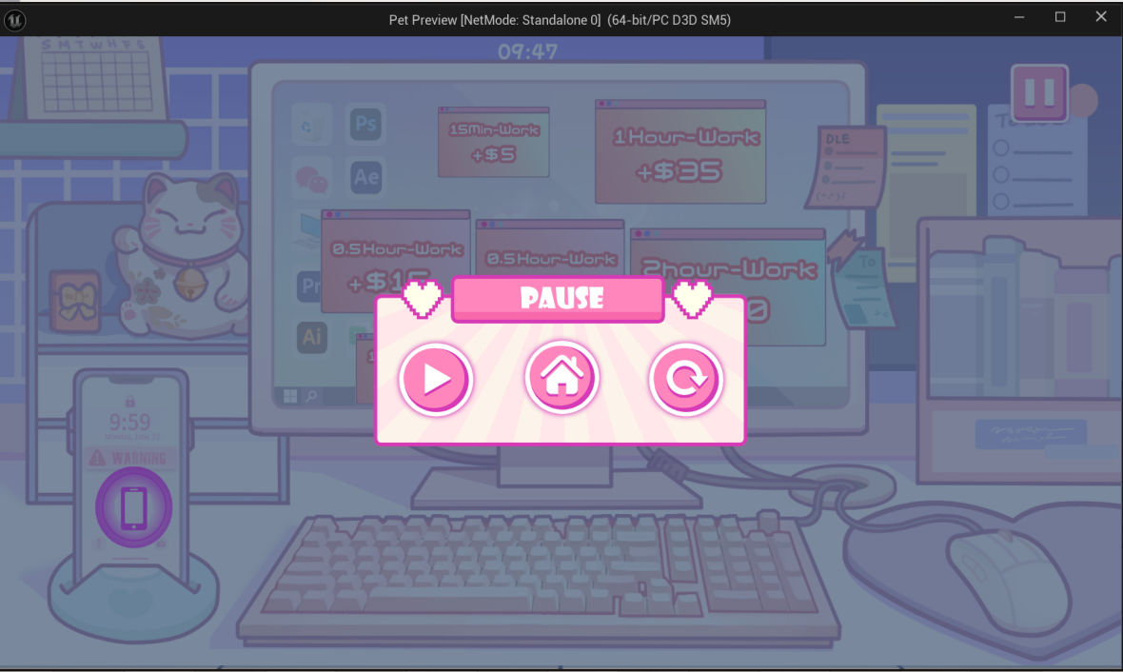
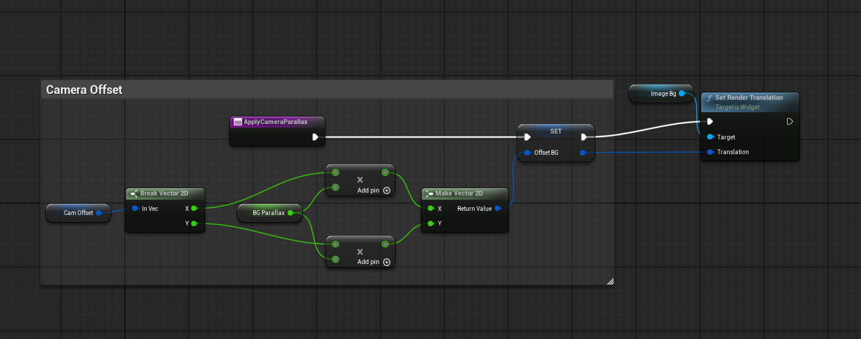
Figure 10: In-Game Screenshots (Camera Menu, Pause Menu)
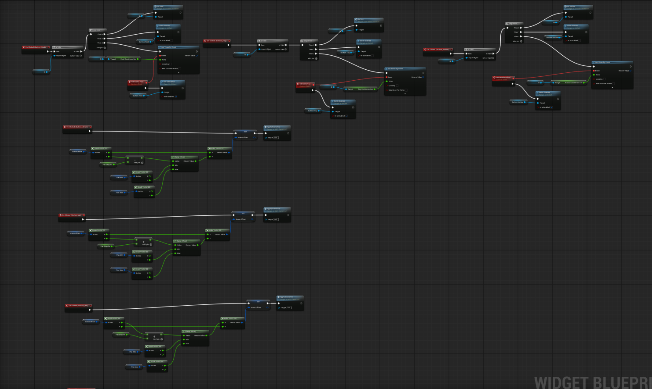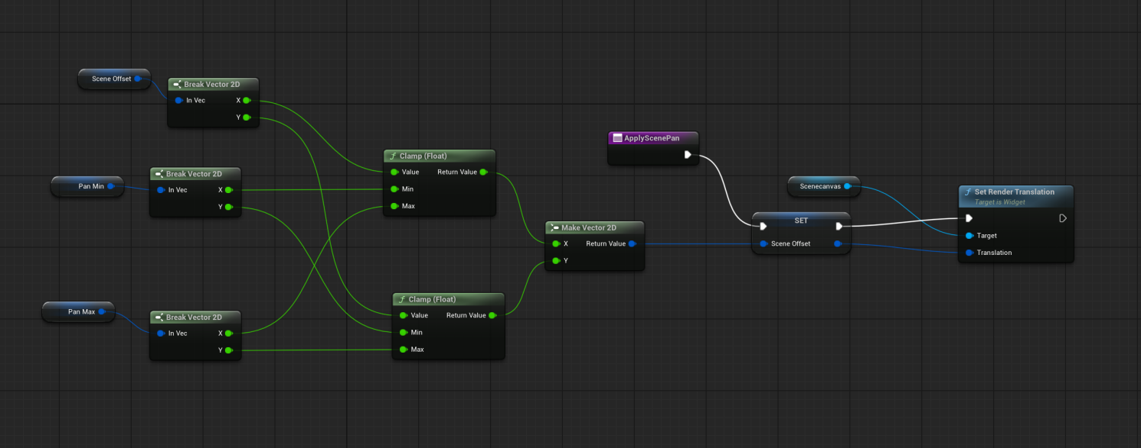
Figure 11: Spatial Constraints Blueprint (Camera Movement)

Validation Methodology

Research Design Overview
Based on the Theory of Constraints (TOC), the study treats surveillance access as the main system bottleneck, because it limits the information available to the player.
Rather than eliminating constraints, this research systematically varies the degree and type of restriction to examine how players adjust their strategies in environments characterized by limited information and control. The validation process is divided into three steps, each of which adds a new type or level of constraint.
To account for differences in playstyle and decision-making tendencies among participants, a within-subject design (Clark, Lawrence, Astley-Jones, & Gray, 2009) is used in all phases. In-game behavioral data are collected through gameplay observation and system records.

Phase 1: Temporal Surveillance Restriction
The first phase of the study examined how self-selected temporal constraints influenced player risk assessment and decision-making behavior. Twenty participants (N = 20) completed a series of gameplay trials in which they voluntarily selected different work durations in exchange for in-game currency rewards. During each work session, players temporarily lost access to pet monitoring and intervention systems.
Unlike forced interruption systems, this phase focuses on how players evaluate pet conditions before willingly entering a restricted state. The purpose of this phase is to examine whether players can balance economic reward against surveillance risk when deciding how long to leave the monitoring interface.
The primary behavioral metric in this phase is the Destructive Event Rate (DER):
$$\text{DER}\text{=}\frac{\text{Number of Pet Destructive Events During Work }}{\text{Total Work Sessions}}$$
This metric evaluates how frequently negative pet behaviors occur during periods of surveillance absence. Higher DER values suggest that players selected overly risky work durations or failed to evaluate the pet’s condition sufficiently before entering work mode. Lower DER values indicate more effective risk assessment and temporal decision-making.
Following the experiment, participants completed Appendix B (Questionnaire 2) to report their self-perceived tension on a 1–7 Likert scale and their intention to anticipate pet behavior before losing access.
This phase identifies temporal restriction as the principal system bottleneck, aligning directly with the Theory of Constraints by reducing the frequency of information access and requiring proactive planning under uncertainty.

Phase 2: Spatial Surveillance Restriction
The second phase of the study investigated how spatial surveillance restrictions, particularly fragmented visibility and incomplete visual information, affected player tension and information-seeking behavior. Ten participants (N = 10) completed a within-subject comparison between two gameplay conditions: a Full View condition, in which the entire room remained visible at all times, and a Restricted View condition, which required players to actively pan the camera to locate the pet.
To evaluate the effect of spatial restriction on perceived tension, a within-subject experiment was conducted.
Ten participants played two versions of the game:
- Restricted view condition: players could see only part of the room and had to move the camera to locate the pet.
- Full view condition: players could see the entire room at all times.
After playing both versions, participants completed Appendix C (Questionnaire 3) to assess whether uncertainty about “what might happen outside the view” significantly increased psychological pressure and fear of missing critical events.
This design allows for a direct comparison of perceived tension under different levels of visual access while controlling for individual differences in player behavior.

Phase 3: Integrated Constraint Validation
The third phase of the study investigated how combined temporal and spatial surveillance restrictions influenced player tension, uncertainty, and decision-making behavior within pet simulation gameplay. Unlike the previous phases, which examined temporal and spatial bottlenecks independently, this phase evaluated the effect of applying both constraints simultaneously within a single gameplay condition.
To evaluate the effect of integrated constraints on perceived psychological pressure, a large-scale player testing session was conducted with 40 participants (N = 40).
During gameplay, participants experienced a combined surveillance system that included:
- restricted camera visibility requiring active search,
- temporary loss of monitoring access during work sessions,
- and uncertainty regarding off-screen pet behavior while the intervention was unavailable.
Several questionnaire items specifically addressed whether the combined use of temporal and spatial bottlenecks generated stronger psychological pressure than a typical pet simulation experience. Additional items examined whether players felt overwhelmed by the need to search, monitor, and prioritize information simultaneously under restricted conditions.
This validation phase investigates whether layered surveillance constraints increase cognitive workload beyond simple reactive monitoring and encourage more deliberate prioritization, predictive attention, and adaptive strategic behavior under uncertainty.

Survey Results and Analysis:
First and Second Demo Feedback:
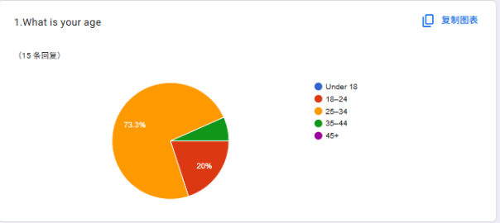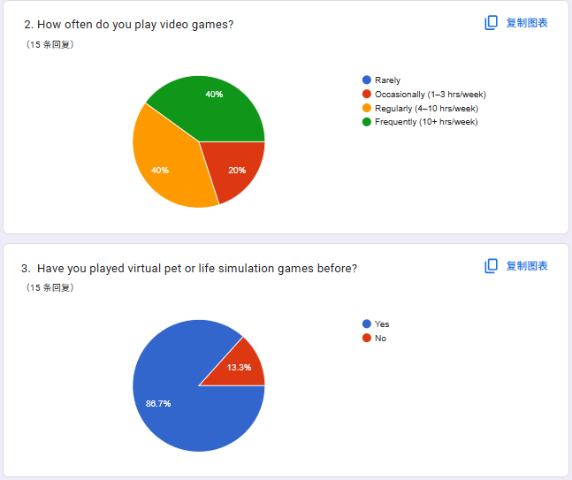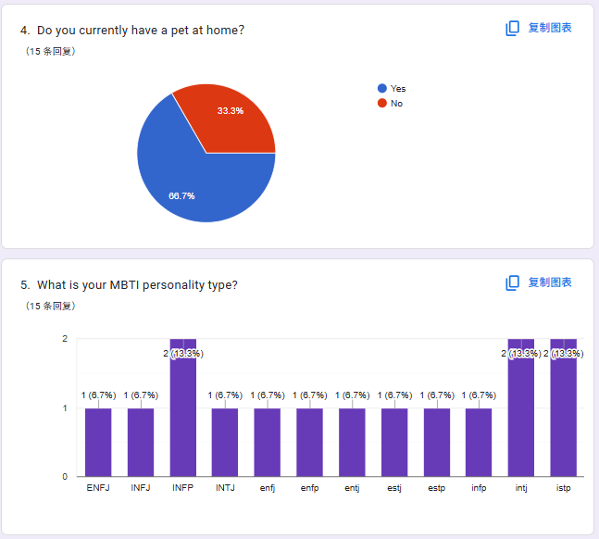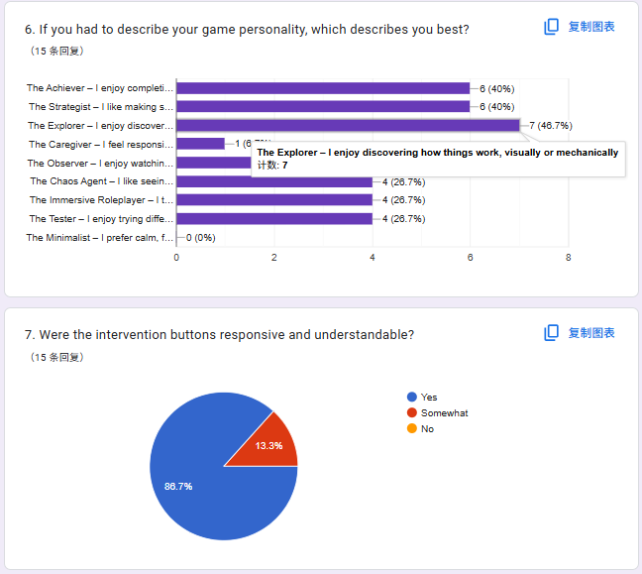
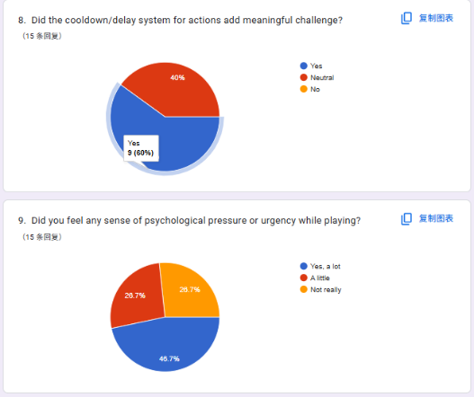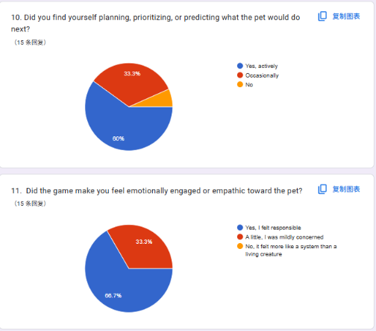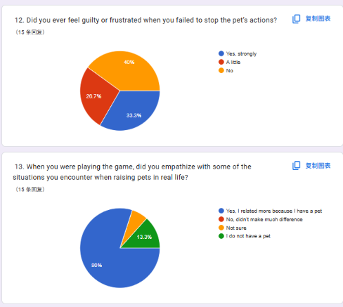
Figure 12: Results of Prototype Testing Feedback Questionnaire
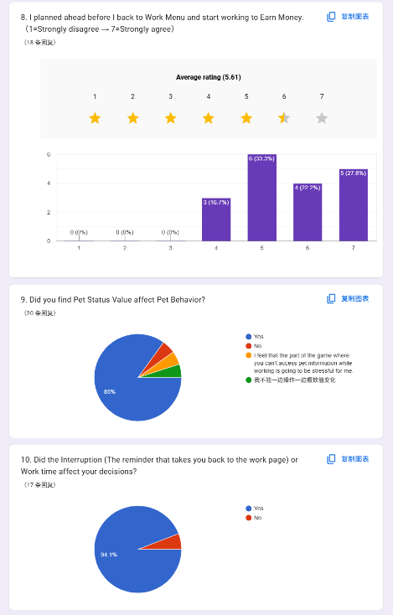
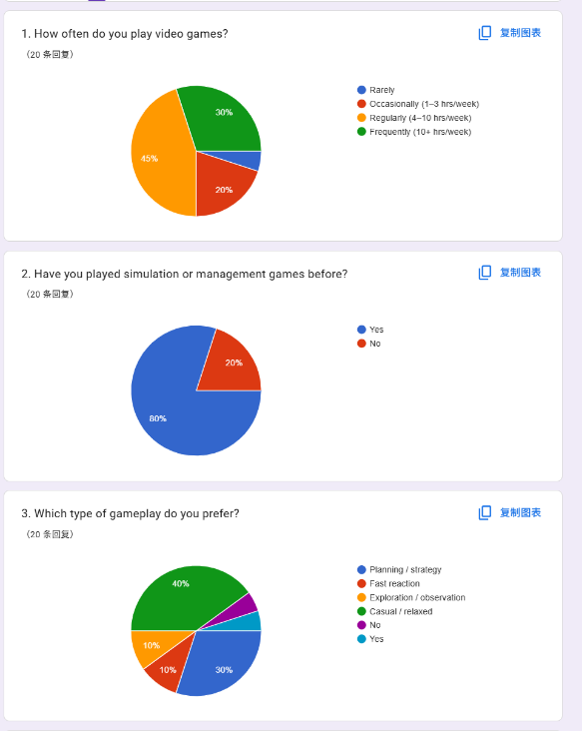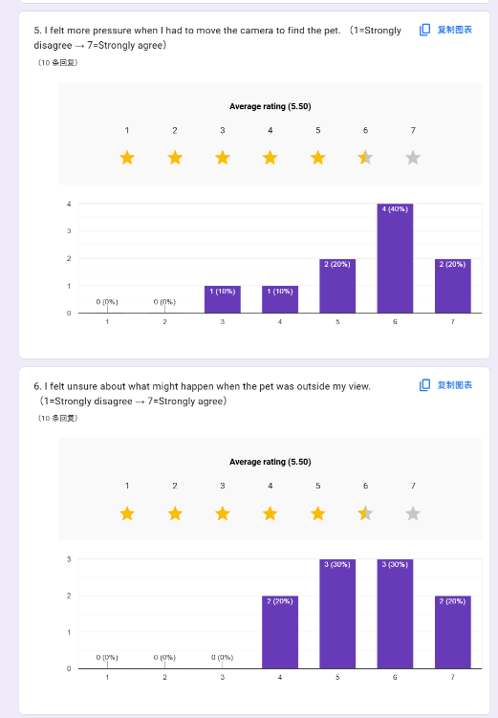
Figure 13: Results of Temporal Constraints Test
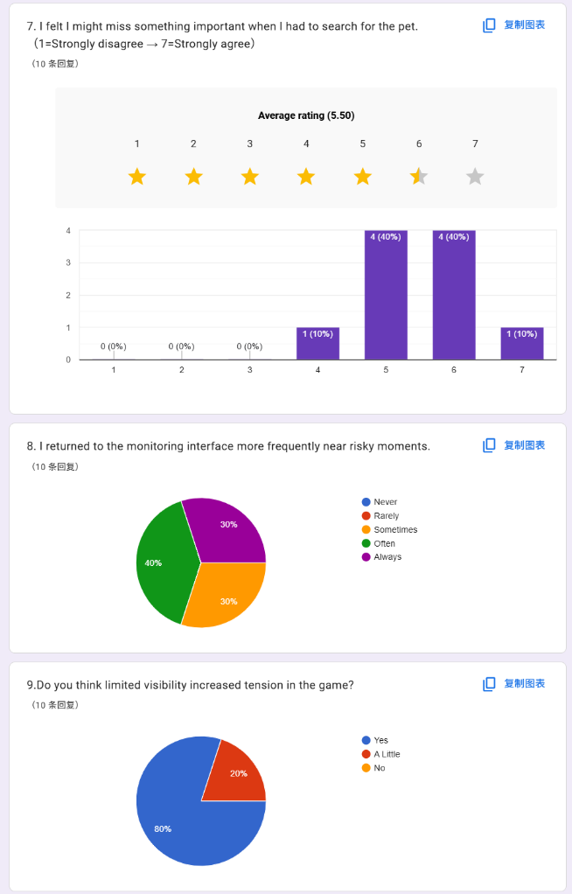
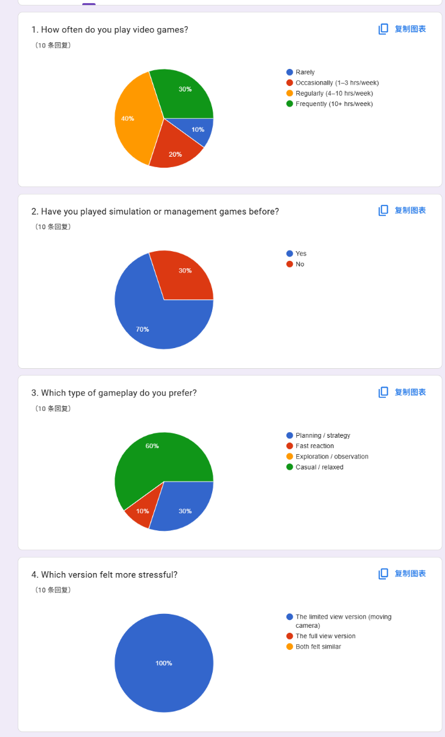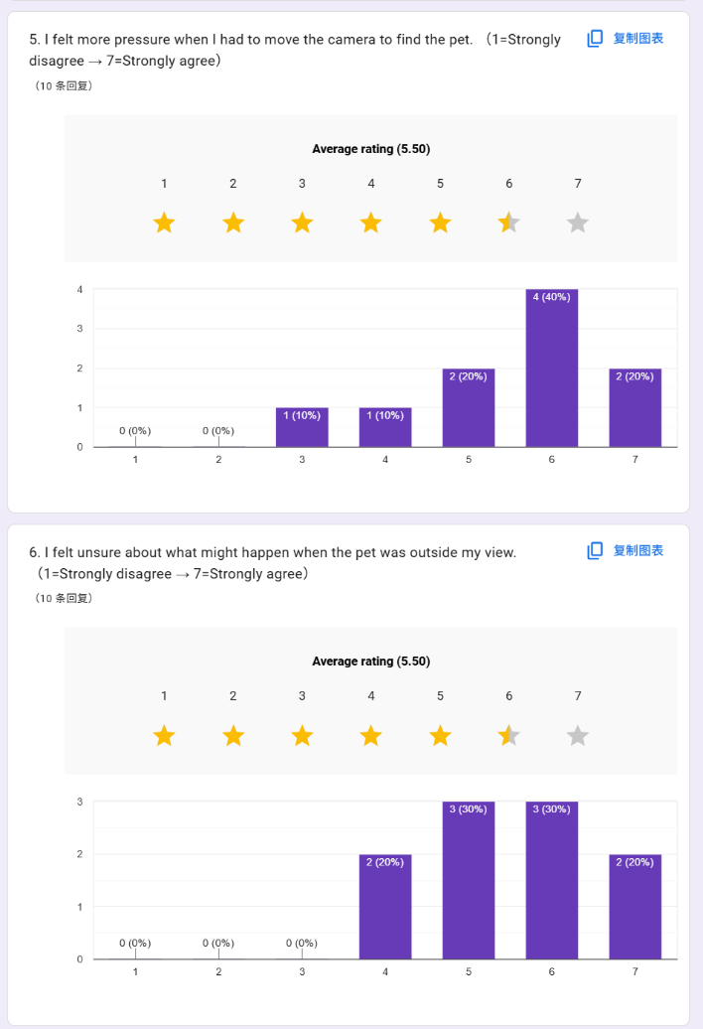
Figure 14: Results of Spatial Constraint Test

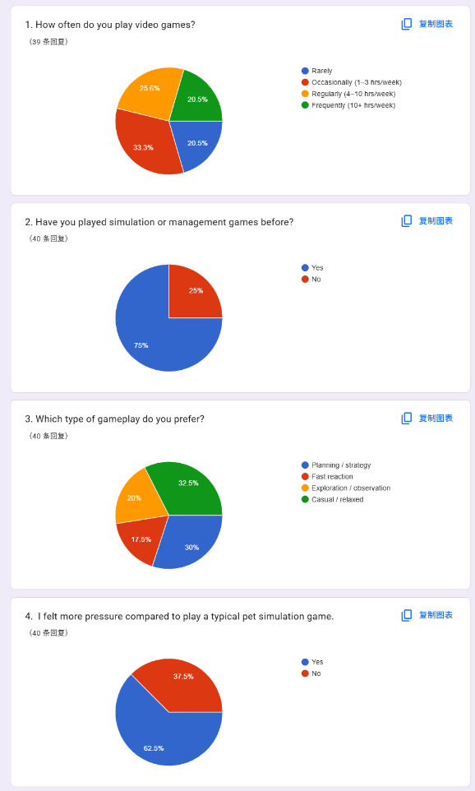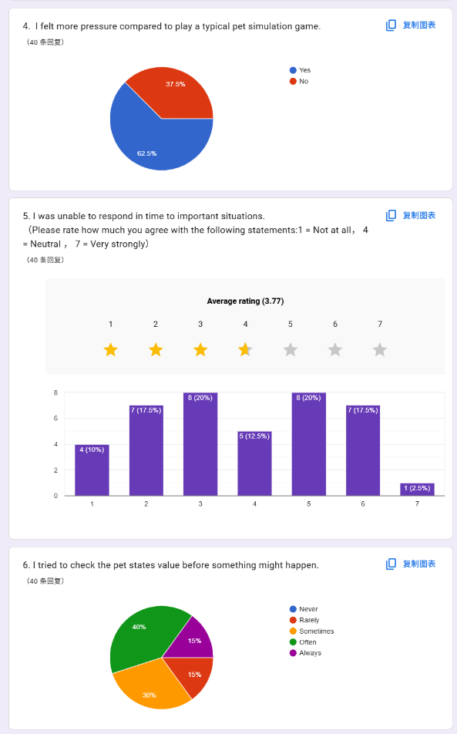
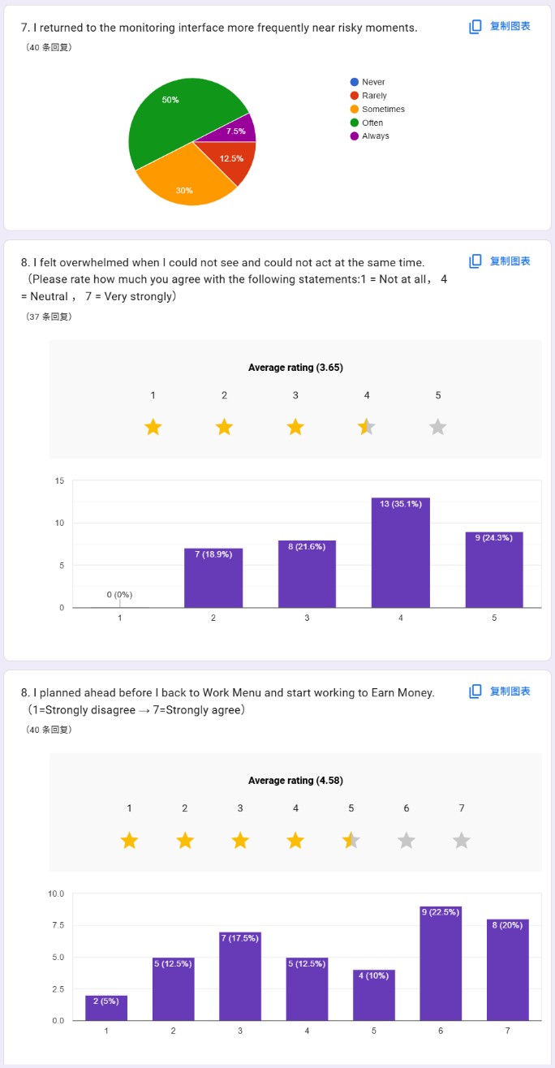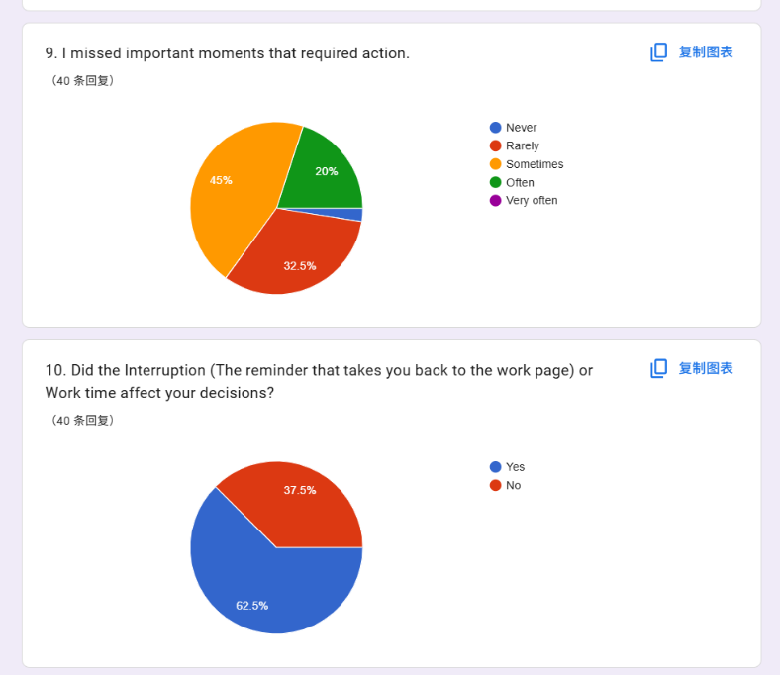
Figure 15: Results of Final Integrated Constraint Test

Test 2 Feedback Interview
During the second-prototype feedback round (Version 2 Demo), five participants completed individual playtesting sessions. This stage was designed to examine how players navigated the revised interface, whether they understood the relationship among pet behavior, work interruptions, and intervention systems, and whether the new constraint structure produced an engaging gameplay experience.
Across the sessions, participants reported a clear sense of psychological tension, particularly when continuous pet monitoring was interrupted in the middle of play. Their comments suggest that the prototype successfully introduced urgency, but also that the system needed clearer consequences and more legible feedback to convert that urgency into deliberate strategic planning.
Participant 2-1 recognized the intended tension but indicated that its intensity was weakened by the absence of explicit consequences: “I can feel some tension when I can’t watch the pet, but it’s not very strong because nothing really happens if I don’t react immediately. There’s no clear punishment.”
Participant 2-2 similarly pointed to uncertainty in the consequence structure, especially in relation to disruptive pet behavior and work-mode feedback: “I didn’t realize that the pet making trouble would cause a loss. And when I was forced back to the work screen, there was no penalty either, so I just went back to take care of the pet again.”
Participant 2-3 emphasized that the hierarchy between pet care and work tasks was not sufficiently explicit: “I wasn’t sure which one I should focus on more, the pet or the work. It felt like both were important, but the game didn’t really tell me what would happen if I ignored one.”
Participant 2-4 described immediate visual feedback as the main trigger of urgency, while also noting that this feedback encouraged reactive behavior more than advance planning: “I kept watching the pet because I could see what it was doing. And if I didn’t pay attention, it would quickly go into a warning state and start doing something bad. That made it feel urgent, but I was mostly reacting to it instead of planning ahead.”
Participant 2-5 also associated urgency with visible warning cues, suggesting that the prototype’s tension was still largely driven by observable threat signals rather than by fully internalized risk anticipation: “It still felt urgent, because if I didn’t watch the pet, it would quickly go into a warning state and start doing something bad. So I kept reacting to it.”

Results

Phase 1: Results of the Self-Selected Temporal Constraint Test
The primary behavioral indicator for this phase was the Destructive Event Rate (DER), which captures how often destructive pet behaviors occurred while players were away from the monitoring interface.
Table 2: Destructive Event Rate (DER) Across Work Durations
Work Duration (s) | DER
5 seconds | 0.12
10 seconds | 0.19
15 seconds | 0.26
20 seconds | 0.34
DER increased consistently as work duration lengthened, indicating that longer interruptions raised the probability of destructive behavior during periods of surveillance absence. The pattern was gradual rather than abrupt, suggesting that players did not simply lose control once monitoring was blocked. Even in the 20-second condition, participants attempted to manage risk by checking pet status values, particularly Mischief and Hunger, before entering work mode. Nevertheless, extended surveillance absences widened the information gap between player knowledge and pet behavior, making it more likely that negative events would unfold before players could return and intervene.
Qualitative feedback from Questionnaire 2 (Appendix B), collected on a 7-point Likert scale, further supports these behavioral results. The responses indicate that temporal restriction did not merely interrupt play; it encouraged players to evaluate system risk before temporarily surrendering monitoring access:
1. Perceived tension (M = 6.1, SD = 0.8): Participants reported sustained psychological tension when monitoring access was blocked, with the effect becoming especially noticeable during the 15-second and 20-second work intervals.
2. Pre-work evaluation (M = 5.8, SD = 1.2): Most players agreed with the statement “I tried to check the pet state before something might happen,” indicating that the work interface encouraged deliberate preparation rather than purely reactive play.
3. Pressure of inaction (M = 5.9): The inability to intervene during the 20-second interval generated the strongest reported pressure, confirming the temporal bottleneck as a meaningful source of cognitive urgency.

Phase 2: Results of the Spatial Surveillance Restriction Test
Consistent with the study hypothesis, participants generally experienced the Restricted View condition as more stressful than the Full View condition. Specifically, 90% of participants identified the limited-visibility version as producing higher psychological pressure, suggesting that visual restriction was immediately recognizable as a gameplay constraint.
Viewed through the Theory of Constraints (TOC), the restricted camera system operated as a spatial bottleneck by reducing informational throughput. Because players could no longer perceive the entire room at once, monitoring shifted from passive observation to active information recovery. Players had to search, infer, and decide under uncertainty about what might be happening outside the visible frame.
Quantitative Results Analysis:
Table 3: Perceived Tension and Pressure Metrics Under Spatial Restriction
Survey Item (Questionnaire 3) | Mean (M) | Standard Deviation (SD)
Pressure caused by moving the camera to locate the pet | 5.8 | 0.92
Uncertainty regarding pet behavior outside the visible area | 6.4 | 0.70
Fear of missing important events while searching | 6.1 | 1.05
Overall increase in tension caused by limited visibility | 6.5 | 0.53
Among the spatial restriction items, uncertainty about off-screen pet behavior produced the highest mean score (M = 6.4). This result suggests that the strongest source of pressure was not camera movement itself, but the absence of reliable information about unobserved space.
Accordingly, the surveillance mechanism no longer functioned as a simple viewing tool. It became an active search process in which players repeatedly attempted to restore missing information. Limited visual access therefore operated as a direct design mechanism for producing psychological tension and sustained attentional demand.

Phase 3: Results of the Final Integrated Constraint Test
The Phase 3 findings show that combining temporal and spatial surveillance restrictions intensified psychological tension, cognitive demand, and strategic pressure across the gameplay experience. More importantly, the integrated condition changed how players approached the system: they could no longer depend on continuous observation or immediate correction, and instead had to manage incomplete information over time.
Participant background data showed that 75% of the sample had prior experience with simulation or management games. However, participants varied in gaming frequency, only 17.5% identified fast-reaction gameplay as their preferred genre, whereas 30% preferred planning- or strategy-oriented experiences. This profile suggests that the prototype primarily engaged players who were more receptive to decision-making, management, and anticipation than to reflex-based interaction.
Participants consistently described the integrated constraint condition as more stressful than a conventional pet simulation experience. Overall, 62.5% reported that the combined restrictions generated noticeably greater pressure than they would expect from a typical game in the genre. Participants also reported moderate difficulty responding to serious situations in time (M = 3.77/7). These results indicate that restricting surveillance access weakened players’ ability to rely on immediate reaction, even though the prototype did not require mechanically demanding input.
The questionnaire responses also revealed clear evidence of anticipatory monitoring. Approximately 55% of participants reported that they “Often” or “Always” checked pet status values before important events occurred, and 57.5% stated that they returned to the monitoring interface more frequently during high-risk moments. Together, these patterns suggest that players began to treat monitoring access as a scarce resource and directed attention toward moments they perceived as strategically important.
At the same time, the combined restriction system produced a notable sense of cognitive overload. The item measuring helplessness when players could neither monitor nor intervene yielded an average score of M = 3.65/5, with 59.4% of participants selecting upper-range scores (4–5). This pattern indicates that layered surveillance constraints generated sustained uncertainty and informational pressure, rather than merely adding superficial difficulty.
Participants also showed signs of proactive preparation before entering work mode. The statement measuring advance planning before work interruptions produced a mean score of M = 4.58/7, indicating that many participants attempted to stabilize the pet’s state before voluntarily losing access to surveillance tools. However, despite these planning efforts, 65% reported that they “Sometimes” or “Often” missed moments requiring intervention. This finding shows that the integrated constraint system was strong enough to challenge player control even when players attempted to anticipate risk.
Finally, 62.5% of participants agreed that work interruption reminders and work duration selection directly influenced their gameplay decisions. Overall, the results support the central premise of this study: intentional mechanical constraints can generate psychological tension while also reshaping attention allocation, information prioritization, and strategic decision-making under uncertainty.

Conclusion
Intentional surveillance constraint can generate meaningful tension in pet simulation games, but that tension does not arise from restriction alone. It emerges when restrictions change how players access information, assess risk, and exercise control. When players cannot continuously monitor the pet, cannot view the full environment, or cannot intervene immediately, they are pushed to make decisions under uncertainty. As a result, the experience shifts from passive observation and routine care toward prediction, prioritization, and risk assessment.
The three validation phases clarified the distinct design role of each constraint. The self-selected temporal restriction transformed work duration into a risk-management choice because longer periods away from surveillance increased the likelihood of destructive pet behavior. The spatial restriction introduced informational uncertainty by preventing players from seeing the entire room at once, turning monitoring into an active process of searching, interpreting, and allocating attention. When temporal and spatial restrictions were combined, players showed stronger evidence of predictive monitoring and strategic planning, while also reporting greater cognitive pressure and more missed opportunities for intervention.
Taken together, these findings suggest that intentional mechanical constraints can add strategic depth to pet simulation gameplay without depending on punishment, failure states, or moral consequences. The project demonstrates that a care-based game can preserve emotional attachment while also asking players to evaluate system states, anticipate possible outcomes, and decide when intervention is necessary or when inaction is strategically acceptable.
At the same time, the study shows that constraint-based design depends heavily on system clarity. Constraints are most effective when players can understand the relationships among pet states, work restrictions, surveillance access, and destructive behaviors. If these relationships remain unclear, psychological tension can become confusion rather than a deliberate strategy. Effective constraint design therefore requires not only reduced access to information or control, but also readable feedback, clear state relationships, and consequences that players can interpret.
Overall, this study argues that pet simulation games can move beyond purely relaxing interaction loops by using carefully designed restrictions to support uncertainty, anticipation, and strategic decision-making. Its contribution lies not only in showing that constraints influence player experience, but also in identifying the mechanisms through which they do so: by reshaping information access, intervention timing, and the player’s need to manage risk under uncertainty.

Limitations and Future Directions

Limitations
Several limitations should be acknowledged in relation to both the prototype and the validation process. First, the project was developed as a playable game experience rather than as a tightly controlled experimental system. Multiple mechanics, including surveillance, work management, pet states, intervention systems, and economic progression, operated simultaneously during testing. Consequently, player behavior was shaped by the interaction of several overlapping systems rather than by a single isolated variable.
A second limitation concerns the clarity and readability of the gameplay systems. Participant feedback indicated that some players needed considerable time to understand the relationships among pet states, work tasks, surveillance restrictions, and destructive behaviors. In many cases, players were not only learning how to identify the pet’s current condition, but also trying to infer how different systems affected one another, such as how work duration changed risk or which pet states were most closely associated with negative outcomes.
Because the testing sessions were relatively short, some participants had not fully understood the overall system logic before the session ended. This issue was compounded by limitations in onboarding, UI readability, and feedback communication, which produced noticeable variation in how players interpreted and responded to the restriction systems. While many participants gradually adapted and began to engage in predictive monitoring and advance planning, others became overwhelmed by time pressure, limited visibility, and incomplete information. Some players did not fully recognize the relationship between pet values and destructive behaviors, leading to confusion and more reactive patterns of play. Nevertheless, this uncertainty also contributed to the tension that the system was designed to produce.
Finally, parts of the analysis relied on self-reported questionnaire data rather than fully automated gameplay telemetry. Although timestamp systems and event logs were implemented to support observation, measures related to anticipation, strategic intention, and cognitive pressure still depended partly on participant interpretation and subjective reporting.

Future Directions
Future research could examine how different forms of intentional restriction, including temporal limitation, spatial restriction, and other constrained interaction systems, produce different levels of emotional pressure, strategic demand, and cognitive workload across player groups. These forms of restriction may affect players in different ways: some may intensify stress through uncertainty and delayed response, whereas others may increase the need for monitoring, prediction, and attention allocation under limited information. A more systematic examination of these relationships could support clearer approaches to emotional pacing and tension balancing in game design. By identifying how restriction systems influence emotion, strategy, attention, and psychological pressure, future research could help designers structure gameplay flow and emotional curves more deliberately.
This research direction may also provide level designers and gameplay designers with more measurable reference points for balancing player tension under different gameplay conditions. For example, future studies could examine the degree of emotional pressure produced by specific forms of spatial restriction, visual limitation, or temporal interruption for different player types. Such findings could support the development of more controlled and intentional systems for emotional progression within games.
Beyond game design, this line of research may also contribute to broader studies of emotional attachment and human–pet relationships in virtual environments. Future work could investigate how simulated caregiving systems shape player empathy, emotional responsibility, and attachment to virtual companions. In addition, the relationship among pet care systems, emotional stress, and player behavior may offer opportunities for interdisciplinary research connected to psychology, emotional well-being, and companion-animal studies in domestic contexts.
Finally, future studies would benefit from larger participant samples, longer testing durations, and more detailed gameplay telemetry. These improvements would make it possible to better understand how players learn, interpret, and adapt to constrained interactive systems over time.

Development Team:
This prototype is being developed primarily by Zhiyun Yu, who is responsible for all gameplay systems, UI logic, interaction design, concept design and scripting in Unreal Engine 5.
Visual support (such as Pet design, environment design and character design) will be provided by Wanzhen Mei, a collaborator focused on post-production art assets. All core development and system logic are handled independently by the primary researcher.

Appendix

Questionnaire 1: Post-Play Test
- What is your age?
- How often do you play video games?
- Have you played virtual pet or life simulation games before?
- Do you currently have a pet at home?
- What is your MBTI personality type?
- If you had to describe your game personality, which describes you best?
- Were the intervention buttons responsive and understandable?
- Did the cooldown/delay system for actions add meaningful challenge?
- Did you feel any sense of psychological pressure or urgency while playing?
- Did you find yourself planning, prioritizing, or predicting what the pet would do next?
- Did the game make you feel emotionally engaged or empathic toward the pet?
- Did you ever feel guilty or frustrated when you failed to stop the pet’s actions?
- When playing, did you empathize with real-life pet situations?
- What did you find most enjoyable or unique about the game?
- What would you improve or adjust?

Questionnaire 2: Temporal Constraint Test
- How often do you play video games?
- Have you played simulation or management games before?
- Which type of gameplay do you prefer?
- I felt tense when I could not monitor the pet.
- I felt pressure knowing I could not act for a period of time.
- I tried to check the pet state before something might happen.
- I returned to the monitoring interface more frequently near risky moments.
- I planned ahead before I lost access to the pet.
- Did you find that pet state values affect pet behavior?
- Did the interruption (being forced back to the work screen) affect your decisions?

Questionnaire 3: Spatial Constraint Test
- How often do you play video games?
- Have you played simulation or management games before?
- Which type of gameplay do you prefer?
- Which version felt more stressful?
- I felt more pressure when I had to move the camera to find the pet.
- I felt unsure about what might happen when the pet was outside my view.
- I felt I might miss something important when I had to search for the pet.
- I returned to the monitoring interface more frequently near risky moments.
- Do you think limited visibility increased tension in the game?

Questionnaire 4: Final Complex Constraint Test
- How often do you play video games?
- Have you played simulation or management games before?
- Which type of gameplay do you prefer?
- I felt more pressure compared to play a typical pet simulation game.
- I was unable to respond in time to important situations.
- I tried to check the pet states value before something might happen.
- I returned to the monitoring interface more frequently near risky moments.
- I felt overwhelmed when I could not see and could not act at the same time.
- I planned ahead before I back to Work Menu and start working to Earn Money.
- I missed important moments that required action.
- Did the Interruption (The reminder that takes you back to the work page) or Work time affect your decisions?

Bibliography
Atkinson, F., & Pruszko, L. (2025). Player agency under constraint: A pilot study on the forced-choice effect in narrative difficulty design. In Proceedings of the 2025 Conference on Creativity and Cognition (pp. 404–408). Association for Computing Machinery. https://doi.org/10.1145/3698061.3735326
Costikyan, G. (2013). Uncertainty in games. MIT Press.
Hunicke, R., LeBlanc, M., & Zubek, R. (2004). MDA: A formal approach to game design and game research. Retrieved from http://users.cs.northwestern.edu/~hunicke/MDA.pdf
Pisklak, J. M., Yong, J. J. H., & Spetch, M. L. (2019). The near-miss effect in slot machines: A review and experimental analysis over half a century later. Journal of Gambling Studies. https://doi.org/10.1007/s10899-019-09891-8
Research and Markets. (2025). Virtual pet simulator apps market forecast to 2030. Retrieved from https://www.researchandmarkets.com/
Science of Business. (n.d.). Theory of Constraints games. Retrieved May 22, 2026, from https://www.scienceofbusiness.com/theory-of-constraints-games/
Sensor Tower. (2024). Q1 performance of top virtual pet apps on Android and iOS in the US. Retrieved from https://www.sensortower.com/
Spiliopoulos, L., Ortmann, A., & Zhang, L. (2018). Complexity, attention, and choice in games under time constraints: A process analysis. Journal of Experimental Psychology: Learning, Memory, and Cognition, 44(10), 1609–1640. https://doi.org/10.1037/xlm0000535

