Reports Template: Title Here
Zhou Gaoqiang, Matric Number
IN6227-2023-Assignment-1-2

INTRODUCTION

Naive Bayes and Decision Tree are dissimilar classifiers in my view. Naïve Bayes is a direct and pure mathematical probability model, while Decision Tree is closer to human thinking. And the proportion of discrete attributes in Census Income Dataset (Adult Dataset) is relatively high. Therefore, in this assignment I select Categorical Naïve Bayes Classifier (hereafter refer to as CNB) and Decision Tree (abbreviated as DT) and compare their computational efficiency and predictive accuracy under different depths of data processing.
Figure 2

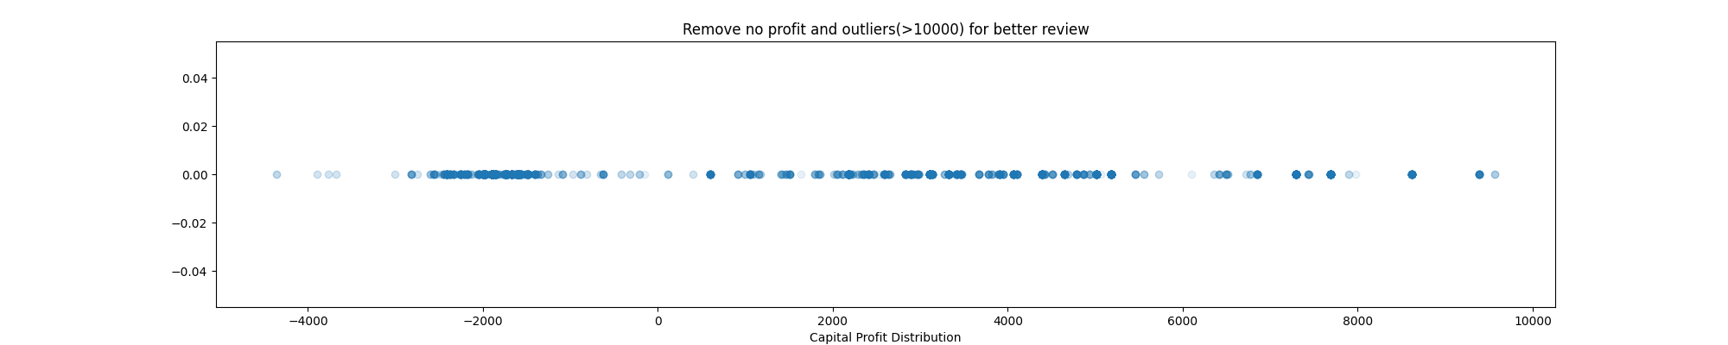
DATA PREOROCESSING

Data preprocessing is always the first step of data mining, and followings are the actions:
Data Cleaning: First, deleted the redundant character ‘.’ and other reminder messages to ensure uniformity of data formats. Second, deleted duplicate attribute ‘Education-num’ since ‘Education’ is the discretized form of ‘Education-num’. Third, deleted ‘Relationship’ due to its ambiguity and depend on other attributes. For example, a person can have different relationships with other family members. Moreover, this dataset already contains the ‘Sex’ and ‘Marital-status’, which are more representative and independent. Fourth, attribute ‘Fnlwgt’ is also decided to delete because from the description we can know that every state has its own probability of selection which lead to no unified quantitative standard.
Figure 3
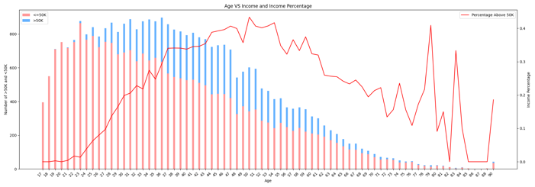
Data discretization: The continues variables must be discretized since both belong to categorical classifiers. Data visualization techniques are used to categorize continuous variables in a reasonable manner.
Figure 1
Among them, attribute ‘Age’ will be roughly segmented into 5 years intervals base on below 2 fundamental observations from Figure 1: one, age and income share a parabolic relationship within a standard working age, another one, income gap is negligible for small age differences, such as 5 years.
Figure 2 is a box plot illustrating the distribution of the attribute ‘hours-per-week’. Intriguingly, the 25th percentile line and 50th percentile line overlap at 40 hours, indicating that most people work 40 hours a week. To further analyze the distribution, I have segmented ‘hours-per-week’ into the following 5 categories: ‘<33’, ‘33-40’, ‘40-45’, ‘45-52’, and ‘>52’.
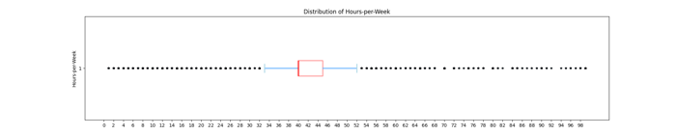
Dimensionality Reduction: ‘Capital-gain’ and ‘Capital-loss’ collectively define capital profit. Thus, I reversed ‘capital-loss’ and integrate it into ‘capital-gain’. Figure 3 is a 1D scatter plot with removed mode (gain=0) and outliers (gain>10000) for better examine the distribution of other values. Based on this figure and a common sense that high capital profit boosts overall income (and vice versa), I use 0 as the midpoint and $3000 as segmentation unit.
Handling missing values: at this step, missing ‘Workclass’ and ‘Occupation’ entries are respectively grouped as ‘Unknown’ to maintain confidentially or handle indeterminate cases. The rest ‘Native-country’ missing entries was solved during data aggregation.
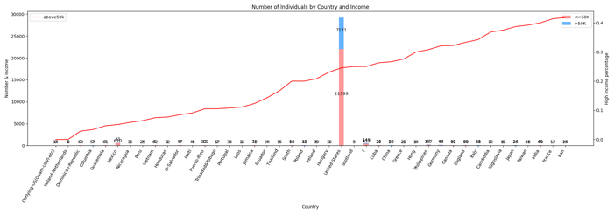
Data Aggregation: DT often falls into overfitting, using aggregation to address minimal occurrences and substantial fluctuations is helpful. Figure 4 shows that a majority of the countries have low representation, hence, restructure ‘Native-country’ data is necessary. The data can be restructured based on geographical or economic criteria or others. In this assignment, categorizing by area seems more intuitive and meaningful. Additionally, the ‘unknown’ and ‘south’ will be integrated into ‘US’ because both cannot be determined by area. This decision is influenced by their similar high-income ratios to ‘US’ and for another reason mentioned in handling missing value.
Figure 4

MODEL TUNING

Categorical Naïve Bayes: smoothing parameter not only address zero probabilities but serves act as a hyperparameter for handling imbalanced datasets. For instance, in the ‘Native-country’, ‘US’ constitutes a substantial majority. Consequently, I use grid search and cross-validation to get best smoothing parameter.
Decision Tree: Pre-pruning and post-pruning are the effective ways to solve overfitting issue in DT. For pre-pruning, here use the hyper-parameters ‘max-depth’, ‘min-samples-split’, and ‘Min-samples-leaf’. Clearly, every increment in tree depth results in additional leaf nodes, new leaf nodes require more samples. Hence, controlling ‘max-depth’ is a very effective measure within a fixed sample size. ‘Min-samples-split’ and ‘min-samples-leaf’ are two similar hyperparameters used to control splitting nodes but can be applied concurrently. ‘Min-samples-leaf’ dictates the tree will splitting will stop if the number of samples in new node post-splitting falls below the hyper-parameter. ‘Min-samples-split’ is more straightforward, stipulating that no further splitting is allowed if the number of samples in nodes is below the set value. For post-pruning, here use the cost complexity pruning (CCP) as it is the sole method provided by SKLEARN for such purposes.

RESULTS

The results were calculated through python with some libraries such as SKLEARN, NUMPY, and PANDAS.
Figure 5 shows a comprehensive results trend among different levels of data processing for both CNB and DT. The indicators Precision and F1-score are calculated after weighted average. Hence, I remove the indicator Recall because it is the same value under this situation.
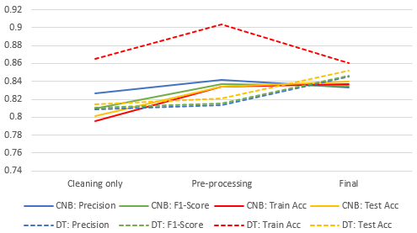
The following Time Compare Table provides comparison of each process timing at different depth of data processing between CNB and DT.
Figure 5

Time Compare (s) | Train | Test | Total
CNB (Cleaning) | 0.0762 | 0.0012 | 0.0774
DT (Cleaning) | 0.0752 | 0.0016 | 0.0768
CNB (Preprocessing) | 0.0849 | 0.0014 | 0.0863
DT (Preprocessing) | 0.0873 | 0.0017 | 0.089
CNB (Final) | 2.6942 | 0.0168 | 2.711
DT (Final) | 355.91 | 0.0016 | 355.91

The Pruning Compare Table provides the performances that between if do pre-pruning or post-pruning in DT individually.
Pruning Compare | Pre-pruning | Post-pruning
Time (s) | 6.8826 | 348.92
Train Accuracy | 0.8673 | 0.8598
Test Accuracy | 0.848 | 0.8482

DISCUSSION

During the practice, some insights have been gained. Notably, data preprocessing is most time-consuming in whole data mining process, using existing tools such as ORANGE, WEKA can be beneficial. Additionally, too much detailed preprocessing may lead to overfitting and sometimes get worse results.
From each model’s standpoint, the DT has a variety of adjustable hyperparameters, leading to a significant increase in computational time to find the optimal set. DT also clearly exhibits marginal effects: the benefit from post-pruning is limited once pre-pruning parameters are generated, and vice versa. However, pre-pruning shows more time-efficient compared to post-pruning from above table. In contrast, the CNB, only 1 hyperparameter, sees a marginal increase in calculation time. While seemingly advantageous over DT, CNB also faces a challenge: it assumes attribute independence, a rarity in read-world cases, possibly hinders higher accuracy. In my view, CNB servers well as a benchmark against other models, help to filter out those models underperform in comparison on given data.

CONCLUSION

Naive Bayes is indeed a highly efficient classifier and has obvious advantages in time. However, its prediction accuracy is slightly weaker, and it is difficult to ensure attributes are independent of each other. The Decision Tree has better result and more malleable. But it is prone to overfitting if without time-consuming pre-pruning and post-pruning. In the end, I think perhaps we should use ensemble classifiers such as ‘Gradient Boosting’, ‘Random Forest’ to avoid inability to balance accuracy and time in complex situations in real world.

REFERENCES

[1] Seeger, M. W., Sellnow, T. and Ulmer, R. R. 2003. Communication and organizational crisis, Westport, CT: Praeger.
[2] Benoit, W. (2018). Crisis and image repair at united airlines: Fly the unfriendly skies. Journal of International Crisis and Risk Communication Research, 1, 11-26. https://doi.org/10.30658/jicrcr.1.1.2

