Sentiment analysis model based on Twitter comments

- Introduction

1.1 Background
With the rapid development of social media, especially the proliferation of user-generated content on platforms such as Twitter (Zimbra et al., 2018). Compared with traditional news reports or blogs, comments on social media, as a form of real-time, language-rich, short-structured text, are more fragmented, instantaneous, and frequently updated, widely reflecting users' attitudes and emotions towards hot events, products and services. Users quickly express their personal opinions through short texts and become “sensors” of social emotions. (Ainley et al., 2021).
Sentiment Analysis, aims at identifying and extracting users' subjective emotions from natural language texts, which are usually classified into sentiment categories such as Positive, Negative, or Neutral. The breadth and openness of Twitter data provide rich resources for sentiment analysis research. Researchers and engineering practitioners can mine it for multi-dimensional information which can be applied to a wider range of applications (Sahayak et al., 2015).
However, due to tweet text's highly unstructured nature, such as common abbreviations, spelling mistakes, special symbols and even multilingual mixes. Coupled with the short text and limited contextual information, make traditional text categorization methods more challenging when dealing with Twitter data (Mohammad, 2017). To address this issue, researchers have started to introduce deep learning methods based on neural networks, such as Recurrent Neural Networks (RNNs), Long Short-Term Memory Networks (LSTMs), and Gated Recursive Unit (GRU) models. The accuracy of social media sentiment analysis has been significantly improved by using these methods (Yue et al., 2018).

1.2 Research Objective
The goal of this project is using machine learning and deep learning techniques to build a sentiment analysis model for Twitter comments, and compare the effectiveness through multiple approaches.
1.2.1 Data preprocessing and modeling: the raw Twitter texts are cleaned, segmented and denoised to construct a sentiment analysis dataset suitable for model training.
1.2.2 Comparison of multi-model experiments: Based on this dataset, the following methods are used for sentiment classification modeling:
- Traditional machine learning method: logistic regression.
- Recurrent neural network series: basic RNN, LSTM, GRU;
- Convolutional neural network (CNN)：basic CNN, LSTM, GRU;
- Pre-trained language model: Pre-trained language model: BERT.
1.2.3 Performance Evaluation and Analysis: The performance of each model on the test set is evaluated through metrics such as accuracy, recall and F1 score.

2. Data

2.1 Dataset Description
This project used the Sentiment Analysis Dataset (https://www.kaggle.com/datasets/prox37/sentiment-analysis-data/data) from Kaggle. Overall, the dataset contains 1,599,999 tweet text. The data is a CSV with emoticons removed. The data file format has 6 fields (2.1.1):
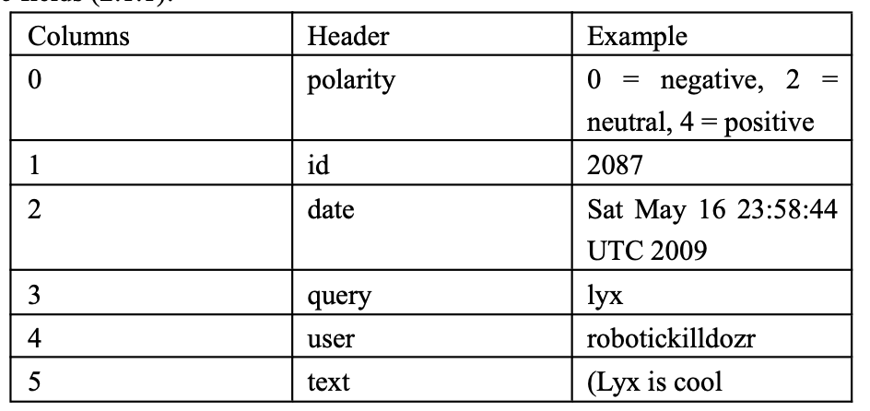
2.1.1
According to the objective of this project, the irrelevant columns were removed. Only “polarity” and “text” were retained. An analysis of the class distribution (2.1.2) showed that the dataset is balanced, with an equal proportion of positive and negative sentiment labels.
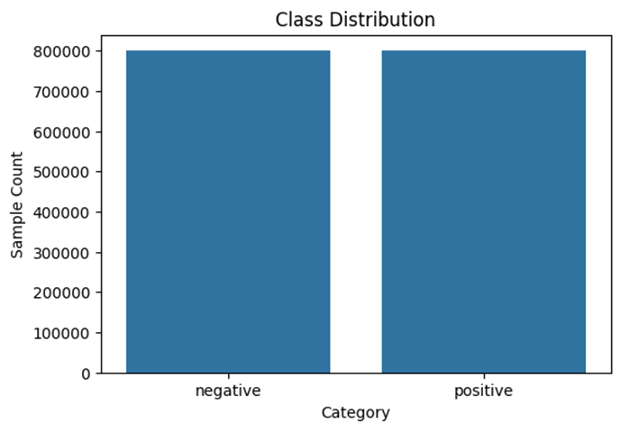
2.1.2
2.2 Date Preprocessing
To improve generalization and reduce dimensionality, several data preprocessing approaches were applied. First, all HTML tags and brackets were removed. Next, abbreviations were expanded to their full forms. The text format like @someone and email addresses were also removed. Additionally, non-ASCII characters, including emojis and special symbols, were filtered out to maintain a clean and consistent text format for model training.
To optimize the vocabulary used for training, word frequency distribution was conducted. The total vocabulary size was extracted, and the cumulative word coverage was calculated (2.2.1).
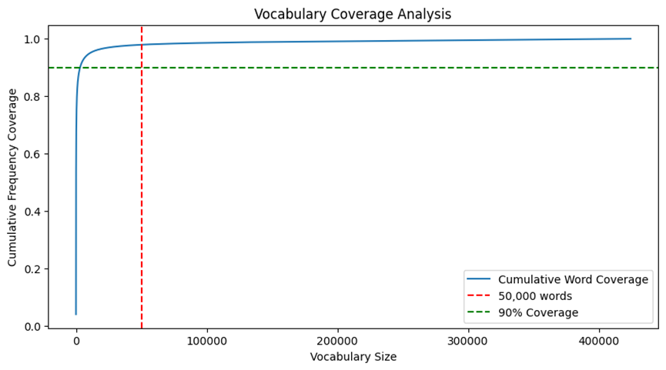
2.2.1
Since the dataset originally labeled sentiment as 0 (negative) and 4 (positive), a label mapping process was applied to convert these values into 0 and 1, respectively, to standardize the binary classification output.

3. Methodology
This project built four different machine learning models (Logistic Regression, RNN, CNN, BERT) to classify the sentiment of the text.
Logistic regression (GeeksforGeeks, 2025) is a supervised machine learning algorithm used for classification tasks where the goal is to predict the probability that an instance belongs to a given class or not.
A RNN (Graph, 2024) is a special type of ANN adapted to work for time series data or data that involves sequences. It is trained to process and convert a sequential data input into a specific sequential data output. Sequential data is data such as words, sentences, time-series data where sequential components interrelate based on complex semantic and syntax rules.
A Convolutional Neural Network (CNN), also known as ConvNet, is a specialized type of deep learning algorithm mainly designed for tasks that necessitate object recognition, including image classification, detection, and segmentation. Beyond image classification tasks, CNNs are versatile and can be applied to a range of other domains, such as natural language processing, time series analysis, and speech recognition (Sharma, 2024).
BERT is a Transformer-based pre-trained language model that understands deep semantic information in text by leveraging bidirectional context modeling. In this project, the DistilBERT version was utilized, as it retains the superior performance of BERT while reducing the model size.
The following is a flow chart of this project.

Feature extraction and vectorization

Data Preprocessing

Model Construction
Model Optimization
Model Evaluation
Model Training

- Logistic Regression
Naive Bayes is a statistical classification method based on Bayes' theorem. Here, the Naive Bayes classifier calculates postive and negative prior probabilities based on the training data, as well as the conditional probabilities of individual words under each category. At the time of testing, the posterior probability of each category is calculated and the category with the highest probability is selected for prediction.

First, segmentation is performed to convert the sentences in each piece of text data into a list of words. Second, three if-functions are set up for additional text preprocessing, including remove_punctuation, remove_numbers, and replace_numbers.
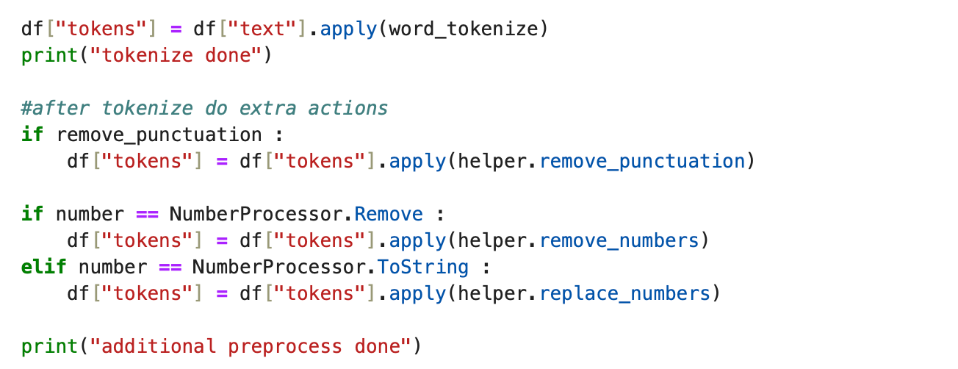
4.1
After that, the dataset is divided and split into training set and testing set.

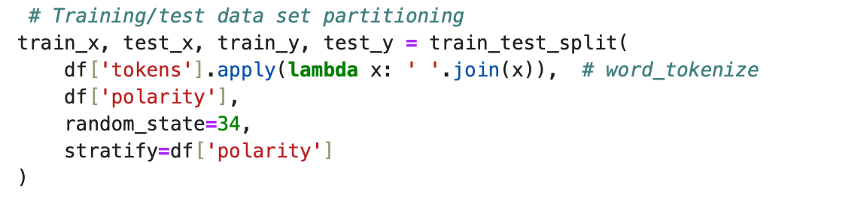
4.2
Creating a machine learning pipeline consists of two main steps: the TF-IDF vectorization and the
plain Bayesian classifier.

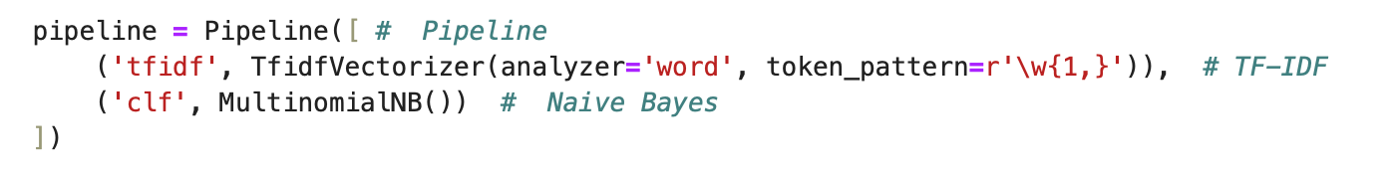
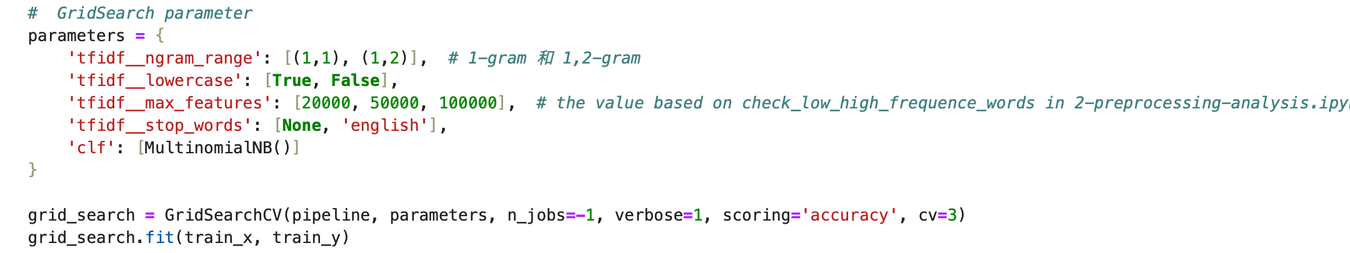
4.3
Use GridSearch to adjust hyperparameters (ngram_range, lowercase, max_features, stop_words). By adjusting these hyperparameters, it is possible to better process the text data and find the model configuration that is best suited to the task of sentiment analysis.

4.4

Perform specific adjustments of remove punctuation, remove numbers and replace numbers and to find how the GridSearch parameter can be adjusted to achieve the optimal combination of parameters.
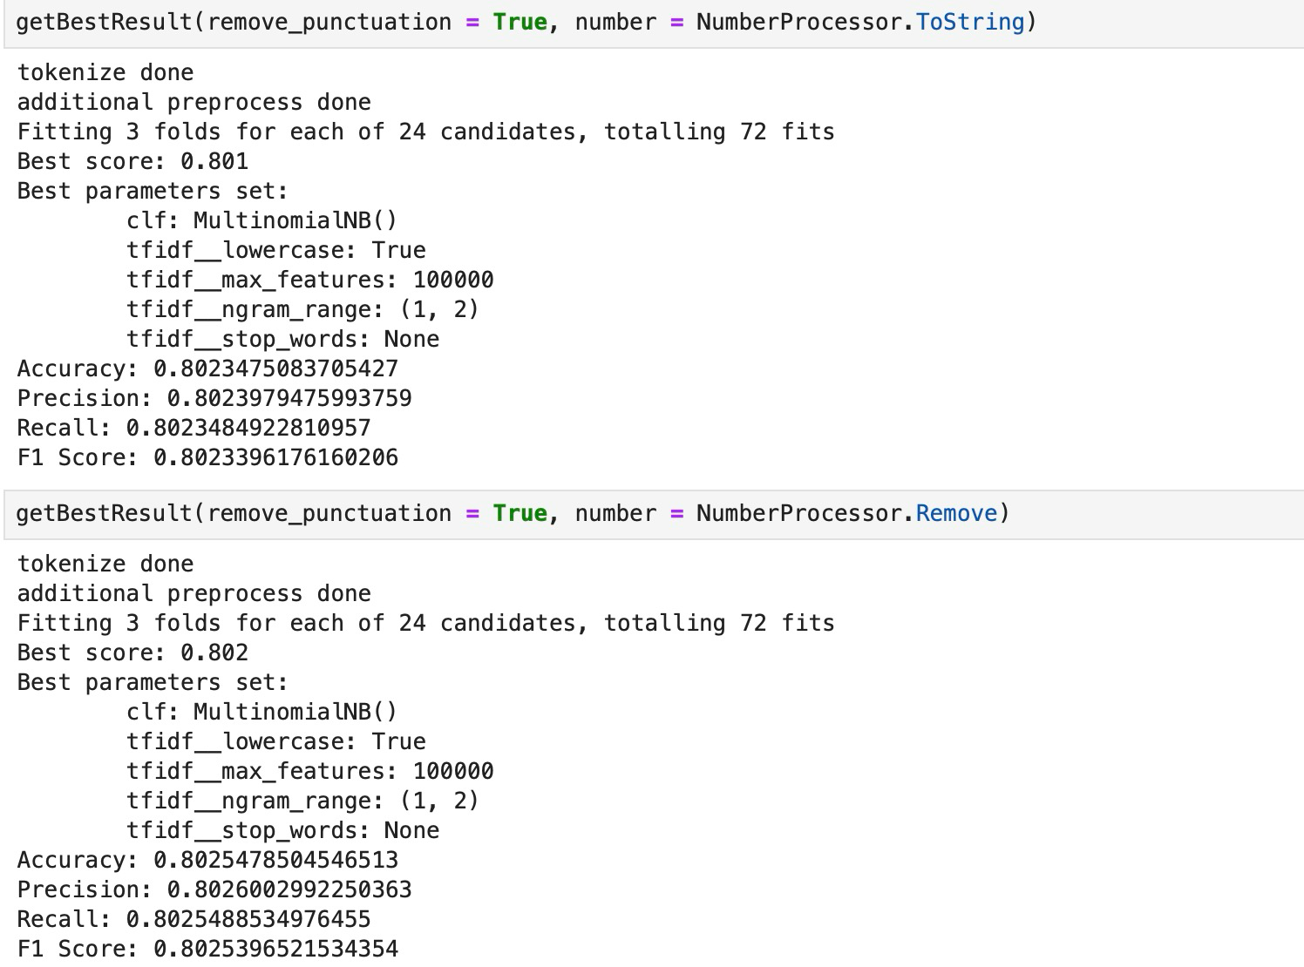
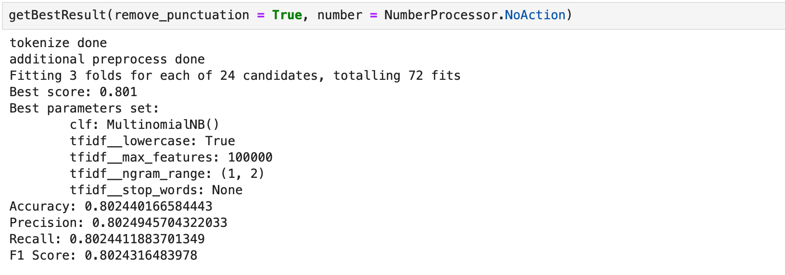
4.5
Further adjust the clf to use logistic regression. This prevents overfitting and balances the complexity of the model. If the regularization is too weak (larger C), the model may become too complex and overfit the training data. If the regularization is too strong (smaller C), the model will be too simple and may not adequately capture the complexity of the data.
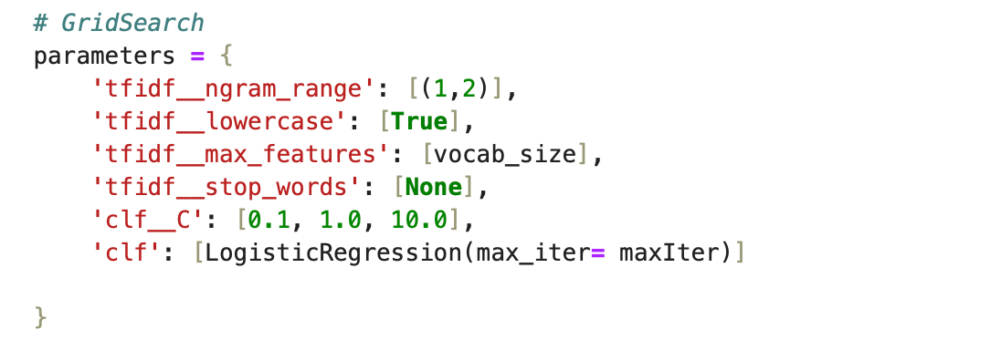
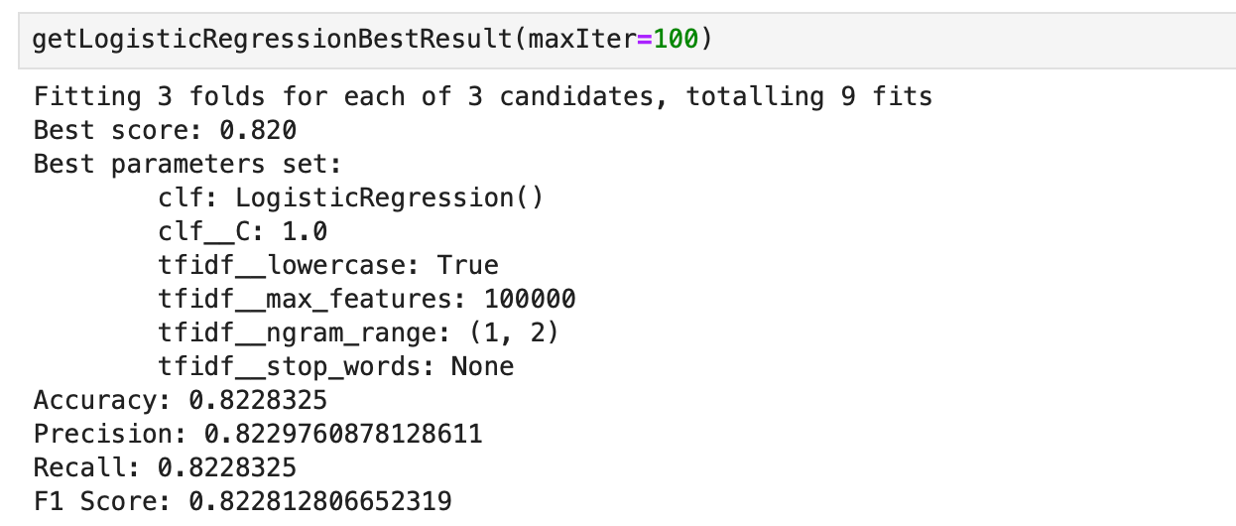
4.6
At this point, the best accuracy of the model is 0.8228325

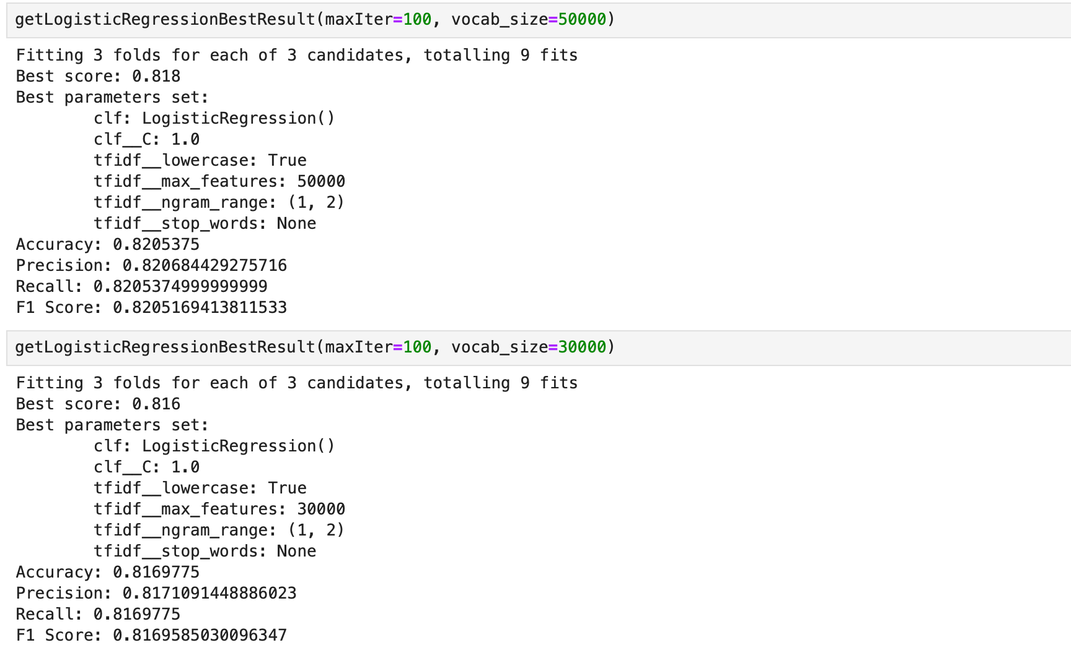
4.7
The vocab_size is then adjusted to 30,000 as well as 50,000 to determine the impact of vocab_size on model performance, and it is found that a larger vocab_size is useful for improving model accuracy.

- RNN

First, use Counter to count the frequency of each word in the dataset, and then construct a vocabulary list based on the word frequency statistics. Limit the size of the vocabulary list to 100,000, keep the most common words. After that, the vocabulary of each text is mapped to index by word2idx.
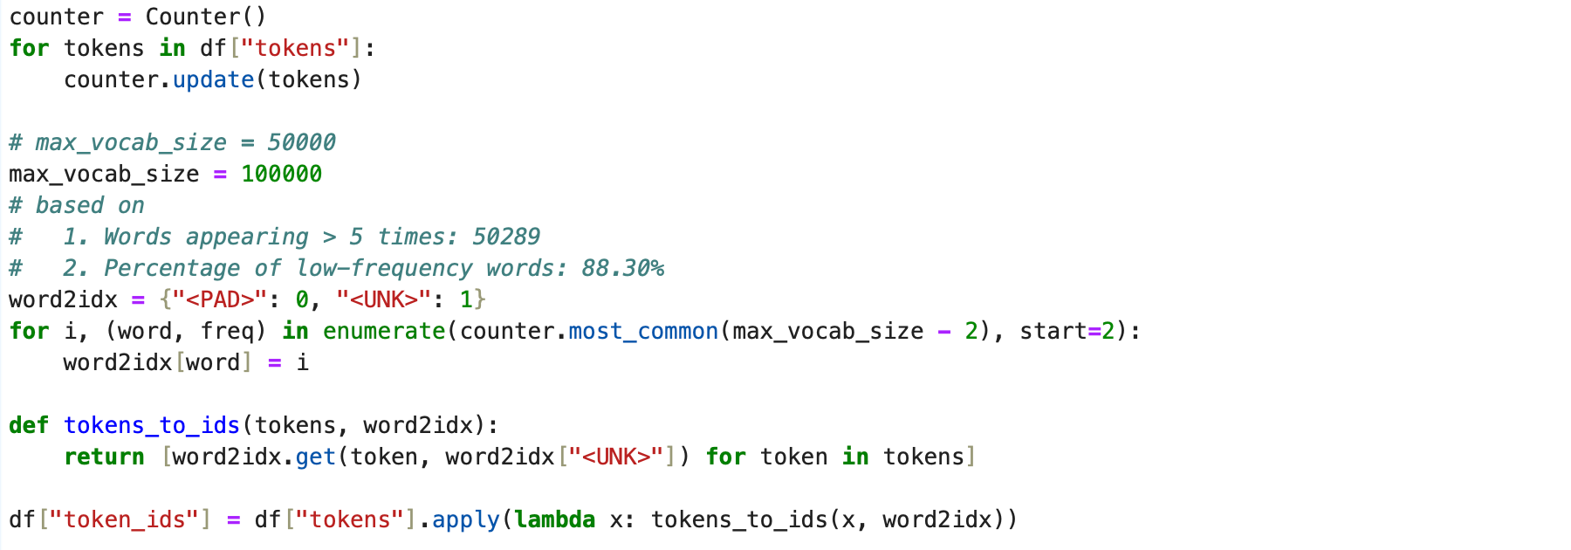
5.1

Split the dataset into a training set (70%), validation set (15%), and test set (15%). When using train_test_split, specify the stratify parameter to ensure that the proportion of samples in each category is the same in the training, validation, and test sets.
5.2

Text and labels are received using TextDataset and the text is transformed into a PyTorch tensor. When processing the data, the text is padded using pad_sequence so that all the text has the same length for subsequent RNN operations.
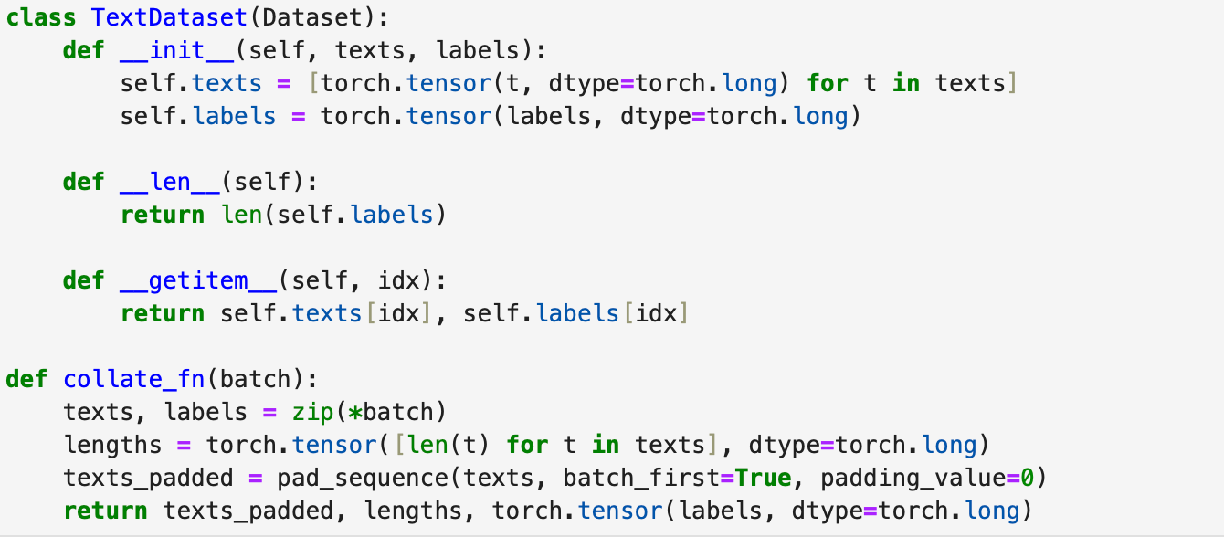
5.3

Wrap training, validation, and test sets into PyTorch's Dataset and DataLoader. Use collate_fn to dynamically fill the sentences of each batch to accommodate variable-length sequences. shuffle=True ensures that the training data is disrupted to improve generalization.
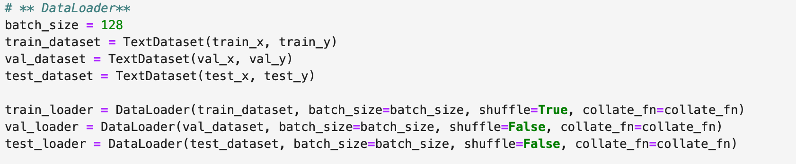
5.4

Construct an embedding_matrix with the same size as the word list and assign the corresponding vector to each word.
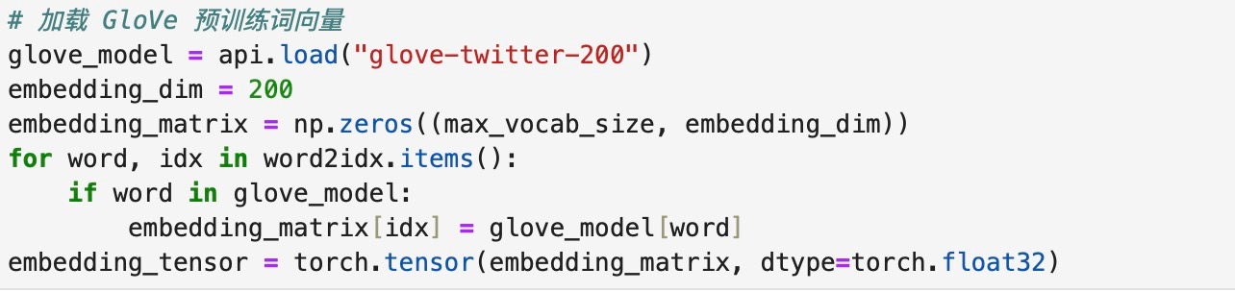
5.5

5.1 Standard RNN

Standard RNN is simpler than LSTMs and GRUs and are suitable for tasks that do not require complex contextual dependencies. However, the standard RNN encounters the vanishing or explosion problem when dealing with long sequences, and thus cannot effectively capture long time dependencies, limiting its application in complex tasks.
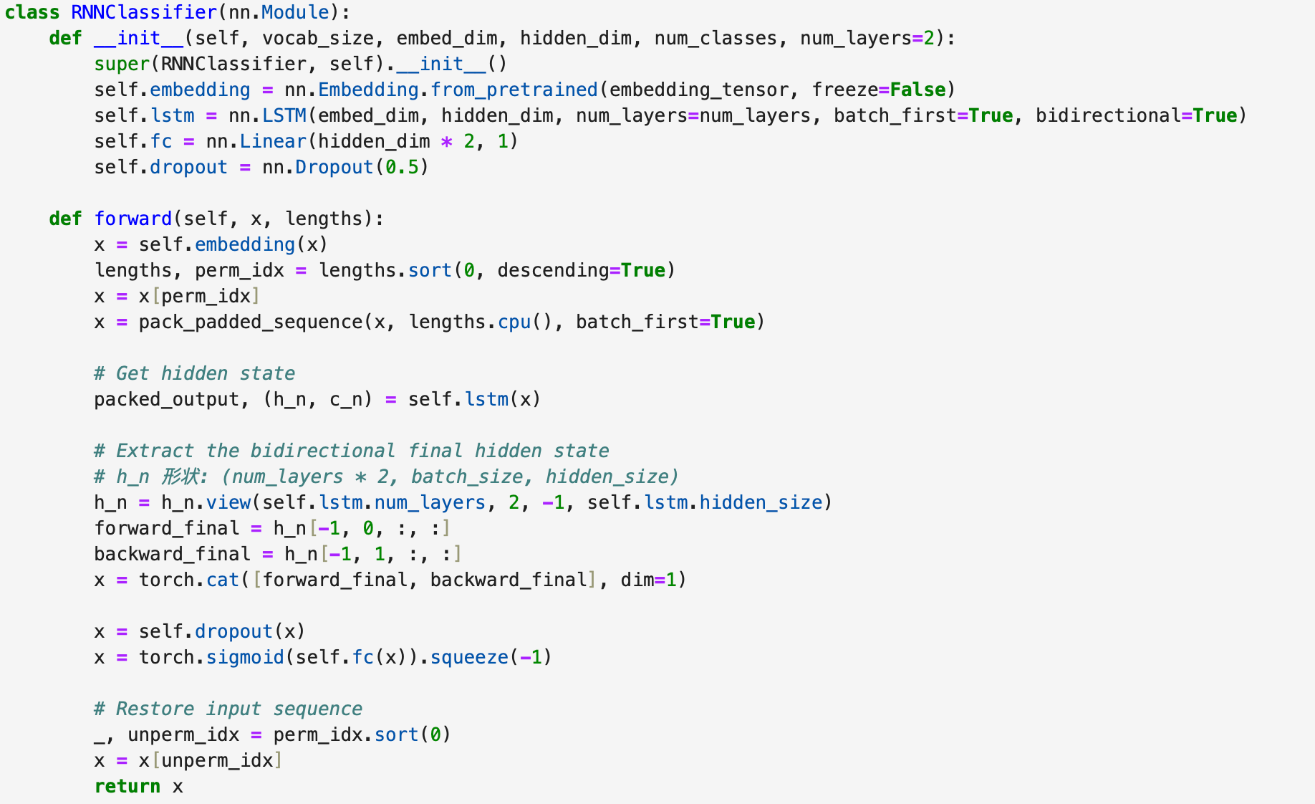
5.1.1

Perform model initialization and hyperparameter setting
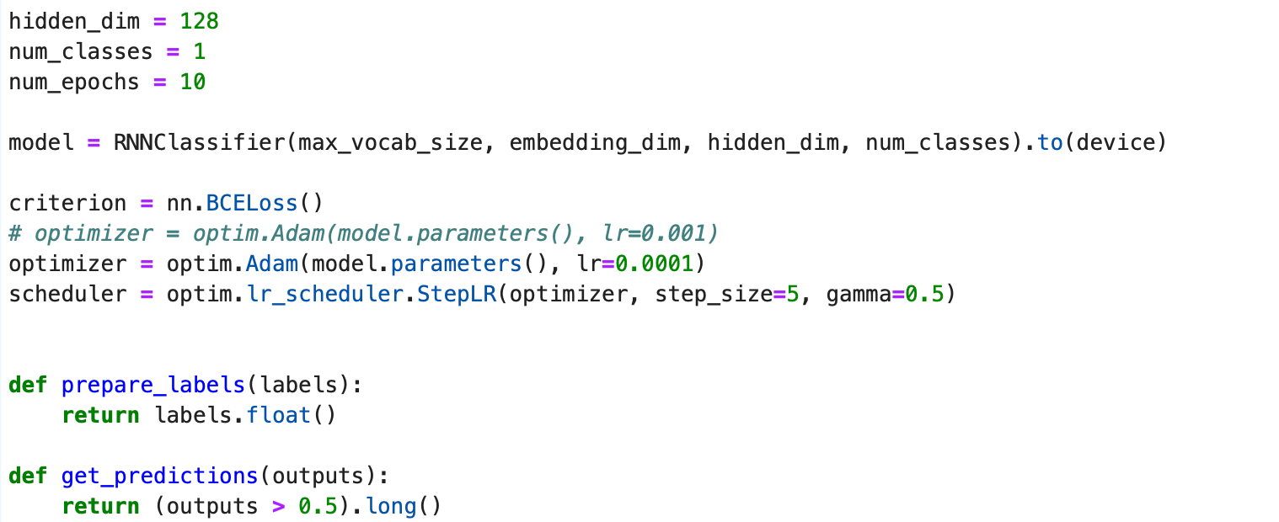
5.1.2
The training cycle of the RNN model, which includes the training of the model, validation, early stopping strategies and loss calculation
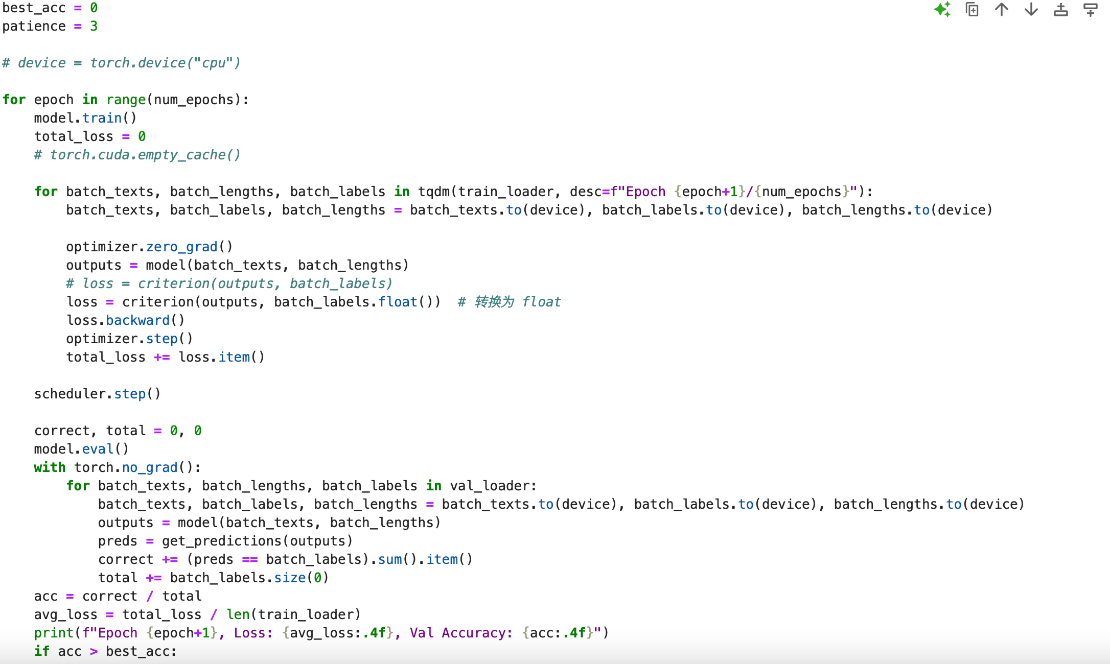

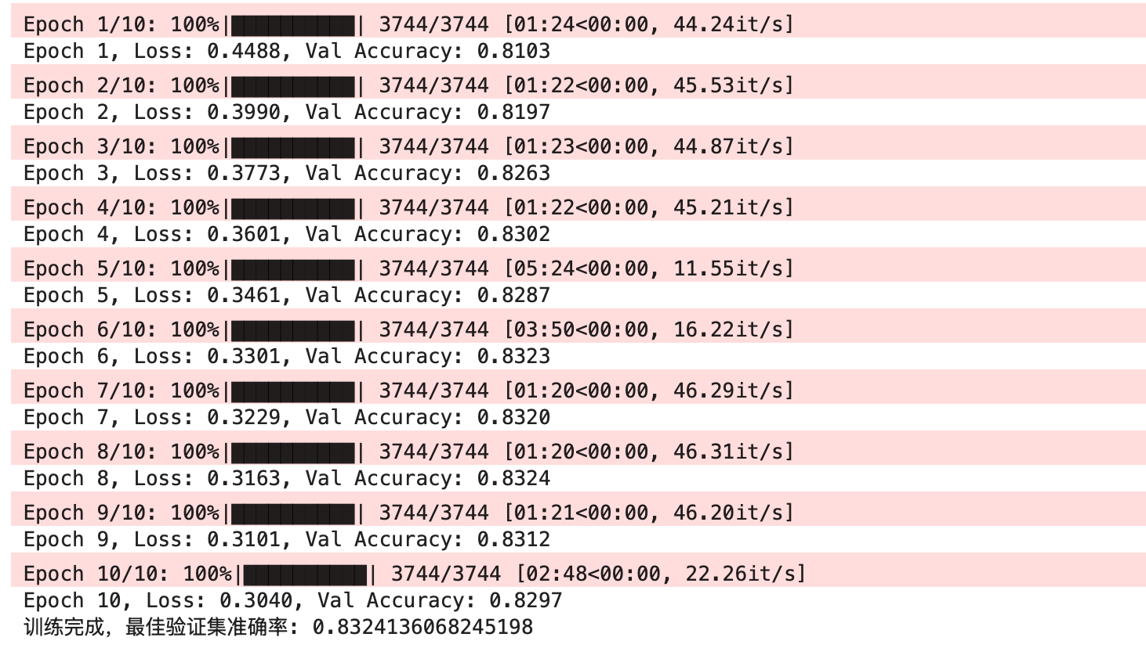
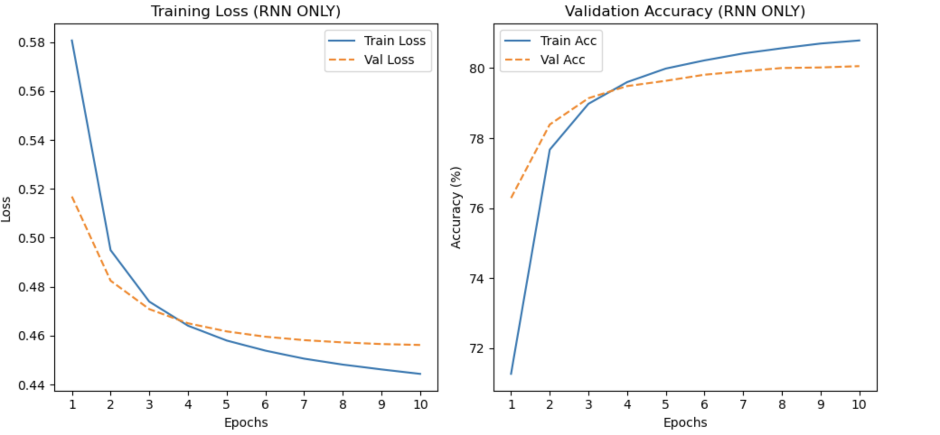
5.1.3
Set up an early stop mechanism, if the accuracy of the validation set is not improved for 3 epochs in a row, the training will be stopped early to avoid overfitting. The best accuracy achieved through training is 0.83.

Evaluating the performance of trained RNN models on test sets
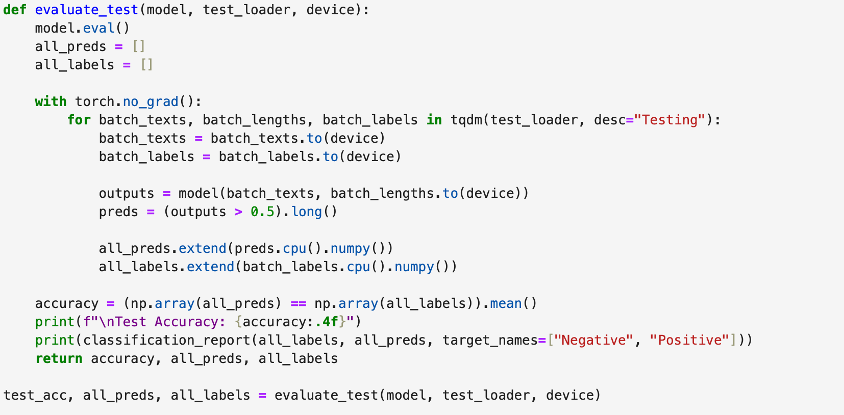
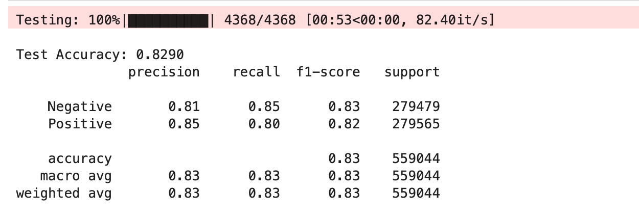
5.1.4
The final TEST ACCURACY for this model was 0.8290.

5.2 GRU
GRU (nn.GRU) was used instead of the standard RNN layer that uses the
GRU is an improved version of RNN that uses update gate and reset gate to control the information flow, which solves the problem of gradient vanishing of traditional RNN in long sequence processing.GRU decides how much information from the previous moment is retained by the update gate, and how much of the previous state is forgotten by the reset gate. Compared with LSTM, GRU has a more concise structure and higher computational efficiency, which is suitable for processing long-range dependent tasks.

The training cycle
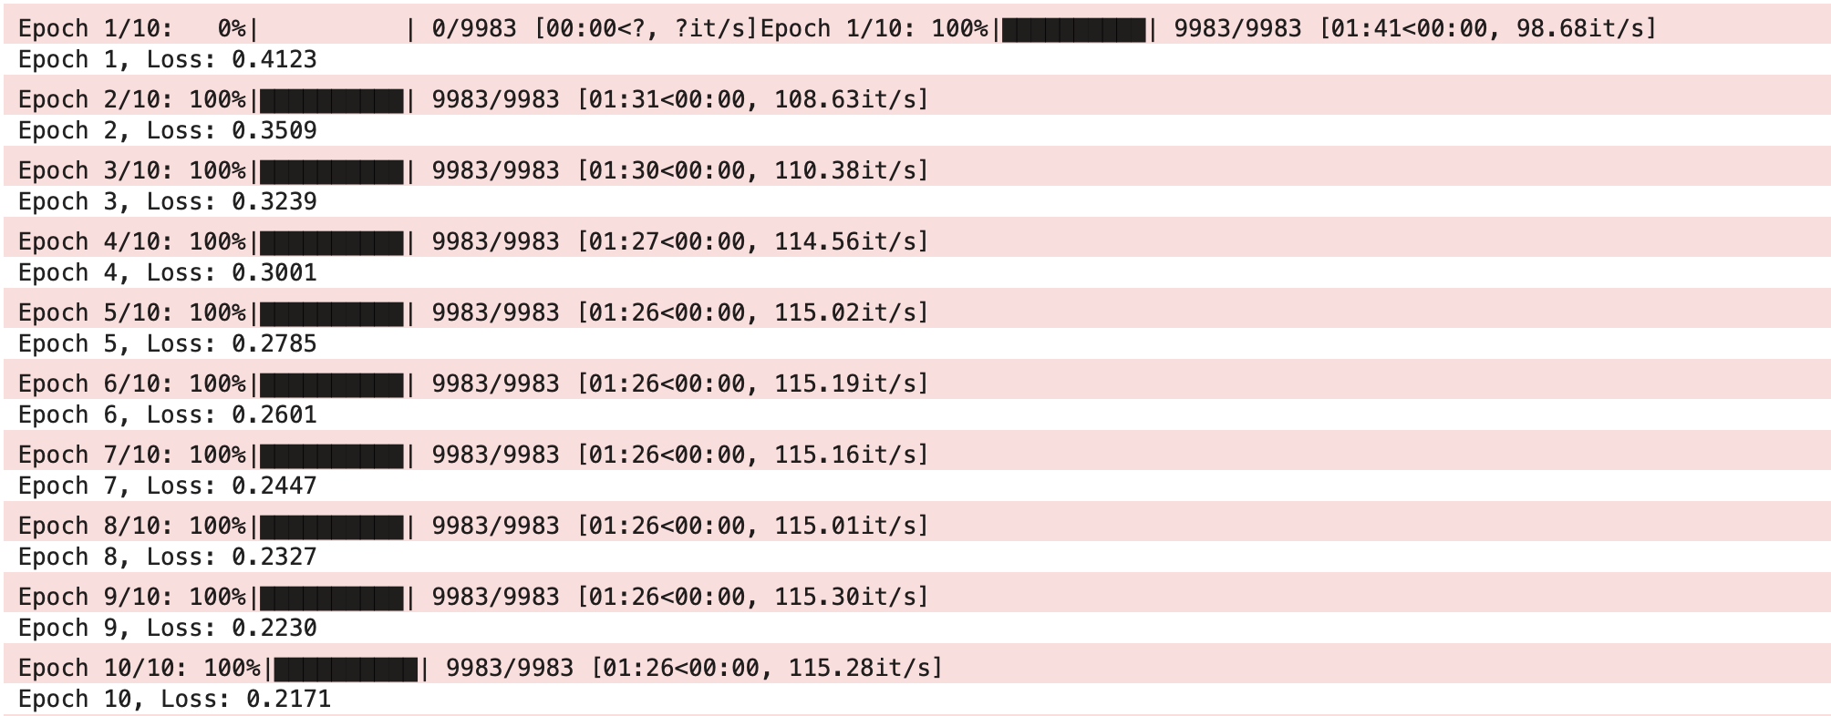
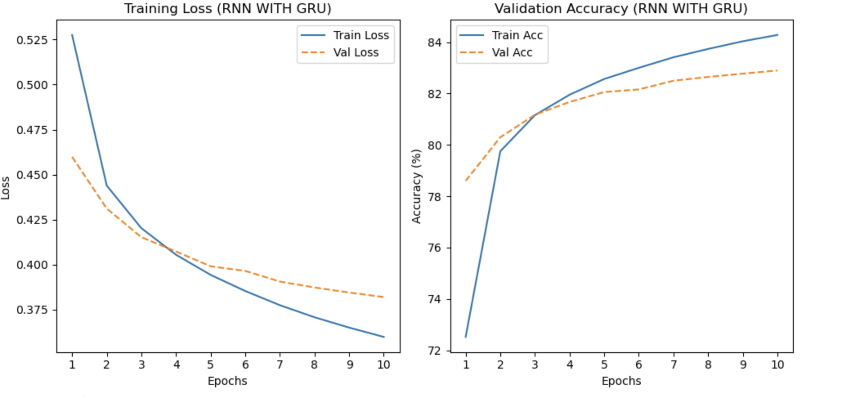
5.2.1
As the training proceeds, the loss is decreasing and the accuracy is increasing, indicating that the model is not overfitting as the training proceeds and has good generalization ability.

Evaluating the performance of trained RNN models on test sets.
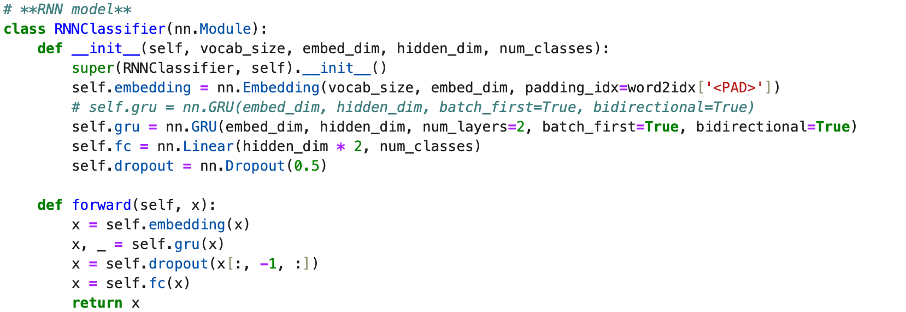
5.2.2
The final test accuracy for this model was 0.83.

5.3 LSTM

LSTM (Long Short-Term Memory Network) is a special kind of RNN, which aims to solve the problem of gradient vanishing and gradient explosion encountered by traditional RNNs during the training process, especially when dealing with long sequential data. LSTM enables the model to memorize the long-term dependency information more efficiently through the introduction of gating mechanism. Compared with GRU, LSTM is more complex and suitable for tasks that require finer control of long-term memory.
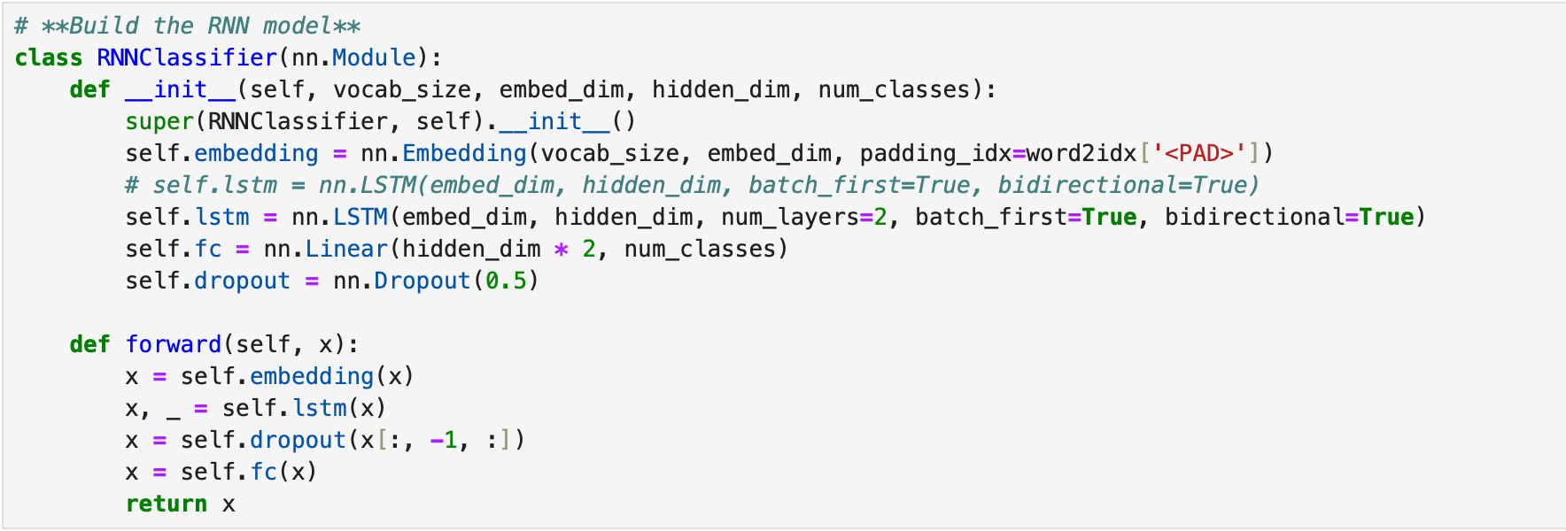

The training cycle
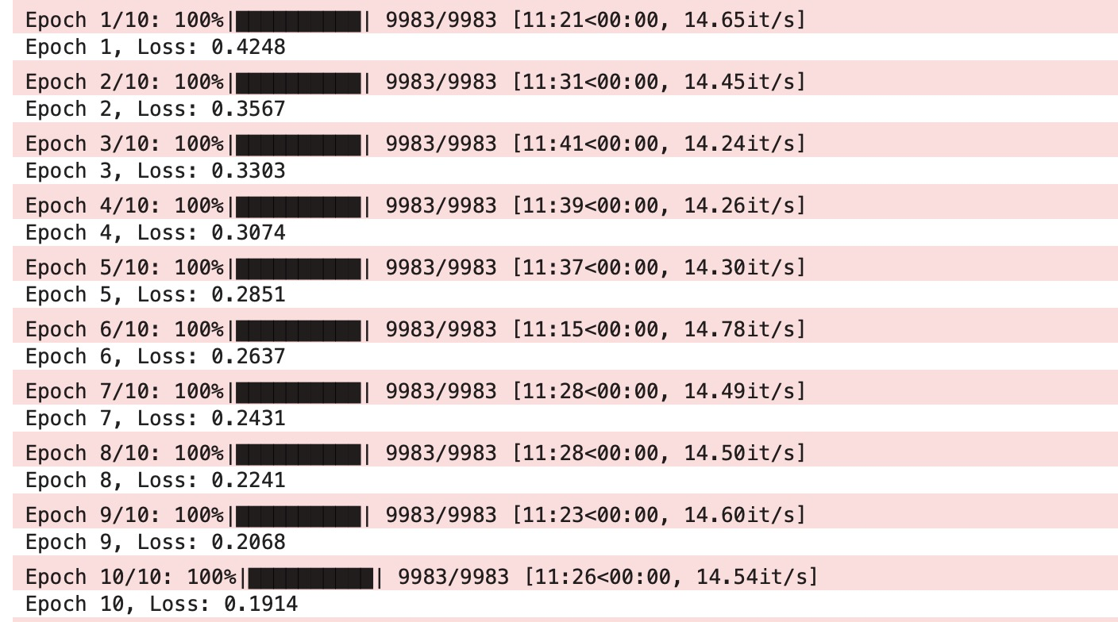

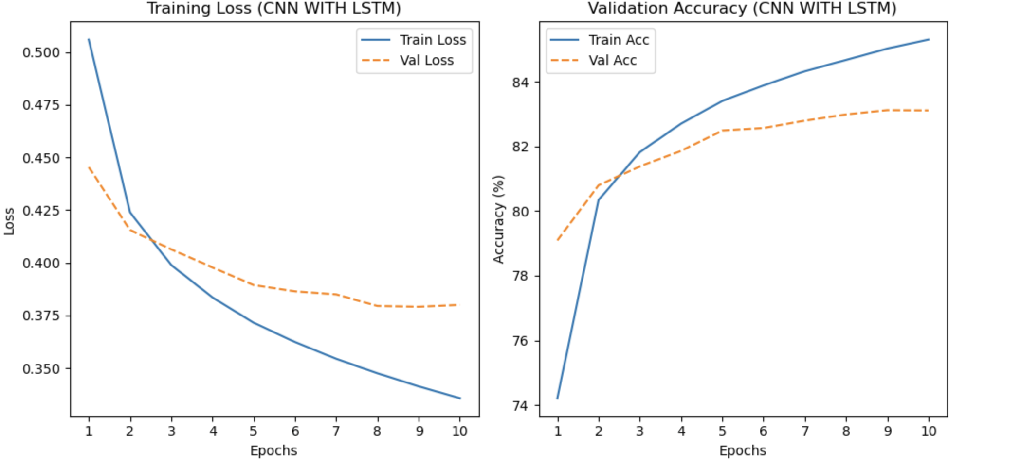
5.3.1
Again as the training proceeds, the loss is decreasing and the accuracy is increasing, indicating that the model exhibits better generalization capabilities as the training proceeds.

Evaluating the performance of trained RNN models on test sets
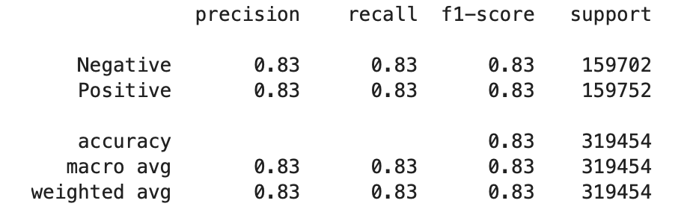
5.3.2
The final test accuracy for this model was 0.83.

4.3 CNN Models
Convolutional Neural Networks (CNNs) is effective for text classification due to their ability to capture local features in sequences of words. CNNs automatically learn n-gram patterns from text and apply weight-sharing techniques to improve efficiency. In this project, different CNN models were built to explore the better performance.
4.3.1 CNN Classifier
The CNNClassifier model for this project includes an embedding layer, multiple convolutional layers with different kernel sizes (3, 4, 5), and a fully connected layer for classification. The embedding layer transforms input words into dense vectors, which are then processed by multiple 1D convolutional layers with varying kernel sizes to capture n-gram features of different lengths. Each convolutional output undergoes ReLU activation and max pooling to retain the most important features, which are then concatenated to form a comprehensive feature representation. Finally, the concatenated features are passed through a fully connected layer that maps them to the output space of num_classes dimensions. This structure enables the model to effectively learn and classify text based on extracted patterns.
Through multiple optimizations of the base model, the final optimized model is as follows (4.3.1.1):
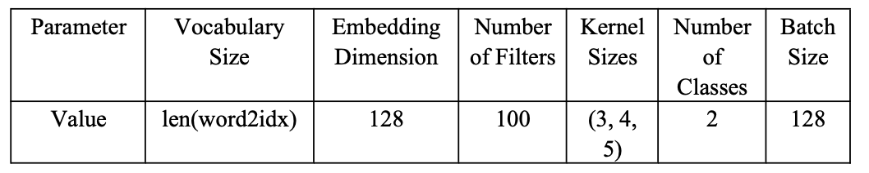
4.3.1.1

The training and validation results of CNN Classifier model are as follows (4.3.1.2) (4.3.1.3):
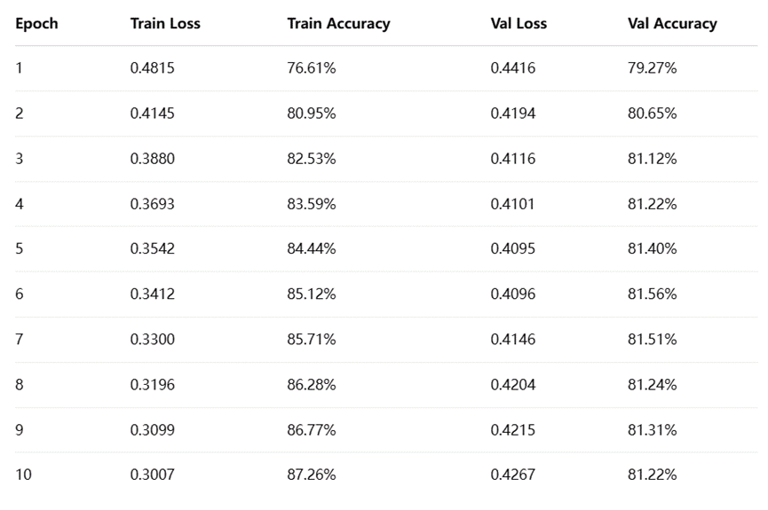
4.3.1.2
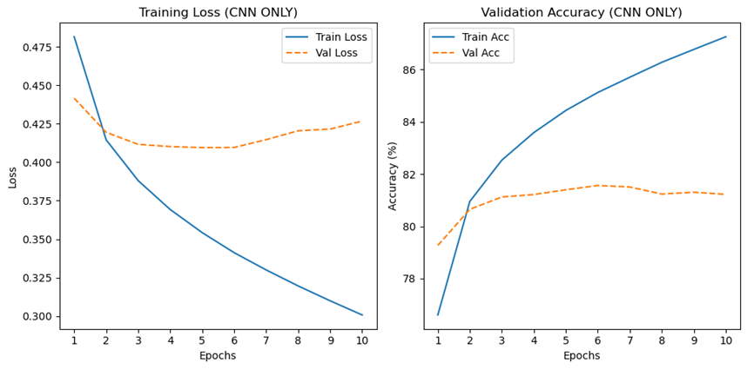
4.3.1.3
During the training process, the model's performance on the training set steadily improved. In the first epoch, the model had a training loss of 0.4815 and an accuracy of 76.61%. By the 10th epoch, the training loss improved to 0.3007, with accuracy increasing to 87.26%. This tendency shows that the model became more effective at learning from the training data as the epochs progressed.
However, when evaluating the model on the validation set, the performance showed a different trend. In the first epoch, the validation loss was 0.4416, with a validation accuracy of 79.27%. As training continued, the validation loss decreased and reached its lowest point of 0.4096 in the 6th epoch, where the model achieved the highest validation accuracy of 81.56%. After the 6th epoch, the validation accuracy started to slightly decrease, and by the 10th epoch, it was 81.22%. This result suggests that while the model's training performance improved consistently, it started to slightly overfit after epoch 6, as the validation accuracy began to decrease.
4.3.2 CNN_LSTM
The CNN_LSTM Classifier model for this project combines convolutional layers for local feature extraction and LSTM layers for sequential modeling, designed to capture both short and long dependencies in text. The model begins with an embedding layer that transforms input words into dense vectors. These embeddings are then passed through a 1D convolutional layer, which applies filters to capture local patterns, such as n-grams. The output of the convolutional layer undergoes ReLU activation to introduce non-linearity, followed by a transformation to match the input format required by the LSTM layer. The LSTM layer processes the sequential features, capturing long-term dependencies across the text. Finally, the output from the last time step of the LSTM is passed through a fully connected layer, which maps the features to the target class labels, allowing for classification.
Through multiple optimizations of the base model, the final optimized model is as follows (4.3.2.1):
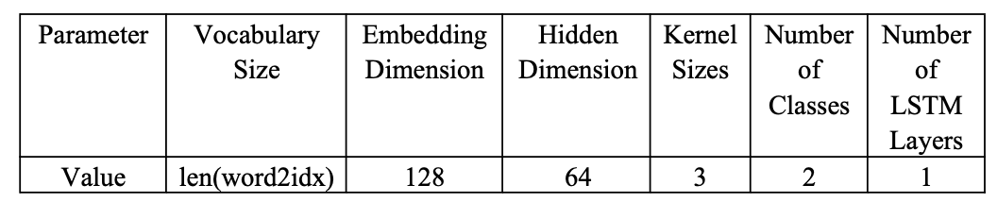
4.3.2.1
The training and verification results of CNN.LSTM Classifier model are as follows (4.3.2.2) (4.3.2.3):
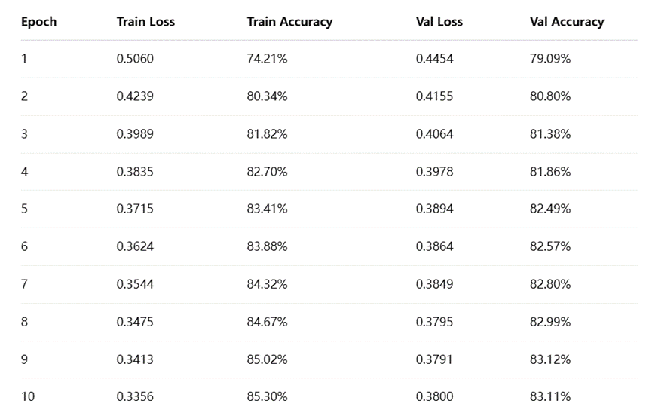
4.3.2.2
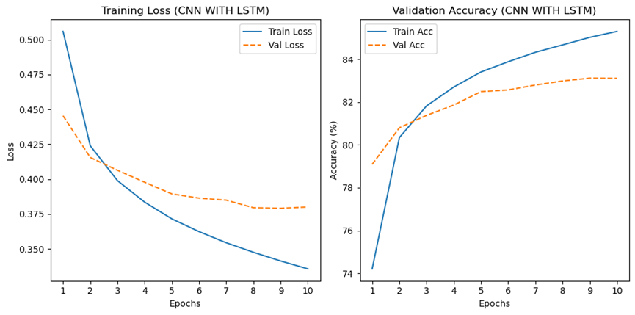
4.3.2.3
The CNN_LSTM model indicated better performance during training. The training loss fell from 0.5060 to 0.3356, presenting that the model was gradually learning and converging. The training accuracy improved from 74.21% to 85.30%, reflecting the model's ability to fit the training data more effectively. Similarly, the validation loss showed a gradual decline from 0.4454 to 0.3800, suggesting that the model's performance on the validation set was also improving over time. The validation accuracy increased from 79.09% to 83.11%, indicating that the model's generalization ability was strengthened. Overall, the CNN_LSTM model achieved a high level of performance with an 83.11% accuracy on the validation set, demonstrating good generalization.
4.3.3 CNN_GRU
The CNN_GRU Classifier model for this project combines convolutional layers for local feature extraction and GRU (Gated Recurrent Unit) layers for sequential modeling, designed to capture both short and long dependencies in text. The model begins with an embedding layer that transforms input words into dense vectors. These embeddings are then passed through a 1D convolutional layer, which applies filters to capture local patterns, such as n-grams. The output of the convolutional layer undergoes ReLU activation to introduce non-linearity, followed by a transformation to match the input format required by the GRU layer. The GRU layer processes the sequential features, capturing long-term dependencies across the text. Finally, the output from the last time step of the GRU is passed through a fully connected layer, which maps the features to the target class labels, allowing for classification.
Through multiple optimizations of the base model, the final optimized model is as follows (4.3.3.1):
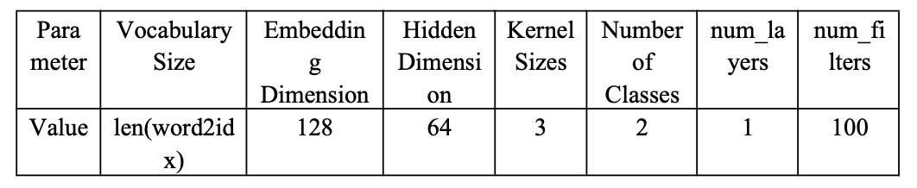
4.3.3.1
The training and verification results of CNN_GRU Classifier model are as follows (4.3.3.2) (4.3.3.3):
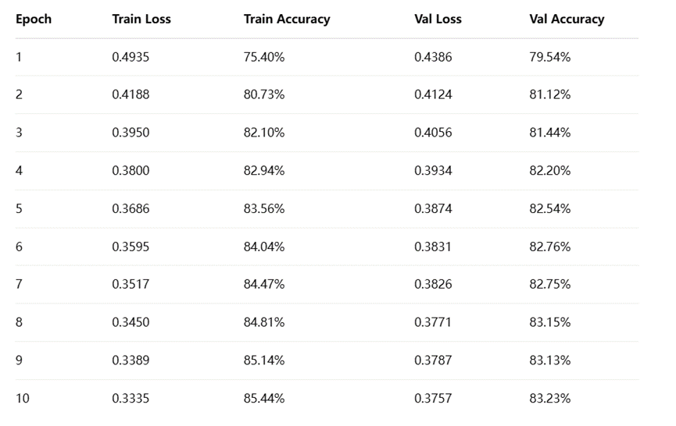
4.3.3.2
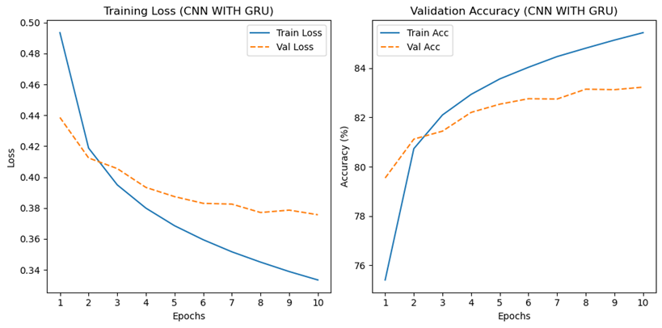
4.3.3.3
The CNN_GRU model results presented the consistent improvement over the course of the training. The training loss decreased from 0.4935 to 0.3335. Correspondingly, the training accuracy improved from 75.40% to 85.44%.
The validation loss followed a similar trend, dropping from 0.4386 to 0.3757, suggesting that the model was generalizing well. The validation accuracy improved from 79.54% to 83.23%, showing that the model's ability to make accurate predictions on the validation dataset.
The final validation accuracy of 83.23% shows the best performance.
4.4 BERT
In this section, the BERT model was used to classify textual data. The BertClassifier model for this project utilizes the DistilBERT model as the backbone, which is a smaller, faster variant of the original BERT model while retaining much of its performance. The model begins by loading the pre-trained DistilBertModel from Hugging Face’s model hub. The input texts are tokenized and passed into this transformer model. The output of the DistilBERT model is then passed through a dropout layer to prevent overfitting. Finally, a fully connected (linear) layer maps the features to the desired number of classes (in this case, 2 classes for binary classification).
Through multiple optimizations of the base model, the final optimized model is as follows (4.4.1):
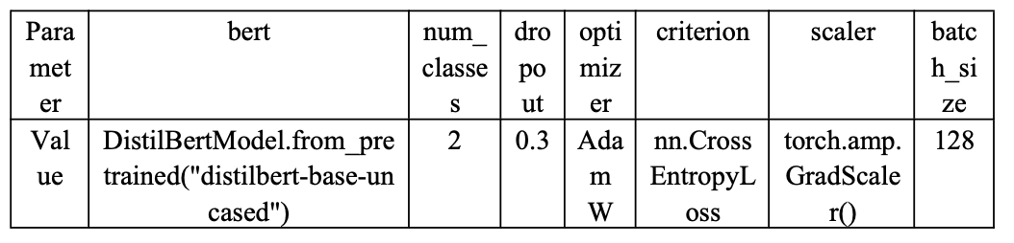
4.4.1
After training the model and performing evaluation, the model's performance is as follows (4.4.2):
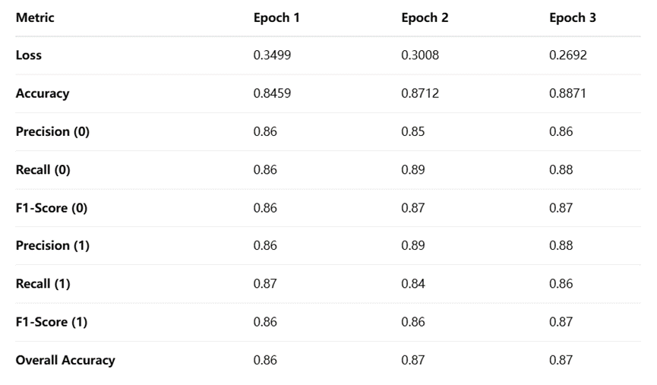
4.4.2
The model's performance improved across the three epochs. Loss decreased from 0.3499 in Epoch 1 to 0.2692 in Epoch 3, indicating better fitting to the data and enhanced performance. Accuracy consistently increased from 84.59% in Epoch 1 to 88.71% in Epoch 3, reflecting the model's growing effectiveness over time. Precision, recall, and F1-score remained balanced for both classes, showing the model's strong capability to identify both negative and positive sentiments.
6. Conclusion
6.1 Comparison of four models
model | Logistic Regression | RNN | CNN | BERT
accuracy | 0.816 | 0.83 | 0.842 | 0.887
In this study, the researchers have built and compared four sentiment classification models, including Logistic Regression, RNN, CNN, and BERT. The results show that deep learning models generally outperform traditional machine learning methods, with BERT achieving the highest accuracy.

Reference：

Ainley, E., Witwicki, C., Tallett, A., & Graham, C. (2021). Using Twitter comments to understand people’s experiences of UK health care during the COVID-19 pandemic: Thematic and sentiment analysis. Journal of Medical Internet Research, 23(10), e31101. https://doi.org/10.2196/31101

Mohammad, S. M. (2017). Challenges in sentiment analysis. In Socio-affective computing (pp. 61–83). https://doi.org/10.1007/978-3-319-55394-8_4

Sahayak, V., Shete, V., Pathan, A., & Department of Information Technology, Savitribai Phule Pune University, Pune, India. (2015). Sentiment analysis on Twitter data. In International Journal of Innovative Research in Advanced Engineering (IJIRAE) (Vol. 2, Issue 1). https://d1wqtxts1xzle7.cloudfront.net/36584429/28.JACS10092-libre.pdf?1423574431=&response-content-disposition=inline%3B+filename%3DSentiment_Analysis_on_Twitter_Data.pdf&Expires=1724869234&Signature=awf68RwOym7NsLD-s3X2e3jhlgLmzw49jYX3VNhDjqQIaysaN4JaJjucVwj6wuhl~YnPIyYVQF2eeBXVI2vRbXqnORI4T7LBvJZAVSB6J3Xnbi6aVX5uvN7PfP04vxmasIjZG-Zuxpg3UFliNn-UJmfwv5apTEbLA~t4FGn8DD-86IDxNQwZdwU7w0IDAVBE1OR-m8z70x1c7qlITjVbhKlJUoRklMcZCR3syhjsiL1tVtWKN6-CLD8FtxGfrPNP3nB8TZA6jrbB4sD~6plqVilNuzKrgyC066cscD0eqQxaYhLBikivzzNPCt20EAwCbs0uOY5Mgqx~esxpCEDmgA__&Key-Pair-Id=APKAJLOHF5GGSLRBV4ZA

Yue, L., Chen, W., Li, X., Zuo, W., & Yin, M. (2018). A survey of sentiment analysis in social media. Knowledge and Information Systems, 60(2), 617–663. https://doi.org/10.1007/s10115-018-1236-4

Zimbra, D., Abbasi, A., Zeng, D., & Chen, H. (2018). The State-of-the-Art in Twitter sentiment analysis. ACM Transactions on Management Information Systems, 9(2), 1–29. https://doi.org/10.1145/3185045

