
IS6751 – TEXT & WEB MINING
Take home project 2

Wee Kim Wee School of Communication and Information
Semester I AY2024-2025

Written by:
Zhou Gaoqiang (G2304064A)

[Word Count: 1753]

TASK 1
The objective of this task it to perform hyperparameter tuning and experimental analysis on sentiment classification models based on RNN, in order to improve the prediction accuracy of the models.
In the initial, I briefly reviewed the dataset and found that it did not contain special characters (such as @name, email addresses, URLs, etc.) and obvious grammatical issues. Therefore, no special character removal or specific tag replacements were performed. Since there are a large number of tuneable hyperparameters, it would be very difficult to adjust all of them simultaneously. Therefore, I attempted to tune different sets of hyperparameters in separate stages. As a preliminary note, under the initial conditions (For the sake of better experimentation, the code related to punctuation removal was temporarily removed), the accuracy was 0.6602.

Stage 1: Preprocessing
In this stage, I gradually enabled the following preprocessing operations one at a time in the experiments to analyse the effectiveness of each method. The preprocessing steps included: punctuation removal, case folding, contraction expansion, stop word removal, WordNet lemmatization, Opinion Lexicon-based sentiment features (To clarify, I implemented this by counting the number of positive and negative words in each review based on the opinion dictionary as an additional 2 dim added to the Full Connection layer of the model.), and applying a word frequency cut off.
Since the original code already includes support for word frequency cutoff by default, no adjustments were made to it for the time being. Instead, experiments were conducted on the remaining six preprocessing methods individually, and the results are as follows:
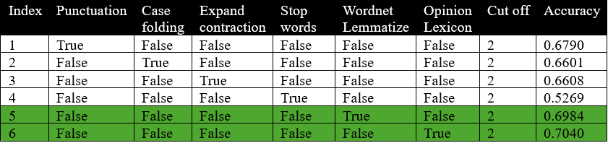
From the experimental results, it was observed that removing stop words led to a significant drop in accuracy. In contrast, expanding contractions and applying case folding had minimal impact on the model's performance. Punctuation removal provided a slight improvement in accuracy, while both WordNet lemmatization and Opinion Lexicon contributed to a notable boost in performance. Therefore, the focus of the subsequent experiments was placed on exploring the optimal combination of punctuation removal, WordNet lemmatization, and Opinion Lexicon.
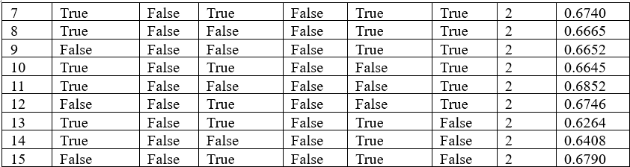
After multiple rounds of experimentation, it was found that no combination outperformed the individual use of WordNet lemmatization and Opinion Lexicon. Hence, based on the results, I made final adjustments to the cutoff value. The results are as follows:
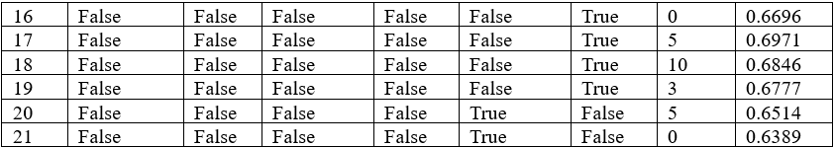
The results also showed no improvement, so I only retained the hyperparameter sets from the 5th and 6th experiments.
Stage 2: Classifier Architecture Tuning
In this stage, I focused on selecting the optimal baseline architecture (RNN, GRU, or LSTM) and systematically tuning key parameters, including word embedding size, RNN hidden size, number of RNN layers, pooling type, bidirectionality, additional fully connected layers, and batch normalization to identify the most effective model configuration.
Since using Opinion Lexicon alone yielded better performance than using WordNet lemmatization alone, I conducted further experiments based primarily on the 6th preprocessing configuration (Acc:0.7040) from the first stage. The results are as follows:
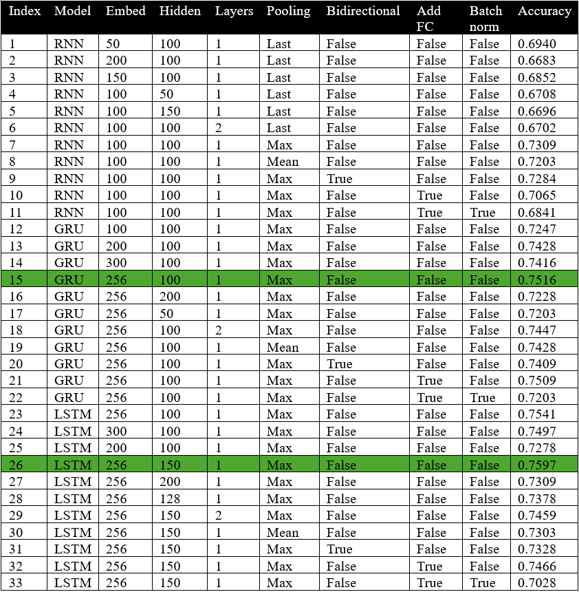
The experiments revealed a consistent trend in model performance: LSTM outperformed GRU, and GRU outperformed RNN. Additionally, increase the embedding size and hidden size was crucial to achieving higher accuracy. Among pooling strategies, max pooling is significantly outperformed other pooling types.
Interestingly, enabling bidirectional RNN, increasing the number of RNN layers, adding an additional full connection layer, or apply batch normalization did not lead to further improvements in accuracy. Based on the fact that training accuracy reached 100% early in multiple rounds of experiments and validation loss increased instead of decreased, I think this is because I used a large enough embedding size and hidden size first, and the model has captured enough semantic representation, continuing to add more complex results may lead to overfitting and degraded performance. In general, in the case of small dataset, overly complex models are unnecessary and may be counterproductive.

Based on the best-performing GRU (15th) and LSTM (26th) configuration, I disabled the Opinion Lexicon and enabled WordNet lemmatization. The results are as follows:
The results were unsatisfactory but expected. Finally, I experimented with different dropout rates based on configurations 15th and 26th. The outcomes are as follows:
The best performance was achieved when the dropout rate was set to 0, which may be attributed to the previously mentioned reasons: the dataset is relatively small, and the model is already sufficiently complex.

Stage 3: Training Hyperparameters Tuning & Add Attention Mechanism
Finally, I experimented with different training hyperparameters, focusing primarily on batch size, learning rate, weight decay, and early stopping. The results are as follows:
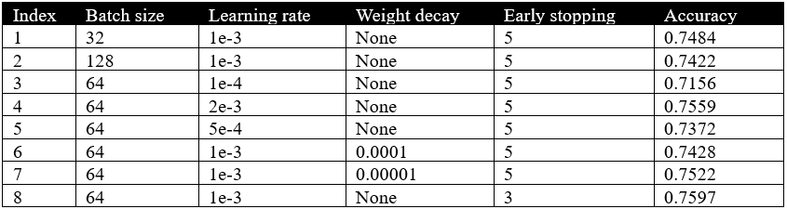
It didn’t seem to have much impact on performance, but using early stopping (with patience of 3) can help speed up training with minimal effect on accuracy.
In an effort to further improve accuracy, I introduced an attention mechanism. However, since attention performs dynamic weighted aggregation - unlike traditional pooling methods which are static and unweighted - the two approaches serve overlapping purposes and are not compatible. Therefore, traditional pooling was disabled after incorporating attention. The results are as below:
It can be observed from the table that self-attention clearly outperforms other attention mechanisms, but still falls short compared to the original max pooling approach. This may be because the current model architecture and hyperparameters were optimized based on pooling and would require additional adjustments to fully leverage attention.
Finally, in the 26th experiment of the 2nd stage, the classification performance reached its best with an accuracy of 75.97%.
Conclusion & Future improvement
In this task, I found that preprocessing methods with strong semantic preservation (e.g. WordNet lemmatization and opinion lexicons-based features) were more effective in improving model performance, while other traditional preprocessing techniques actually degraded performance. Among the base models, LSTM outperformed GRU and RNN, and Max Pooling proved more effective than Mean Pooling.
Another important observation on this relatively small dataset is that significantly increasing model complexity such as using bidirectional or multi layers tended to cause overfitting and reduce performance. Although I attempted to incorporate attention mechanisms, they did not outperform Max Pooling, suggesting that a more comprehensive structural adjustment may be needed to fully leverage the benefits of attention.
For future improvements, we can explore We can explore further adjustments based on self-attention mechanisms, and also apply data augmentation techniques, such as word replacements, to help reduce the risk of overfitting and improve the model’s generalization ability.

TASK 2
Task 2 requires performing sentiment classification based on various transformer-based models. However, unlike Task 1, transformer models do not require traditional preprocessing steps, as such operations may disrupt contextual integrity and potentially degrade classification accuracy. This concern has been thoroughly discussed in recent studies, which demonstrate that operations such as stopword removal, word lemmatization, and punctuation strpping can interfere with pre-trained tokenization and context-aware embeddings in models like BERT and its variants (Kurniasih & Manik, 2022; Haviana & Mulyono, 2023; Kanigiri et al., 2024). Therefore, such preprocessing steps are intentionally omitted and will not be further verified in this task.

Stage 1: Classifier Architecture Tuning
Due to the relatively high training cost of transformer-based models, this stage focused on tuning core architecture choices and key parameters. Specifically, I experimented with different base models, varied the number of frozen layers, adjusted the maximum input length, and fine-tuned the dropout rate of the final full connection layer.
I explored freezing certain layers of the pre-trained models because I learned that freezing the lower layers can help the model better adapt to the specific task and reduce the risk of overfitting, especially when working with relatively small datasets. As for adjusting the maximum input length, it was done to better capture the complete contextual information while maintaining a balance with training efficiency.
Statement:
- without any modifications, the test accuracy was 85.42%.
- BERT-base-cased and RoBERTa-base each contain 12 encoder layers, while DistilRoBERTa-base has only 6. Therefore, for BERT and RoBERTa, I will experiment with freezing 0, 3, 6, and 9 layers, whereas for DistilRoBERTa, I will only froze 0 and 3 layers.
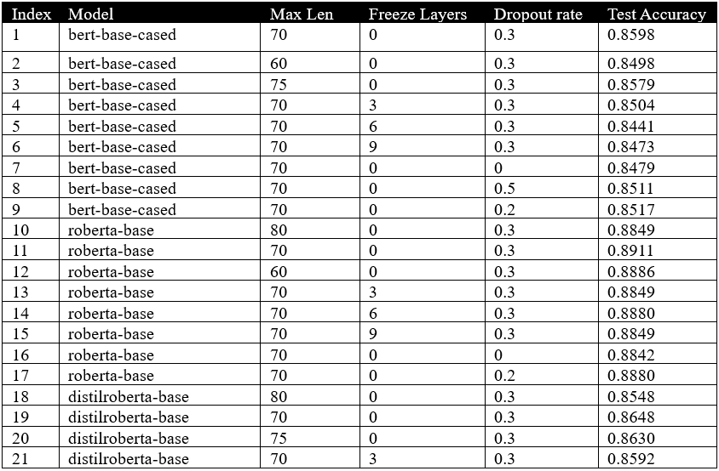
Based on the experimental results, RoBERTa-base achieved the best performance, and a max length of 70 also outperformed other values. Additionally, although freezing layers did not lead to improved accuracy, it significantly reduced training time due to the fewer number of trainable layers.
It was evident that transformer-based models outperformed RNNs in sentiment classification. Therefore, I extended my experiments by exploring several larger and more specialized models, including both general-purpose and sentiment-specific pre-trained models. These included:
- albert-base-v2: a model with parameter efficiency.
- roberta-large: a larger variant of RoBERTa with enhanced capacity.
- textattack/roberta-base-SST-2: fine-tuned specifically on the SST-2 sentiment dataset.
- cardiffnlp/twitter-roberta-base-sentiment: trained for sentiment analysis on Twitter data.
- nateraw/bert-base-uncased-emotion: fine-tuned for emotion detection.
The results are as follows:
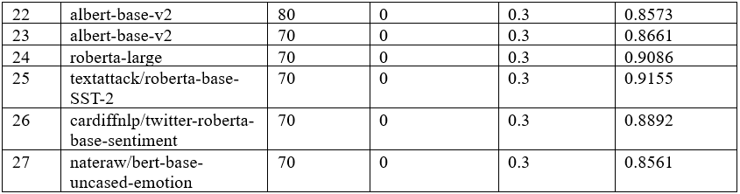
It is evident that the roberta-base-SST-2 model provided by TextAttack performed exceptionally well in testing. Therefore, I proceeded to further fine-tune this model, and the results are as follows:
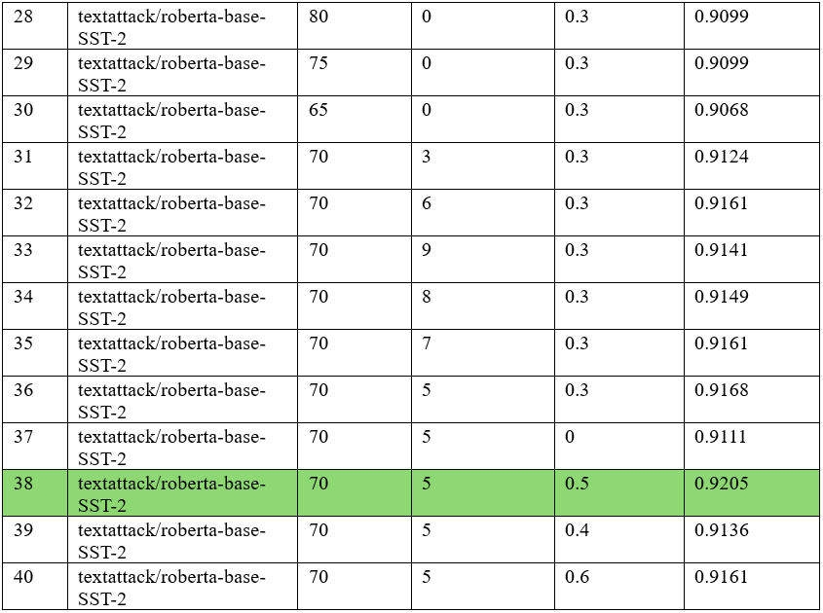
Finally, when freezing the first 5 layers and setting the dropout rate to 0.5, the model achieved its best performance on this dataset, reaching an accuracy of 92.05%.

Stage 2: Training Hyperparameters Tuning
Next, I continued tuning serval training-related hyperparameters, based on the 38th experiment from stage 1. The adjustments were similar to those in Task 1, but with early stopping removed, and additional introduced for warmup ratio and gradient clipping (clip_grad_norm). Warmup step refers to gradually increasing the learning rate during the early phase of training to avoid model instability. The warmup ratio indicates the proportion of total training steps allocated to this process (Gotmare et al., 2018). Gradient clipping is used to trim gradients when they become too large, preventing gradient explosion (Bu et al., 2023). The results are as follows:
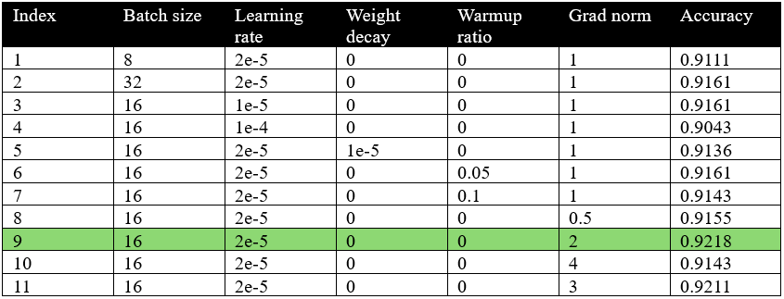
In the 9th experiment, when gradient clipping norm was set to 2, the model achieved its best test accuracy of 92.18%
Conclusion & Future Improvement
In this task, Transformer-based models demonstrated significantly better performance compared to the RNN architectures used in Task 1. The fine-tuned roberta-base-SST-2 model provided by TextAttack stood out as the best-performing model, indicating that models pretrained in domain-specific contexts often outperform general-purpose models in their respective fields.
Moreover, during fine-tuning of pretrained models, freezing some encoder layers not only helps significantly reduce training time but also improves model stability and reduces the risk of overfitting. Adjusting the maximum input length (Max Length) achieves similar benefits. While the overall performance gains from these strategies were relatively modest, they provide valuable practical experience for scaling up training in future tasks.
For future improvements, We can also apply the data augmentation techniques used in Task 1, explore more effective pretrained models available online, and perform more fine-grained hyperparameter tuning.

Reference:
Kurniasih, R., & Manik, S. (2022). On the role of text preprocessing in BERT embedding-based DNNs for classifying informal texts. Retrieved from https://www.researchgate.net/publication/361640948
Haviana, A. D., & Mulyono, A. A. (2023). The impact of text preprocessing on sentiment analysis using BERT. In 2023 6th International Conference on Information and Communications Technology (ICOIACT) (pp. 815–820). IEEE. https://doi.org/10.1109/ICOIACT57888.2023.10295797
Kanigiri, S., Kummitha, H. K., Vemulapalli, D., & Reddy, K. R. (2024). Influence of text preprocessing on fine-tuned transformer models for sentiment classification. In 2024 IEEE International Conference on Artificial Intelligence (ICAI) (pp. 210–215). IEEE. https://doi.org/10.1109/ICAI58723.2024.10786699
Gotmare, A., Keskar, N. S., Xiong, C., & Socher, R. (2018). A closer look at deep learning heuristics: Learning rate restarts, warmup and distillation [arXiv preprint arXiv:1810.13243]. https://arxiv.org/abs/1810.13243
Bu, Z., Wang, Y. X., & Zha, S. (2023). Automatic clipping: Differentially private deep learning made easier and stronger. In Advances in Neural Information Processing Systems (NeurIPS 2023). https://proceedings.neurips.cc/paper_files/paper/2023/file/8249b30d877c91611fd8c7aa6ac2b5fe-Paper-Conference.pdf

