Original Result:

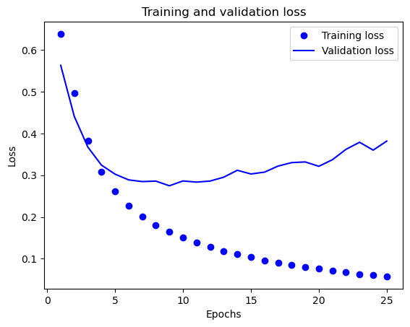1. Training loss and Validation loss.

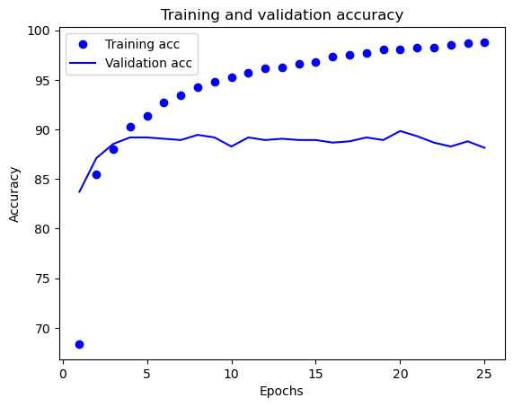2. Training and validation accuracy.

3. Test loss and accuracy.

Test loss: 0.469

Test Accuracy: 85.03

4. confusion_matrix

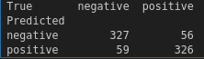

5. classification report

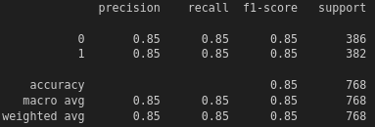

6. prediction result: this is a pretty awesome book -> positive

Task 1-1: update one-hot to term-frequency **only**

1. training loss and validation loss

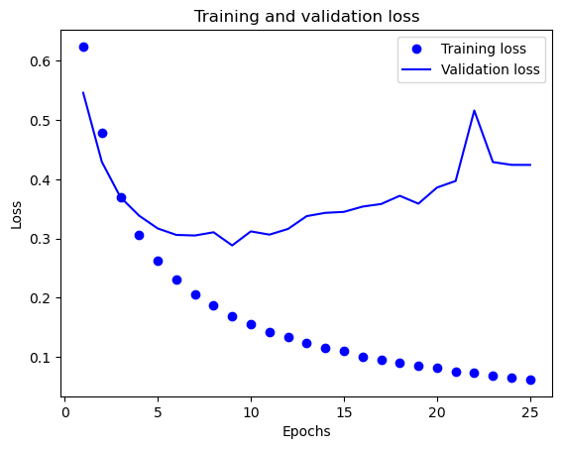

2. Training and validation accuracy.

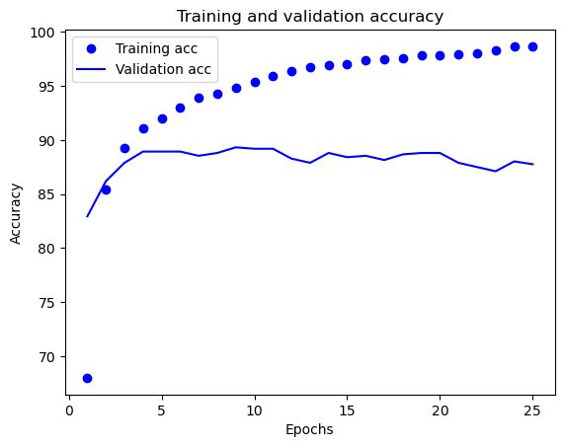

3. Test loss and accuracy.

Test loss: 0.482

Test Accuracy: 86.07

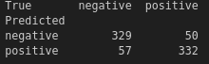4. confusion_matrix

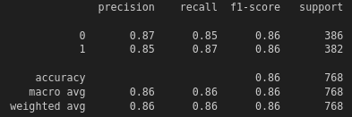5. classification report

6. prediction result: this is a pretty awesome book -> **positive**

Task 1-2 (1): add 1 additional hidden layer **only(equal dim=20)**

1. training loss and validation loss

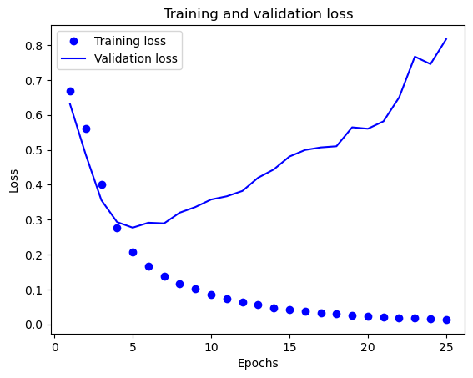

2. Training and validation accuracy.

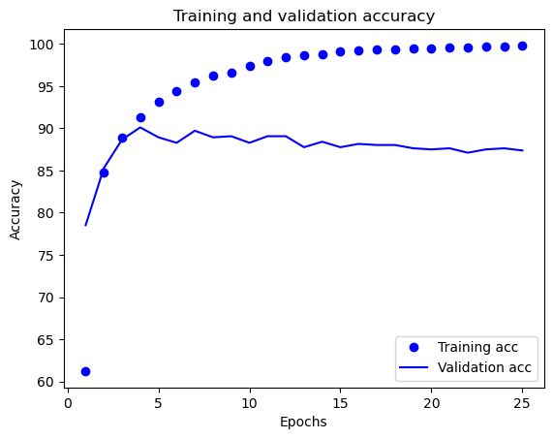

3. Test loss and accuracy.

Test loss: 0.887

Test Accuracy: 84.64

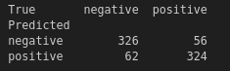4. confusion_matrix

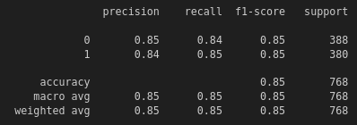5. classification report

6. prediction result: this is a pretty awesome book → **positive**

Task 1-2 (2): add 1 additional hidden layer **only (dim=10)**

1. training loss and validation loss

2. Training and validation accuracy.

3. Test loss and accuracy.

Test loss: 0.727

Test Accuracy: 85.16

4. confusion_matrix

5. classification report

6. prediction result: this is a pretty awesome book → **positive**

Task 1-2 (3): add 1 additional hidden layer **only (dim=40)**

1. training loss and validation loss

2. Training and validation accuracy.

3. Test loss and accuracy.

Test loss: 1.199

Test Accuracy: 83.59

4. confusion_matrix

5. classification report

6. prediction result: this is a pretty awesome book → **positive**

Task 1-3: change the frequency cutoff to 0 **only**

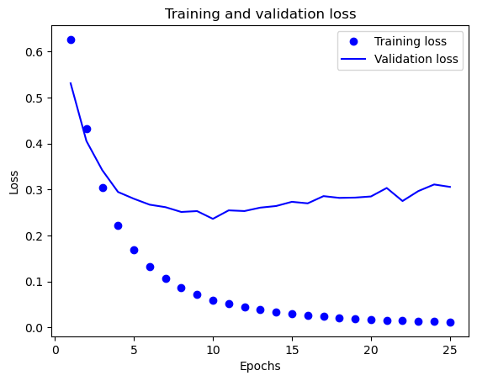1. training loss and validation loss

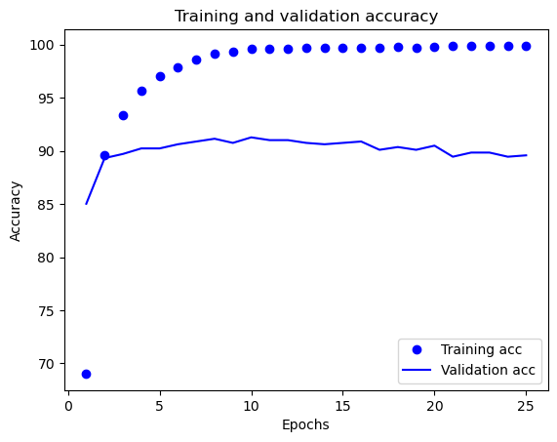2. Training and validation accuracy.

3. Test loss and accuracy.

Test loss: 0.314

Test Accuracy: 87.50

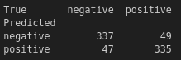4. confusion_matrix

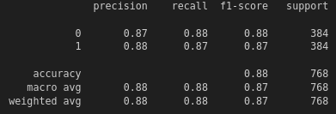5. classification report

6. prediction result: this is a pretty awesome book →**positive**

Task 1-4 (1): find **best combination** among of above approaches.

(one-hot to term-frequency. && add 1 additional hidden layer **dim=10**)

1. training loss and validation loss

2. Training and validation accuracy.

3. Test loss and accuracy.

Test loss: 0.754

Test Accuracy: 84.24

4. confusion_matrix

5. classification report

6. prediction result: this is a pretty awesome book → **positive**

Task 1-4 (2): find **best combination** among of above approaches.

(one-hot to term-frequency. && change the frequency cutoff to 0)

1. training loss and validation loss

2. Training and validation accuracy.

3. Test loss and accuracy.

Test loss: 0.338

Test Accuracy: 87.89

4. confusion_matrix

5. classification report

6. prediction result: this is a pretty awesome book → **positive**

Task 1-4 (3): find **best combination** among of above approaches.

(add 1 additional hidden layer **dim=10** && change the frequency cutoff to 0)

1. training loss and validation loss

2. Training and validation accuracy.

3. Test loss and accuracy.

Test loss: 0.417

Test Accuracy: 88.54

4. confusion_matrix

5. classification report

6. prediction result: this is a pretty awesome book → **positive**

Task 1-4 (3): find **best combination** among of above approaches.

(one-hot to term-frequency. && add 1 additional hidden layer **dim=10** && change the frequency cutoff to 0)

1. training loss and validation loss

2. Training and validation accuracy.

3. Test loss and accuracy.

Test loss: 0.462

Test Accuracy: 87.63

4. confusion_matrix

5. classification report

6. prediction result: this is a pretty awesome book → **positive**

Task 2-1:

1. training loss and validation loss

2. Training and validation accuracy.

3. Test loss and accuracy.

Test loss:

Test Accuracy:

4. confusion_matrix

5. classification report

6. prediction result: this is a pretty awesome book →

Task 2-2:

1. training loss and validation loss

2. Training and validation accuracy.

3. Test loss and accuracy.

Test loss:

Test Accuracy:

4. confusion_matrix

5. classification report

6. prediction result: this is a pretty awesome book →

Task 2-3:

1. training loss and validation loss

2. Training and validation accuracy.

3. Test loss and accuracy.

Test loss:

Test Accuracy:

4. confusion_matrix

5. classification report

6. prediction result: this is a pretty awesome book →