[Oracle 19c创建用户时出现“ORA-65096: invalid common user or role name”的错误](https://www.cnblogs.com/siyunianhua/p/4004361.html)

这篇文章主要介绍CDB和PDB的基本管理，资料来源oracle官方。

基本概念：

Multitenant Environment：多租户环境

CDB（Container Database）：数据库容器

PD（Pluggable Database）：可插拔数据库

CDB与PDB关系图

     COMMON USERS(普通用户)：经常建立在CDB层，用户名以C##或c##开头；  
  
     LOCAL USERS(本地用户)：仅建立在PDB层，建立的时候得指定CONTAINER。

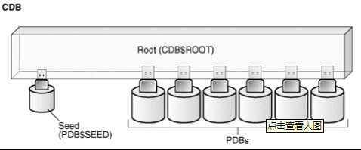

在oracle 12c中，使用了一个container(容器)的概念，让我们先看看官方的对它的介绍，为了保留最原始的意思，这里引用英文而不翻译了。

The data dictionary in each container in a CDB is separate, and the current container is the container whose data dictionary is used for name resolution and for privilege authorization. The current container can be the root or a PDB. Each session has exactly one current container at any point in time, but it is possible for a session to switch from one container to another.  
  
Each container has a unique ID and name in a CDB. You can use the CON_ID and CON_NAME parameters in the USERENV namespace to determine the current container ID and name with the SYS_CONTEXT function.

1、查看Oracle 12c的版本

SQL> select * from v$version;

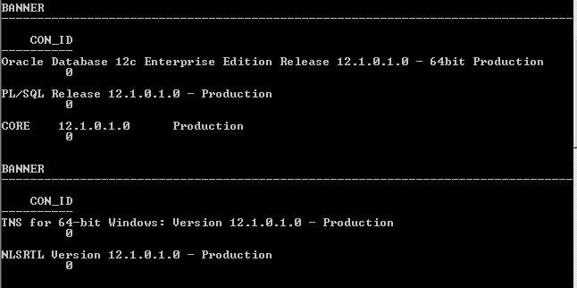

SQL>select sys_context ('USERENV', 'CON_NAME') from dual;   
SYS_CONTEXT('USERENV','CON_NAME')   
----------------------------------------------------------------------------------------------------  
 CDB$ROOT

2、我们可以通过ALTER SESSION SET CONTAINER 指定其他容器

SQL>select con_id,dbid,NAME,OPEN_MODE from v$pdbs;



3、将Pdb open：

SQL> alter pluggable database pdborcl open;



4、查看容器

SQL>select con_id,dbid,NAME,OPEN_MODE from v$pdbs;

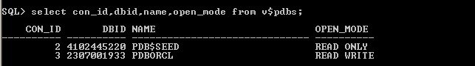

5、切换容器到pdb

SQL> alter session set container=PDBORCL;



6、查看当前使用容器

SQL>select sys_context ('USERENV', 'CON_NAME') from dual;

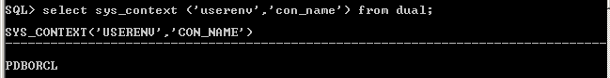

7、创建用户

SQL>create user informix identified by gmgl;

SQL>grant dba to informix;

