Director AI JSON Routing Stress Test
Integrated Technical Report
Gemini 3.1 Flash Lite proxy study for the retired Gemini 1.5 Flash benchmark brief
Prepared in English from the uploaded benchmark scripts and Word reports
19 March 2026
Primary reporting baseline | Baseline JSON (streaming, minimal), because it is the closest substitute for the original Gemini 1.5 Flash routing brief.
Best overall routing package | Compressed CSV + local JSON reconstruction: 87.04% routing accuracy and 93.75% state retention.
Latency outcome | No scenario met the <500 ms target. After normalization to API latency, p50 remained 1016-1325 ms across all runs.
Key interpretation | The gain from the compressed package is a compound effect of shorter instructions, relaxed MIME/output burden, shorter response strings, and local JSON reconstruction—not an isolated single-variable test.

Executive summary. The original task was to validate a Director AI router against four KPIs: format compliance, routing accuracy, state retention, and latency under 500 ms. Because Gemini 1.5 Flash is no longer available, all uploaded benchmarks were executed with Gemini 3.1 Flash Lite. This revised report preserves the previously compared scenarios and adds the newly uploaded compressed-output/local-reconstruction variant.

1. Scope and normalization rule
All scenarios evaluate the same routing space—chat, task, dev, and doc—over 324 requests (36 requests per subtest × 3 concurrency levels × 3 difficulty buckets: Simple, Complex/Interrupt, and Edge Case).
Latency normalization. At the user's request, every latency chart and table in this version uses API latency. For non-streaming runs, this is the reported end-to-end API latency. For streaming runs, the full-response latency is used as the API-latency equivalent so that all four scenarios are directly comparable.

2. Benchmark scenario matrix
Scenario | Mode | Thinking | Max output tokens | Output format | Local reconstruction
Baseline JSON (streaming, minimal) | Streaming | minimal | 96 | Native JSON | No
Control A (non-streaming, minimal) | Non-streaming | minimal | 100 | Native JSON | No
Control B (non-streaming, unrestricted) | Non-streaming | unrestricted | 1024 | Native JSON | No
Compressed CSV + local JSON (streaming, minimal) | Streaming | minimal | 30 | CSV short string | Yes
The new benchmark package adds an aggressive compression path: the Director system prompt was shortened, JSON MIME forcing was removed, the user wrapper was shortened to 'U:', and the model returned a very short CSV-like string such as 'c,1.0,0,0,hi'. The client then reconstructed standard JSON locally before passing it to the original scoring logic.

3. Overall KPI comparison
Scenario | Format compliance | Routing accuracy | State retention | API latency <500 ms | Total tokens
Baseline JSON (streaming, minimal) | 99.69% | 77.47% | 50.00% | 0.00% | 114,201
Control A (non-streaming, minimal) | 100.00% | 86.11% | 75.00% | 0.00% | 123,292
Control B (non-streaming, unrestricted) | 100.00% | 86.11% | 75.00% | 0.00% | 123,292
Compressed CSV + local JSON (streaming, minimal) | 100.00% | 87.04% | 93.75% | 0.00% | 50,970

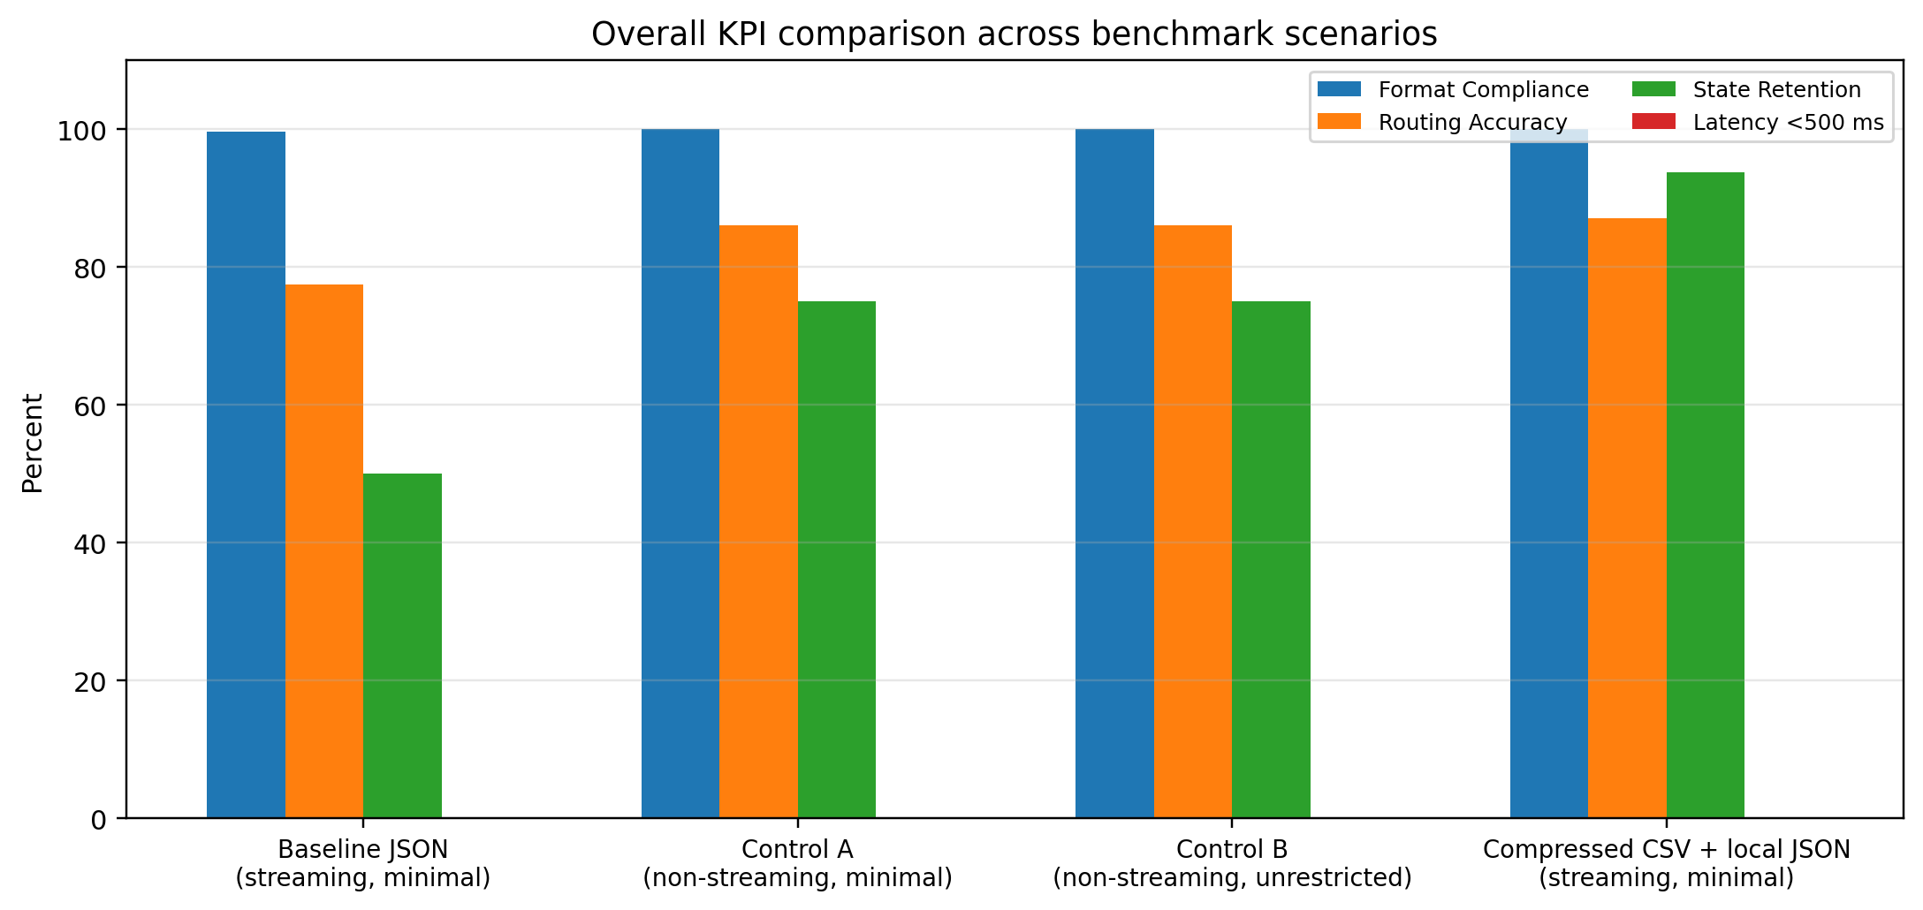
Figure 1. Overall KPI comparison across the four benchmark scenarios.
Interpretation. The original streaming baseline remained very strong as a formatter but weak as a robust router. The best overall package in the uploaded materials was the compressed local-reconstruction variant, which raised routing accuracy from 77.47% to 87.04% and state retention from 50.00% to 93.75%. Neither non-streaming control changed the latency-under-500 ms outcome: all four scenarios remained at 0.00%.

4. API latency and efficiency
Scenario | API p50 (ms) | API p95 (ms) | API latency <500 ms | Total tokens
Baseline JSON (streaming, minimal) | 1154.13 | 2055.67 | 0.00% | 114,201
Control A (non-streaming, minimal) | 1324.92 | 2199.77 | 0.00% | 123,292
Control B (non-streaming, unrestricted) | 1301.72 | 2038.27 | 0.00% | 123,292
Compressed CSV + local JSON (streaming, minimal) | 1016.04 | 1548.03 | 0.00% | 50,970

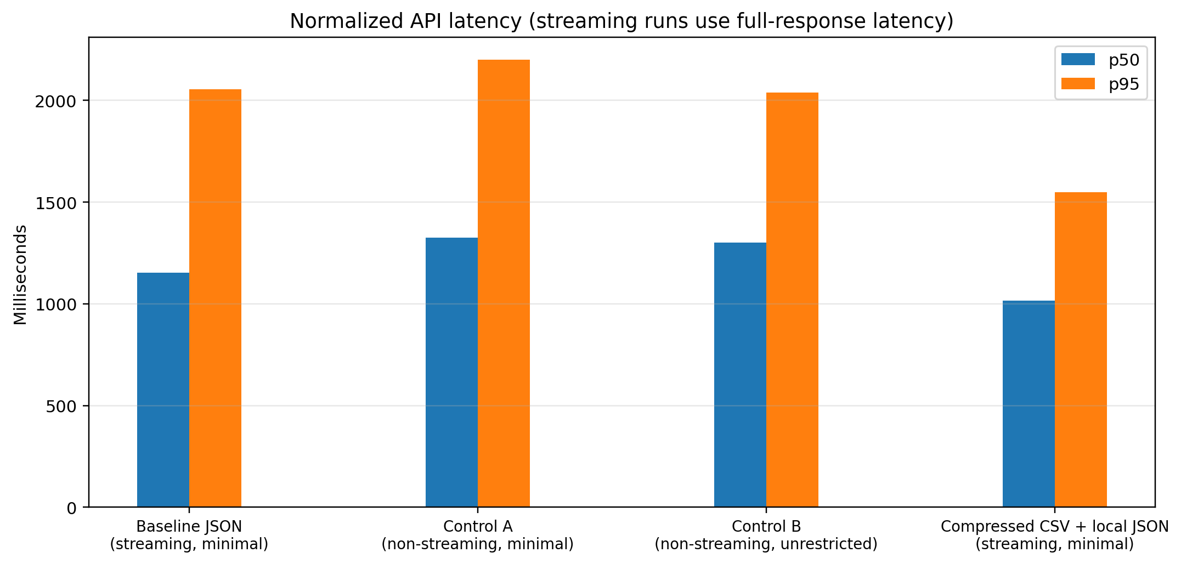
Figure 2. Normalized API latency comparison. Streaming runs use full-response latency to match non-streaming API latency.
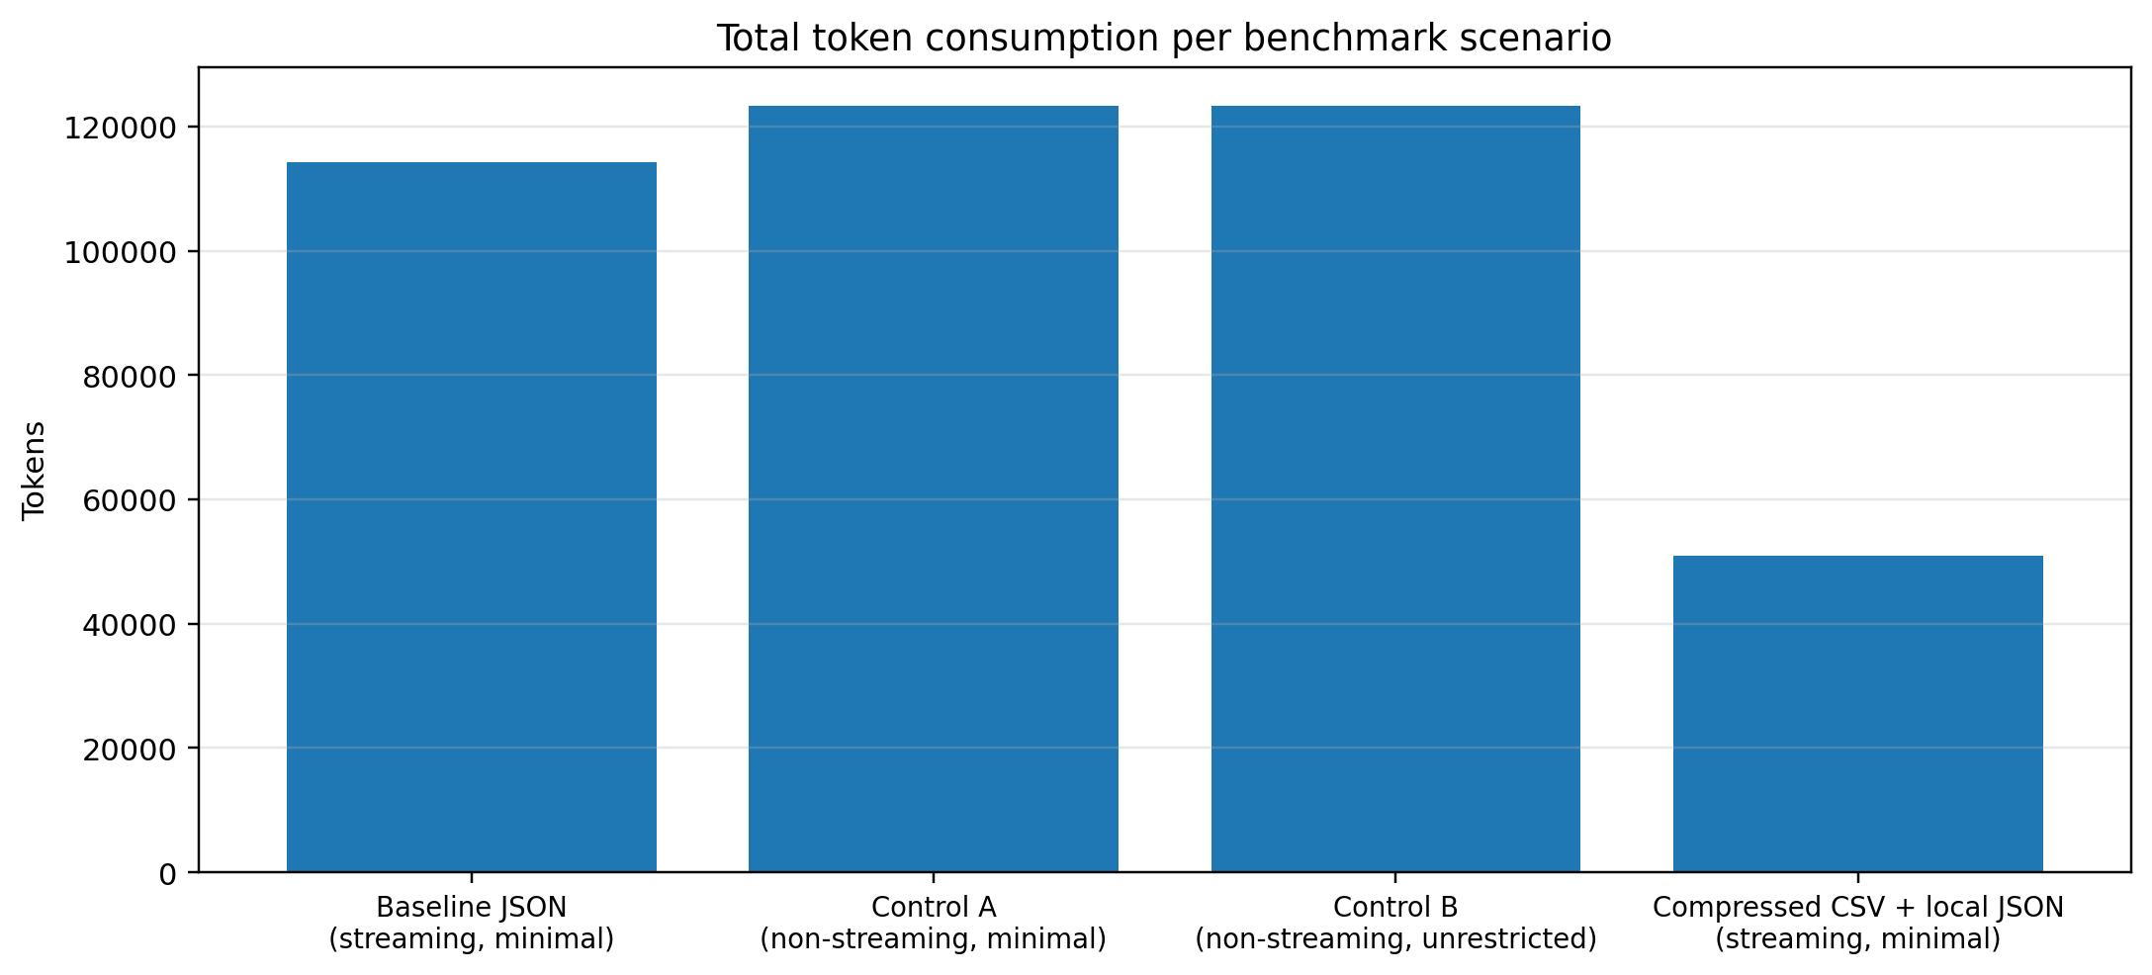
Figure 3. Total token consumption dropped sharply in the compressed-output/local-reconstruction package.
Baseline JSON → compressed local reconstruction | Observed delta
Format compliance | +0.31 pp
Routing accuracy | +9.57 pp
State retention | +43.75 pp
API latency p50 | -138.09 ms
API latency p95 | -507.64 ms
Total tokens | -63,231 (-55.4%)

Engineering note. The user-provided rationale is that standard JSON mode forces the model to emit full JSON syntax—braces, quotes, full key names, and schema-valid structure—whereas the compressed mode emits only a short comma-separated string. That mechanism is directionally consistent with the benchmark: the compressed package reduced token volume by 55.4%, improved the median API latency by 138.09 ms, and improved the p95 tail by 507.64 ms relative to the standard streaming baseline.

5. Difficulty-level behavior
Scenario | Simple | Complex/Interrupt | Edge Case | Best / worst pattern
Baseline JSON (streaming, minimal) | 99.07% | 66.67% | 66.67% | Best: Simple; worst: Complex/Interrupt
Control A (non-streaming, minimal) | 100.00% | 100.00% | 58.33% | Best: Simple; worst: Edge Case
Control B (non-streaming, unrestricted) | 100.00% | 100.00% | 58.33% | Best: Simple; worst: Edge Case
Compressed CSV + local JSON (streaming, minimal) | 86.11% | 83.33% | 91.67% | Best: Edge Case; worst: Complex/Interrupt

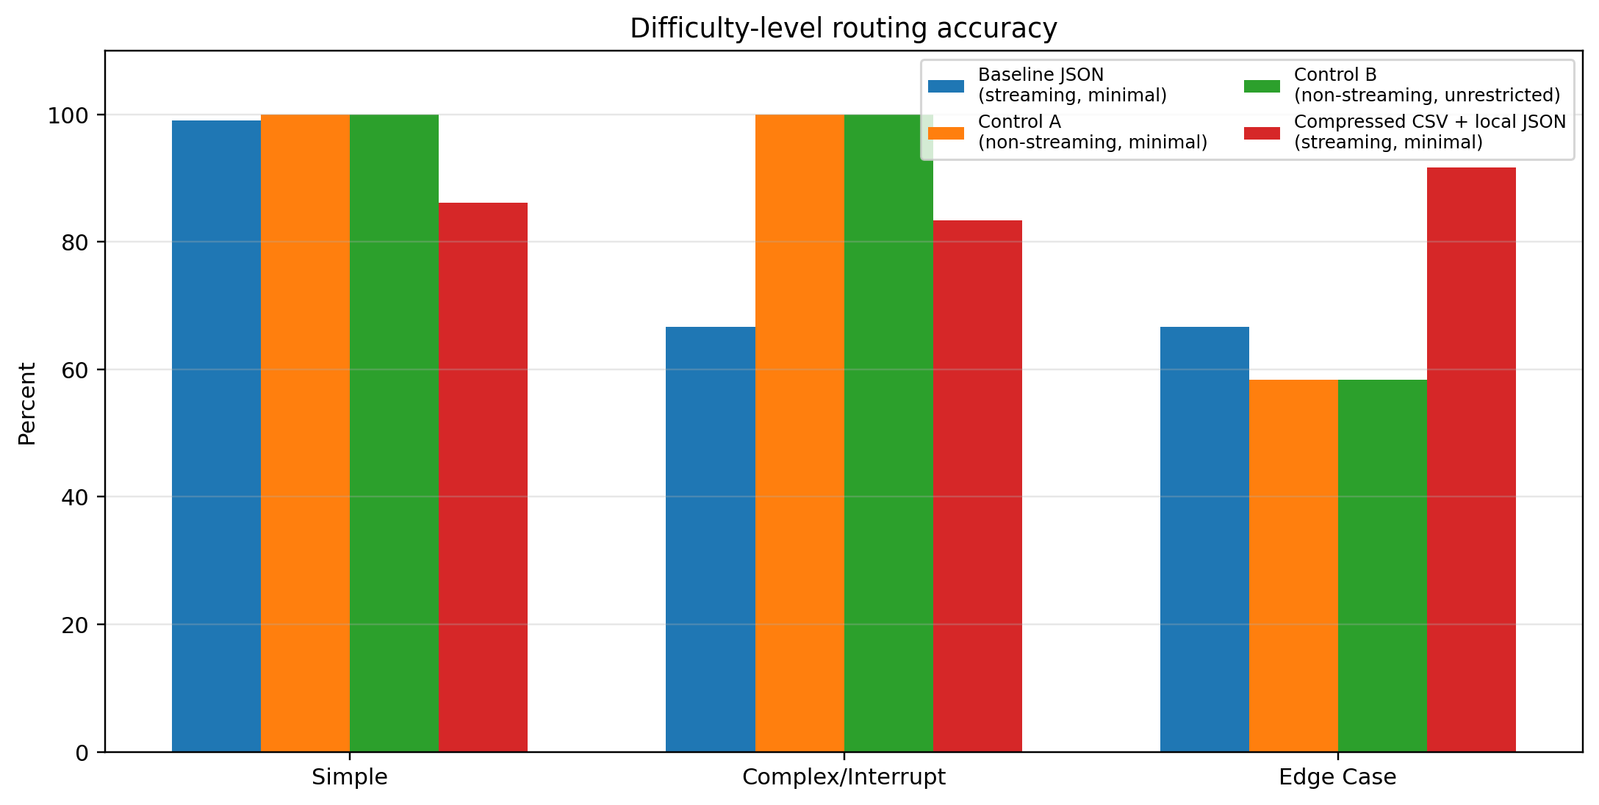
Figure 4. Difficulty-level routing accuracy by scenario.
The difficulty split reveals two distinct failure signatures. The baseline streaming JSON router was almost perfect on Simple prompts (99.07%) but collapsed on both Complex/Interrupt and Edge Case inputs (66.67% each). The two non-streaming control prompts solved most of the interruption-heavy workload (100.00% on Complex/Interrupt) but remained fragile on lexical ambiguity in Edge Case inputs (58.33%). The compressed local-reconstruction package was the most balanced profile: 86.11% on Simple, 83.33% on Complex/Interrupt, and 91.67% on Edge Case.

6. Why the compressed package improved
Design dimension | Standard JSON mode | Compressed local reconstruction mode
System instruction | Longer natural-language routing explanation and full JSON schema expectations. | Short symbolic mapping (c/t/v/d) with a minimal return format.
Response MIME | application/json; model is burdened with schema-valid JSON output. | text/plain; model returns a tiny CSV-like string and the client rebuilds JSON.
User wrapper | Verbose wrapper tags around the user message. | Very short wrapper (U:) to reduce input overhead.
Returned string | Full JSON object with braces, quotes, and key names. | Extremely short string such as "c,1.0,0,0,hi".
Downstream handoff | Model must produce the final machine-readable object. | Client reconstructs the final JSON locally before scoring/downstream use.

This optimization should be interpreted as a package effect rather than a pure output-length ablation. Four things changed together: the instruction surface was compressed, the response MIME constraint was relaxed, the wrapper around the user message was shortened, and the final JSON formatting was moved to the client. The uploaded run therefore supports a pragmatic engineering conclusion—'make the model emit less and let the client normalize the structure'—but it does not by itself prove which single sub-change contributed the most.

7. Conclusion for AO core validation
- Gemini 3.1 Flash Lite is a workable proxy for the retired Gemini 1.5 Flash validation task, but none of the uploaded scenarios met the latency-under-500 ms KPI.
- If the project needs the closest historical proxy, the baseline JSON streaming minimal run remains the best analogue to the original brief; however, it is not the best-performing package.
- If the project needs the strongest practical routing package from the uploaded experiments, the compressed CSV + local reconstruction variant is the current winner: it combines the best routing accuracy (87.04%), the best state retention (93.75%), the lowest token volume (50,970), and the best normalized latency among the four runs (p50 1016.04 ms, p95 1548.03 ms).
- The remaining technical gap is latency. The next iteration should focus on reducing request overhead and token generation further, while preserving the stronger instruction compression and client-side normalization pattern.

Appendix A. Source files used
Uploaded source | Purpose in this report
gemini-3.1-miniaml-Streaming requests.py / report.docx | Baseline streaming JSON scenario; proxy for the original Gemini 1.5 Flash brief.
genimi-3.1-miniaml.py / report.docx | Non-streaming minimal control.
gemini-3.1-unrestricted.py / report.docx | Non-streaming unrestricted control.
gemini-3.1-miniamal-json-local-combine.py / Report.docx | Compressed-output plus local-reconstruction scenario added in this revision.
The accompanying code bundle contains the four benchmark scripts exactly as provided in the workspace, packaged separately from this memo.

Appendix B. Scenario-by-concurrency operational summary
The table below preserves the per-concurrency operational view but uses API-latency normalization. For streaming scenarios, API latency is represented by full-response latency.
Scenario | Difficulty | Conc. | Route acc. | State retention | API p50 (ms) | API p95 (ms)
Baseline JSON (streaming, minimal) | Simple | 1 | 97.22% | N/A | 1097.32 | 6014.21
Baseline JSON (streaming, minimal) | Simple | 2 | 100.00% | N/A | 1058.42 | 1624.09
Baseline JSON (streaming, minimal) | Simple | 3 | 100.00% | N/A | 1069.49 | 1530.82
Baseline JSON (streaming, minimal) | Complex/Interrupt | 1 | 66.67% | 50.00% | 1204.95 | 3724.16
Baseline JSON (streaming, minimal) | Complex/Interrupt | 2 | 66.67% | 50.00% | 1210.51 | 1639.68
Baseline JSON (streaming, minimal) | Complex/Interrupt | 3 | 66.67% | 50.00% | 1302.31 | 2017.70
Baseline JSON (streaming, minimal) | Edge Case | 1 | 66.67% | 50.00% | 1186.38 | 1994.80
Baseline JSON (streaming, minimal) | Edge Case | 2 | 66.67% | 50.00% | 1177.76 | 2048.89
Baseline JSON (streaming, minimal) | Edge Case | 3 | 66.67% | 50.00% | 1186.92 | 1523.94
Control A (non-streaming, minimal) | Simple | 1 | 100.00% | N/A | 1333.40 | 1739.03
Control A (non-streaming, minimal) | Simple | 2 | 100.00% | N/A | 1290.29 | 3216.60
Control A (non-streaming, minimal) | Simple | 3 | 100.00% | N/A | 1420.13 | 2788.30
Control A (non-streaming, minimal) | Complex/Interrupt | 1 | 100.00% | 100.00% | 1343.90 | 1906.85
Control A (non-streaming, minimal) | Complex/Interrupt | 2 | 100.00% | 100.00% | 1297.05 | 1662.49
Control A (non-streaming, minimal) | Complex/Interrupt | 3 | 100.00% | 100.00% | 1352.34 | 12185.79
Control A (non-streaming, minimal) | Edge Case | 1 | 58.33% | 50.00% | 1347.50 | 2743.68
Control A (non-streaming, minimal) | Edge Case | 2 | 58.33% | 50.00% | 1213.13 | 1790.79
Control A (non-streaming, minimal) | Edge Case | 3 | 58.33% | 50.00% | 1311.30 | 1681.69
Control B (non-streaming, unrestricted) | Simple | 1 | 100.00% | N/A | 1207.34 | 1923.50
Control B (non-streaming, unrestricted) | Simple | 2 | 100.00% | N/A | 1290.47 | 1909.13
Control B (non-streaming, unrestricted) | Simple | 3 | 100.00% | N/A | 1355.48 | 2509.58
Control B (non-streaming, unrestricted) | Complex/Interrupt | 1 | 100.00% | 100.00% | 1265.40 | 1770.09
Control B (non-streaming, unrestricted) | Complex/Interrupt | 2 | 100.00% | 100.00% | 1239.58 | 1850.01
Control B (non-streaming, unrestricted) | Complex/Interrupt | 3 | 100.00% | 100.00% | 1327.37 | 1934.43
Control B (non-streaming, unrestricted) | Edge Case | 1 | 58.33% | 50.00% | 1358.39 | 2128.73
Control B (non-streaming, unrestricted) | Edge Case | 2 | 58.33% | 50.00% | 1313.18 | 2145.54
Control B (non-streaming, unrestricted) | Edge Case | 3 | 58.33% | 50.00% | 1434.79 | 1998.52
Compressed CSV + local JSON (streaming, minimal) | Simple | 1 | 86.11% | N/A | 938.82 | 1163.49
Compressed CSV + local JSON (streaming, minimal) | Simple | 2 | 86.11% | N/A | 962.19 | 1210.25
Compressed CSV + local JSON (streaming, minimal) | Simple | 3 | 86.11% | N/A | 930.54 | 1261.84
Compressed CSV + local JSON (streaming, minimal) | Complex/Interrupt | 1 | 83.33% | 87.50% | 1002.34 | 1261.10
Compressed CSV + local JSON (streaming, minimal) | Complex/Interrupt | 2 | 83.33% | 87.50% | 1135.91 | 1567.56
Compressed CSV + local JSON (streaming, minimal) | Complex/Interrupt | 3 | 83.33% | 87.50% | 1042.20 | 1701.37
Compressed CSV + local JSON (streaming, minimal) | Edge Case | 1 | 91.67% | 100.00% | 1011.67 | 1461.84
Compressed CSV + local JSON (streaming, minimal) | Edge Case | 2 | 91.67% | 100.00% | 1164.22 | 2213.67
Compressed CSV + local JSON (streaming, minimal) | Edge Case | 3 | 91.67% | 100.00% | 1148.30 | 1436.21

Appendix C. Scenario-specific notes
Baseline JSON (streaming, minimal). This is the closest proxy to the original Gemini 1.5 Flash JSON-routing brief. Its strength is near-perfect format compliance and very high Simple-case routing, but it is fragile under interruptions and ambiguous lexical mixtures.
Control A (non-streaming, minimal). This control mainly demonstrates that harder routing rules can recover Complex/Interrupt behavior, but the benefit is offset by severe Edge Case ambiguity and no latency win.
Control B (non-streaming, unrestricted). This run confirms that simply allowing more reasoning/output budget does not materially outperform the compute-limited control under the uploaded workload.
Compressed CSV + local JSON (streaming, minimal). This is the most promising engineering direction. It combines instruction compression, shorter outputs, MIME relaxation, and client-side normalization, producing the best practical quality/latency trade-off in the uploaded materials.

