**Tutorial – how to use Kinect with Unity**

**Requirements:**

1. Make sure, that you have installed the Unity Kinect Wrapper. (download [here](http://wiki.etc.cmu.edu/unity3d/index.php/Microsoft_Kinect_-_Microsoft_SDK#Integrating_with_Unity))
2. 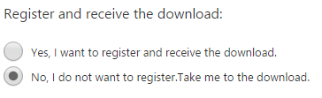Use the Kinect for Windows Runtime v1.8. (download [here](http://www.microsoft.com/en-us/download/confirmation.aspx?id=40277))
3. Use also the Kinect for Windows SDK v1.8
   1. download [here](https://www.microsoft.com/en-us/download/details.aspx?id=40278)
   2. Click “continue”
   3. You don’t need to register (figure 1)

figure register for download

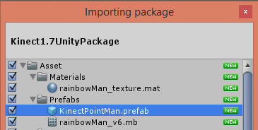**how to use Kinect with Unity:**

figure import package

1. open unity
2. import the Unity Package of wrapper in Unity
   1. Assets > import package > custom package > *‘file’*
3. Use the emulator
   1. select ‘KinectPrefab’
4. add a mask for both hands
   1. go to Assets > Script > Kinect > KinectModelControllers
   2. open KinectPointController.cs

figure add mask

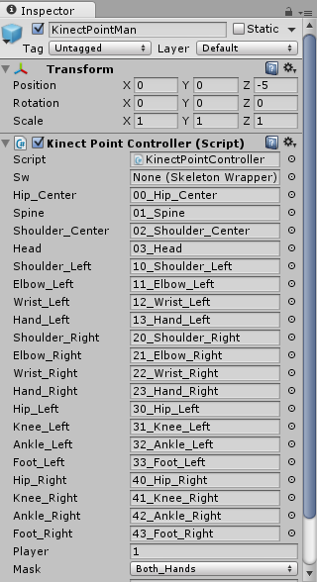

**…**

* 1. add your mask in “public enum BoneMask”
     1. e.g. for both hands: Both_Hands = Left_Hand | Right_Hand

1. select your mask
   1. choose your mask (figure 3)