**Tutorial – how to use Kinect with Unity**

**Requirements:**

1. Make sure, that you have installed the Unity Kinect Wrapper. (download [here](http://wiki.etc.cmu.edu/unity3d/index.php/Microsoft_Kinect_-_Microsoft_SDK#Integrating_with_Unity))
2. Use the Kinect for Windows Runtime v1.8. (download [here](http://www.microsoft.com/en-us/download/confirmation.aspx?id=40277))
3. Use also the Kinect for Windows SDK v1.8
   1. 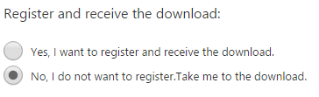download [here](https://www.microsoft.com/en-us/download/details.aspx?id=40278)
   2. Click “continue”
   3. You don’t need to register (figure 1)

figure 1 register for download

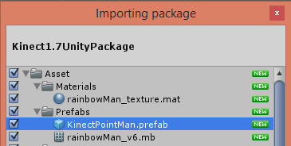**How to use Kinect with Unity:**

1. open unity

figure 2 import package

1. import the Unity Package of wrapper in Unity
   1. Assets > import package > custom package > ‘file’
2. If you want to use a real Kinect (< v 2.0)
   1. Setup Kinect (figure 3)
      1. Check if Use Emulator is unchecked in Kinect Preftab
      2. Check if Kinect Sensor Script is enabled
      3. The Sensor Height is the height of the physical Kinect above the ground
3. If you want to use the emulator:
   1. Check: Use the emulator is checked in ‘Kinect Preftab’ (figure 3)
   2. 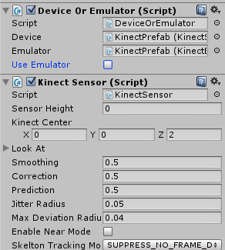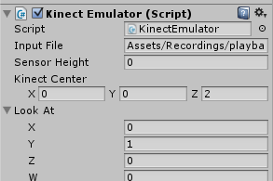Then you have to select a recording, do this in the Emulator Settings (see figure 4) 🡪 Input File … Filepath to the recording (if you don’t have a recording see point 5)

figure 3 kinect sensor setting

figure 4 emulator settings

1. if you don’t have a recording you need a real Kinect 1 sensor and active the recorder script
   1. 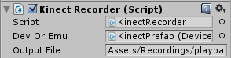Activate the recorder script (figure 5)

figure 5 recorder setting

* 1. Connect the Kinect with your Computer
  2. Run a Scene including (KinectPreftab, Kinect Point Main, Main Camera, and a Light)
     1. Now you should see a skeleton with joints
     2. Press F10 to start recording and F10 again to stop it
  3. In the status you now see that a recording file is stored, you can now use this in the emulator

1. If you need a special mask for just showing some defined Points, add a mask for both hands
   1. go to Assets > Script > Kinect > KinectModelControllers
   2. open KinectPointController.cs
   3. add your mask in “public enum BoneMask”
      1. e.g. for both hands: Both_Hands = Left_Hand | Right_Hand
2. select your mask

figure 6 add mask

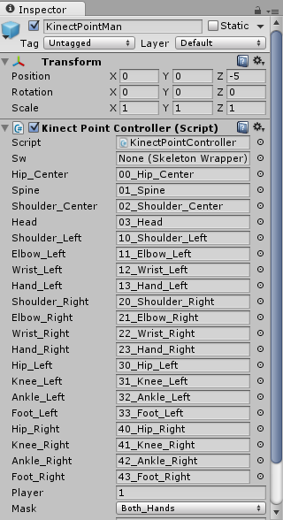

* 1. choose your mask (figure 6)

1. When you now press play, you should see just the selected Points, in this case booth hands (figure 7)

**…**

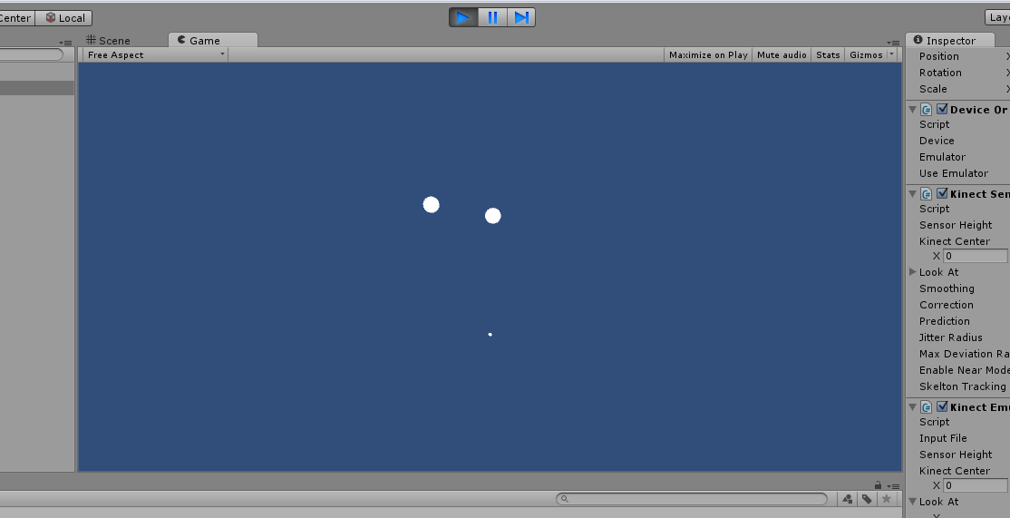

figure 7 result

**…**

**Caveats and Stuff**

* Sometimes there are problems with the real Kinect. This will result in a the following failure:
  + NuiInitialize Failed. UnityEngine.Debug:Log(Object)KinectSensor:Awake() (at Assets/Script/Kinect/KinectWrapper/KinectSensor.cs:147)
  + (Also show in the status bar: NuiInitialize failed, Left bottom corner of unity)
  + If this occurs just reopen unity. Most of the times we get this error when a other app is connecting with the Kinect.
* If the playback of the recording didn’t work – check the input file path of the emulator script