### Architecture

This diagram illustrates the architecture of Prometheus and some of its ecosystem components:

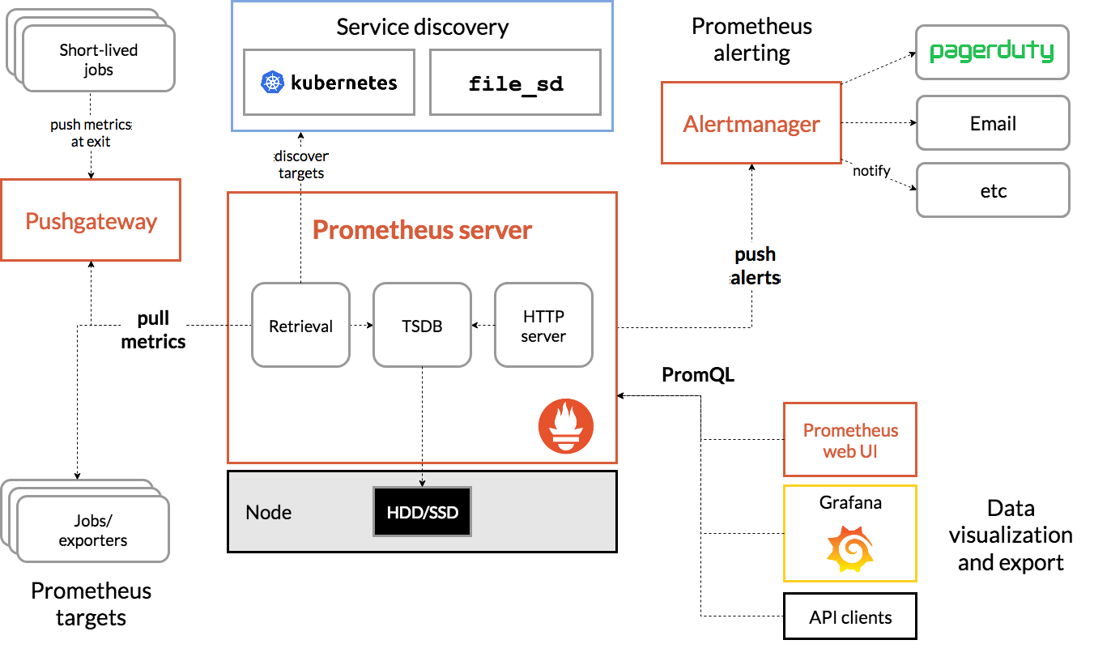

Prometheus scrapes metrics from instrumented jobs, either directly or via an intermediary push gateway for short-lived jobs. It stores all scraped samples locally and runs rules over this data to either aggregate and record new time series from existing data or generate alerts. [Grafana](https://grafana.com/) or other API consumers can be used to visualize the collected data.

### What are metrics?

In layperson terms, metrics are numeric measurements. Time series means that changes are recorded over time. What users want to measure differs from application to application. For a web server it might be request times, for a database it might be number of active connections or number of active queries etc.

Metrics play an important role in understanding why your application is working in a certain way. Let's assume you are running a web application and find that the application is slow. You will need some information to find out what is happening with your application. For example the application can become slow when the number of requests are high. If you have the request count metric you can spot the reason and increase the number of servers to handle the load.

Metrics noun [ plural ] /ˈmetrɪks/ U a set of numbers that give information about a particular process or activity

Metre noun UK (US meter) /ˈmiː.tər/ (MEASUREMENT) [ C ] (written abbreviation m) a unit of measurement equal to 100 centimetres

（长度单位）米

Millisecond noun [ C ] /ˈmɪl.ɪˌsek.ənd/ (written abbreviation ms); (msec.) a unit of time equal to 0.001 seconds

毫秒（时间单位，＝1／1000秒）