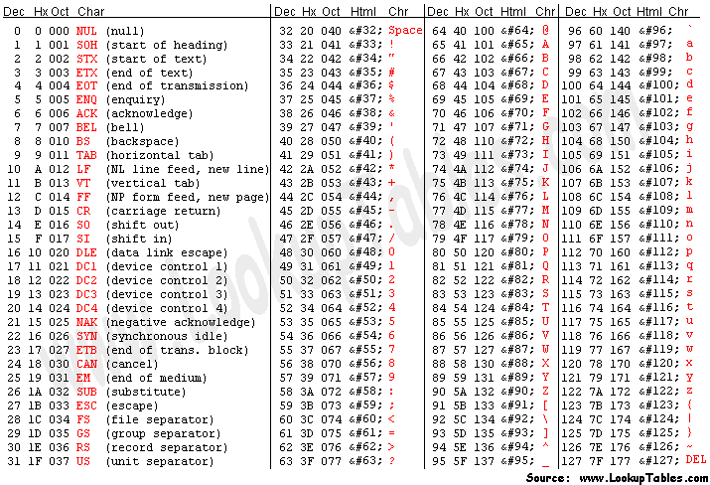

import java.util.HashMap;

import java.util.Map;

public class RandomValue2 {

public static String base = "abcdefghijklmnopqrstuvwxyz0123456789";

private static String firstName="赵钱孙李";

private static String girl="秀娟英";

private static String boy="伟刚勇";

private static String[] road="重庆大厦,黑龙江路,十梅庵街".split(",");

private static String[] email_suffix="@gmail.com,@yahoo.com,@msn.com".split(",");

public static int getNum(int start,int end) {

return (int)(Math.random()*(end-start+1)+start);

}

public static String getEmail(int lMin,int lMax) {

int length=getNum(lMin,lMax);

StringBuffer sb = new StringBuffer();

for (int i = 0; i < length; i++) {

int number = (int)(Math.random()*base.length());

sb.append(base.charAt(number));

}

sb.append(email_suffix[(int)(Math.random()*email_suffix.length)]);

return sb.toString();

}

private static String[] telFirst="134,135,136".split(",");

public static String getTel() {

int index=getNum(0,telFirst.length-1);

String first=telFirst[index];

String second=String.valueOf(getNum(1,888)+10000).substring(1);

String third=String.valueOf(getNum(1,9100)+10000).substring(1);

return first+second+third;

}

private static String name_sex = "";

private static String getChineseName() {

int index=getNum(0, firstName.length()-1);

String first=firstName.substring(index, index+1);

int sex=getNum(0,1);

String str=boy;

int length=boy.length();

if(sex==0){

str=girl;

length=girl.length();

name_sex = "女";

}else {

name_sex="男";

}

index=getNum(0,length-1);

String second=str.substring(index, index+1);

int hasThird=getNum(0,1);

String third="";

if(hasThird==1){

index=getNum(0,length-1);

third=str.substring(index, index+1);

}

return first+second+third;

}

private static String getRoad() {

int index=getNum(0,road.length-1);

String first=road[index];

String second=String.valueOf(getNum(11,150))+"号";

String third="-"+getNum(1,20)+"-"+getNum(1,10);

return first+second+third;

}

public static Map getAddress() {

Map map=new HashMap();

map.put("name", getChineseName());

map.put("sex", name_sex);

map.put("road", getRoad());

map.put("tel", getTel());

map.put("email", getEmail(6,9));

return map;

}

}

public class CsvDataExporter01 {

public static void main(String[] args) throws IOException {

// 数量 默认100

int amount = 100;

File file = new File("data.csv");

BufferedWriter bufferedWriter = new BufferedWriter(new FileWriter(file));

String csvHead = "客户号,姓名,手机号码,固话,邮箱,openid,regId,企业微信\n";

bufferedWriter.write(csvHead);

for (int i = 0; i < amount; i++) {

String phoneNumber = getPhoneNumber();

String line = String.format(",%s,%s,,,,,\n", "张三", phoneNumber);

bufferedWriter.write(line);

}

bufferedWriter.close();

}

private static HashSet<String> phoneNumbers = new HashSet<>();

private static String getPhoneNumber() {

String number = null;

while (true) {

number = RandomValue.getTel();

if (phoneNumbers.contains(number)) {

continue;

}

phoneNumbers.add(number);

break;

}

return number;

}

}