**Table 16.1 Storage Engines Feature Summary**

| **Feature** | **MyISAM** | **Memory** | **InnoDB** | **Archive** | **NDB** |
| --- | --- | --- | --- | --- | --- |
| **B-tree indexes** | Yes | Yes | Yes | No | No |
| **Backup/point-in-time recovery (note 1)** | Yes | Yes | Yes | Yes | Yes |
| **Cluster database support** | No | No | No | No | Yes |
| **Clustered indexes** | No | No | Yes | No | No |
| **Compressed data** | Yes (note 2) | No | Yes | Yes | No |
| **Data caches** | No | N/A | Yes | No | Yes |
| **Encrypted data** | Yes (note 3) | Yes (note 3) | Yes (note 4) | Yes (note 3) | Yes (note 3) |
| **Foreign key support** | No | No | Yes | No | Yes (note 5) |
| **Full-text search indexes** | Yes | No | Yes (note 6) | No | No |
| **Geospatial data type support** | Yes | No | Yes | Yes | Yes |
| **Geospatial indexing support** | Yes | No | Yes (note 7) | No | No |
| **Hash indexes** | No | Yes | No (note 8) | No | Yes |
| **Index caches** | Yes | N/A | Yes | No | Yes |
| **Locking granularity** | Table | Table | Row | Row | Row |
| **MVCC** | No | No | Yes | No | No |
| **Replication support (note 1)** | Yes | Limited (note 9) | Yes | Yes | Yes |
| **Storage limits** | 256TB | RAM | 64TB | None | 384EB |
| **T-tree indexes** | No | No | No | No | Yes |
| **Transactions** | No | No | Yes | No | Yes |
| **Update statistics for data dictionary** | Yes | Yes | Yes | Yes | Yes |

***Notes:***

1. Implemented in the server, rather than in the storage engine.

2. Compressed MyISAM tables are supported only when using the compressed row format. Tables using the compressed row format with MyISAM are read only.

3. Implemented in the server via encryption functions.

4. Implemented in the server via encryption functions; In MySQL 5.7 and later, data-at-rest encryption is supported.

5. Support for foreign keys is available in MySQL Cluster NDB 7.3 and later.

6. Support for FULLTEXT indexes is available in MySQL 5.6 and later.

7. Support for geospatial indexing is available in MySQL 5.7 and later.

8. InnoDB utilizes hash indexes internally for its Adaptive Hash Index feature.

9. See the discussion later in this section.

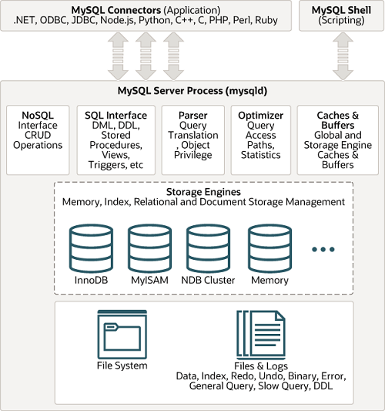

Microsoft Open Database Connectivity (ODBC)

Procedure /prəˈsiː.dʒər/ a set of instructions in a computer program that does a particular task（计算机的）应用程序

privilege /ˈprɪv.əl.ɪdʒ/ an advantage that only one person or group of people has, usually because of their position or because they are rich（特定个体或群体的）特权，特别待遇

engine /ˈen.dʒɪn/a machine that uses the energy from liquid fuel or steam to produce movement发动机；引擎

optimize /ˈɒp.tɪ.maɪz/ to make something as good as possible使优化，完善

statistic /stəˈtɪs.tɪk/

foreign /ˈfɒr.ən/ belonging or connected to a country that is not your own外国的

MyISAM is based on ISAM (Indexed Sequential Access Method), an indexing algorithm developed by IBM

(有索引的顺序访问方法)

InnoDB由Innobase Oy公司所开发 ，2006年五月时由甲骨文公司并购。

The MySQL NDB engine dates back to the 1990s when it was first developed as the Network DataBase (NDB) by Mikael Ronström (who is still a MySQL Cluster developer) while he was with Ericsson.

[root@centos /root]# rsync -h

rsync is a file transfer program capable of efficient remote update via a fast differencing algorithm.

Usage: rsync [OPTION]... SRC [SRC]... DEST

or rsync [OPTION]... SRC [SRC]... [USER@]HOST:DEST

or rsync [OPTION]... SRC [SRC]... [USER@]HOST::DEST

or rsync [OPTION]... SRC [SRC]... rsync://[USER@]HOST[:PORT]/DEST

or rsync [OPTION]... [USER@]HOST:SRC [DEST]

or rsync [OPTION]... [USER@]HOST::SRC [DEST]

or rsync [OPTION]... rsync://[USER@]HOST[:PORT]/SRC [DEST]

Options

-v, --verbose increase verbosity

-a, --archive archive mode; equals -rlptgoD (no -H,-A,-X)

-r, --recursive recurse into directories

-l, --links copy symlinks as symlinks

-p, --perms preserve permissions

-o, --owner preserve owner (super-user only)

-g, --group preserve group

-t, --times preserve modification times

-n, --dry-run perform a trial run with no changes made

--exclude=PATTERN exclude files matching PATTERN

Use "rsync --daemon --help" to see the daemon-mode command-line options.

See http://rsync.samba.org/ for updates, bug reports, and answers