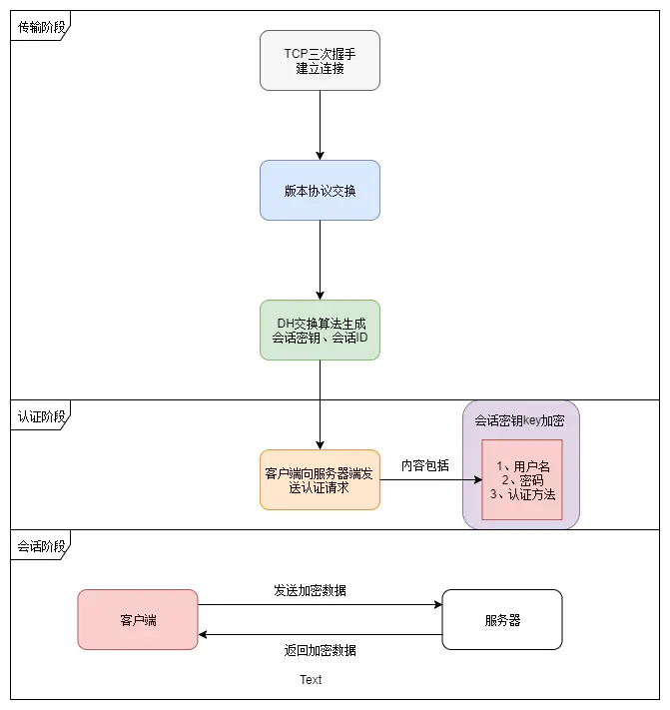

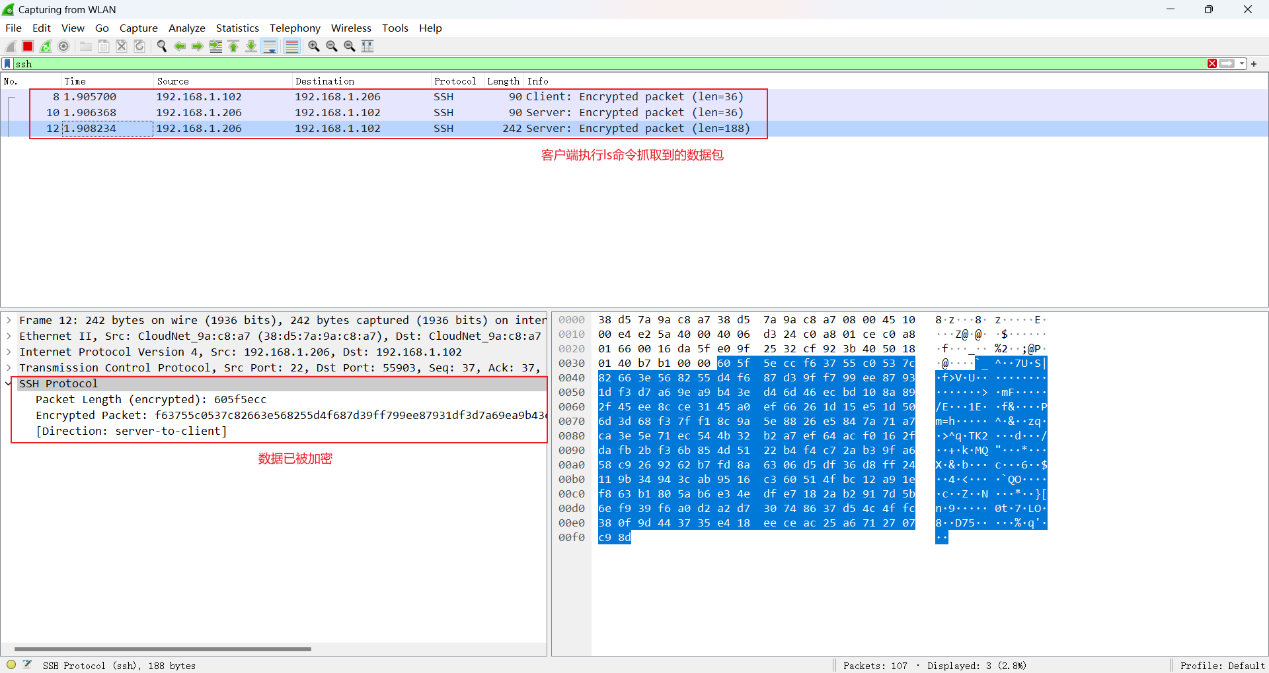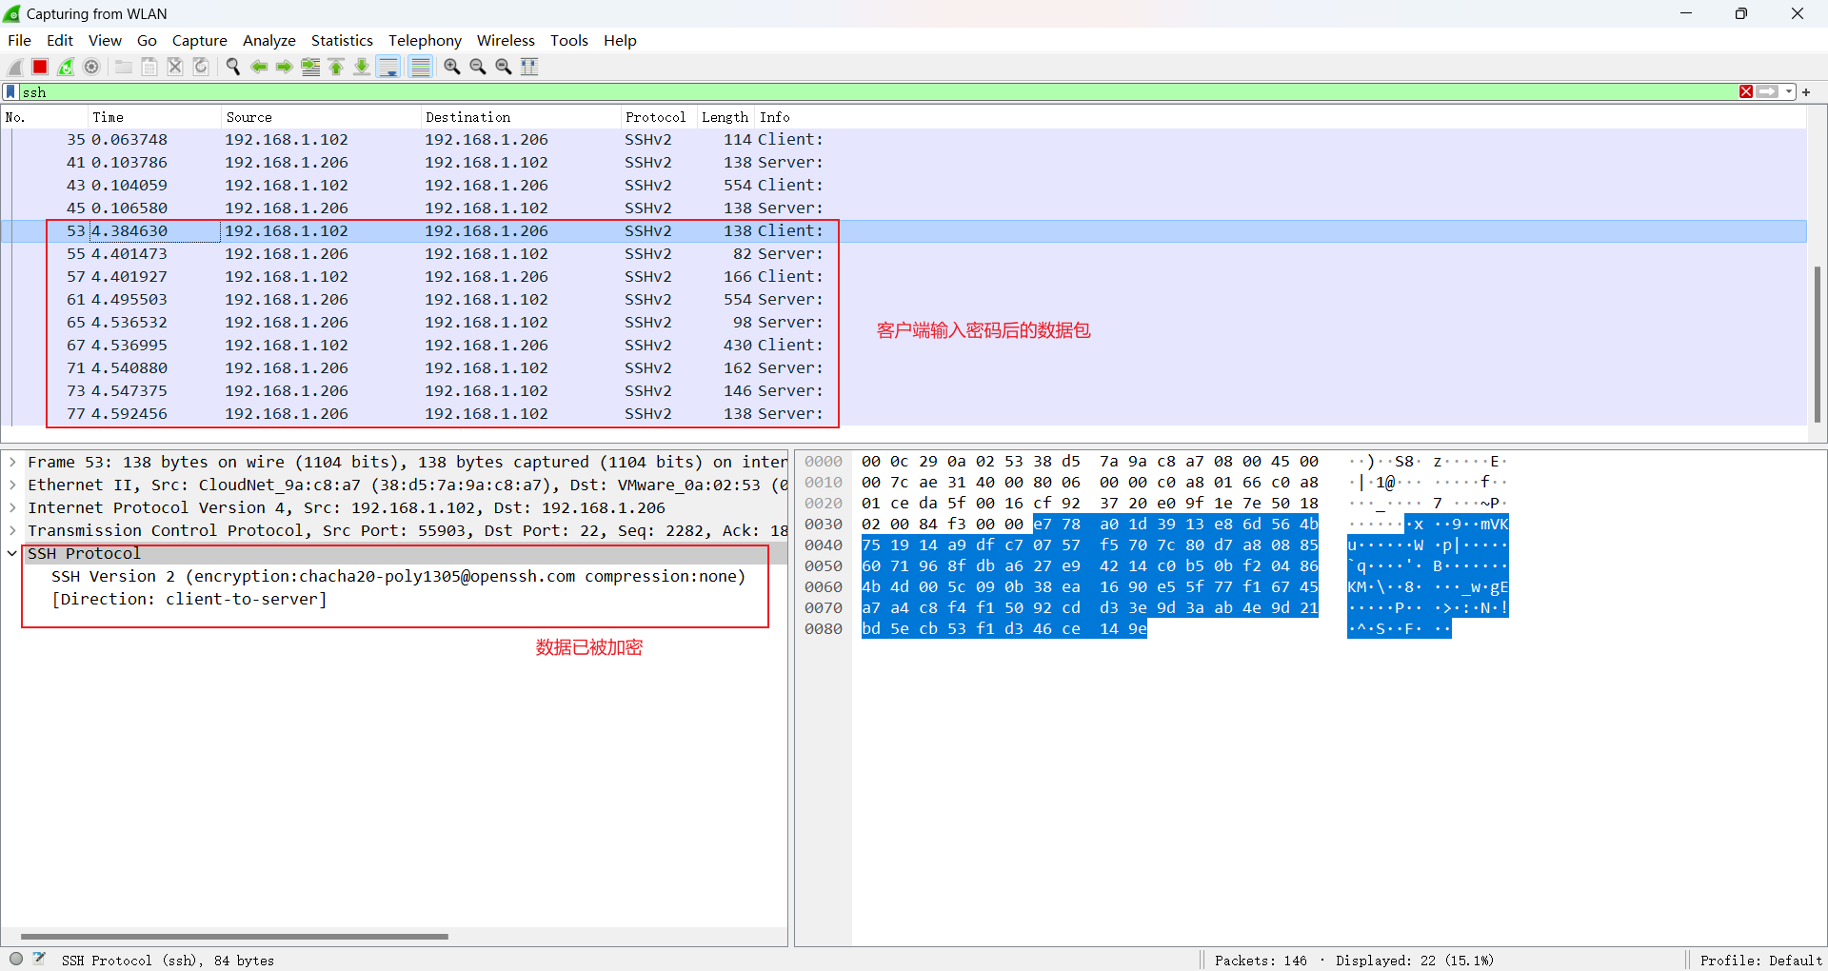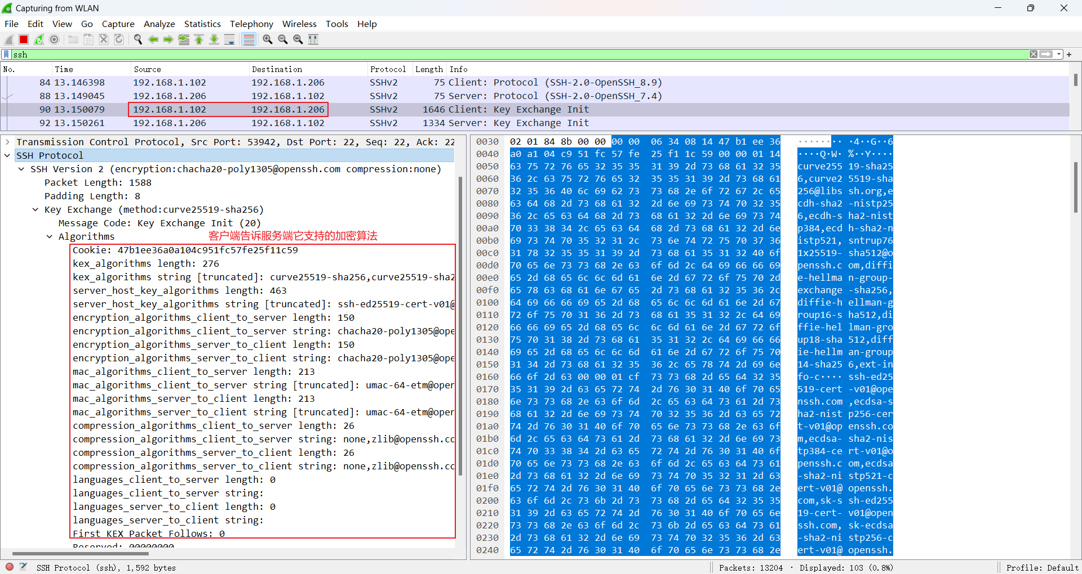

# SSHv2  
  
RFC 4250 https://www.rfc-editor.org/rfc/rfc4250 Protocol Assigned Numbers 协议编号定义   
RFC 4251 https://www.rfc-editor.org/rfc/rfc4251 Protocol Architecture 协议架构   
RFC 4252 https://www.rfc-editor.org/rfc/rfc4252 Authentication Protocol 认证协议   
RFC 4253 https://www.rfc-editor.org/rfc/rfc4253 Transport Layer Protocol 传输层协议

RFC 4254 https://www.rfc-editor.org/rfc/rfc4254 Connection Protocol 连接协议   
RFC 5655 https://www.rfc-editor.org/rfc/rfc4255 Using DNS to Securely Publish Secure Shell (SSH) Key Fingerprints   
RFC 5656 https://www.rfc-editor.org/rfc/rfc4256 Generic Message Exchange Authentication 通用消息交换认证 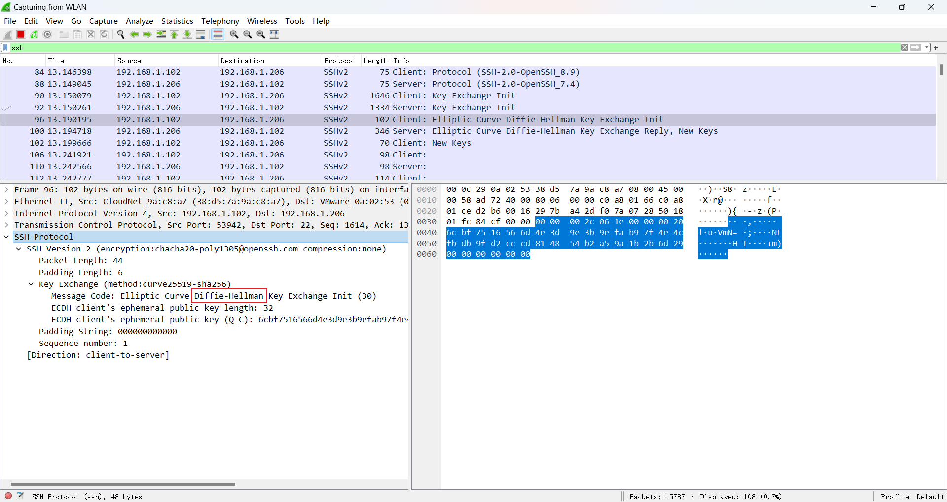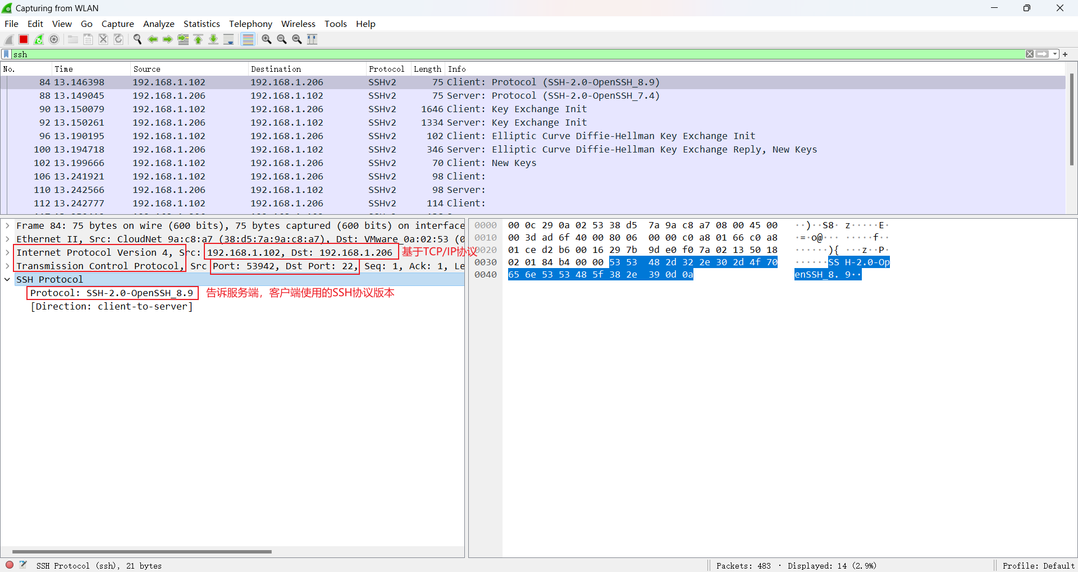

## SSH 两种级别的安全认证

基于口令的安全认证 账号密码  
基于密匙的安全认证 公钥/私钥