<https://blog.csdn.net/qq_26761587/article/details/73691189>

关于使用spring mvc时出现 HTTP Status 400 - Required String parameter 'xx' is not present

post传数组解决方式

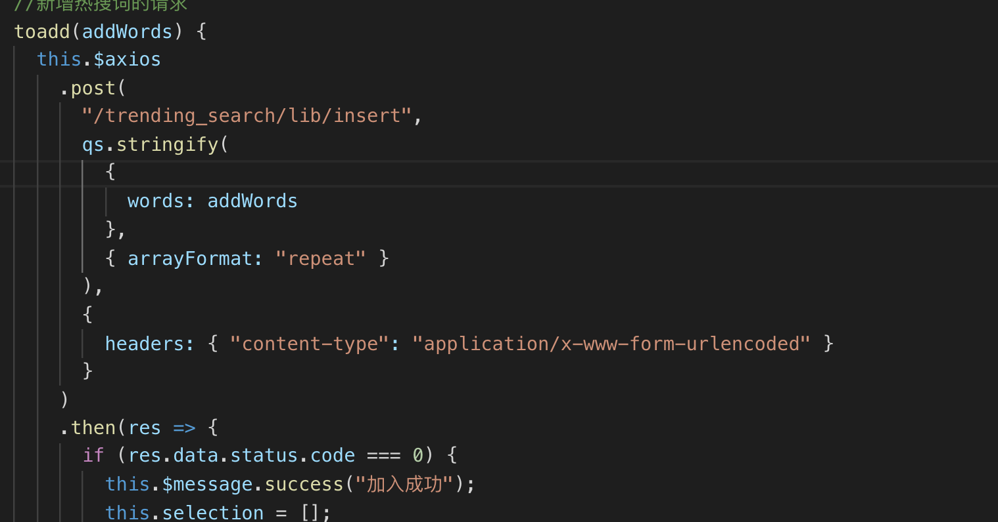

qs.stringify(

{

words: addWords

},

{ arrayFormat: "repeat" }

),

{

headers: { "content-type": "application/x-www-form-urlencoded" }

}

get方式传数组

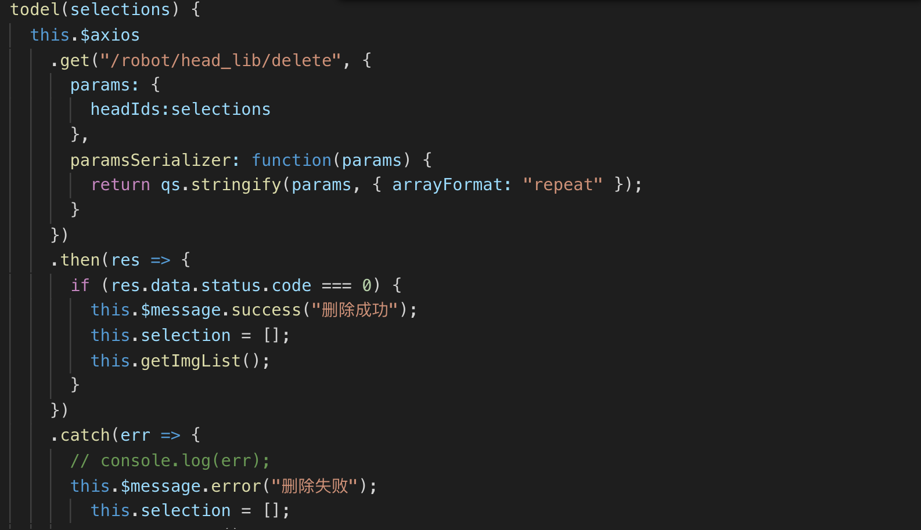

this.$axios

.get("/robot/head_lib/delete", {

params: {

headIds:selections

},

paramsSerializer: function(params) {

return qs.stringify(params, { arrayFormat: "repeat" });

}

})