get方式传递数组

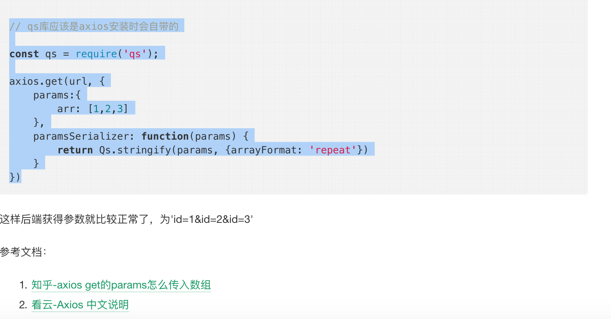

// qs库应该是axios安装时会自带的

const qs = require('qs');

axios.get(url, {

params:{

arr: [1,2,3]

},

paramsSerializer: function(params) {

return Qs.stringify(params, {arrayFormat: 'repeat'})

}

})

1. <https://www.zhihu.com/question/272032105>
2. <https://www.kancloud.cn/yunye/axios/234845>