
Available online at www.sciencedirect.com


ScienceDirect

Procedia Computer Science 110 (2017) 410–415

The 12th International Conference on Future Networks and Communications (FNC-2017)

Modern and Responsive Mobile-enabled Web Applications

Farrukh Shahzad^{a,}
ªPolestar Global, Houston, TX, USA 77082

Abstract

Rapid web technology improvements in the last few years have powered software developers to quickly write responsive mobile-friendly applications. The innovative web frameworks and libraries make it easy to have same software code base for desktop and mobile devices. Single-page applications oﬀer a more-native-app-like experience to the user. This also means a web application can easily be converted to a native mobile application if desired. This allows software products to be evolved continuously at a much faster pace with features added on daily basis. The software companies who can adopt these technologies will most likely see the benefit in the long run as they can oﬀer new and modified products faster than their competitors.

In this paper, we review some of the state-of-the-art web technologies, third-party libraries, and frameworks for quick interactive web development. Finally, we present a simple interactive browser-based, mobile friendly web application which was developed using one of the latest web development framework.

© 2017 The Authors. Published by Elsevier B.V.
Peer-review under responsibility of the Conference Program Chairs.

Keywords: Web-based Applications; JavaScript; Web Framework, Mobile-friendly Application, Single-Page Applications

1. Introduction

In the last few years, several web technology innovations have allowed software designers and engineers to quickly develop responsive mobile-friendly applications. These improvements include web frameworks and libraries which allow quick and user-friendly application development for desktop and mobile devices. In fact, it is quite common to have single code base for an application which functions on the desktop and mobile devices (like smart phones and tablets). The successful software companies will adopt these technologies quickly to stay ahead of their competitors by oﬀering new and modified products at a much faster rate.

The content of a web page are described by HyperText Markup Language (HTML). HTML5 evolves from HTML and includes new attributes and behaviors. Apart from HTML5, the building blocks for most of the modern browser-based applications include JavaScript (JS) and Cascading Style Sheets (CSS3).

Single-Page Applications (SPAs) are web-based applications which load a single HTML page and dynamically update the page content as the user interacts with the application through menus and side bars. These applications oﬀer a more-native-app-like experience to the user. Fluid and responsive web applications are created, without constant

Corresponding author. Tel.: +1-713-261-7494. E-mail address: farrukh.shahzad@polestarglobal.com

1877-0509 © 2017 The Authors. Published by Elsevier B.V. Peer-review under responsibility of the Conference Program Chairs. 10.1016/j.procs.2017.06.105
Farrukh Shahzad / Procedia Computer Science 110 (2017) 410–415 | 411

page reloads, using AJAX (Asynchronous JavaScript and XML) technology, which communicate with server-side scripts to receive as well as send information in a variety of formats (usually from/to a persistent storage like database). The applications that uses basic functions of persistent storage namely Create, Read, Update, Delete (CRUD) are called CRUD applications. CRUD are the basic operations to be done in a data repository.

In one of our previous works¹, we reviewed some state-of-the-art web technologies, third-party libraries and frame-works that can be utilized to fulfill the promise of interactive browser based custom visualization applications. These libraries uses client-based technologies for appending and manipulating Scalable Vector Graphics (SVG) elements, which is supported in almost all modern browsers, smart phones and tablets.

Shaikh et. al.² presented some state-of-the-art web based tools and libraries for client-side browser-based visu-alization. They introduced a novel web-based network visualizer and simulator application which utilizes HTML, JavaScript and Bootstrap.

Some of the contribution of this work includes brief description of latest tools and frameworks which are backbone of modern web applications and a simple description of the architecture of a modern web application.
The rest of this paper is organized as follow. In section 2, we provide some background related to modern web development and list some latest framework and libraries. We provide modern web application architecture in section 3. We present an example application in section 4. The conclusion of our work is provided in the last section.

2. Latest Web Framework and Libraries

In this section, we review some of the JavaScript libraries which are designed for modern browsers and smart devices. These libraries exploited the advancement in HTML5, CSS3 and JavaScript and provide an Application Programming Interface (API) for developer to create web-based mobile-friendly applications. Lightweight frame-works add structure to a web application and oﬀer a way to handle navigation between diﬀerent views, and typically split the application into layers implementing the Model-View-Controller (MVC) design pattern. These libraries and frameworks are developed using pure JavaScript, so users get interactivity without requiring round-trips to servers and without any additional plugins.

- jQuery is a popular JavaScript library³. jQuery helps in finding and manipulating the Document Object Model (DOM) elements, processing browser events, and dealing with browser incompatibilities. jQuery is an extensi-ble library, and thousands of plugins have been created by developers from around the world.
- AngularJS is a toolset for building the framework most suited to application development. It is fully extensible and works well with other libraries. Every feature can be modified or replaced to suit unique development workflow and feature needs⁴. AngularJS is often used for creating single-page applications, where only certain portions of the page (sub-views) are updated as a result of the user‘s actions or data being sent from the server. Other features include tw-way data-binding, reusable components, deep linking, built-in services for backend communication and localization support. Mobile Angular is another User Interface (UI) framework that is built on AngularJS and Bootstrap for mobile-friendly application development.

- Angular Angular 2 (or just Angular) is an open source JavaScript framework maintained by Google. It is an evolution of its popular predecessor, AngularJS. Apart from JavaScript, Angular applications can be developed in Dart, or TypeScript⁵. The framework makes it simpler to create custom components that can be added to HTML documents and to implement application logic. Angular uses data binding extensively, includes a dependency injection module, supports modularization, and oﬀers a routing mechanism. Whereas AngularJS was MVC-based, Angular is not. This framework doesnt include UI components.

- Bootstrap is the most popular HTML, CSS, and JS framework for developing responsive, mobile first projects on the web⁶. It is an open source library of UI components developed by Twitter. The components are built using the responsive web design principles, which makes this library extremely valuable for web applications that needs to automatically adjust its layout depending on the screen resolution.

- Google‘s Material Design libraries is a new library of UI components called Material Design, which may become an alternative to Bootstrap. Material Design is optimized for cross-device use and comes with a set of nice-looking UI components⁷. Material Design is a unified system that combines theory, resources, and tools for crafting digital experiences.
412 Farrukh Shahzad / Procedia Computer Science 110 (2017) 410–415

  - React is an open source library by Facebook for building user interfaces⁸. It‘s non-intrusive and can be used with any other library or a framework. React creates its own virtual DOM object, minimizing access to browser‘s DOM, which results in better performance. For content rendering, React introduces the JSX format, which is a JavaScript syntax extension that looks like XML. Using JSX is recommended but optional.

  - Node.js (or Node) is a framework or a library, as well as is a runtime environment⁹. This framework can be used to develop JavaScript programs that run outside the browser. The Node.js framework includes an API to work with the filesystem, access databases, listen to HTTP requests, and more.

  - Jasmine is an open source framework for testing JavaScript code¹⁰. It includes a set of functions that test whether certain parts of your application behave as expected. Jasmine is often used with Karma, which is a test runner that allows you to run tests in diﬀerent browsers.

- Modern Web application architecture

Fig. 1a depicts a modern web application architecture. Ideally, no data is read from the DOM but application

outputs HTML and perform element operations as needed. No data is stored in random objects or in the DOM. A set of models represent all the data in the application. Views receive change notifications (via events) from models and handle redrawing as appropriate. Views utilizes template to render information as per user interface design. Model also reads and writes from/to storage (usually a database) using AJAX and server-side scripts. These scripts are written in server-side dynamic languages like PHP or ASP.

Fig. 1b shows architecture of a typical AngularJS application. Controllers are written in JavaScript and are the behavior behind the DOM elements.. This makes it easy to test, maintain, reuse code. Services are also written JavaScript and access data or information from model via AJAX requests (server communication). Views are usually HTML-based (including any CSS) and receives information from model via controller (as is or after some post-processing). Data-binding is an automatic way of updating the view whenever the model changes, as well as updating the model whenever the view changes. Views/template also provide client-side form validation. AngularJS lets developer declare the validation rules of the form without having to write JavaScript code. Models provide reads and writes access to persistent storage, like a database, and written in some server-side scripting language (like PHP).
Single Page Applications (SPA) have more complex state transitions than a server-side applications because there are:

- DOM events that cause small state changes in views,

- model events when model values are changed,
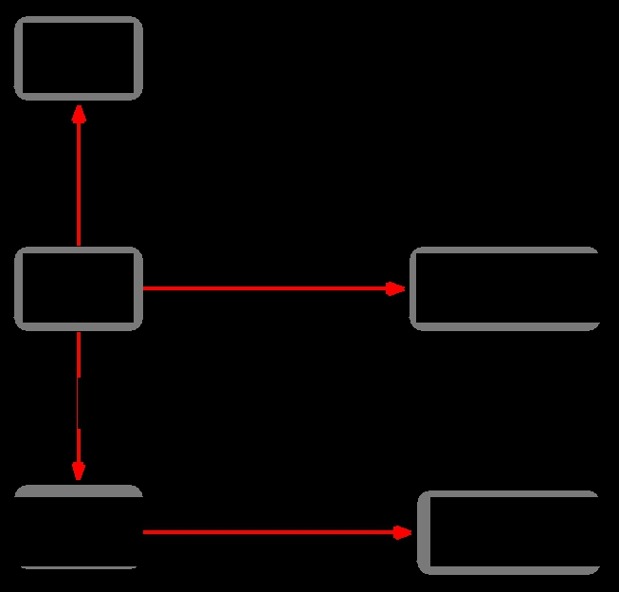

DOM
 |  | Controllers
View | Template | Model | Services | Model
 |  | (scope) | Services | Model
 |  | Views
Model | Storage | Client |  | Server
 | (a) Modern web application architecture |  | (b) A typical AngularJS application architecture.
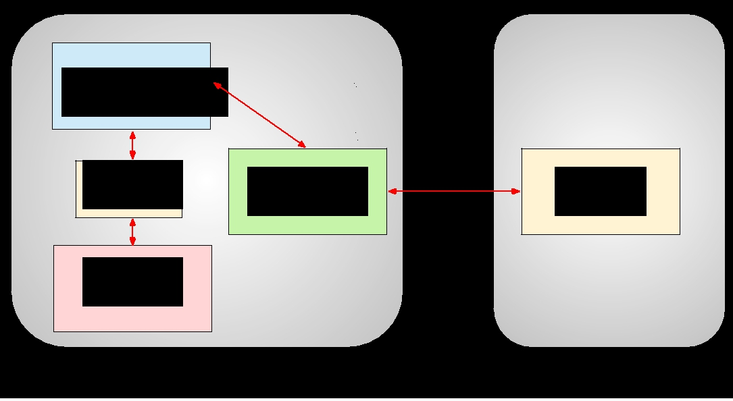

Fig. 1: Application architecture for a modern web applications

Farrukh Shahzad / Procedia Computer Science 110 (2017) 410–415 | 413

- application state changes that cause views to be swapped,

- global state changes,

- delayed results from backend CRUD operations via AJAX.

One of the advantages of using development frameworks is that the above issues are handled or notified seamlessly by the framework and software developer stay focus on the actual business logic and user interface design.

4. An Example

We have utilized the technologies and libraries introduced in previous section and developed few custom applica-tions. We will present one of the interactive application which was designed and developed in a week.

Family Harmony Maps is an interactive; color-based; diagnostic parenting method which allows Parents and/or a Family to fill out age-appropriate need maps to be used as input for analysis and scoring. The method was converted into an online tool which analyses the input data, computes a parenting score and provides family-specific and gender-specific harmony maps to serve as direct indicators of how harmonious the relationship between parents and their children is. The parenting score and family harmony scores are calculated by comparing the the user-entered maps with an ideal parenting map.

User/Parent choose a color (Green, yellow, red by repeat clicking on the box) that best describes parenting style (under five diﬀerent attributes) during each of their child(ren) specific age periods. The parent entry-map is shown in Fig. 2a and corresponding options are shown as legends (Fig. 2b). Similar entry-maps are available for children to fill (a separate map for boys and girls). The maps have six(6) rows corresponding to six age groups and five(5) columns corresponding to five attributes describing important parenting aspects.

A sample of final user-filled entry-maps for parent and children are shown Fig. 3a. These maps are entered by a parent and their children (separate maps for girls and boys). These maps are compared with an ideal map to compute the parents and children’s harmony scores and corresponding harmony maps are calculated and displayed as output. A sample computed family harmony maps for parent and children are shown Fig. 3b. The corresponding legends are shown in Fig. 2c.

The data submitted by diﬀerent families regardless of their country of origin, religion or ethnicity is then collected and stored in a database for further processing and analysis. A number of parameters are evaluated to assess the harmony of a family or a group of families within a community as a function of parents’ and children’s country of residence, age, ethnicity and religion to draw certain parenting themes, trends and styles.
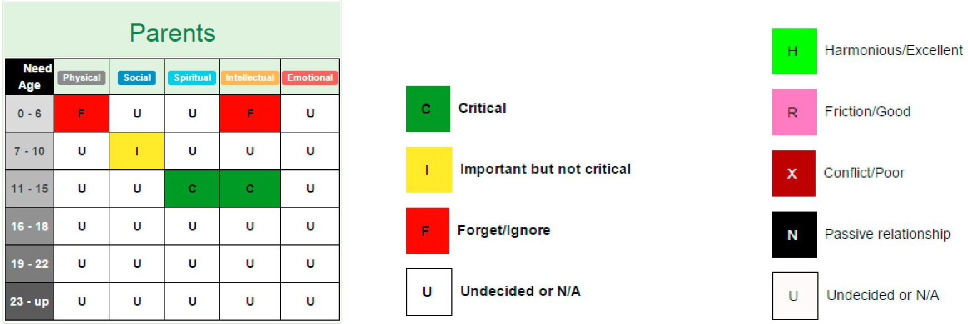

(a) Parent map (b) User selectable map options (c) Harmony maps legends

Fig. 2: User inputs data by clicking on each box of a map

414 Farrukh Shahzad / Procedia Computer Science 110 (2017) 410–415
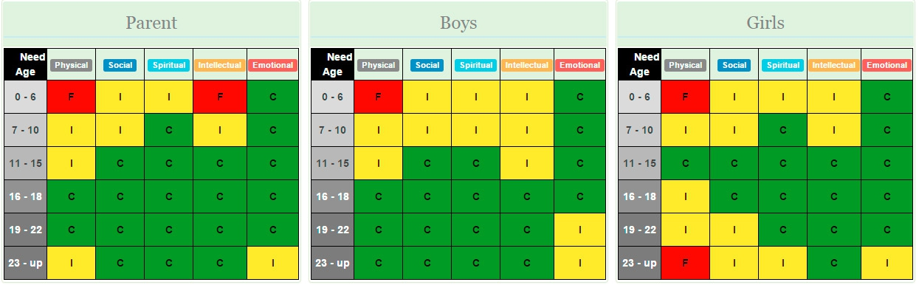

(a) User filled maps
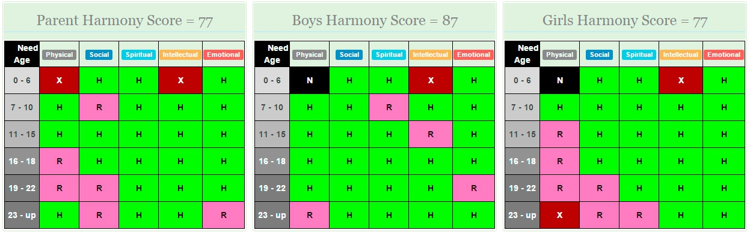

(b) Family Harmony Maps

Fig. 3: User-entered and final computed harmony maps.

Conclusion

We presented and compared some of the latest framework, web-based tools and libraries available for mobile-friendly responsive browser-based applications. We also introduced an interactive and lightweight web-based single-page social application. We believe that the successful software companies will adopt these technologies quickly to stay ahead of their competitors. The innovative web frameworks and libraries allow software products to be evolved continuously.

As future work, we will continue building on the presented and other applications to improve user friendliness and performance. The use of presented development framework allow fast turn around time and new features will be easier to implement.

References

- Shahzad, F., Sheltami, T.R., Shakshuki, E.M., Shaikh, O.. A Review of Latest Web Tools and Libraries for State-of-the-art Visualiza-tion. Procedia Computer Science 2016;98:100–106. URL: http://linkinghub.elsevier.com/retrieve/pii/S187705091632138X. doi:10.1016/j.procs.2016.09.017.

- Shaikh, O., Shahzad, F.. Visual-netsim: Development of an interactive browser based network simulator. In: 2016 Future Technologies

Conference (FTC). IEEE. ISBN 978-1-5090-4171-8; 2016, p. 718–724. URL: http://ieeexplore.ieee.org/document/7821684/. doi:10.1109/FTC.2016.7821684.

- jQuery: The Write Less, Do More, JavaScript Library. ???? URL: https://jquery.com/.

- AngularJS: Superheroic JavaScript MVW Framework. ????. URL: https://angularjs.org/.
Farrukh Shahzad / Procedia Computer Science 110 (2017) 410–415 | 415

- Angular: One framework. Mobile & desktop. ????. URL: https://angular.io/.

- Bootstrap: The world’s most popular mobile-first and responsive front-end framework. ???? URL: http://getbootstrap.com/.

- Google‘s Material Design libraries. ???? URL: https://design.google.com/resources/.

- React: A JavaScript Library for Building User Interfaces. 2017. URL: https://facebook.github.io/react/.

- Node.js: A JavaScript runtime. ???? URL: https://nodejs.org.

- Jasmine: A behavior-driven development framework. ???? URL: https://jasmine.github.io/.

