mac搭建phpstudy环境

<https://www.jianshu.com/p/f4fd87fea61c?utm_campaign=maleskine&utm_content=note&utm_medium=seo_notes&utm_source=recommendation>

网址

**站点域名管理**

**<https://blog.csdn.net/qq_33962835/article/details/79772257> 参考地址**

1.进入apache的安装目录

cd /private/etc/apache2

找到httpd.conf

输入httpd-vhosta.conf找到站点目录配置文件，去掉前边的#号注释

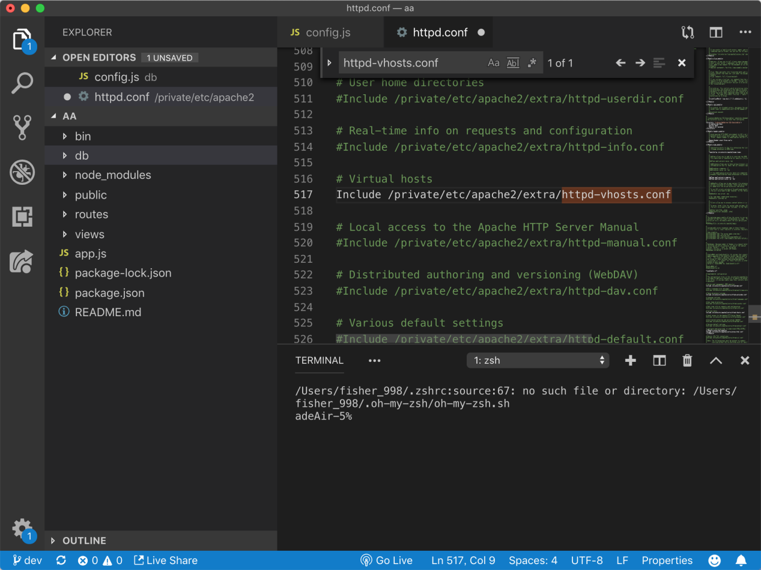

1. 进入开启的虚拟主机文件httpd-vhosts.conf进行域名配置，位置：/private/etc/apache2/extra目录下

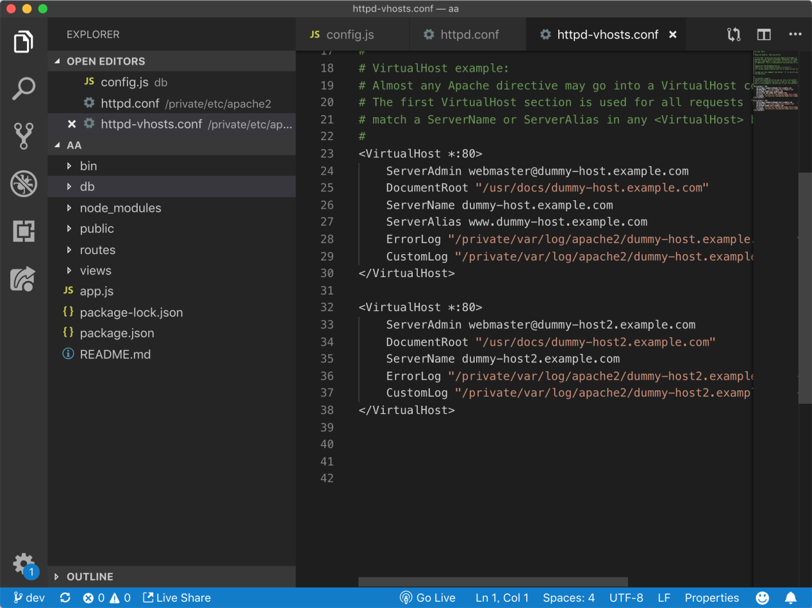

<VirtualHost *:80>

ServerAdmin webmaster@dummy-host.example.com

DocumentRoot "/usr/docs/dummy-host.example.com"

ServerName dummy-host.example.com

ServerAlias www.dummy-host.example.com

ErrorLog "/private/var/log/apache2/dummy-host.example.com-error_log"

CustomLog "/private/var/log/apache2/dummy-host.example.com-access_log" common

</VirtualHost>

<VirtualHost *:80>

ServerAdmin webmaster@dummy-host3.example.com

DocumentRoot "/Library / WebServer/Documents/os"

ServerName oa.com

</VirtualHost>

配置hosts文件

位置 cd /etc/

etc下的hosts文件打开

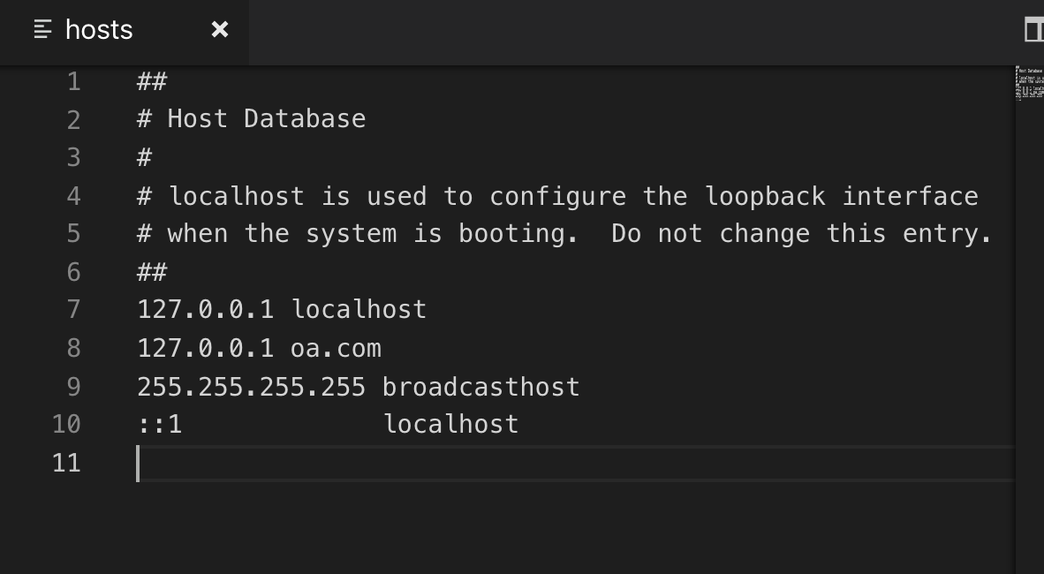

按照已有的格式进行配置

在地址栏中去掉默认index路径

<https://zhidao.baidu.com/question/1929426138676277907.html>

最后效果 原来 myoa.com/index/login/index.html

