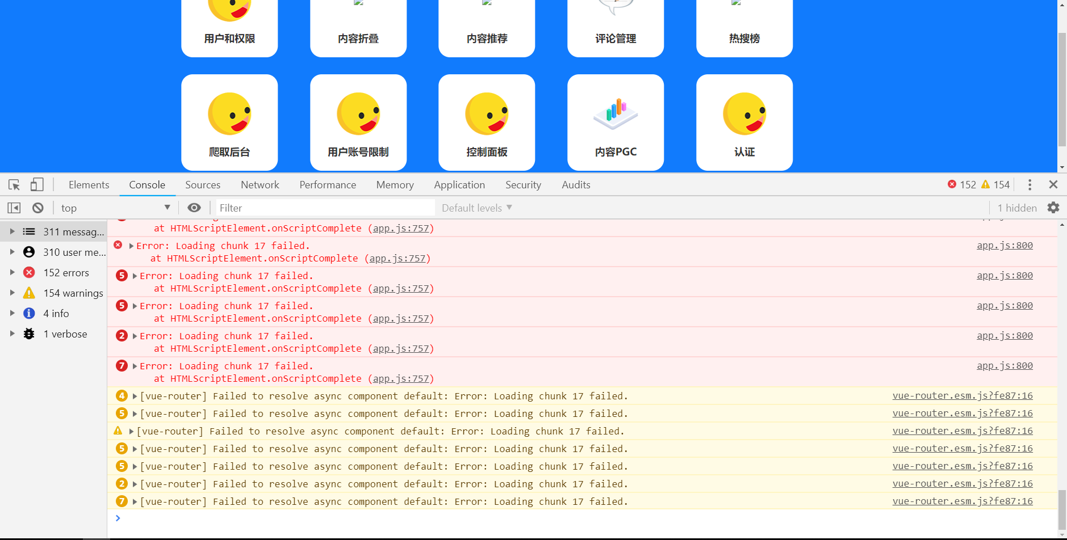

// //出现模块加载失败时调用

router.onError((error) => {

const pattern = /Loading chunk (\d)+ failed/g;

const isChunkLoadFailed = error.message.match("asas:",pattern);

const targetPath = router.history.pending.fullPath;

if (isChunkLoadFailed) {

router.replace(targetPath);

}

});

解决代码，但是放到main.js中无用，待解决