**We offer a complete & diverse afternoon program for K~12th grade school students. This stimulating program follows a school-based curriculum, as well as provides supplementary work to ensure the success and well-being of students. We offer a variety of classes that focus on developing and strengthening the core skills that will be assets to students’ study habits and academic careers.**

Here at **ReadWriteThink**, our mission is to provide educators, parents, and afterschool professionals with access to the highest quality practices in reading and language arts instruction by offering the very best in free materials.

To develop and nurture students of character in an environment of integrity and excellence through the study of the arts.

Every individual is unique. The quality of the relationship between a student and a teacher is what makes the learning process more effective and enjoyable. Each class/lesson is tailored to the student's needs to create that personal experience.

Music Classes

**We tailor the classes to fit *your*needs.**

**You pick the goal. We'll find the best way to get you there.**

**Pre-K Art**

A wonderful program designed just for our preschool and kindergarteners to explore all the wonderful things of the art world. Students will sketch, paint, build, collage, etc to really discover how creative we can be!

**K-1 ART**

Age appropriate art projects with introductions to watercolor, sketching, painting, 3d art, and more! Check out these 45 minute classes. So much fun!

**ELEMENTARY ART**

​

Meet the Masters, learn about Art history, and explore all different mediums. This is a great class for all students grades 2-5. This class inspires students to think outside the box, look at things from different perspectives, and find creative ways to transfer ideas to paper. Try out this amazing class taught by the very best teachers!

**Semi Private**

Bring a friend or 2 and have your own class designed just for you! Please contact us to inquire about availability and scheduling.

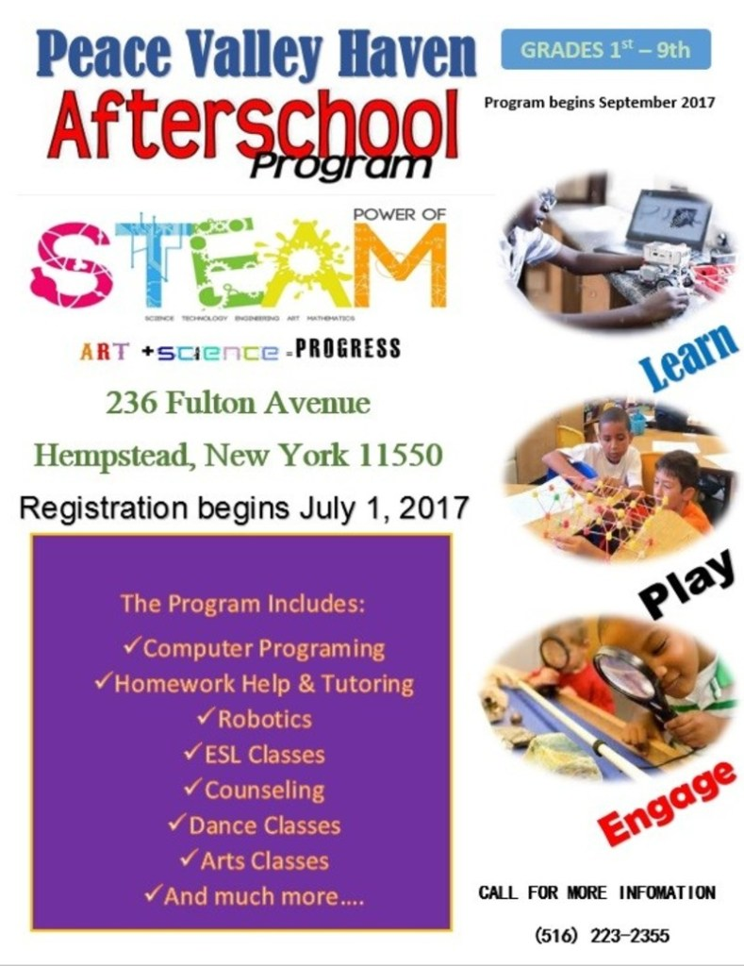

**After School Activities**

Find fun, safe and engaging activities for your program participants.

**Activities Listing**

**Age Group:**6-9 yrs, 9-12 yrs, 13+ yrs

**Time Requirement:**15 minutes

**Activity Type:**Creative Art

**Play Area:**Classroom (small indoor space)

**Group Size:**Large Group, Medium Group, Small Group

**The NIA After School Program**Developing World Class Leaders  
   
Serious fun and adventure awaits your child in our  
after school program. Each week your child   
explores something new at NIA. Exciting curriculum   
projects, special events. The activities we offer   
help promote Health, Physical Activities and   
Cognitive Reasoning through both active indoor  
and outdoor game activities.  
   
Interest Clubs throughout the school year give children a chance to participate in small group related to personal interests and explore new activities and hobbies such as builders and designers club, drama, music, dance, chess, martial arts, boxing, poetry, knitting, crocheting, journal club and much more.

Kindergarten through Grade 6  
   
*Homework Assistance  
*Super Field Trips on Early Dismissal Days!  
*Special Events  
*Sports Clinic   
    (Volleyball, Tennis, Basketball, Football, etc.)  
*Selective Holiday Day Camps  
*Friday Various Clubs and Activities- Arts & Crafts, Chess, Charm & Modeling, Gymnastics/ Rock   
   Climbing & much more!  
*Dinner/ Snack