Name______________________________

Entity Identification Problems

The “First Street Club” needs to keep track of its members. The members need to receive the newsletter regularly. There are several committees within the club, and each person may serve on only one committee. The finance committee wants to record the amount of money that individual members contribute to the club and report the total to them at the end of the year. The club needs to purchase supplies such as paper and bulletin covers. The secretary, a member of the staff, deals with several different office supplies companies.

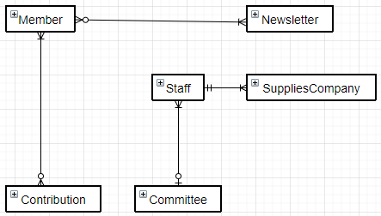

The “Cool College” is divided into several schools: a school of business, a school of engineering and computer science, a school of physical sciences, and a school of liberal arts. The information stored on each school code, school name, location, and dean number. Each school is administered by a dean. The information about each dean includes a unique dean number, his/her name and phone number.

