**CS 31 Database Management Programming Lecture 14**

**Client Server Architecture**

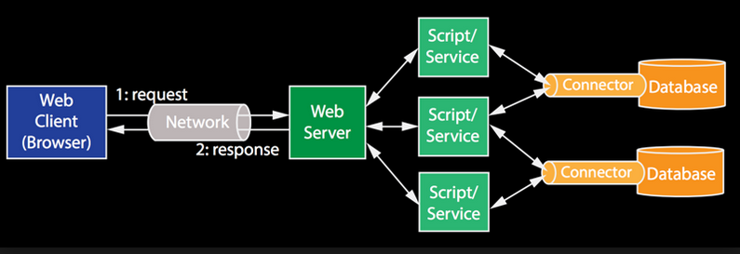

**Web Client (Browser) Technologies**

**Hypertext Markup Language (HTML)** – a markup language used to create documents on the World Wide Web; defines the structure and layout of a Web document by using a variety of tags and attributes

**Cascading Style Sheets (CSS)** – describe how HTML elements are to be displayed; CSS can be used to describe margins, padding, and much more

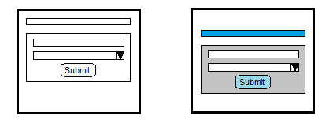

**JavaScript** – a client-side programming language commonly used in web development; it was originally developed by Netscape as a means to add dynamic and interactive elements to websites

**Apache Web Server** – a popular Web server that runs on most operating systems

**PHP: Hypertext Processer (PHP)** – a server-side scripting language used to interact with a DBMS; PHP provides different API for various DBMS

**Application Program Interface (API)** – a set of program procedures or functions that can be called to invoke a set of services; includes the names of the procedures and a name, purpose and data type of parameters to be provided

A DBMS product can provide a library of functions to call for database services. The names of procedures and their parameters constitute the API for that library.

// Connect to the DBMS

$link = mysqli_connect("host", "user", "password", "database");

// Run a query – returns a "pointer" to the first row

$resultSet = mysqli_query($link, "query");

// Access the result set, row by row

while ($row = mysqli_fetch_assoc($resultSet)) {

// Display columns of current row

echo "<p>" . $row["Column1"] . "\t" .

$row["Column2"] . "\t" .

...

$row["ColumnN"] . "</p>";

}

// Free the result set

mysqli_free_result($resultSet);

// Close the connection

mysqli_close($link);

**AMP (Apache, MariaDB/MySQL, PHP/Python/Perl)** – solution stacks are used to run dynamic websites

A LAMP will run on Linux, WAMP on Windows, and MAMP on Macintosh.

**Open Database Connectivity (ODBC)** – a standard API by which programs can access and process databases, spreadsheets, text files, and other table-like structures in a DBMS-independent manner.

**Java Database Connectivity (JDBC)** – A standard interface by which application programs written in Java can access and process SQL databases (or table structures such as spreadsheets and text tables) in a DBMS-independent manner.

**Model View Controller (MVC)** – a software architecture pattern commonly used to implement user interfaces; it separates the data definition (model), presentation layer (view), and application logic (controller)

**ADO.NET** – a data access technology that is part of Microsoft's .NET initiative

**Database Recovery**

Multiple transactions can be active when an unexpected shutdown occurs. Logs are kept for data that is being changed for active transactions. Two logs that are important to recovery are the undo and redo logs.

**Rollback** – the process of recovering a database in which before images are applied to the database to return to an earlier checkpoint or other point at which the database is logically consistent; uncommitted transactions are undone – undo log

**Rollforward** – the process of recovering a database by applying after images to a saved copy of the database to bring it to a checkpoint or other point at which the database is logically consistent; committed transactions are redone – redo log