**CS 31 Database Management Programming Lecture 5**

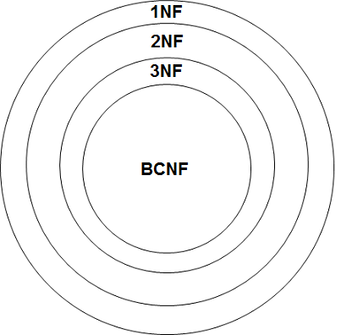

The higher normal forms are included within the lower normal forms.

**1st Normal Form (1NF)** – a table that has all the characteristics of a relation and a defined primary key

**2nd Normal Form (2NF)** – a table that is in 1st Normal Form and has no partial dependencies

**Partial Dependency** – a condition where an attribute is dependent on only part of a composite primary key instead of on the whole key

**3rd Normal Form (3NF)** – a table that is in 2nd Normal Form and has no transitive dependencies

**Transitive dependency** – In a relation having at least three attributes, for example, R(A, B, C), the situation in which A determines B, B determines C, but B does not determine A. Non-key column(s) determine other non-key column(s).

**Boyce-Codd Normal Form (BCNF)** – a relation in which all redundancy based on functional dependency has been removed

I swear to construct my tables so that all non-key columns are dependent on:

* The key, (1st NF)
* The whole key, (2nd NF)
* And nothing but the key, (3rd NF)

So help me Codd!

To remove partial/transitive dependencies:

* Move all functionally dependent columns and a copy of the determinant from the old (denormalized) relation. The determinant column(s) become the primary key of the new relation and remain in the old relation as a foreign key.

**Lab Lecture 5**

**LIKE** – used in **WHERE** clause for pattern matching

**%** matches zero or more characters

**_** matches exactly one character

In some cases, the **TRIM** function will need to be used for **LIKE** to work correctly.

**NULL** – An attribute value that has never been supplied. The value may be unknown, not appropriate, or not exist altogether.

When creating tables we can add a **NOT NULL** constraint, which will not allow values to be **NULL**. By default, except for primary key columns, **NULL** values are allowed.

To check if values are/are not **NULL**, use the **IS NULL** or **IS NOT NULL** syntax. Note **<=>** can be used for checking if values are **NULL**. There is no equivalent operator for **IS NOT NULL**.

The **IFNULL()** function lets you return an alternative value if an expression is **NULL**.

SELECT IFNULL(CatalogPage, 'Not in printed catalog')

FROM catalog_sku_2015;