API P2PL (RDL) Testing Document
API MANAGEMENT


COPYRIGHT NOTICE
Copyright © (2020) by BNI-STI
All right reserved. This material is confidential and proprietary to BNI-STI and no part of this material should be reproduced, published in any form by any means, electronic or mechanical including photocopy or any information storage or retrieval system nor should the material be disclosed to third parties without the express written authorization of BNI-STI.

Testing Scenario
[Describe all scenario for all phases]

Unit Test Plan

No. | Description | Expected Result | Criteria
TC-01 | Get API Token | Acces_token is successfully created | Pass
TC-02 | Normal Scenario Register Investor | Register Investor is successful | Pass
TC-03 | Abnormal Scenario Register Investor: IdNumber/KTP already register | Register Investor is failed | Pass
TC-04 | Normal Scenario Register Investor Account IDR | Register Investor account is successful | Pass
TC-05 | Abnormal Scenario Register Investor Account: Invalid CIF number | Register Investor account is failed | Pass
TC-06 | Abnormal Scenario Register Investor Account: Invalid accountType | Register Investor account is failed | Pass
TC-07 | Abnormal Scenario Register Investor Account: Invalid currency | Register Investor account is failed | Pass
TC-08 | Normal Scenario Inquiry Account Info | Inquiry Account Info is successful | Pass
TC-09 | Abnormal Scenario Inquiry Account Info: Invalid Account number | Inquiry Account Info is failed | Pass
TC-10 | Abnormal Scenario Inquiry Account Info VA: Invalid VA Number | Inquiry Account Info is failed | Pass
TC-11 | Normal Scenario Inquiry Account Balance | Inquiry Account Balance is successful | Pass
TC-12 | Abnormal Scenario Inquiry Account Balance: Invalid Account Number | Inquiry Account Balance is failed | Pass
TC-13 | Abnormal Scenario Inquiry Account Balance VA: Invalid VA Number | Inquiry Account Balance is failed | Pass
TC-14 | Normal Scenario Inquiry Account History | Inquiry Account History is successful | Pass
TC-15 | Abnormal Scenario Inquiry Account History: Invalid Account Number but Register in BNI API | Inquiry Account History is failed | Pass
TC-16 | Abnormal Scenario Inquiry Account History: Account Number is Not Register in BNI API | Inquiry Account History is failed | Pass
TC-17 | Normal Scenario Payment Using Transfer (debit account / account Number: IDR) | Payment Using Transfer is successful | Pass
TC-18 | Normal Scenario Payment Using Transfer (Transfer from IDR to USD) | Payment Using Transfer is failed | Pass
TC-19 | Abnormal Scenario Payment Using Transfer: Invalid Account Number but Register in BNI API | Payment Using Transfer is failed | Pass
TC-20 | Abnormal Scenario Payment Using Transfer: Insufficient fund | Payment Using Transfer is failed | Pass
TC-21 | Abnormal Scenario Payment Using Transfer: Account Number status is Closed | Payment Using Transfer is failed | Pass
TC-22 | Abnormal Scenario Payment Using Transfer: Account Number is not register in BNI API | Payment Using Transfer is failed | Pass
TC-23 | Abnormal Scenario Payment Using Transfer: duplicate requestUuid | Payment Using Transfer is failed | Pass
TC-24 | Normal Scenario Inquiry Payment Status Transfer | Inquiry Payment Status is successful | Pass
TC-25 | Abnormal Scenario Inquiry Payment Status Transfer : Invalid Request UUID | Inquiry Payment Status is failed | Pass
TC-26 | Normal Scenario Payment Using Clearing | Payment Using Clearing is successful | Pass
TC-27 | Normal Scenario Inquiry Payment Status Clearing | Inquiry Payment Status Clearing is successful | Pass
TC-28 | Abnormal Scenario Payment Using Clearing: Amount > 1 Billion | Payment Using Clearing is failed | Pass
TC-29 | Normal Scenario Payment Using RTGS | Payment Using RTGS is successful | Pass
TC-30 | Normal Scenario Inquiry Payment Status Using RTGS | Inquiry Payment Status Using RTGS is successful | Pass
TC-31 | Abnormal Scenario Payment Using RTGS: Amount < 100 Million | Payment Using RTGS is failed | Pass
TC-32 | Normal Scenario Inquiry Interbank: Link | Inquiry Interbank ATM Link is successful | Pass
TC-33 | Normal Scenario Payment Interbank: Link | Payment Interbank Link is successful | Pass
TC-34 | Normal Scenario Inquiry Payment Status Interbank: Bersama | Inquiry Payment Status Interbank: Bersama is successful | Pass

System/Integration Test Plan
Skenario testing sesuai dengan Unit test Plan
Testing scenario as listed on Unit Test Plan

No. | Description | Expected Result | Criteria
TC-01 |  |  | [Pass/Failed]
TC-02

User Acceptance Test Plan
Skenario testing sesuai dengan Unit test Plan
Testing scenario as listed on Unit Test Plan

No. | Description | Expected Result | Criteria
TC-01 |  |  | [Pass/Failed]
TC-02

Deployment Test Plan
Skenario testing sesuai dengan Unit test Plan
Testing scenario as listed on Unit Test Plan

No. | Description | Expected Result | Criteria
TC-01 |  |  | [Pass/Failed]
TC-02

Generate Credentials Phase
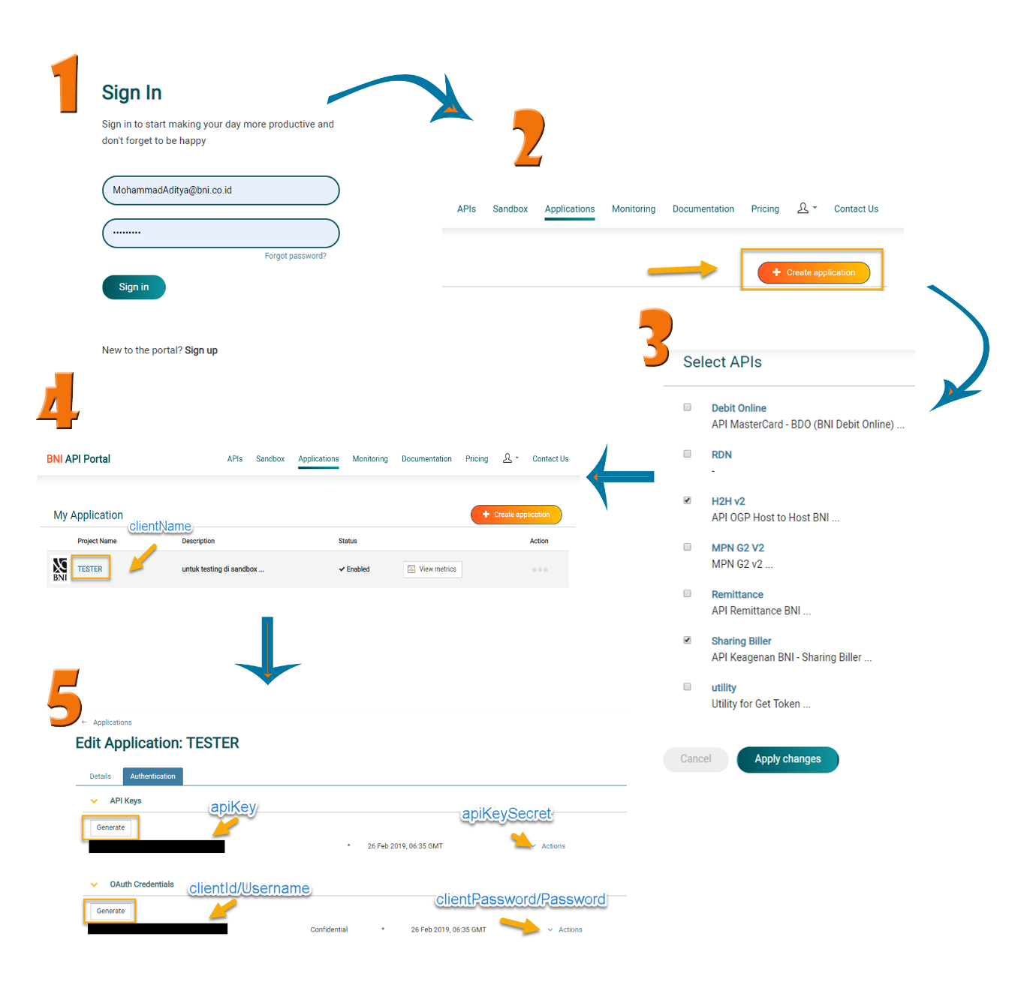

Test Result

Get API Token

Preparations
Get username (client_id) and password (client_secret) from Oauth Credentials “Generate Credentials Phase”.

Exit Acceptance Criteria
Acces_token is successfully created

Procedure
• Lakukan transaksi berdasarkan skenario

do transactions based on the scenario.

• Lengkapi dokumentasi.

Complete documentation.

Output

Captured Screen
Via Utility

Via Service di P2P Lending

Request Message (to BNI)
Via Utility

Response Message (from BNI)
Via Utility

Via Service di P2P Lending

Normal Scenario Register Investor

Preparations
Testing Data :
"idNumber": "331234766887878518",
Operation : Register Investor

Exit Acceptance Criteria
Register Investor is successful

Procedure
• Lakukan transaksi berdasarkan skenario

do transactions based on the scenario.

• Lengkapi dokumentasi.

Complete documentation

Output

Captured Screen

Request Message (to BNI)

Response Message (from BNI)

Abnormal Scenario Register Investor: IdNumber/KTP already register

Preparations
Testing Data :
"idNumber": "312234766887878519",
Operation : Register Investor

Exit Acceptance Criteria
Register Investor is failed

Procedure
• Lakukan transaksi berdasarkan skenario

do transactions based on the scenario.

• Lengkapi dokumentasi.

Complete documentation

Output

Captured Screen

Request Message (to BNI)

Response Message (from BNI)

Normal Scenario Register Investor Account IDR

Preparations
Testing Data :

"cifNumber": "9100749959",
"accountType": "RDL",
"currency": "IDR",

Operation : Register Investor Account

Exit Acceptance Criteria
Register Investor account is successful

Procedure
- Lakukan transaksi berdasarkan skenario

do transactions based on the scenario.

- Lengkapi dokumentasi.

Complete documentation.

Output

Captured Screen

Request Message (to BNI)

Response Message (from BNI)

Abnormal Scenario Register Investor Account: Invalid CIF number

Preparations
Testing Data :
"cifNumber": "123456789",
Operation : Register Investor Account

Exit Acceptance Criteria
Register Investor account is failed

Procedure
• Lakukan transaksi berdasarkan skenario

do transactions based on the scenario.

• Lengkapi dokumentasi.

Complete documentation.

Output

Captured Screen

Request Message (to BNI)

Response Message (from BNI)

Abnormal Scenario Register Investor Account: Invalid accountType

Preparations
Testing Data :
"accountType": "RDA",
Operation : Register Investor Account

Exit Acceptance Criteria
Register Investor account is failed

Procedure
• Lakukan transaksi berdasarkan skenario

do transactions based on the scenario.

• Lengkapi dokumentasi.

Complete documentation.

Output

Captured Screen

Request Message (to BNI)

Response Message (from BNI)

Abnormal Scenario Register Investor Account: Invalid currency

Preparations
Testing Data :
"currency": "AUD",
Operation : Register Investor Account

Exit Acceptance Criteria
Register Investor account is failed

Procedure
• Lakukan transaksi berdasarkan skenario

do transactions based on the scenario.

• Lengkapi dokumentasi.

Complete documentation.

Output

Captured Screen

Request Message (to BNI)

Response Message (from BNI)

Normal Scenario Inquiry Account Info

Preparations
Testing Data :
"accountNumber": "0115476117"
Operation : Inquiry Account Info

Exit Acceptance Criteria
Inquiry Account Info is successful

Procedure
• Lakukan transaksi berdasarkan skenario

do transactions based on the scenario.

• Lengkapi dokumentasi.

Complete documentation.

Output

Captured Screen

Request Message (to BNI)

Response Message (from BNI)

Abnormal Scenario Inquiry Account Info : Invalid Account Number

Preparations
Testing Data :
"accountNumber": "1122334455"
Operation : Inquiry Account Info

Exit Acceptance Criteria
Inquiry Account Info is failed

Procedure
• Lakukan transaksi berdasarkan skenario

do transactions based on the scenario.

• Lengkapi dokumentasi.

Complete documentation.

Output

Captured Screen

Request Message (to BNI)

Response Message (from BNI)

Abnormal Scenario Inquiry Account Info VA: Invalid VA Number

Preparations
Testing Data :
"accountNumber": "8150000000000111"
Operation : Inquiry Account Info

Exit Acceptance Criteria
Inquiry Account Info is failed

Procedure
• Lakukan transaksi berdasarkan skenario

do transactions based on the scenario.

• Lengkapi dokumentasi.

Complete documentation.

Output

Captured Screen

Request Message (to BNI)

Response Message (from BNI)

Normal Scenario Inquiry Account Balance

Preparations
Testing Data :
"accountNumber": "0115476117"

Operation : Inquiry Account Balance

Exit Acceptance Criteria
Inquiry Account Balance is successful

Procedure
• Lakukan transaksi berdasarkan skenario

do transactions based on the scenario.

• Lengkapi dokumentasi.

Complete documentation.

Output

Captured Screen

Request Message (to BNI)

Response Message (from BNI)

Abnormal Scenario Inquiry Account Balance: Invalid Account Number

Preparations
Testing Data :
"accountNumber": "0221869561"
Operation : Inquiry Account Balance

Exit Acceptance Criteria
Inquiry Account Balance is failed

Procedure
• Lakukan transaksi berdasarkan skenario

do transactions based on the scenario.

• Lengkapi dokumentasi.

Complete documentation.

Output

Captured Screen

Request Message (to BNI)

Response Message (from BNI)

Abnormal Scenario Inquiry Account Balance VA: Invalid VA Number

Preparations
Testing Data :
"accountNumber": "9881045044352004"
Operation : Inquiry Account Balance

Exit Acceptance Criteria
Inquiry Account Balance is failed

Procedure
• Lakukan transaksi berdasarkan skenario

do transactions based on the scenario.

• Lengkapi dokumentasi.

Complete documentation.

Output

Captured Screen

Request Message (to BNI)

Response Message (from BNI)

Normal Scenario Inquiry Account History

Preparations
Testing Data :
"accountNumber": "0115476117"
Operation : Inquiry Account History

Exit Acceptance Criteria
Inquiry Account History is successful

Procedure
• Lakukan transaksi berdasarkan skenario

do transactions based on the scenario.

• Lengkapi dokumentasi.

Complete documentation.

Output

Captured Screen

Request Message (to BNI)

Response Message (from BNI)

Abnormal Scenario Inquiry Account History: Invalid Account Number but Register in BNI API

Preparations
Testing Data :
"accountNumber": "0317246677"
Operation : Inquiry Account History

Exit Acceptance Criteria
Inquiry Account History is failed

Procedure
• Lakukan transaksi berdasarkan skenario

do transactions based on the scenario.

• Lengkapi dokumentasi.

Complete documentation.

Output

Captured Screen

Request Message (to BNI)

Response Message (from BNI)

Abnormal Scenario Inquiry Account History: Account Number is Not Register in BNI API

Preparations
Testing Data :
"accountNumber": "0315617904"
Operation : Inquiry Account History

Exit Acceptance Criteria
Inquiry Account History is failed

Procedure
• Lakukan transaksi berdasarkan skenario

do transactions based on the scenario.

• Lengkapi dokumentasi.

Complete documentation.

Output

Captured Screen

Request Message (to BNI)

Response Message (from BNI)

Normal Scenario Payment Using Transfer (debit account /accountNumber: IDR)

Preparations
Testing Data :
"accountNumber": "0115476117",
"beneficiaryAccountNumber": "0115471119",
Operation : Payment Transfer

Exit Acceptance Criteria
Payment Using Transfer is successful

Procedure
• Lakukan transaksi berdasarkan skenario

do transactions based on the scenario.

• Lengkapi dokumentasi.

Complete documentation.

Output

Captured Screen

Request Message (to BNI)

Response Message (from BNI)

Abnormal Scenario Payment Using Transfer (Transfer from IDR to USD)

Preparations
Testing Data :
"accountNumber": "0317448636",
"beneficiaryAccountNumber": "0315591246",
Operation : Payment Transfer

Exit Acceptance Criteria
Payment Using Transfer is failed

Procedure
• Lakukan transaksi berdasarkan skenario

do transactions based on the scenario.

• Lengkapi dokumentasi.

Complete documentation.

Output

Captured Screen

Request Message (to BNI)

Response Message (from BNI)

Abnormal Scenario Payment Using Transfer: Invalid Account Number but Register in BNI API

Preparations
Testing Data :
"accountNumber": "0317246677",
"beneficiaryAccountNumber": "0316029783",
Operation : Payment Transfer

Exit Acceptance Criteria
Payment Using Transfer is failed

Procedure
• Lakukan transaksi berdasarkan skenario

do transactions based on the scenario.

• Lengkapi dokumentasi.

Complete documentation.

Output

Captured Screen

Request Message (to BNI)

Response Message (from BNI)

Abnormal Scenario Payment Using Transfer: Insufficient fund

Preparations
Testing Data :
"accountNumber": "0316999571",
"beneficiaryAccountNumber": "0316029783",
Operation : Payment Transfer

Exit Acceptance Criteria
Payment Using Transfer is failed

Procedure
• Lakukan transaksi berdasarkan skenario

do transactions based on the scenario.

• Lengkapi dokumentasi.

Complete documentation.

Output

Captured Screen

Request Message (to BNI)

Response Message (from BNI)

Abnormal Scenario Payment Using Transfer: Account Number status is Closed

Preparations
Testing Data :
"accountNumber": "0316999605",
"beneficiaryAccountNumber": "0316029783",
Operation : Payment Transfer

Exit Acceptance Criteria
Payment Using Transfer is failed

Procedure
• Lakukan transaksi berdasarkan skenario

do transactions based on the scenario.

• Lengkapi dokumentasi.

Complete documentation.

Output

Captured Screen

Request Message (to BNI)

Response Message (from BNI)

Abnormal Scenario Payment Using Transfer: Account Number is not register in BNI API

Preparations
Testing Data :
"accountNumber": "0315617904",
"beneficiaryAccountNumber": "0316029783",
Operation : Payment Transfer

Exit Acceptance Criteria
Payment Using Transfer is failed

Procedure
• Lakukan transaksi berdasarkan skenario

do transactions based on the scenario.

• Lengkapi dokumentasi.

Complete documentation.

Output

Captured Screen

Request Message (to BNI)

Response Message (from BNI)

Abnormal Scenario Payment Using Transfer: Duplicate requestUuid

Preparations
Testing Data :
"requestUuid": "FAD9D7E0FEBF11E9"
"accountNumber": "0317448636",
"beneficiaryAccountNumber": "0316029783",
Operation : Payment Transfer

Exit Acceptance Criteria
Payment Using Transfer is failed

Procedure
- Lakukan transaksi berdasarkan skenario

do transactions based on the scenario.

- Lengkapi dokumentasi.

Complete documentation.

Output

Captured Screen

Request Message (to BNI)

Response Message (from BNI)

Normal Scenario Inquiry Payment Status Transfer

Preparations
Testing Data :
"requestUuid": "106323AEB63D4FF0"
Operation : Payment Transfer

Exit Acceptance Criteria
Inquiry Payment Status is successful

Procedure
- Lakukan transaksi berdasarkan skenario

do transactions based on the scenario.

- Lengkapi dokumentasi.

Complete documentation.

Output

Captured Screen

Request Message (to BNI)

Response Message (from BNI)

Abnormal Scenario Inquiry Payment Status Transfer : Invalid Request UUID

Preparations
Testing Data :
"requestUuid": "5415C150FF7111E9"
"requestedUuid": "123456AAAAAABBB0"
Operation : Inquiry Payment Status

Exit Acceptance Criteria
Inquiry Payment Status is Failed

Procedure
- Lakukan transaksi berdasarkan skenario

do transactions based on the scenario.

- Lengkapi dokumentasi.

Complete documentation.

Output

Captured Screen

Request Message (to BNI)

Response Message (from BNI)

Normal Scenario Payment Clearing

Preparations
Testing Data :
"accountNumber": "0115476117",
"amount": "300000000",

Operation : Payment Clearing

Exit Acceptance Criteria
Payment Clearing is successful

Procedure
- Lakukan transaksi berdasarkan skenario

do transactions based on the scenario.

- Lengkapi dokumentasi.

Complete documentation.

Output

Captured Screen

Request Message (to BNI)

Response Message (from BNI)

Normal Scenario Inquiry Payment Status Clearing

Preparations
Testing Data :
"requestUuid": "BE955700FED811E9"
"requestedUuid": "B7FB3C30FED711E9"

Operation : Inquiry Payment Status

Exit Acceptance Criteria
Inquiry Payment Status Clearing is successful

Procedure
- Lakukan transaksi berdasarkan skenario

do transactions based on the scenario.

- Lengkapi dokumentasi.

Complete documentation.

Output

Captured Screen

Request Message (to BNI)

Response Message (from BNI)

Abnormal Scenario Payment Using Clearing: Amount > 1 Billion

Preparations
Testing Data :
"accountNumber": "0116724773",
"beneficiaryAccountNumber": "123456",
"amount": "5000000000",
Operation : Payment Clearing

Exit Acceptance Criteria
Payment Using Clearing is failed

Procedure
- Lakukan transaksi berdasarkan skenario

do transactions based on the scenario.

- Lengkapi dokumentasi.

Complete documentation.

Output

Captured Screen

Request Message (to BNI)

Response Message (from BNI)

Normal Scenario Payment Using RTGS

Preparations
Testing Data :
"accountNumber": "0115476117",
"amount": "150000000",
Operation : Payment RTGS

Exit Acceptance Criteria
Payment Using RTGS is successful

Procedure
- Lakukan transaksi berdasarkan skenario

do transactions based on the scenario.

- Lengkapi dokumentasi.

Complete documentation.

Output

Captured Screen

Request Message (to BNI)

Response Message (from BNI)

Normal Scenario Inqury Payment Status Using RTGS

Preparations
Testing Data :
"requestedUuid": "AF0EB3A0FEDB11E9"
Operation : Inquiry Payment Status

Exit Acceptance Criteria
Inquiry Payment Status RTGS is successful

Procedure
- Lakukan transaksi berdasarkan skenario

do transactions based on the scenario.

- Lengkapi dokumentasi.

Complete documentation.

Output

Captured Screen

Request Message (to BNI)

Response Message (from BNI)

Abnormal Scenario Payment Using RTGS: Amount < 100 Million

Preparations
Testing Data :
"accountNumber": "0116724773",
"beneficiaryAccountNumber": "123456",
"amount": "500000",
Operation : Payment RTGS

Exit Acceptance Criteria
Payment Using RTGS is failed

Procedure
- Lakukan transaksi berdasarkan skenario

do transactions based on the scenario.

- Lengkapi dokumentasi.

Complete documentation.

Output

Captured Screen

Request Message (to BNI)

Response Message (from BNI)

Normal Scenario Inquiry Interbank: Link

Preparations
Testing Data :
"accountNumber": "0115476117",
"beneficiaryBankCode": "002",
"beneficiaryAccountNumber": "00200000"

Operation : Inquiry Intebank Account

Exit Acceptance Criteria
Inquiry Interbank is successful

Procedure
- Lakukan transaksi berdasarkan skenario

do transactions based on the scenario.

- Lengkapi dokumentasi.

Complete documentation.

Output

Captured Screen

Request Message (to BNI)

Response Message (from BNI)

Normal Scenario Payment Interbank: Link

Preparations
Testing Data :
"accountNumber": "0115476117",
"beneficiaryBankCode": "002",
"beneficiaryAccountNumber": "00200000"
Operation : Payment Interbank

Exit Acceptance Criteria
Payment Interbank is successful

Procedure
- Lakukan transaksi berdasarkan skenario

do transactions based on the scenario.

- Lengkapi dokumentasi.

Complete documentation.

Output

Captured Screen

Request Message (to BNI)

Response Message (from BNI)

Normal Scenario Payment Status Interbank: Bersama

Preparations
Testing Data :
"requestedUuid": "5415C150FF7111E9"
Operation : Inquiry Payment Status

Exit Acceptance Criteria
Inquiry Payment Status is successful

Procedure
- Lakukan transaksi berdasarkan skenario

do transactions based on the scenario.

- Lengkapi dokumentasi.

Complete documentation.

Output

Captured Screen

Request Message (to BNI)

Response Message (from BNI)

Conclusion and Suggestions
[Describe testing result conclusion]

