# ELEG 6318 - P01

# Deep Learning

**Spring 2023 – Homework 1**

**Title:** Performance comparison and analysis on **Perceptron** with different activation functions and loss functions.

* Building two Perceptrons with the following two groups of activation functions and loss functions on the training set (train_catvnoncat.h5)
  + Group 1:
    - Activation function:

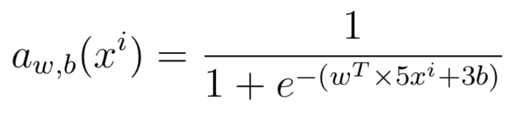

* + - Loss function:

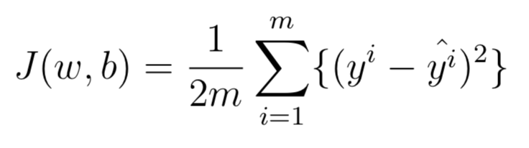

* + Group 2:
    - Activation function:

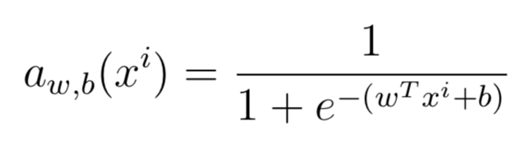

* + - Loss function:

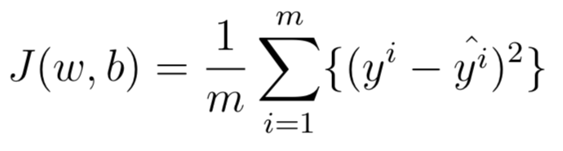

* Testing these two implemented Perceptrons on the testing dataset (test_catvnoncat.h5), respectively, with the same hyper-parameters: learning rate: 0.01, iterations: 2000.
* Calculate the training accuracies and compare their differences
* Calculate the testing accuracies and compare their differences
* Plot the learning curves for these two Perceptron, respectively and compare and analyze their differences.

**Requirements:**

* Submitting the source code (**Jupyter notebook** files from Google Colab) and the data you use for the project, where the codes have no bugs.
* Write and submit the project report with the following parts:
  + Project description
  + Model description
  + Result analysis
* **Please submit all required materials (Jupyter notebook, data, summary) within one package (.zip file) before the due.**
* **Loss 5 points directly if missing the due.**

**Due: 03/06/2023**