1. Go to <https://github.com/zhounapeuw/NAPE_imaging_analysis/tree/dev_py3_6_upgrade>
   1. Under the code tab, download the repo (download ZIP)

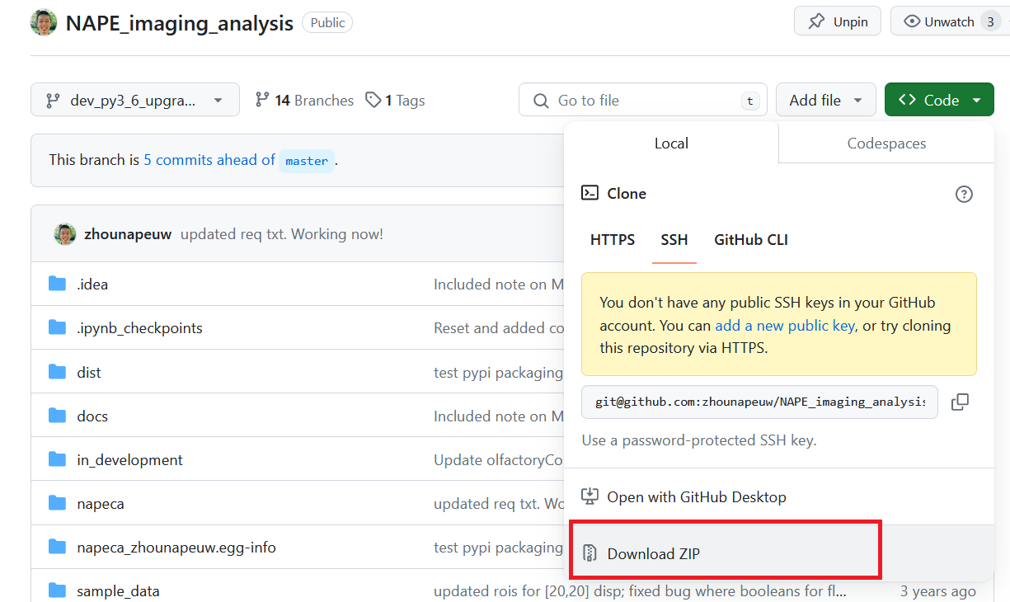

1. Open anaconda prompt
2. Create a new anaconda environment. For example: conda create --name napeca_parallel python=3.6
3. Navigate to the downloaded repo’s root folder. For example: cd C:\Users\stuberadmin\Documents\GitHub\NAPE_imaging_analysis
4. Install the prerequisite packages: pip install -r requirements.txt
5. Open jupyter notebook and open up main_parallel.ipynb; edit files_to_analyze.py as you normally would
6. Run the notebook. In the automatic prompts, it will ask if you want to parallelize across sessions or within session (this is the new parallelization option) and this will automatically determine the number of processes and distribute the data.