Auditing constrained geospatial allocation under annual land-cover product uncertainty

Abstract
Public land-cover products are increasingly used where authoritative local time series are unavailable, but product choice can alter both apparent urban change and model rankings. We present an auditable protocol for constrained spatial allocation using Geospatial Kernel, the algorithmic core of a Geospatial World Model, as the focal execution layer. Two annual 10-m products for Abu Dhabi city, Google Dynamic World (2017–2024) and an ArcGIS-served Impact Observatory/Microsoft/Esri series (2017–2025), were harmonized to the same 100-m, six-class modelling contract. Leakage-controlled expanding-window tests compared a FLUS-style ANN–CA, Geospatial Kernel, GeoFM-LDN, persistence and random minimum-change allocation using three seeds and 1,000 spatial-block bootstrap resamples. The target year supplied oracle class totals and evaluation labels only. In 2024, the ArcGIS-served series mapped 335.57 km² as built versus 155.98 km² in Dynamic World; built-class intersection over union was 0.449. Kernel ranked first in all four Dynamic World targets from 2021 to 2024, but in only two of four matched ArcGIS-served targets; FLUS-style led in 2021 and GeoFM-LDN in 2022. Kernel’s ArcGIS-minus-Dynamic World strict change Figure of Merit ranged from -0.244 to +0.205. Yet the product-specific 2031 planning frontiers retained FLUS-style and Kernel candidates in all three scenarios. The results support an inspectable proposal–projection–writeback boundary while showing that comparative skill is label-product dependent. Neither product is authoritative local land-use truth, model outputs remain 100 m, and the 2026–2031 maps are conditional stress tests rather than official forecasts.

Highlights
- Cross-product backtests expose label dependence in model rankings.
- Kernel leads four Dynamic World and two of four matched ArcGIS folds.
- Proposal–projection–writeback traces preserve allocation auditability.
- ArcGIS-served labels extend the scenario origin state to 2025.
- The 2026–2031 maps remain 100-m stress tests, not statutory forecasts.

Keywords
Geospatial World Model; land-cover change; constrained allocation; cellular automata; Abu Dhabi; scenario planning

Introduction
Land-cover change is a spatial process. Development demand is expressed as a quantity, but its consequences depend on where each new cell is placed relative to roads, existing built areas, ecological features and other land-cover classes. This coupling matters for urban planning because two maps with the same total built area can imply very different infrastructure requirements and environmental pressures. Cellular-automata and suitability-based models have long provided a way to distribute land demand across a map, including CLUE-S, SLEUTH, Dinamica EGO, FLUS, local-attribute urban CA models and more recent patch-generating or deep-learning CA models (Verburg et al., 2002; Silva and Clarke, 2002; Soares-Filho et al., 2002; Lau and Kam, 2005; Liu et al., 2017; Liang et al., 2021). Global Earth-observation products now make it possible to construct annual, spatially aligned inputs for cities that lack a harmonized local data archive (Brown et al., 2022; Gorelick et al., 2017).
Validation studies have also shown that agreement in unchanged cells can mask poor allocation of actual change. Quantity and allocation disagreement, destination-specific transition scores and explicit calibration/validation protocols are therefore preferable to a single overall-accuracy number (Pontius et al., 2008; Pontius and Millones, 2011; van Vliet et al., 2011, 2016). This distinction is central here because the benchmark uses noisy annual labels and tests both one-step allocation and recursive rollout.
The main technical difficulty is not producing another categorical raster. It is keeping the semantics of a planning action separate from the learned transition tendency. A model may predict that a cell is likely to become built, yet the resulting map can still violate a water exclusion, miss the requested class totals or become inconsistent when the next year is simulated from the model’s own output. These failure modes are particularly important when the model is used to compare scenarios rather than to reproduce one observed transition. Latent-dynamics approaches such as GeoFM-LDN can represent continuous geospatial state and condition transitions on demand, whereas traditional ANN-plus-cellular-automata systems combine suitability with explicit neighbourhood evolution. Neither design, by itself, guarantees that action semantics, hard constraints, state persistence and evidence provenance are visible at the same execution boundary.
We address this systems problem by studying Geospatial Kernel, the core transition layer of a Geospatial World Model (GWM). The Kernel represents one simulation step as a typed state, a typed action, a transition proposal, a constraint projection and a state writeback. The learned proposal remains domain-specific; the runtime contract is domain-neutral. For Abu Dhabi land-cover planning, the proposal is a six-class probability cube, and the projection allocates only mutable cells until the action’s feasible class totals are reached. This separation makes the planning operation inspectable: a reviewer can distinguish what the transition model preferred from what the constraints admitted.
We evaluate this design in a controlled public-data benchmark rather than treating the benchmark as an official data release. All candidates consume the same 100-m grid, annual class-count actions, hard exclusions and evaluator. The historical track uses observed target counts to isolate spatial allocation skill from demand error. A matched protocol is run separately on Dynamic World and on an ArcGIS-served annual product so that dependence on the complete label-product pipeline is visible. The original planning track starts from the 2024 Dynamic World state; the refreshed track starts from the 2025 ArcGIS-served state. Both apply three planner-supplied actions: moderate growth, green-priority growth and high outward growth. Abu Dhabi Plan 2030 provides an institutional planning context for discussing urban structure, but the numerical actions are not calibrated to that plan or to an official population forecast (Abu Dhabi Urban Planning Council, 2007). We ask four questions: whether the Kernel execution contract is auditable, whether its allocation skill is competitive, whether comparative conclusions survive a change of land-cover product and whether the candidates produce feasible, spatially distinct scenario allocations.
The paper makes three bounded contributions. First, it gives a concrete state–action–constraint formulation for using a geospatial kernel as an algorithmic core rather than as an opaque end-to-end predictor. Second, it defines an evaluation protocol that combines expanding-window temporal tests, zero-model controls, spatial bootstrap contrasts and a whole-product-pipeline replication rather than relying on one favourable split. Third, it turns future maps into explicit stress-test artefacts, including cumulative rasters and vectorized transition footprints, while preserving the distinction between public-data land cover and authoritative legal land use.

Methods

Portable audit protocol
The benchmark separates a reusable audit protocol from the Abu Dhabi adapter. For any city or geospatial domain, the protocol requires: (i) a declared class crosswalk and spatially stratified label-confidence tiers; (ii) persistence and minimum-change zero models; (iii) destination-correct multi-class change FoM with quantity and allocation diagnostics; (iv) spatial-block bootstrap intervals and paired model contrasts on a frozen evaluation mask; (v) an explicit check for structural-zero metrics before Pareto selection; (vi) a versioned objective table with direction, units and interpretation; and (vii) a state–action–constraint trace recording proposal, projection, hard-mask status and state writeback. The protocol also requires every model/year/seed record to report the number of predicted changed cells. A record with predicted_change_pixels == 0 is marked as a degenerate output and reviewed alongside structural-zero metrics; it cannot by itself be interpreted as model superiority or real land-cover stability. The protocol reports domain validity separately from execution completeness and requires independent change validation before a categorical map is presented as an observed land-use product. A structural-zero metric is flagged operationally when its denominator is zero for every candidate under the declared action and constraint rules; for exact-count allocation, a conversion rate is also a structural zero when the protected/source rule makes the relevant source class monotonically non-decreasing, so no eligible source cells can contribute to that transition. Such a metric is reported descriptively and excluded from Pareto selection.

Abu Dhabi implementation: boundary, grid and temporal protocol
The study boundary is the polygon returned for OpenStreetMap relation R4479763, representing Abu Dhabi city (OpenStreetMap contributors, 2026). All rasters were aligned to a canonical 100-m grid in EPSG:32640 with 475 columns and 360 rows. A cell was included when its centre fell within the city polygon and when the common public-data mask indicated valid coverage. The benchmark profile records the source geometry, raster transform, dimensions and SHA-256 hashes. The effective evaluation mask contains 79,726 cells.
The original Dynamic World sequence contains annual states for 2017–2024. Models were fit using the four transitions 2017→2018, 2018→2019, 2019→2020 and 2020→2021. A 2021→2022 transition was used for validation during model development. The original historical test starts from 2022 and evaluates 2023 and 2024 in an open-loop rollout without observed-state writeback. Its planning test starts from the observed 2024 state and recursively generates 2025–2031. The refreshed product track adds a separate annual sequence for 2017–2025, starts planning from its observed 2025 state and generates 2026–2031.
The leakage-controlled analysis used expanding one-step windows with origins in 2020–2023 for both products and an additional 2024 origin for the ArcGIS-served series. For origin year $t$, training included only observations available at or before $t$; the held-out $t+1$ label was prohibited from feature construction, model fitting and GeoFM-LDN epoch selection. The target supplied only observed class totals for oracle allocation, evaluation labels and the common-coverage mask. This design isolates spatial allocation conditional on known demand and is not an end-to-end demand forecast. Each fold locked origin-year water and wetland cells and omitted the two road-distance features, because the available OpenStreetMap snapshot was accessed in 2026. Kernel consequently used 23 features and the FLUS-style track used the remaining five continuous drivers. A machine-tested temporal firewall records permitted target-year uses for every model, seed and fold. The two product tracks match the boundary, 100-m grid, model implementations, seeds, target-year protocol, oracle-action rule, evaluator and 1,000-resample 8 × 8-cell spatial bootstrap. Annual labels, origin states, oracle totals, origin water/wetland masks and quality semantics remain product specific; the experiment therefore tests the complete public-product pipelines rather than an isolated label substitution. The original 2023–2024 headline comparison is less strict because it uses the later road snapshot and remains a secondary unmatched-pipeline result.

Public data and class semantics
Dynamic World V1 provides annual scene-argmax labels and mean top-class probabilities (Brown et al., 2022). The nine Dynamic World labels were crosswalked to six canonical classes: water (source 0), woody vegetation (1), low vegetation (2, 4 and 5), wetland (3), built (6) and bare (7). Source class 8 was excluded.
The second sequence was materialized from the public ArcGIS ImageServer Sentinel2_10m_LandCover, whose metadata attributes the global annual series to Impact Observatory, Microsoft and Esri (Impact Observatory et al., 2026). Its Sentinel-2 classification lineage follows the deep-learning mapping approach described by Karra et al. (2021). Source values were mapped to water (1), woody vegetation (2), wetland (4), low vegetation (5 and 11), built (7) and bare (8); snow/ice (9) and cloud (10) were excluded. Native 10-m labels were retained for audit, then aggregated after crosswalking by majority among usable cells in each 10 × 10 block. The resulting majority fraction served as the ArcGIS-track aggregation-quality term; it is not equivalent to Dynamic World’s top-class probability. Both sequences are explicitly treated as public land cover. Neither provides residential, commercial or industrial land use, zoning, cadastral status or development approvals.
Annual 64-dimensional AlphaEarth embeddings were spatially averaged to the canonical grid and locally L2-normalized (Brown et al., 2025). Monthly NOAA/VIIRS/DNB/MONTHLY_V1/VCMSLCFG night-time-light radiance was averaged by year (Elvidge et al., 2021). The Copernicus DEM GLO-30 COPERNICUS/DEM/GLO30_2024_1 collection supplied elevation and a finite-difference slope derivative (European Space Agency, 2024). OpenStreetMap road geometries were rasterized into distance-to-road and distance-to-major-road surfaces. ESA WorldCover 2021 supplied public water and wetland/mangrove constraint proxies (Zanaga et al., 2022). All dynamic and static layers were checked for exact CRS, transform, width and height agreement.
For an external public-product diagnostic, the ESA WorldCover 2020 v1.0 and 2021 v2.0 built-up class (value 50) was converted to built fraction on each 100-m benchmark cell (Zanaga et al., 2021, 2022). Built presence was tested at fractions of 0.05, 0.10, 0.20 and 0.30. Built gain required a cell to cross from below to at or above the threshold; built loss used the reverse definition. Binary precision, recall, F1 and intersection over union were calculated for the Dynamic World transition and for the 2020-origin predictions. The original oracle-demand comparison uses Dynamic World 2021 built counts; because the built count decreases in this window, it cannot allocate any built gains and is a structural-zero, zero-power test of gain location. We therefore also supplied the WorldCover built-gain count as the action, ranked candidate cells with the 2020-origin Kernel proposal, and compared it with random allocation from the same candidate population. This count-controlled variant is the informative allocation diagnostic, but it remains product agreement rather than ground-truth validation: the two WorldCover years use different product versions, WorldCover and Dynamic World both derive from Sentinel observations, and neither represents statutory Abu Dhabi land use.

Geospatial Kernel state, action and transition proposal
Let $S_{t}(i)$ denote the six-class state at valid cell $i$, $A_{t}$ the action for the interval $t→t+1$, and $X_{t}$ the aligned driver layers. The Kernel separates a proposal from a projection:
$$Q_{t}(i,c)=p_{θ}\left(c∣x_{i}(S_{t},X_{t})\right), S_{t+1}=Π_{C,A_{t}}(Q_{t},S_{t}).$$
The feature vector $x_{i}$ contains 25 values: six one-hot current-class indicators; twelve neighbourhood proportions, comprising 3 × 3 and 7 × 7 windows for each of the six classes; and seven continuous variables, namely normalized row and column coordinates, clipped elevation, clipped slope, log-transformed VIIRS radiance, log distance to roads and log distance to major roads. A scikit-learn histogram gradient-boosting classifier estimates the six-class probability vector (Pedregosa et al., 2011). It uses learning rate 0.08, 120 iterations, at most 31 leaf nodes, minimum leaf size 40 and L2 regularization 1.0.
Training samples combine all changed valid cells and a 20% random sample of stable valid cells in each fit transition. The sample weight is the product of a change emphasis, $1+51(S_{t}≠S_{t+1})$, and a quality factor, $0.5+min(r_{t},r_{t+1})$. Here $r$ is Dynamic World mean top probability in the original track and the within-block majority fraction in the ArcGIS-served track. These terms have different semantics and are retained as parts of their respective product pipelines. A held-out target is never used during fitting or model selection.

Constraint projection and state writeback
For a mutable source cell $i$ of class $s$ and target class $c$, the base allocation score is
$$q_{i,s→c}=logp_{θ}(c∣x_{i})−logp_{θ}(s∣x_{i})+λρ_{i,c}^{(7)},$$
where $ρ_{i,c}^{(7)}$ is the 7 × 7 fraction of neighbouring cells currently in class $c$, and $λ=0.35$. The algorithm computes class deficits and excesses from the action’s feasible target counts, ranks all admissible source–target candidates by $q$, and changes cells in descending order until all deficits and excesses are zero. Permanent water and the protected wetland/ecological mask are held fixed. If the counts cannot be satisfied without changing a hard-exclusion cell, the step fails closed rather than silently violating the action.
The projected raster is written as the next KernelState. Every step records a state reference, action evidence, model version, parameter reference, projection status and diagnostic counts. The runtime checks domain identity, source-time consistency and action time advancement. This execution contract is the Geospatial Kernel’s algorithmic contribution; the Abu Dhabi adapter supplies the land-cover-specific features, learner and constraint masks.

Baselines and common evaluator
The baseline was run through a GeoSOS-derived FLUS-style ANN–CA console (author-modified build; paper-benchmark-flus-v1.1) using seven continuous drivers: normalized row and column coordinates, elevation, slope, VIIRS radiance, distance to roads and distance to major roads. Its ANN suitability surface was passed to a cellular-automata allocation stage with the common class totals and public hard mask. The archived run used one 2021 training year, eight ANN hidden neurons, a 3 × 3 CA neighbourhood, neighbourhood strength 1.0, acceleration factor 0.1 and 1,000 iterations. Its frozen transition matrix protected water and wetland but did not prohibit built-to-non-built transitions. The algorithmic base is traceable to the GeoSOS team’s public FLUS source release (Liu et al., 2017; GeoSOS team, n.d.); an archived source repository at an anonymized revision contains the modifications used for this paper. Those modifications add train/train-update entry points and FLUS_RANDOM_SEED deterministic seeding for both ANN sampling and CA roulette draws, so the build is not the unmodified upstream executable. Version v1.1 changes only failure handling for invalid input reads; valid-input algorithmic paths and benchmark rasters are unchanged from v1. A 25-feature Kernel-matched input was then executed with absolute paths for seeds 31, 47 and 73 and is reported only as a platform-sensitive diagnostic. It shares the Kernel feature family, but not the learning target or projection semantics: the FLUS ANN estimates same-year label suitability $p(S_{t}∣X_{t})$, whereas the Kernel proposal is trained to estimate a next-state transition $p(S_{t+1}∣S_{t},X_{t})$ before constrained projection. Matching features therefore does not match the training task. Two intermediate configurations were retained as mechanism diagnostics: 13 features (seven drivers plus current-class indicators) and 19 features (seven drivers plus neighbourhood fractions). The 25-feature run collapsed to zero change for macOS seeds 47 and 73 and for all three independent external Windows x86_64 verification runs; the remaining macOS seed-31 run is not used as a valid estimator. The external evidence is identified in Supplementary Table S3; its source rasters are not locally archived. The 19-feature mode produced changes for all three macOS seeds but underfilled the observed 4,500 and 8,464 changed cells in 2023 and 2024. Both modes are therefore diagnostic-only.
GeoFM-LDN (Geospatial Foundation-Model Latent Dynamics Network; the repository’s former paper58 path identifier) was implemented as a demand-conditioned residual latent-dynamics network on 64-channel AlphaEarth patches. Three 128-channel convolutions use dilation rates 1, 2 and 4, followed by a 1 × 1 projection to a 64-dimensional latent state. A 12-dimensional action vector (origin and target counts for six classes) is encoded by a two-layer MLP and broadcast across the patch before concatenation with the embedding. Group normalization and GELU activations are used in the residual blocks. A scikit-learn logistic-regression decoder maps the predicted latent embedding to six semantic classes. Training uses 64 × 64 patches, batch size 2, eight epochs, AdamW with learning rate $3×{10}^{−4}$ and weight decay ${10}^{−4}$; the loss is the weighted sum of cosine embedding loss, 0.5 semantic cross-entropy, 0.1 demand-consistency loss and 0.2 hard-constraint consistency loss. The released checkpoints correspond to seeds 31, 47 and 73 and were trained in August 2026. The default reproduction loads these fixed checkpoints rather than retraining; the runner exposes retraining separately. Fixed checkpoints do not remove the decoding runtime boundary: categorical output still depends on the locked Torch and scikit-learn stack. Same-stack reproduction is the declared reference; no independent cross-stack GeoFM-LDN raster comparison is claimed, and changes between pre-lock and locked-environment outputs are not attributed to CPU architecture or to one library. During allocation, GeoFM-LDN directly calls the Geospatial Kernel allocate_action routine, so both methods share the same constrained projection and differ primarily in their proposal model. The comparison is therefore a proposal/pipeline comparison, not a comparison of two independent projection architectures. The name describes this benchmark implementation and does not attribute an external publication or performance claim.
For the cross-product backtest, the FLUS-style suitability fit expanded from 2017 through the origin year, the Kernel transition fit ended at the origin, and GeoFM-LDN used only pre-origin label years for its decoder, pre-selection transitions for network fitting and the transition ending at the origin for epoch selection. All GeoFM-LDN folds were retrained for eight epochs at each seed rather than loading the original fixed checkpoints. The three learned candidates were evaluated alongside persistence and an exact-count random minimum-change allocator. Kernel, GeoFM-LDN and random allocation met feasible oracle class totals exactly; the finite-iteration FLUS-style CA retained any unmet demand as normalized demand total variation rather than receiving a post-hoc raster correction.
The common evaluator computes actual class counts, normalized demand total variation, hard-mask violations, strict multi-class change FoM, binary change FoM, change F1, overall accuracy and macro-F1 for historical runs. The strict FoM counts a hit only when the predicted destination class equals the observed destination class; wrong destination changes are retained in the denominator. It also generates persistence and minimum-change zero controls, spatial-block bootstrap intervals and paired model-difference intervals for strict FoM, overall accuracy and macro-F1. For planning runs it additionally computes ecological conversion, new-built neighbourhood fraction, new-built component counts, the union of 2024 built and newly built components, all-final-built component counts, a 500-m leapfrog rate, distances to roads and prior built cells, infrastructure proxy distance and built retirement. Pareto membership is calculated within each scenario over three release objectives: major-road distance, prior-built distance and union-built component density. Ecological conversion is retained as a descriptive public-data pressure proxy because it is structurally zero for the two exact-count allocators and therefore has no discriminating power in their comparison. Vegetation gain is a scenario input and remains descriptive, not an objective.

Scenario actions and uncertainty
The moderate-growth, green-priority-growth and high-outward-growth actions are stored in the tracked product-specific scenario manifests; the legacy compact path identifier is retained only for artifact compatibility. It is not an endorsement of compact-city outcomes, which can have distributional trade-offs (Burton, 2000). Dynamic World-origin actions cover 2025–2031 and ArcGIS-origin actions cover 2026–2031. Their totals are explicit extensions of the preceding annual difference and are not derived from an official population, housing or infrastructure forecast. Future exogenous rasters are held at their respective final observed-year values. The green-priority action is not a water-budget model. Each candidate is run at seeds 31, 47 and 73, and planning tables report arithmetic means and population standard deviations. No p-values are reported because the three seeds describe computational variability, not independent field samples. The primary Pareto comparison is within each scenario, contrasting the three models under the same product-specific action; cross-product frontier membership is a sensitivity test, not a forecast-accuracy comparison. The current release objective set is road access, prior-built distance and union-built component density. Ecological conversion is reported as a diagnostic rather than a Pareto objective because it is structurally zero for the exact-count Kernel and GeoFM-LDN allocations. We treat this as a release objective set rather than a prespecified planning preference, and treat its variants as robustness diagnostics.

Change polygons and reproducibility
For each model–scenario pair, annual and cumulative differences from the origin raster are extracted as changed 100-m cells and dissolved into GeoPackage layers. The Dynamic World-origin delivery manifest covers 45 ensemble rasters for 2027–2031 and nine vector packages. The ArcGIS-origin delivery contains 54 ensemble rasters for 2026–2031, nine multilayer GeoPackages and matching Shapefiles; a separate native-10-m GeoPackage records observed 2024→2025 product change. The audit scripts fail on missing source rasters, reports or vectors. Historical predictions and bootstrap reports for both product tracks retain per-file hashes and temporal-firewall declarations. The vector layers preserve raster-cell geometry and should not be interpreted as cadastral parcels.

Results

A common benchmark separates allocation skill from demand assumptions
The benchmark covers the Abu Dhabi city polygon represented by OpenStreetMap relation R4479763. The canonical grid is a 475 × 360 lattice in EPSG:32640 at 100-m resolution. The original Dynamic World evaluation mask contains 79,726 cells and the ArcGIS-served track contains 79,775 cells before target-specific common-coverage checks. Each cell represents 1 ha. Both annual sequences were harmonized to six land-cover classes: water, woody vegetation, low vegetation, wetland, built and bare. AlphaEarth annual embeddings, VIIRS night-time lights, Copernicus DEM derivatives and OpenStreetMap road distances supplied transition drivers. ESA WorldCover and public OpenStreetMap geometries supplied water, wetland and infrastructure exclusion proxies.
The comparison shared the canonical grid, origin states, target actions, hard masks and evaluator, but the public-data run was not information-balanced. The original FLUS-style control used seven continuous drivers in its external ANN suitability model, whereas Geospatial Kernel used 25 features including current-class indicators and neighbourhood proportions; GeoFM-LDN used AlphaEarth latent embeddings and the Kernel allocator. We therefore report the original result as an unmatched-input pipeline comparison, not evidence that one learner is intrinsically superior. The additional 25-feature FLUS run is a feature-space diagnostic only, because it still learns same-year suitability rather than next-state transitions and does not use the Kernel projection implementation. Across six platform–seed runs, five produced zero-change outputs through current-class identity leakage. The archived FLUS console is a Mach-O arm64 executable rebuilt from the public GeoSOS source base with the author-modified train/train-update entry points and FLUS_RANDOM_SEED seeding patch; its exact source is archived at FLUS_console_crossplatform commit deb0a54. It is not asserted to be bitwise equivalent to an unmodified upstream build. All headline and diagnostic runs used seeds 31, 47 and 73.
The execution trace makes the distinction between proposal and admission explicit. A Kernel step records the source state, action, probability-cube proposal, projected state, model identity, input evidence and next-state reference. The runtime checks that the action advances the source time and that the projected raster becomes the next state. This is the operational meaning of the Kernel in this study: not a claim that all GWM domains share the same learner, but a claim that they can share an auditable execution contract. The shared inputs and execution boundary are summarized in Fig. 1.
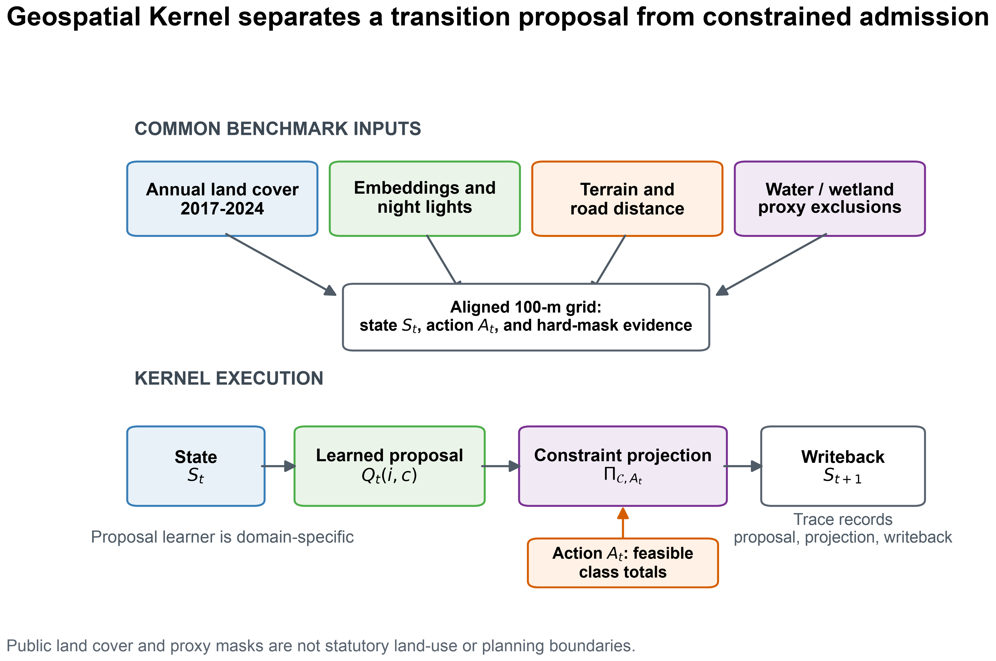
Benchmark and Geospatial Kernel execution contract. Public annual land-cover, embedding, night-light, terrain and road layers are aligned to a common 100-m Abu Dhabi grid. The Kernel exposes a learned proposal, a constraint projection and a state writeback. The schematic describes a public-data benchmark and does not imply statutory planning boundaries.

Historical and planning results
The historical track uses observed target class totals to isolate spatial allocation from demand estimation. The primary metric is strict multi-class change FoM: a hit requires the predicted destination class to equal the observed destination class, while wrong destination changes remain in the denominator (Pontius et al., 2008). Overall accuracy, macro-F1, change F1 and binary FoM are secondary diagnostics. Uncertainty is estimated with an 8 × 8-pixel spatial-block bootstrap, and model contrasts are computed from the same resampled blocks for each frozen seed. Persistence and random minimum-change allocation are explicit zero-model controls.
The original planning track starts from the observed 2024 state and applies three synthetic class-count actions through 2031. The release objective set is version 6. It uses mean distance of new built cells to major roads, mean distance to pre-existing built cells and connected components in the union of 2024 built and newly built cells per 1,000 valid cells. These are public-data proxies. Ecological conversion is retained as a descriptive diagnostic, not an objective, because it is structurally zero for the two exact-count allocators. Vegetation gain is excluded because it is supplied directly by the scenario action, and all-final- built component density is reported only as a diagnostic because it can be changed by built-cell retirement. No weighted composite score is used. Because the objective set changed across the review rounds, we disclose the lineage: v1 included seven access, ecological, neighbourhood and gain terms; v2 proposed roads, prior-built distance, fragmentation and leapfrog rate but was not run; v3 used ecological conversion, roads, leapfrog rate and built retirement; and v4 combined roads, prior-built distance, all-built fragmentation and vegetation gain. The current v6 release replaces v5 after the review identified the structural-zero ecological objective and the semantic inversion of new-only fragmentation. Sensitivity sets are recomputed on the same rasters and reported as robustness analyses, not as additional preregistered claims. These are measurable public-data proxies rather than claims about welfare, equity or statutory zoning.
The released public-data bundle supports a complete re-scoring of the current historical rasters and a re-compilation of the 2025–2031 planning rasters. The strict multi-class transition FoM (mean across three seeds) was 0.1256, 0.1961 and 0.1619 for the FLUS-style console, Geospatial Kernel and GeoFM-LDN in 2023, and 0.1782, 0.2529 and 0.2708 in 2024, respectively. Under this unmatched public-data pipeline, Geospatial Kernel had the largest 2023 value, whereas GeoFM-LDN had the largest 2024 value after recursive two-step rollout; no single model dominated both horizons. These rankings are conditional on the different inputs, learners and shared evaluation projection.
Table 1. Historical strict destination-change FoM. Values are means across three frozen computational seeds. The 25-feature FLUS run is excluded because it is not a comparable estimator: five of six platform–seed runs collapsed to zero change. Persistence (0.0000 in both years) and random minimum-change allocation (0.0253 in 2023; 0.0605 in 2024) are explicit zero-model controls and are plotted in Fig. 2.
Target year | FLUS-style ANN-CA | Geospatial Kernel | GeoFM-LDN
2023 (one-step) | 0.1256 | 0.1961 | 0.1619
2024 (two-step open-loop) | 0.1782 | 0.2529 | 0.2708
Spatial-block bootstrap model contrasts support these differences. For 2023, Kernel minus the FLUS-style control was 0.0703 [0.0558, 0.0866] and GeoFM-LDN minus Kernel was -0.0341 [-0.0479, -0.0209]. For 2024, GeoFM-LDN minus Kernel was 0.0177 [0.0033, 0.0314]. These are conditional pipeline contrasts on public labels, not independent-sample significance tests. The persistence control had higher overall accuracy than every learned candidate (0.9436 in 2023 and 0.8938 in 2024), illustrating why change-specific metrics are necessary. Fig. 2 shows the four historical metrics alongside the persistence and random minimum-change controls; main-model bars use three-seed population standard deviations, whereas the paired spatial-block intervals above are the uncertainty summaries used for model contrasts. The 25- and 19-feature FLUS diagnostics are reported in the machine-readable archive and Supplementary Table S3.
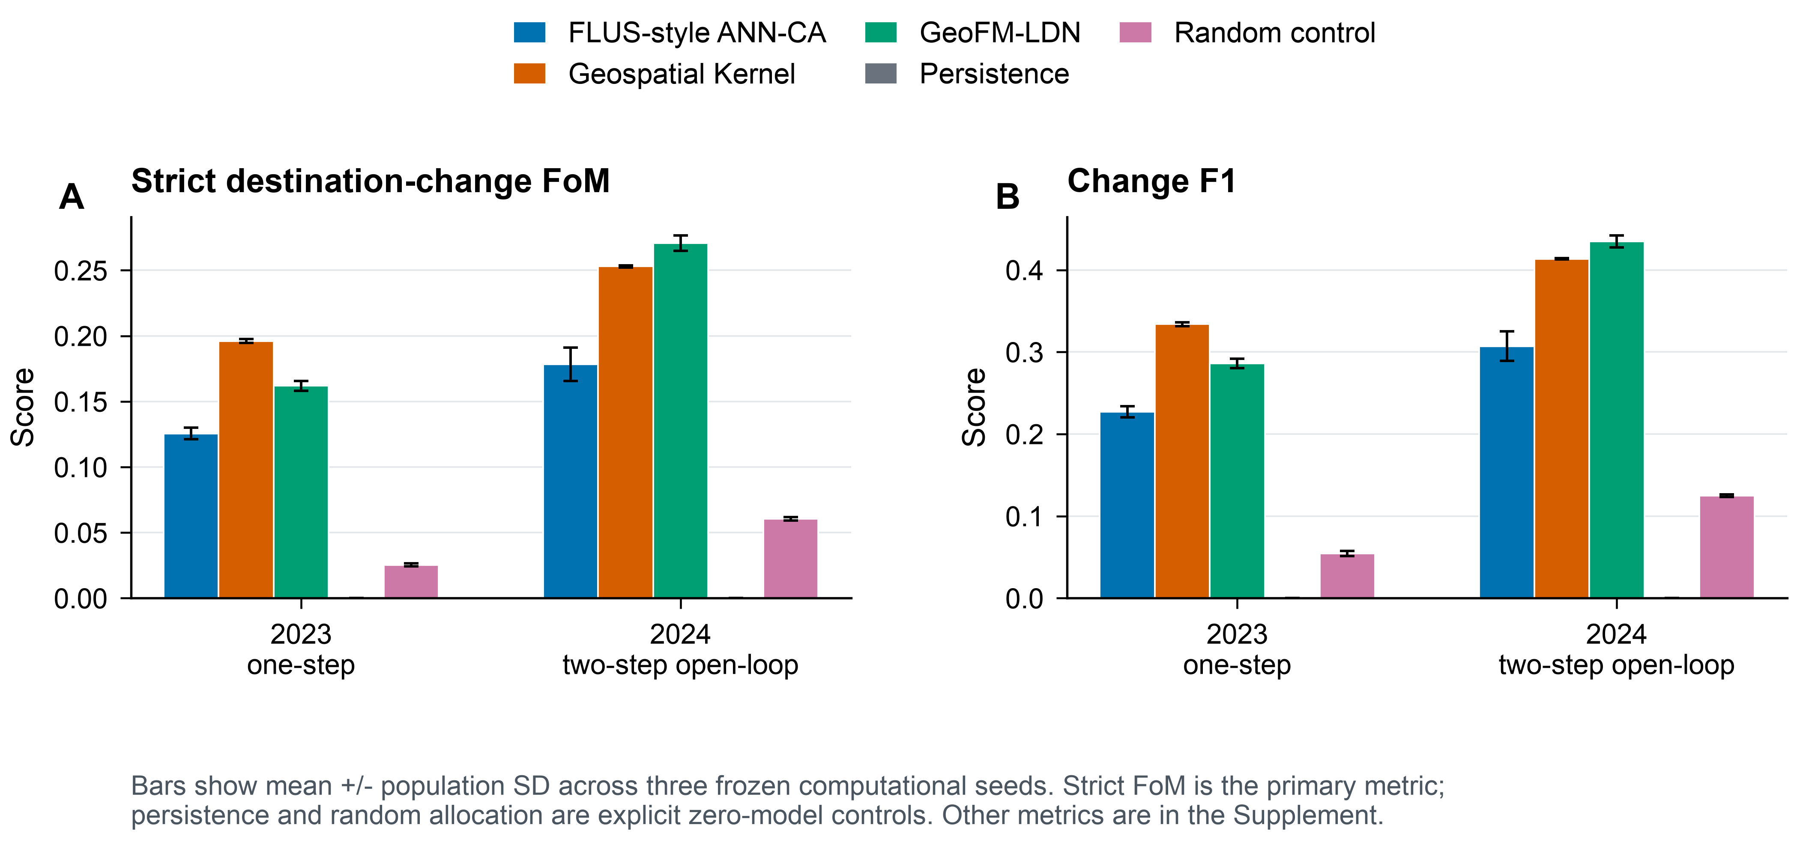
Historical allocation skill. Strict destination-change FoM is the primary metric; change F1 is shown as a secondary diagnostic. Bars show mean plus or minus population standard deviation across the three frozen seeds. Persistence and random allocation are explicit zero-model controls.
An additional FLUS input-dimension analysis was also completed. The 25-feature run is not a valid point estimator: macOS seeds 47 and 73 and all three independent external Windows x86_64 verification runs produced zero-change outputs, whereas macOS seed 31 was the sole non-collapsed run. The six-run pattern is therefore platform-sensitive and is retained as an identity-leakage diagnostic, not as a Kernel contrast. The 19-feature diagnostic was run for all three macOS seeds. Its strict FoM ranged from 0.1071 to 0.1617 in 2023 and from 0.0872 to 0.1386 in 2024; predicted changes ranged from 1,702 to 2,417 and from 1,805 to 2,499 cells, respectively, compared with 4,500 and 8,464 observed changes. Demand total variation ranged from 0.0153 to 0.0305 in 2023 and from 0.0615 to 0.0767 in 2024. These results show why matching feature dimensions cannot make the tasks equivalent: FLUS learns static suitability $p(S_{t}∣X_{t})$, while the Kernel learns next-state transitions and then projects them against action deficits and hard constraints.
The confidence sensitivity is a label-quality and selection-effect diagnostic, not an independent validation set or a model-skill test. Requiring both the origin and target Dynamic World mean top probability to exceed 0.5 retains only 25 of 4,500 observed changes (0.56%) in 2023 and 56 of 8,464 (0.66%) in 2024. Strict FoM is 0.000 for all three models in 2023; in 2024 the means are 0.0040 for the FLUS-style console, 0.0055 for Geospatial Kernel and 0.0188 for GeoFM-LDN. Screening only the confidence of the year immediately preceding the target avoids filtering on target-year confidence, but still retains only 129 (2.87%) and 93 (1.10%) observed changes in 2023 and 2024, respectively. Its 2023 FoM values remain 0.000; its 2024 means are 0.0040, 0.0041 and 0.0120 for the FLUS-style console, Kernel and GeoFM-LDN. The two filters therefore describe label selection rather than establishing or rescuing model skill. Dynamic World also reports built pixels increasing from 9,359 in 2022 to 15,598 in 2024 (67%), while the median one-year reversion fraction is 0.3611 and the mean fraction of cells below confidence 0.5 is 0.5497. Test-year change counts are approximately twice the training-transition counts. Because the same grid cells recur across years and the Kernel includes coordinate features, a training–test memory effect cannot be excluded; the reported scores should therefore be interpreted as conditional agreement with the public product.

Rolling-origin and external-product tests expose temporal and label dependence
The leakage-controlled expanding-window test produced mean Kernel strict FoM values of 0.2595, 0.0724, 0.2116 and 0.1816 for the 2021, 2022, 2023 and 2024 one-step targets, respectively. The corresponding random minimum-change values were 0.0524, 0.0048, 0.0200 and 0.0323; persistence produced no predicted change and therefore zero strict FoM. Paired 8 × 8-cell spatial-block contrasts between Kernel and each zero model excluded zero in every target year and each of the three seeds. The shared low 2022 values (Kernel 0.0724; random 0.0048) indicate a difficult 2021→2022 transition for all allocators, consistent with the elevated label-reversion rate in Fig. S2 and the contemporaneous fluctuation in Dynamic World built counts, rather than a Kernel-specific failure. Persistence also retained higher overall accuracy than Kernel in 2022–2024, whereas Kernel had higher overall accuracy only in 2021. The change-specific and all-cell metrics therefore answer different questions.
The WorldCover comparison has two distinct interpretations. Across built fractions from 0.05 to 0.30, WorldCover contained 1,445–1,802 built-gain cells and 1,408–1,506 built-loss cells. Dynamic World-to-WorldCover built-gain F1 was only 0.0111–0.0192. Dynamic World built pixels decreased from 9,642 in 2020 to 8,553 in 2021, so under the 2020→2021 Dynamic World oracle-demand action the Kernel, random and persistence allocators necessarily produced no built-gain cells. Their F1 of 0 is therefore a structural-zero, zero-power result and cannot evaluate gain-location skill. The informative count-controlled variant used the WorldCover gain count as the action and ranked 2020-origin Kernel proposals against a random allocation from the same candidate population. Kernel F1 was 0.0157–0.0397 versus 0.0251–0.0277 for random allocation. The mean ± sample-SD pairs (Kernel versus random) were 0.0157 ± 0.0008 versus 0.0268 ± 0.0058 at 0.05, 0.0228 ± 0.0007 versus 0.0277 ± 0.0036 at 0.10, 0.0268 ± 0.0011 versus 0.0251 ± 0.0011 at 0.20, and 0.0397 ± 0.0007 versus 0.0251 ± 0.0075 at 0.30. Thus Kernel was below random at 0.05, the 0.10–0.20 differences were not distinguishable from three-seed variation, and only the 0.30 result was clearly above random. The low-threshold deficit is consistent with WorldCover cells that barely exceed 5% built fraction, including sparse or road-edge structure that Dynamic World does not consistently label as built; the Kernel proposal learned from Dynamic World therefore ranks these product- specific gains later than random candidates. For 2021 built stock, Kernel F1 was 0.3518–0.3971, while persistence was 0.3886–0.4387. The corresponding Dynamic World 2020 and 2021 observed-stock baselines were 0.3908–0.4334 and 0.3501–0.3924, respectively, showing that the apparent persistence advantage mirrors greater agreement of the 2020 label with WorldCover rather than a model advantage. Fig. 3 separates these stock and count-controlled gain comparisons; none is authoritative validation.
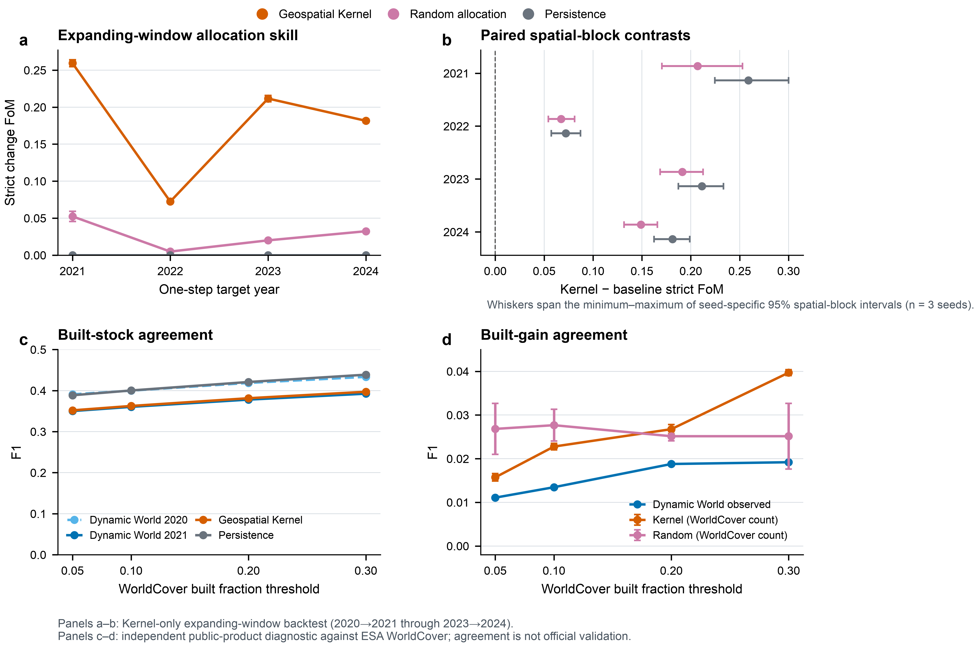
Rolling-origin robustness and external-product diagnostics. Panel a reports strict destination-change FoM for four leakage-controlled one-step targets; points show means and sample standard deviations across three computational seeds. Panel b reports Kernel-minus-baseline paired spatial-block contrasts; points are mean seed medians and whiskers span the minimum to maximum of seed-specific 95% intervals from 1,000 resamples of 8 × 8-cell blocks. Panel c compares same-year Dynamic World 2020 and 2021 built stocks, plus 2021 Kernel and persistence predictions, with the corresponding WorldCover products at four 100-m built-fraction thresholds. Panel d compares Dynamic World built gain with the count-controlled Kernel and random allocations, where WorldCover gain count is supplied as the action. The original oracle-demand gain test is structural-zero and is not plotted as model evidence. The WorldCover comparison is an external public-product diagnostic, not authoritative ground truth. Source data are provided in source_data_fig03_rolling_external_diagnostics.csv.
The reference reproduction environment is macOS arm64 with Python 3.11 and scikit-learn 1.9.0. The archived Linux arm64 rerun uses Python 3.12 and scikit-learn 1.8.0, so it measures a cross-stack boundary rather than an architecture-only effect. Across six rasters (2023 and 2024 for each seed), it differs from the current reference by 498–1,147 cells (0.62–1.44% of valid cells), with strict-FoM deltas from -0.0023 to 0.0010. An author-controlled GitHub Actions Ubuntu x86_64 rerun under Python 3.11.16 and scikit-learn 1.9.0 matched all six released categorical reference rasters exactly; its archived audit is linked in Code availability. This is a scoped locked-stack regression result, not universal bitwise identity. Independent external Windows FLUS verification is documented with its provenance limitation in Supplementary Table S3; its source rasters are not locally archived. The archived comparison report records the exact paths and environment fields for the arm64 pair.

Cross-product replication changes measured model skill
The harmonized products disagree materially even before a model is fitted. Across 2017–2024, same-year all-class agreement ranged from 0.651 to 0.745 and built-class intersection over union from 0.320 to 0.449. In 2024, Dynamic World mapped 155.98 km² of built land on the common grid, whereas the ArcGIS-served Impact Observatory/Microsoft/Esri series mapped 335.57 km². The latter declined to 327.31 km² in 2025. The added year improves the currency of the public origin state, but neither the larger built stock nor the native 10-m pixel size establishes greater local accuracy.
Under the leakage-controlled matched protocol, Geospatial Kernel had the largest mean strict FoM in all four Dynamic World targets (0.2595, 0.0724, 0.2116 and 0.1816 for 2021–2024), but in only two of the four matched ArcGIS-served targets. FLUS-style ANN–CA led the ArcGIS-served 2021 target (0.0625 versus Kernel 0.0154 and GeoFM-LDN 0.0314), GeoFM-LDN led in 2022 (0.4488 versus 0.2775 and 0.2227), and Kernel numerically led in 2023 and 2024 (0.1619 and 0.1674). The Kernel-minus-random paired spatial-block interval excluded zero in every ArcGIS-served year and seed, including the additional 2025 target, but its ArcGIS-minus-Dynamic World mean FoM difference was -0.244, +0.205, -0.050 and -0.014 across the four matched years. Thus the learned allocator contains repeatable spatial signal relative to its zero model, while its absolute score and rank remain dependent on the product pipeline. The finite-iteration FLUS-style CA retained demand total variation up to 0.00153 in the ArcGIS-served track and 0.00415 in Dynamic World; the exact-count Kernel, GeoFM-LDN and random allocators had zero demand error by construction. Supplementary Table S6 reports all target years and product-agreement values.
The planning conclusion was more stable than the historical ranking. Recomputing the same three-objective Pareto rule on each product-specific 2031 scenario bundle retained FLUS-style and Kernel candidates, and excluded GeoFM-LDN, in all three scenarios. This does not validate either future bundle; it shows only that frontier membership was insensitive to this particular public-product replacement under the released proxy objectives. Fig. 4 separates changes in mapped stock, same-year product agreement, ArcGIS-served historical skill and the matched product difference.
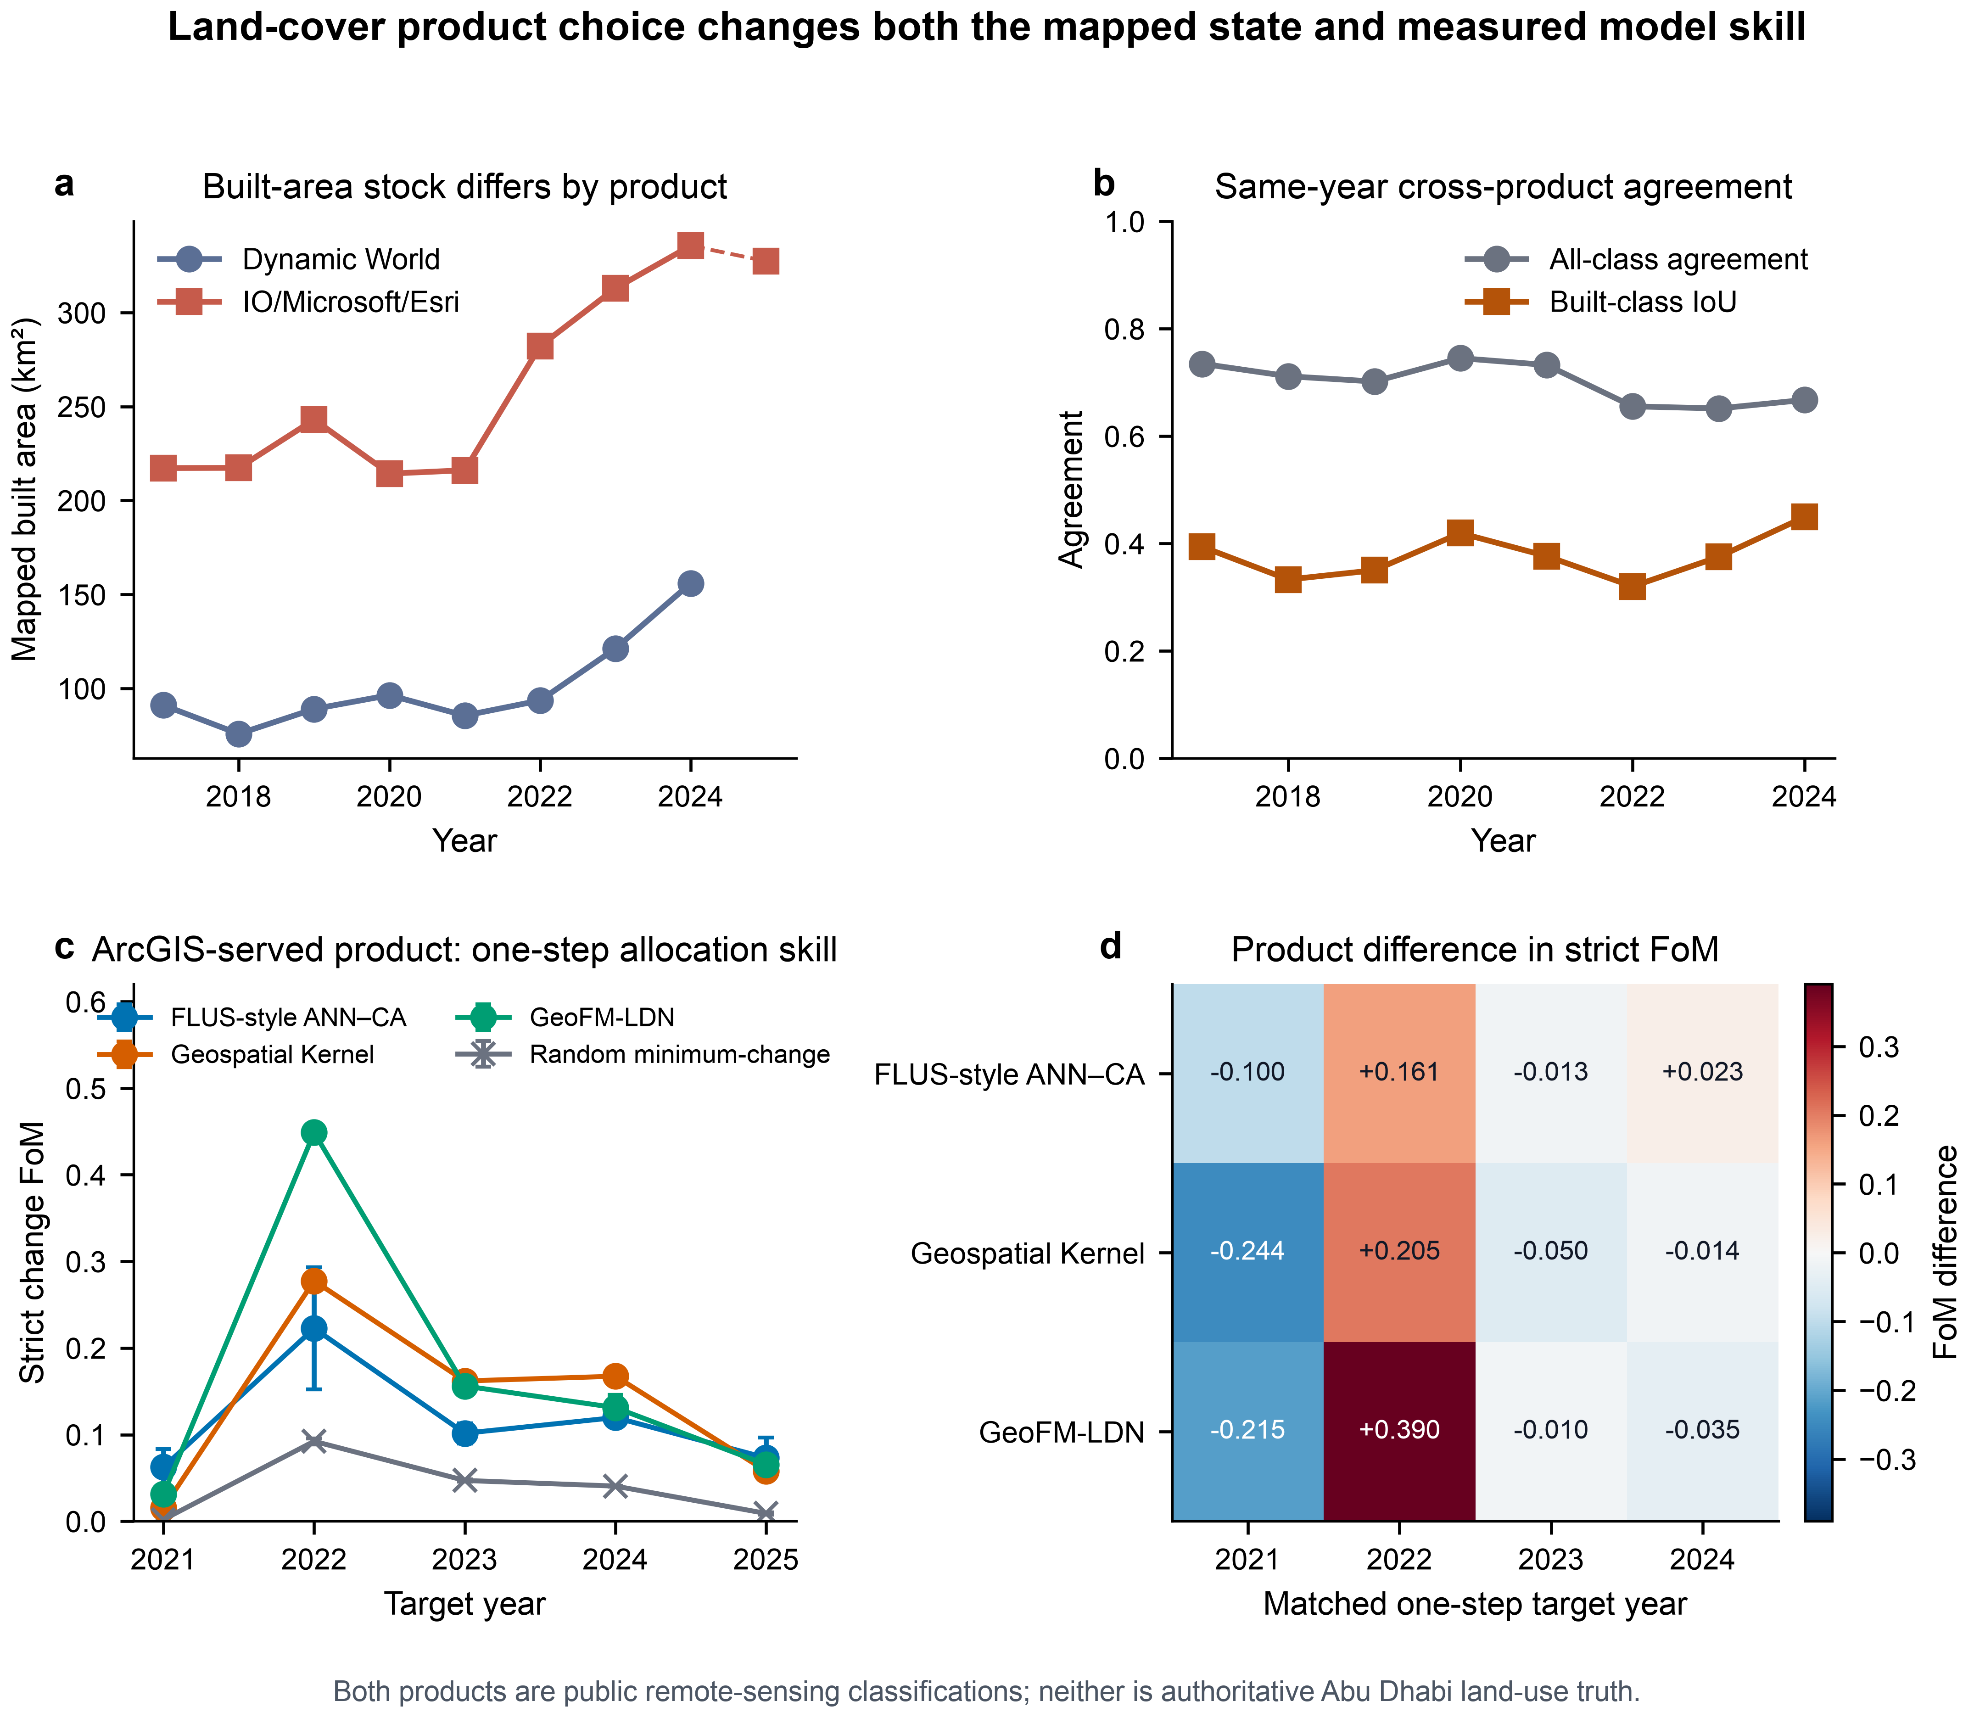
Land-cover product robustness. Panel a compares annual mapped built area; only the ArcGIS-served Impact Observatory/Microsoft/Esri series extends to 2025. Panel b reports same-year all-class agreement and built-class intersection over union after six-class harmonization at 100 m. Panel c reports strict destination-change FoM for the ArcGIS-served expanding-window backtest; points are three-seed means and whiskers are population standard deviations. Panel d gives the ArcGIS-served-minus-Dynamic World mean FoM for the four matched one-step targets. All models omit the later road snapshot. Product-specific labels, origin states, oracle totals, origin water/wetland masks and quality semantics are retained, so this is a whole-product-pipeline test rather than authoritative validation. Source data are provided in source_data_fig04_product_robustness.csv.
The planning compiler compares the three models within each of the three scenarios. At 2031, the FLUS-style control has union-built component densities of 2.48–3.27 per 1,000 valid cells, the Kernel 2.92–4.28 and GeoFM-LDN 3.21–4.35. The Kernel is closer to major roads and prior built cells, whereas the union metric shows that this edge-filling pattern does not automatically imply lower overall fragmentation than the FLUS-style allocations. Under the release objective set, the within-scenario frontiers contain FLUS-style and Kernel candidates in all three scenarios; GeoFM-LDN is dominated in each scenario. In the preceding v5 formulation, GeoFM-LDN could appear non-dominated only because its ecological-conversion value was the same structural zero as the exact-count Kernel; that zero is not a model advantage. Ecological conversion is therefore retained only as a diagnostic in v6. All sensitivity variants retain the same FLUS-style/Kernel two-model frontier. These statements are conditional on public proxy layers and synthetic actions, not model superiority claims. The corresponding objective profiles and diagnostic trade-offs are shown in Fig. 5.
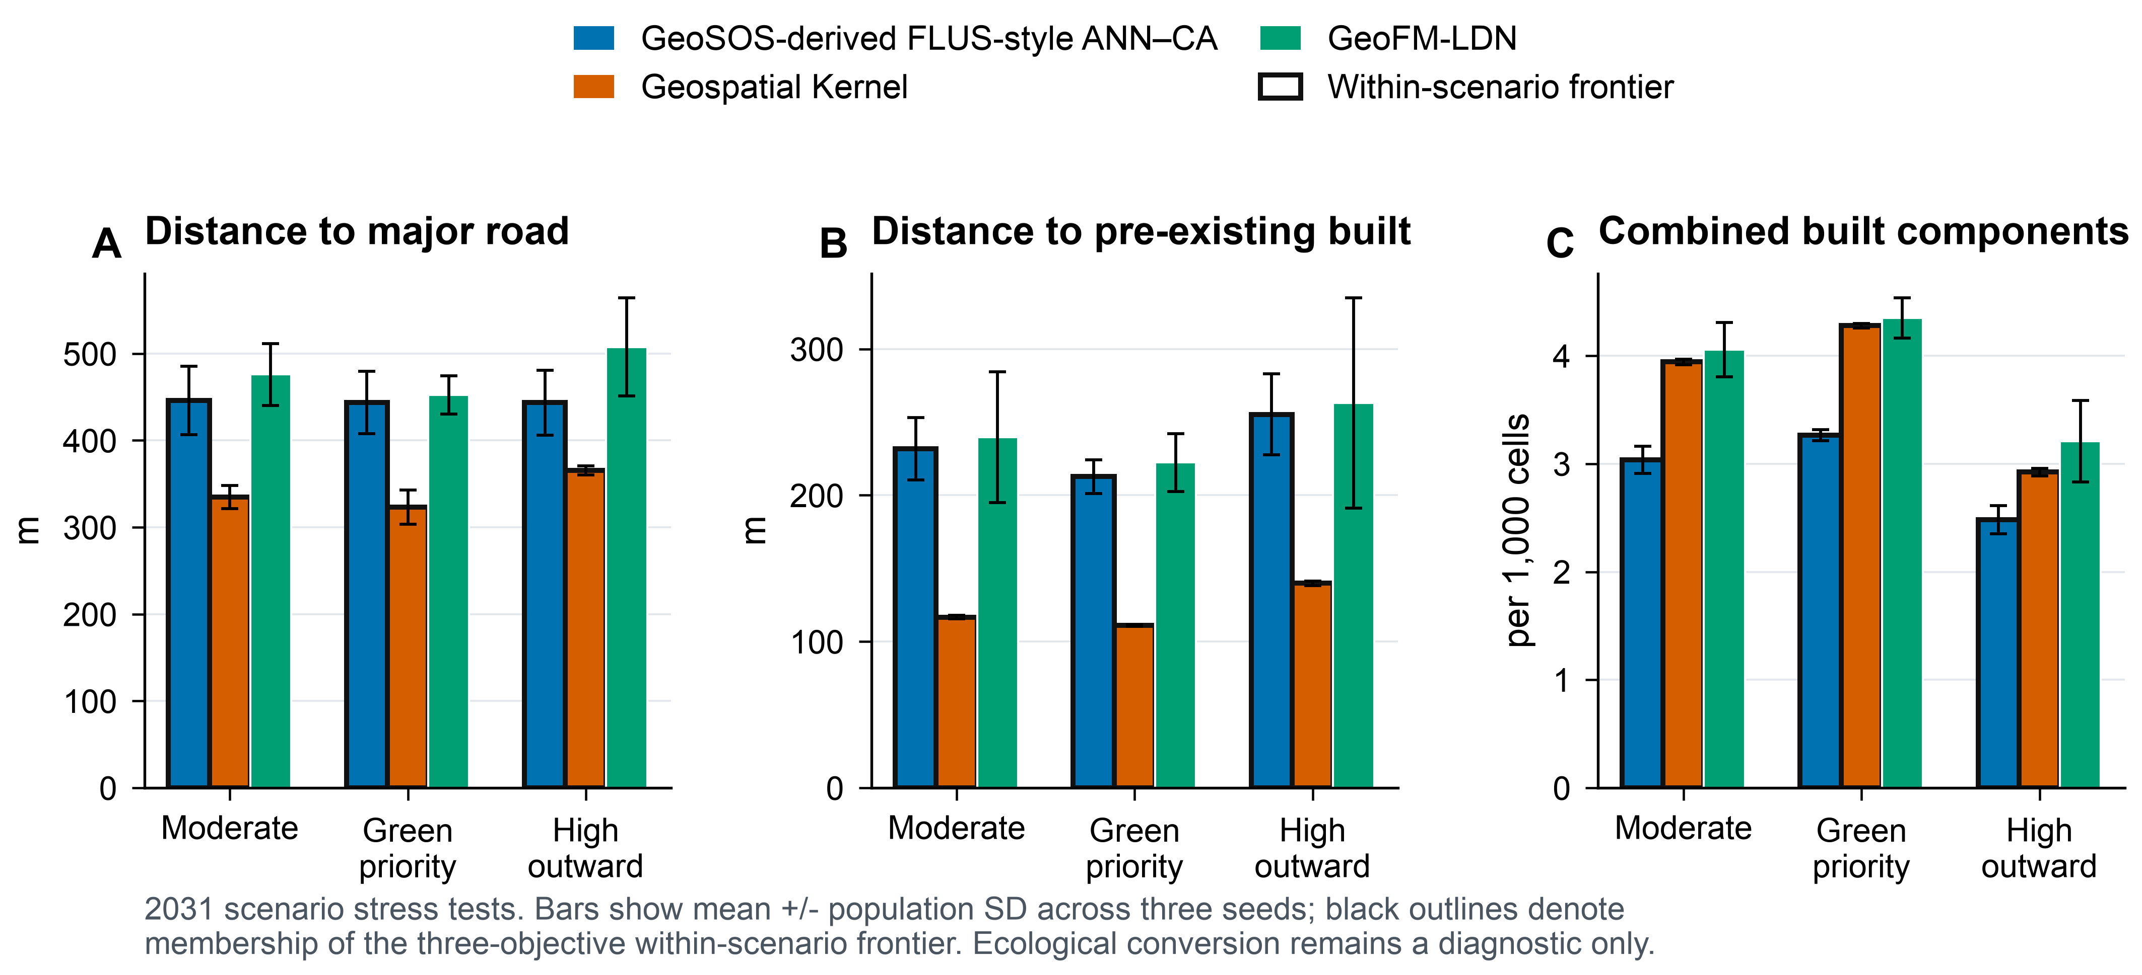
Conditional planning objectives. The 2031 outcomes compare the three models under moderate-growth, green-priority-growth and high-outward-growth actions. Panels show the three release objectives: distance to major roads, distance to pre-existing built cells, and connected components in the combined 2024-built and newly built footprint. Black outlines indicate membership of the within-scenario Pareto frontier.
Table 2. 2031 within-scenario planning objectives. Values are means across three seeds. Road and pre-existing-built distances are in metres; components are the number in the combined 2024-built and newly built footprint per 1,000 valid cells. Ecological conversion is a descriptive fraction of new-built cells whose origin was woody vegetation, low vegetation or wetland. Asterisks indicate the primary within-scenario Pareto frontier.
Scenario / model | Road (m) | Prior built (m) | Components / 1,000 | Ecology* | Frontier
Moderate
FLUS-style ANN–CA | 446.1 | 231.6 | 3.035 | 0.0168 | *
Geospatial Kernel | 334.7 | 116.7 | 3.943 | 0.0000 | *
GeoFM-LDN | 475.9 | 239.7 | 4.056 | 0.0000
Green priority
FLUS-style ANN–CA | 443.7 | 212.7 | 3.265 | 0.0177 | *
Geospatial Kernel | 323.1 | 111.0 | 4.277 | 0.0000 | *
GeoFM-LDN | 452.1 | 222.3 | 4.348 | 0.0000
High outward
FLUS-style ANN–CA | 443.5 | 255.3 | 2.484 | 0.0131 | *
Geospatial Kernel | 365.5 | 139.8 | 2.923 | 0.0000 | *
GeoFM-LDN | 507.5 | 263.0 | 3.207 | 0.0000

Sensitivity shows a stable but not fully explained neighbourhood contribution
The base Kernel allocation score adds a 7 × 7 target-class neighbourhood fraction with weight 0.35. The existing sensitivity and mechanism artefacts are retained as diagnostic controls; they do not identify a causal effect because the proposal features and allocator both contain spatial context. The neighbourhood term is therefore interpreted as evidence about the execution mechanism, not as an independently estimated planning preference. Fig. 6A shows focused proposal controls, and Fig. 6B reports the matched runtime controls.
In the post-hoc neighbourhood-weight sensitivity, mean strict FoM ranged from 0.19570 to 0.19609 in 2023 and from 0.25273 to 0.25304 in 2024; the complete strict-evaluator scan is provided in Supplementary Table S2. These changes are small relative to the model contrasts and are not interpreted causally. Objective-set sensitivity on the planning rasters retained the FLUS-style and Kernel candidates in all scenarios. GeoFM-LDN was dominated in all three scenarios after the structurally zero ecological-conversion term was removed from the release objectives.

Mechanism controls separate learned proposal from runtime projection
Mechanism controls separate the learned proposal from runtime projection, hard constraints and recursive writeback. They are not causal policy experiments. Deleting the action reduces mean strict FoM by 0.1124 in 2023 and 0.1699 in 2024, whereas deleting the hard constraint increases it by 0.014 and 0.011, respectively. The former is expected because the historical task supplies oracle target counts; it shows that much of the measured skill belongs to the action-conditioned allocator rather than to a demand forecast. The latter is an important warning: allowing changes inside the exclusion mask can improve agreement with noisy labels while violating the planning contract. The controls therefore support an execution-level interpretation but do not prove that either component causes an urban outcome.
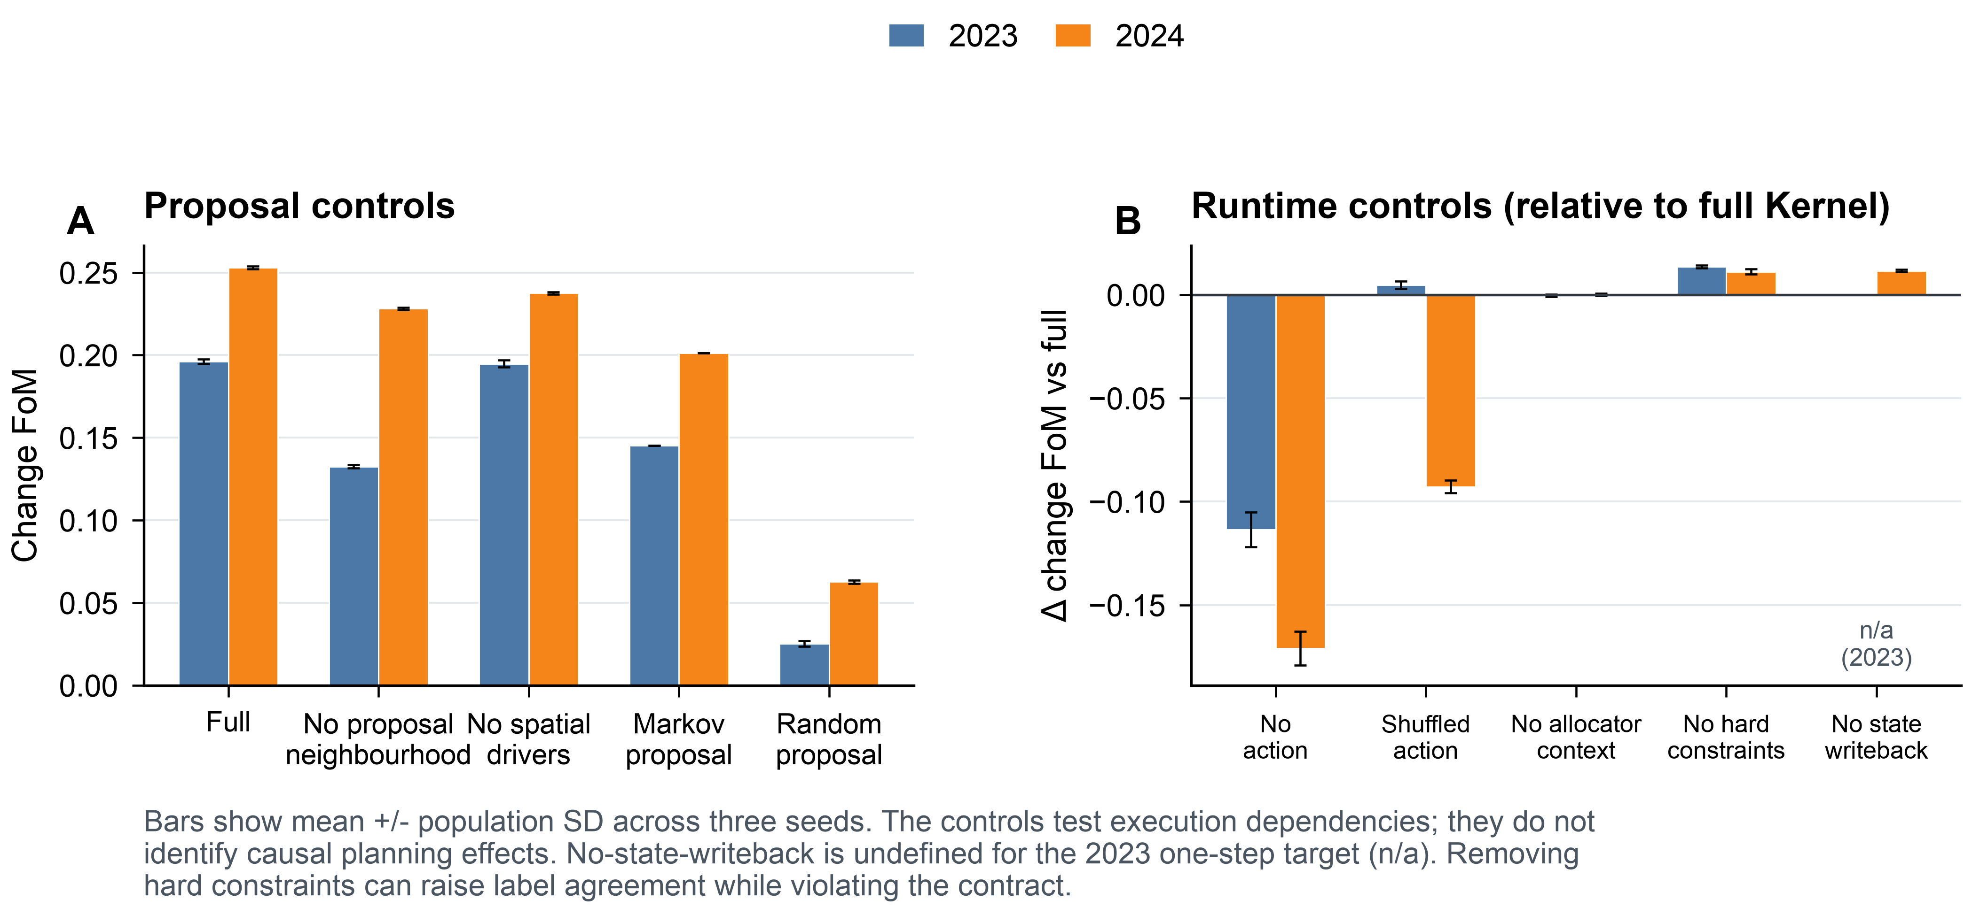
Mechanism controls. Panel A compares the full transition proposal with selected proposal controls. Panel B gives the strict destination-change FoM difference between matched runtime controls and the full Kernel. Bars show mean plus or minus population standard deviation across the three frozen seeds. The no-state-writeback control is undefined for the 2023 one-step target and is therefore shown only for 2024. These are execution diagnostics, not causal policy experiments.

Spatial footprints are scenario-conditioned, not parcel predictions
The 2031 majority-vote ensemble L1 demand errors were 8, 44 and 42 pixels for the Kernel’s moderate, green-priority and high-outward scenarios, respectively; the corresponding GeoFM-LDN errors were 1,580, 1,524 and 1,148 pixels and the FLUS-style errors were 2,504, 2,888 and 2,568 pixels. Seed-level projections meet their feasible class totals, but majority voting can produce a different raster and therefore a non-zero ensemble error. All 312 historical, rolling-origin and planning prediction records passed the raster audit, and the two frozen WorldCover evidence rasters passed the evidence audit. Fig. 7 uses the high-outward scenario to make the spatial contrast legible; the complete nine-panel atlas is provided as Fig. S1. These are raster-cell change footprints, not parcel boundaries or statutory zoning maps.
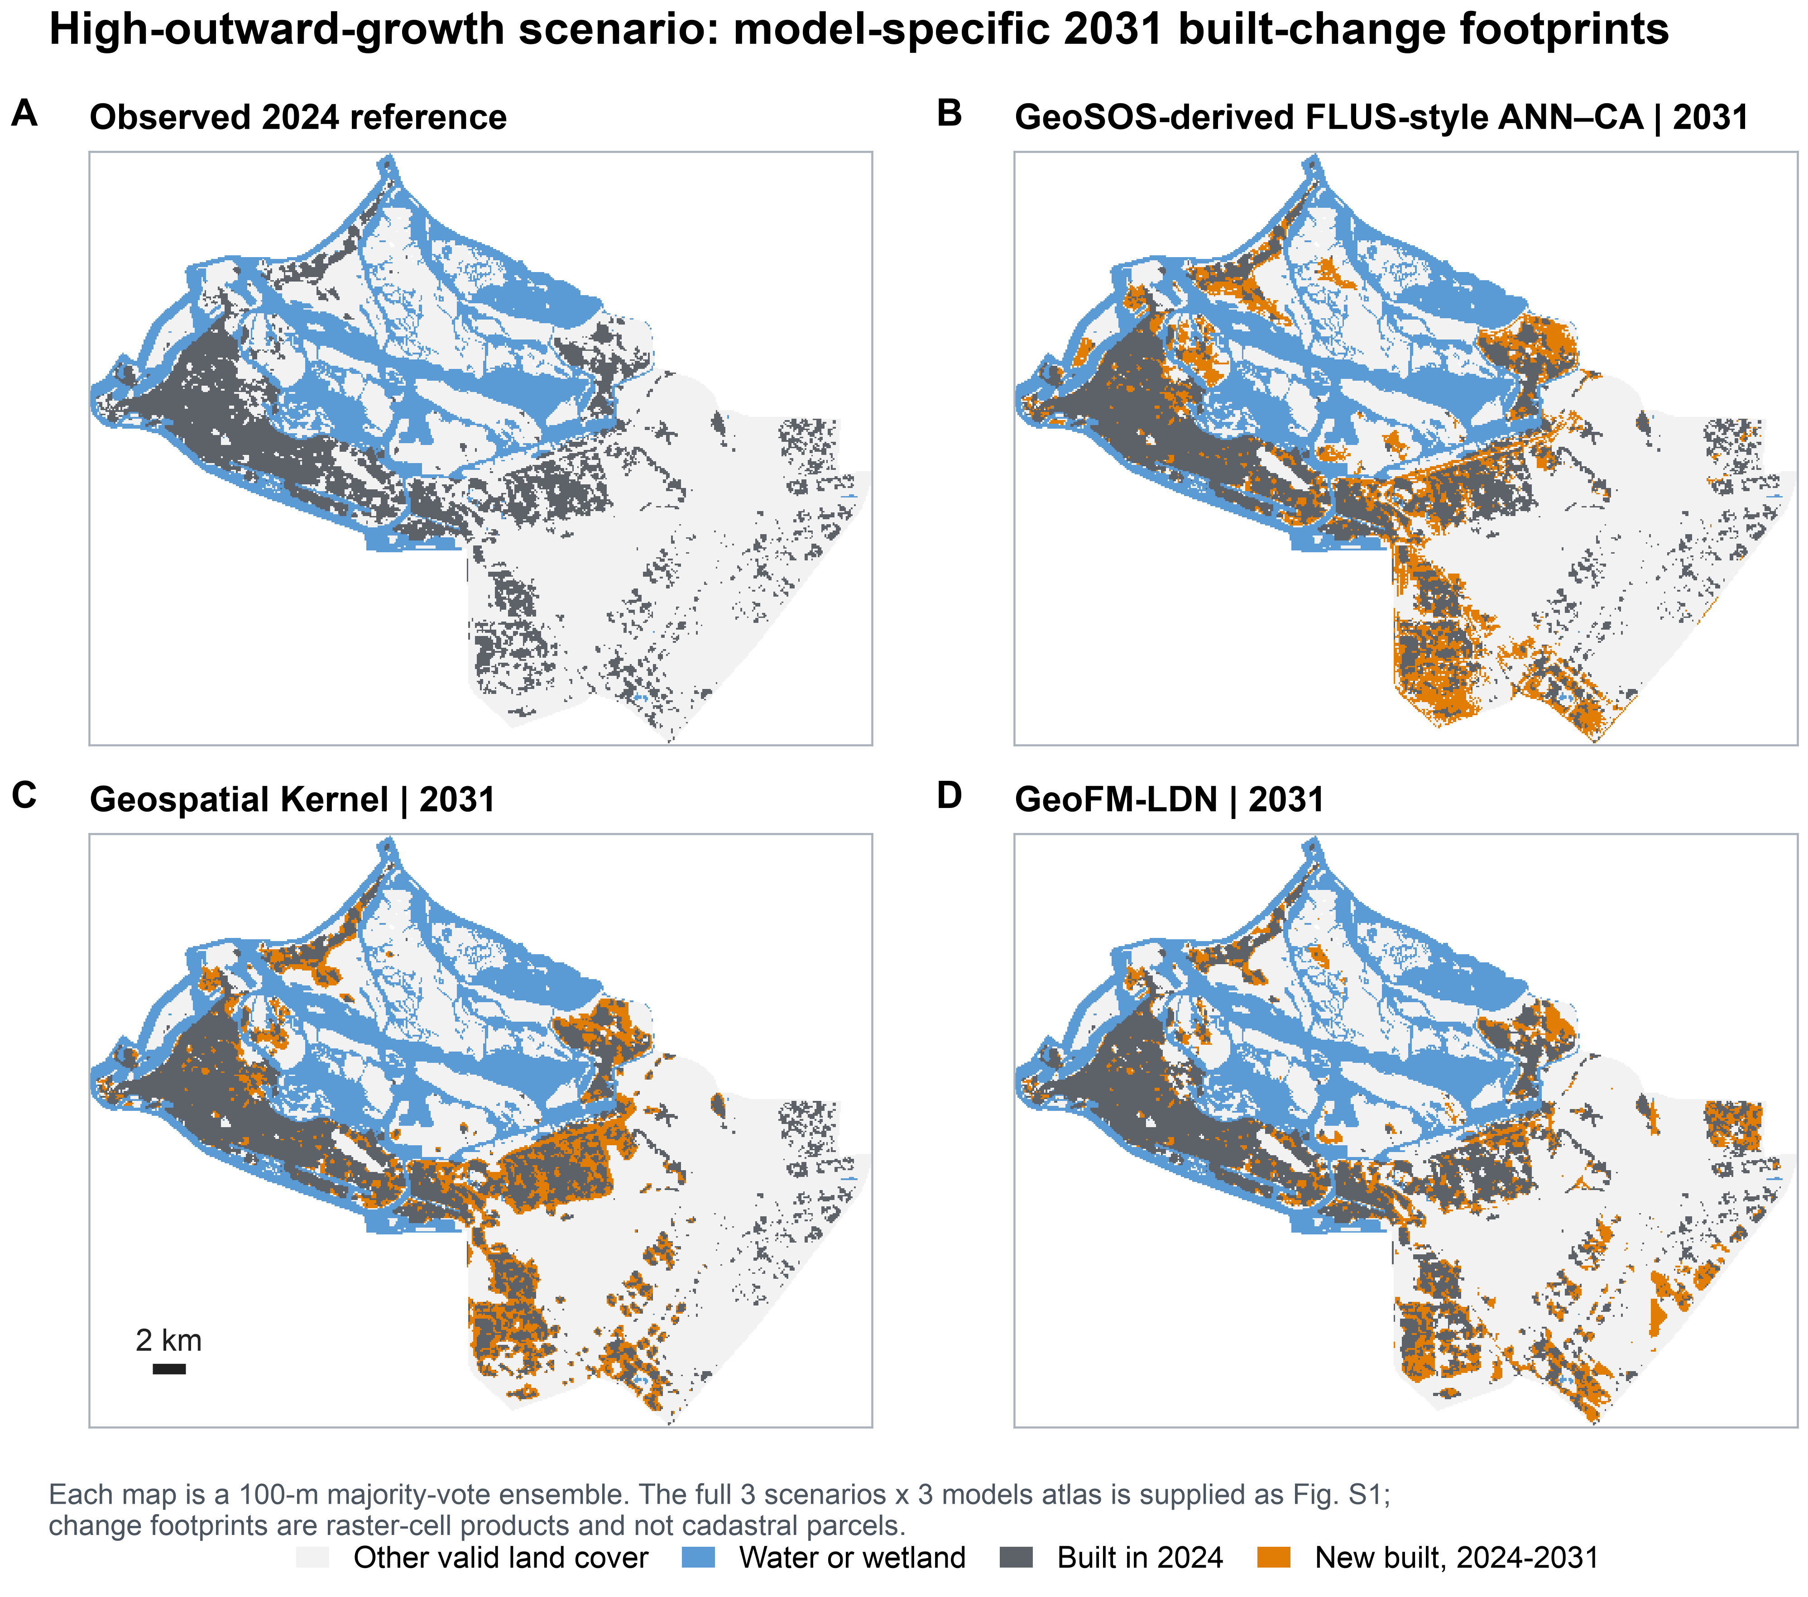
High-outward-growth spatial footprints. The observed 2024 state is compared with each model’s 2031 majority-vote ensemble. Orange denotes cells newly built between 2024 and 2031; grey denotes cells already built in 2024. The map is a 100-m scenario stress-test product, not a cadastral or statutory land-use map.

Discussion
This study positions Geospatial Kernel as a candidate execution layer for constrained spatial reasoning and, more broadly, proposes an audit protocol for annual label-product uncertainty. The defensible contribution is that a transition proposal and a planning admission rule can be represented and inspected separately even when the observational product changes. Kernel exceeded the random minimum-change control in every Dynamic World and ArcGIS-served expanding-window fold, but product replacement changed its absolute FoM by as much as 0.244 downward and 0.205 upward and changed which learned model ranked first. The original unmatched 2023–2024 result is therefore supporting evidence, not a universal ordering. By contrast, the released three-objective planning frontiers retained FLUS-style and Kernel candidates across both product-specific scenario bundles. Historical allocation skill and conditional planning-objective membership are different robustness questions; neither is a test of statutory forecast accuracy.
The WorldCover diagnostic also does not provide blanket external validation: the original Dynamic World-count gain comparison is structurally zero-powered because the observed built count declines. Its count-controlled variant remains near opportunity-level agreement overall: Kernel is below random at 0.05, indistinguishable from random at 0.10–0.20 given three-seed variation, and above random only at 0.30. The low-threshold deficit is consistent with WorldCover’s sparse or road-edge cells just above the 5% built-fraction threshold being inconsistently represented by Dynamic World. Confidence filtering, rolling-window stability, WorldCover agreement and the new complete-product replication test different failure modes. None substitutes for authoritative local validation.
The evidence remains bounded. The six classes are remote-sensing land cover, not statutory residential, commercial or industrial land use. Dynamic World and the ArcGIS-served series are both global products derived from Sentinel observations; their disagreement does not identify which label is correct. Product-native quality terms and origin-year water/wetland masks also differ, so the replication measures complete pipeline dependence rather than a causal effect of replacing labels alone. The available 2020–2021 WorldCover diagnostic is neither fully independent nor authoritative, and no local reference change sample or observed 2026–2031 label exists. The original headline analysis also uses a 31 July 2026 OSM road snapshot, which may contain roads constructed after 2022. This information is shared by all three pipelines and therefore does not change their ordering, but it can affect absolute scores; the strict rolling-origin analysis removes those road features and should define the no-leakage boundary. As a descriptive bound, the road-free rolling 2023 one-step FoM is 0.2116, of the same order as the headline 2023 value of 0.1961; these values are not directly comparable because the rolling fit uses 23 features and training through 2022, whereas the headline fit uses 25 features and training through 2021. Public wetland and protected-area layers are proxies, future drivers are held at 2024, and the green-priority action has no water-budget constraint. The FLUS-style control is an Apple-Silicon binary rebuilt from the public GeoSOS source base with the modified train/train-update and deterministic-seeding patches; its headline comparison uses seven drivers. The 25-feature run is a platform-sensitive identity-leakage diagnostic: five of six platform–seed runs collapsed to zero change, so the non-collapsed macOS seed-31 result is not used as a comparative estimate. These public-data stress tests therefore do not establish causal planning effects or a validated Abu Dhabi forecast. An authoritative deployment would replace public labels and masks with locally approved land-use, infrastructure, ecological and development-demand records while retaining the same execution contract.

Conclusions
Replacing Dynamic World with a newer ArcGIS-served 10-m annual product did not simply raise or lower every score. It changed mapped built stock, transition prevalence and the leading model by year. Geospatial Kernel remained consistently better than random minimum-change allocation, but it was not universally the best learned model. Its strongest transferable property in this experiment is therefore the auditable separation of learned proposal, constrained projection and state writeback, not a product-independent accuracy claim.
The refreshed series adds a 2025 public origin state, native-10-m audit rasters and complete 2026–2031 raster and vector scenario deliveries. Model execution remains at 100 m, and both future bundles are conditional stress tests. A valid operational forecast still requires locally approved land-use history, planning constraints, demand assumptions and an independent change-validation design.

Data availability
The public-data benchmark manifests, reports, generated delivery artefacts and source-data tables are available from an anonymized repository and archival package. Repository and archive identifiers are withheld during double-anonymized review and will be supplied in the accepted version. The package includes the Dynamic World and ArcGIS-served product-track reports, aligned public rasters, planning outputs, raster-cell transition footprints and integrity manifests. Authoritative Abu Dhabi land-use and independent reference data are not part of this study.

Code availability
The analysis scripts, benchmark protocol, model runners, figure-generation code, model assets and integrity checks are maintained in the accompanying anonymized repository and archival package. Identifiers and contact details are withheld during double-anonymized review and will be supplied in the accepted version.

Declarations
Funding, competing interests, author contributions, acknowledgements and ethics information are supplied in the separate title page and submission metadata.

References
Abu Dhabi Urban Planning Council. (2007). Plan Abu Dhabi 2030: urban structure framework plan. Abu Dhabi, United Arab Emirates.
Brown, C. F., Brumby, S. P., Guzder-Williams, B., Birch, T., Hyde, S. B., Mazzariello, J., Czerwinski, W., Pasquarella, V. J., Haertel, R., Ilyushchenko, S., Schwehr, K., Weisse, M., Stolle, F., Hanson, C., Guinan, O., Moore, R., & Tait, A. M. (2022). Dynamic World, near real-time global 10 m land use land cover mapping. Scientific Data, 9, 251. https://doi.org/10.1038/s41597-022-01307-4
Brown, C. F., Kazmierski, M. R., Pasquarella, V. J., Rucklidge, W. J., Samsikova, M., Zhang, C., Shelhamer, E., Lahera, E., Wiles, O., Ilyushchenko, S., Gorelick, N., Zhang, L. L., Alj, S., Schechter, E., Askay, S., Guinan, O., Moore, R., Boukouvalas, A., & Kohli, P. (2025). AlphaEarth Foundations: An embedding field model for accurate and efficient global mapping from sparse label data. arXiv. https://doi.org/10.48550/arXiv.2507.22291
Burton, E. (2000). The compact city: just or just compact? A preliminary analysis. Urban Studies, 37, 1969–2006. https://doi.org/10.1080/00420980050162184
Elvidge, C. D., Zhizhin, M., Ghosh, T., Hsu, F.-C., & Taneja, J. (2021). Annual time series of global VIIRS nighttime lights derived from monthly averages: 2012 to 2019. Remote Sensing, 13, 922. https://doi.org/10.3390/rs13050922
European Space Agency. (2024). Copernicus DEM GLO-30: global 30 m digital elevation model [Data set]. Google Earth Engine Data Catalog. https://developers.google.com/earth-engine/datasets/catalog/COPERNICUS_DEM_GLO30_2024_1
GeoSOS team, Sun Yat-sen University. (n.d.). FLUS source code for non-commercial academic research. http://www.geosimulation.cn/FLUS-source-code.html (accessed 6 September 2026).
Gorelick, N., Hancher, M., Dixon, M., Ilyushchenko, S., Thau, D., & Moore, R. (2017). Google Earth Engine: planetary-scale geospatial analysis for everyone. Remote Sensing of Environment, 202, 18–27. https://doi.org/10.1016/j.rse.2017.06.031
Impact Observatory, Microsoft, & Esri. (2026). Sentinel-2 10m land cover time series of the world [Data set]. ArcGIS ImageServer. https://ic.imagery1.arcgis.com/arcgis/rest/services/Sentinel2_10m_LandCover/ImageServer (accessed 8 September 2026).
Karra, K., Kontgis, C., Statman-Weil, Z., Mazzariello, J. C., Mathis, M., & Brumby, S. P. (2021). Global land use/land cover with Sentinel 2 and deep learning. 2021 IEEE International Geoscience and Remote Sensing Symposium IGARSS, 4704–4707. https://doi.org/10.1109/IGARSS47720.2021.9553499
Lau, K. H., & Kam, B. H. (2005). A cellular automata model for urban land-use simulation. Environment and Planning B: Planning and Design, 32, 247–263. https://doi.org/10.1068/b31110
Liang, X., Guan, Q., Clarke, K. C., Liu, S., Wang, B., & Yao, Y. (2021). Understanding the drivers of sustainable land expansion using a patch-generating land use simulation (PLUS) model: A case study in Wuhan, China. Computers, Environment and Urban Systems, 85, 101569. https://doi.org/10.1016/j.compenvurbsys.2020.101569
Liu, X., Liang, X., Li, X., Xu, X., Ou, J., Chen, Y., Li, S., Wang, S., & Pei, F. (2017). A future land use simulation model (FLUS) for simulating multiple land use scenarios by coupling human and natural effects. Landscape and Urban Planning, 168, 94–116. https://doi.org/10.1016/j.landurbplan.2017.09.019
OpenStreetMap contributors. (2026). OpenStreetMap data, Abu Dhabi relation R4479763 and Geofabrik GCC extract, accessed 31 July 2026. https://www.openstreetmap.org
Pedregosa, F., Varoquaux, G., Gramfort, A., Michel, V., Thirion, B., Grisel, O., Blondel, M., Prettenhofer, P., Weiss, R., Dubourg, V., Vanderplas, J., Passos, A., Cournapeau, D., Brucher, M., Perrot, M., & Duchesnay, E. (2011). Scikit-learn: Machine learning in Python. Journal of Machine Learning Research, 12, 2825–2830. https://jmlr.org/papers/v12/pedregosa11a.html
Pontius, R. G., Jr., Boersma, W., Castella, J.-C., Clarke, K., de Nijs, T., Dietzel, C., Duan, Z., Fotsing, E., Goldstein, N., Kok, K., Koomen, E., Lippitt, C. D., McConnell, W., Mohd Sood, A., Pijanowski, B., Pithadia, S., Sweeney, S., Trung, T. N., Veldkamp, A. T., & Verburg, P. H. (2008). Comparing the input, output, and validation maps for several models of land change. The Annals of Regional Science, 42, 11–37. https://doi.org/10.1007/s00168-007-0138-2
Pontius, R. G., Jr., & Millones, M. (2011). Death to Kappa: birth of quantity disagreement and allocation disagreement for accuracy assessment. International Journal of Remote Sensing, 32, 4407–4429. https://doi.org/10.1080/01431161.2011.552923
Silva, E. A., & Clarke, K. C. (2002). Calibration of the SLEUTH urban growth model for Lisbon and Porto, Portugal. Computers, Environment and Urban Systems, 26, 525–552. https://doi.org/10.1016/S0198-9715(01)00014-X
Soares-Filho, B. S., Cerqueira, G. C., & Pennachin, C. L. (2002). DINAMICA—a stochastic cellular automata model designed to simulate the landscape dynamics in an Amazonian colonization frontier. Ecological Modelling, 154, 217–235. https://doi.org/10.1016/S0304-3800(02)00059-5
van Vliet, J., Bregt, A. K., & Hagen-Zanker, A. (2011). Revisiting Kappa to account for change in the accuracy assessment of land-use change models. Ecological Modelling, 222, 1367–1375. https://doi.org/10.1016/j.ecolmodel.2011.01.017
van Vliet, J., Bregt, A. K., Brown, D. G., van Delden, H., Heckbert, S., & Verburg, P. H. (2016). A review of current calibration and validation practices in land-change modeling. Environmental Modelling & Software, 82, 174–182. https://doi.org/10.1016/j.envsoft.2016.04.017
Verburg, P. H., Soepboer, W., Veldkamp, A., Limpiada, R., Espaldon, V., & Mastura, S. S. A. (2002). Modeling the spatial dynamics of regional land use: the CLUE-S model. Environmental Management, 30, 391–405. https://doi.org/10.1007/s00267-002-2630-x
Zanaga, D., Van De Kerchove, R., De Keersmaecker, W., Souverijns, N., Brockmann, C., Quast, R., Wevers, J., Grosu, A., Paccini, A., Vergnaud, S., Cartus, O., Santoro, M., Fritz, S., Georgieva, I., Lesiv, M., Carter, S., Herold, M., Li, L., Tsendbazar, N.-E., Ramoino, F., & Arino, O. (2021). ESA WorldCover 10 m 2020 v100 [Data set]. Zenodo. https://doi.org/10.5281/zenodo.5571936
Zanaga, D., Van De Kerchove, R., Daems, D., De Keersmaecker, W., Brockmann, C., Kirches, G., Wevers, J., Cartus, O., Santoro, M., Fritz, S., Lesiv, M., Herold, M., Tsendbazar, N.-E., Xu, P., Ramoino, F., & Arino, O. (2022). ESA WorldCover 10 m 2021 v200 [Data set]. Zenodo. https://doi.org/10.5281/zenodo.7254221

Supplementary information outline
- Supplementary Note 1: Complete data crosswalk, quality metrics and public/proxy status.
- Supplementary Note 2: Kernel runtime schemas, audit fields and adapter boundary.
- Supplementary Table S1: Full 2025–2031 model–scenario objective matrix with per-seed values.
- Supplementary Table S2: Neighbourhood-weight sensitivity at 0, 0.175, 0.35 and 0.7 (see supplementary_table_S2_neighbourhood_weight_sensitivity.md).
- Supplementary Table S3: FLUS 13-, 19- and 25-feature diagnostics, platform boundary and demand-underfill evidence (see supplementary_table_S3_flus_feature_diagnostics.md).
- Supplementary Table S4: Raster and vector delivery audit, hashes and layer counts.
- Supplementary Table S5: Rolling-origin and WorldCover external-product diagnostics (see supplementary_table_S5_rolling_external_diagnostics.md).
- Supplementary Table S6: Matched Dynamic World and ArcGIS-served whole-product-pipeline backtests (see supplementary_table_S6_product_robustness.md).
- Fig. S1: Full 3-scenarios × 3-model 2031 new-built footprint atlas (figures/figS01_planning_atlas_2031.*).
- Fig. S2: Dynamic World confidence and high-confidence change sensitivity (figures/figS02_input_label_quality.*).
- Fig. S3: Historical maps and change-error maps for 2024 (figures/figS03_historical_2024_maps_and_errors.*).
- Fig. S4: Driver layers and experiment design in English (figures/figS04_driver_layers_and_experiment_design.*).

