From Parcels to Blocks: Rescaling Deep Reinforcement Learning for Farmland Consolidation Planning through Spatial Abstraction
Ning Zhou, Xiang Jing*
School of Software and Microelectronics, Peking University, Beijing 100871, China
* Corresponding author: jingxiang@pku.edu.cn

Abstract
Deep reinforcement learning (DRL) has shown potential for farmland spatial layout optimization on synthetic grids, but prior work demonstrates that parcel-level DRL fails catastrophically at scale on real cadastral data due to swap near-independence—where individual exchange decisions are largely independent of prior decisions, eliminating the sequential planning advantage that DRL requires. This paper proposes a block-level spatial abstraction that rescales the optimization from thousands of individual parcels to tens or hundreds of spatially coherent consolidation blocks, restoring the sequential interdependencies necessary for effective DRL. Our framework operates on a “macroscopic planning, microscopic execution” principle: a DRL agent trained with Maskable Proximal Policy Optimization allocates a limited consolidation budget across competing blocks (macroscopic planning), while a connectivity-aware greedy engine executes optimized parcel swaps within each selected block (microscopic execution). We introduce a novel reward signal based on baimu fang (100-mu consolidated field, ≥6.67 ha contiguous farmland) formation—a central metric in China’s farmland consolidation policy—alongside slope reduction and contiguity improvement. Experiments on three townships in Bishan District, Chongqing (78 to 338 blocks, derived from 3,607 to 12,950 parcels), demonstrate that the block-level formulation achieves 100% training convergence across all 15 seed–township combinations—compared to only 20% (3/15) for the parcel-level approach—completely resolving the scalability bottleneck. Notably, the DRL agent develops emergent township-specific strategies under identical hyperparameters: a balanced multi-objective strategy on the small township, a contiguity-and-baimu fang-focused strategy on the medium township that achieves the highest contiguity improvement (+0.115) and is the only method with positive baimu fang area growth (+12.9 ha), and a baimu fang-focused strategy on the large township that forms 5 new consolidated fields (far exceeding all baselines). These findings demonstrate that spatial abstraction—lifting the decision granularity to policy-relevant consolidation units—is a principled and effective approach to scaling DRL for real-world farmland consolidation planning, with direct alignment to China’s Comprehensive Land Consolidation policy framework.
Keywords: deep reinforcement learning ; farmland consolidation ; spatial abstraction ; block-level optimization ; baimu fang ; land use policy

1. Introduction
% ============================================================================
Farmland consolidation—the spatial reorganization of fragmented agricultural parcels into contiguous, productive blocks—is a central instrument of China’s Comprehensive Land Consolidation policy (quanyu tudi zonghe zhengzhi). Recent policy directives from the Ministry of Natural Resources emphasize the formation of baimu fang (100-mu consolidated fields, ≥6.67 ha of contiguous farmland) and qianmu fang (1,000-mu fields, ≥66.7 ha) as quantitative targets for consolidation projects, reflecting the operational reality that mechanized agriculture requires large, connected arable blocks rather than dispersed smallholdings [long2018land, liu2014land]. In the mountainous regions of southwest China, where steep slopes, fragmented ownership, and interspersed forest create particularly challenging spatial configurations, the optimization of farmland–forest exchange plans—determining which steep-slope farmland parcels to convert to forest and which gentle-slope forest parcels to convert to farmland—is a combinatorial problem of considerable complexity.
Deep reinforcement learning (DRL) has emerged as a promising paradigm for sequential spatial optimization. In a proof-of-concept study on synthetic grid data, zhou2026transferable demonstrated that Maskable Proximal Policy Optimization (Maskable PPO) with a dimension-invariant scoring policy can effectively optimize parcel-level farmland layouts, achieving consistent slope reduction and contiguity improvement with zero-shot cross-dataset transferability. However, a subsequent scaling study on real cadastral parcels from China’s Third National Land Survey (TNLS) revealed fundamental limitations: at the parcel level, DRL exhibits bimodal convergence—either converging to strong policies or failing completely—with convergence rates declining from 100% on small townships (3,607 parcels) to 0% on large townships (12,950 parcels) [zhou2026scaling]. The root cause was identified as swap near-independence: on irregular parcels with heterogeneous areas, each exchange decision’s quality depends primarily on local parcel attributes rather than on prior decisions, making greedy selection near-optimal and eliminating DRL’s sequential planning advantage.
This diagnosis points directly to a solution: the problem must be reformulated at a spatial scale where genuine sequential interdependencies exist. Rather than selecting individual parcels (where decisions are near-independent), the agent should allocate a consolidation budget across competing spatial units, where investing in one unit reduces resources available for others. This resource-competition structure creates the sequential dependencies that DRL requires to outperform simpler methods.
We propose a block-level spatial abstraction that operationalizes this insight. The framework consists of three stages:
- Spatial restructuring: Thousands of irregular parcels are aggregated into tens to hundreds of spatially coherent consolidation blocks using a hybrid method combining natural barrier segmentation (roads, waterways, construction land) with constrained agglomerative clustering.
- Block-level MDP: The optimization is formulated as a Markov Decision Process where the agent selects which block to invest consolidation resources in at each step, observing per-block characteristics and global state metrics.
- Connectivity-aware execution: Within each selected block, a deterministic greedy engine executes farmland–forest swaps using a novel connectivity-aware scoring function that preferentially removes steep, isolated farmland and converts gentle, farmland-adjacent forest—creating spatial spillover effects across block boundaries.
This “macroscopic planning, microscopic execution” design draws a direct analogy to real-world consolidation governance: a Natural Resources Bureau director allocates annual consolidation quotas across townships and villages (macroscopic planning), while local implementers execute specific parcel-level land-type conversions within their assigned areas (microscopic execution). Our framework encodes this two-level decision structure, making the DRL agent’s behavior interpretable in policy terms. Fig. fig:framework illustrates the overall architecture.
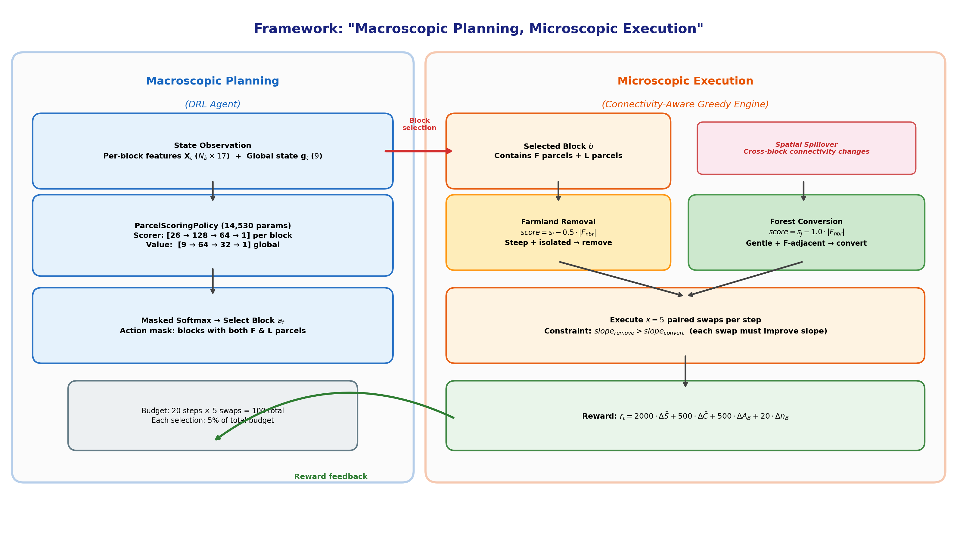
Figure: “Macroscopic planning, microscopic execution” framework architecture. The DRL agent allocates a consolidation budget across competing blocks (left), while a deterministic greedy engine executes optimized parcel swaps within each selected block (right). Spatial spillover across block boundaries creates the sequential dependencies that DRL exploits.

A key innovation is the introduction of baimu fang formation as both a reward signal and an evaluation metric. While prior work optimized for mean farmland slope and contiguity index—abstract statistical measures—baimu fang count and area are directly actionable policy targets: consolidation projects are evaluated and funded based on the number and total area of newly formed consolidated fields. By incorporating this metric, our framework bridges the gap between algorithmic optimization and policy-relevant outcomes.
We evaluate the framework on three townships spanning a 3.6× range in parcel count (3,607 to 12,950), comparing against four baselines (Greedy-Global, Greedy-Sequential, Random-Block, Round-Robin) across 5 random seeds per township. The principal findings are:
- The block-level MDP achieves 100% training convergence (15/15 seed–township combinations), completely resolving the scalability failure reported for parcel-level DRL (3/15 convergence).
- Under identical hyperparameters, the DRL agent develops emergent township-specific strategies: balanced on the small township, contiguity-and-baimu fang area-focused on the medium township, and baimu fang count-focused on the large township—demonstrating that the learned policy adapts to local spatial structure.
- On the large township where parcel-level DRL fails entirely (0% convergence), the block-level agent forms 5 new baimu fang per episode—a result unmatched by any baseline method (the next best achieves 2).
- The framework produces extremely low variance across random seeds (reward coefficient of variation <1% on the large township), indicating robust and reproducible optimization.
These results demonstrate that spatial abstraction—a conceptually simple but empirically powerful idea—is the key to scaling DRL for real-world farmland consolidation planning. The remainder of this paper is organized as follows: Section sec:related reviews related work; Section sec:data describes the study area and data; Section sec:methods presents the methodology in detail; Section sec:results reports experimental results; Section sec:discussion discusses implications and limitations; and Section sec:conclusions concludes.
% ============================================================================

2. Related Work
% ============================================================================

2.1 Farmland consolidation optimization
Farmland consolidation has been studied extensively using operations research and spatial optimization methods. Multi-objective evolutionary algorithms, particularly NSGA-II [deb2002fast] and boundary-based genetic algorithms [cao2012spatial], have been applied to land-use allocation at village and county scales. Integer programming approaches can guarantee optimality for linearizable objectives but struggle with neighborhood-dependent spatial metrics [aerts2003using]. Heuristic methods including simulated annealing [cao2011sustainable] and ant colony optimization [liu2012multi] offer flexible single-solution or population-based alternatives. However, these methods share a common limitation: they treat optimization as a static assignment problem, solving for a complete configuration without exploiting the sequential structure of consolidation decisions.
Recent work in China has emphasized the formation of standardized farmland blocks (gaobiaozhun nongtian) as the operational unit for consolidation planning [wu2005consolidation]. The baimu fang (100-mu field, ≥6.67 ha) serves as the fundamental planning unit in many provinces, with explicit numeric targets specified in consolidation project approval documents. Despite this policy emphasis, existing optimization methods operate at the parcel level without explicit consideration of consolidated block formation.

2.2 DRL for spatial optimization
Deep reinforcement learning has been applied to several spatial planning tasks. zheng2023spatial applied DRL to spatial planning of urban communities, demonstrating that policy gradient methods can learn effective spatial configurations. wang2021deep applied adversarial DRL to urban generation. In ecological planning, equihua2024conservation applied DRL to connectivity conservation planning. For farmland-specific applications, zhou2026transferable proposed a Maskable PPO framework with a dimension-invariant ParcelScoringPolicy for farmland–forest exchange optimization, achieving slope reduction and contiguity improvement on synthetic grid data with zero-shot cross-dataset transfer. zhou2026scaling subsequently identified the scalability limits of this parcel-level approach on real cadastral data, attributing the failure to swap near-independence arising from parcel area heterogeneity and sparse spatial interactions.
No existing work has applied DRL at the block level for farmland consolidation, nor has any prior study incorporated policy-relevant metrics such as baimu fang formation into the DRL reward structure.

2.3 Hierarchical and multi-scale optimization
The idea of decomposing spatial optimization across scales has precedent in operations research. Hierarchical reinforcement learning (HRL) decomposes complex tasks into sub-goals at different levels of abstraction [barto2003recent]. In spatial planning, li2011coupling proposed coupling different optimization scales through cellular automata. However, formal HRL methods (e.g., options framework, feudal networks) introduce substantial algorithmic complexity and training instability. Our approach achieves a similar scale decomposition through a simpler mechanism: the block-level agent selects where to invest, while a deterministic engine handles how to execute—avoiding the need to learn policies at both levels simultaneously.
% ============================================================================

3. Study Area and Data
% ============================================================================

3.1 Study area
The study area is Bishan District (29.4\degree–29.7\degreeN, 106.0\degree–106.3\degreeE), Chongqing Municipality, southwest China (Fig. fig:study_area). Bishan lies at the transition between the Sichuan Basin and surrounding low-mountain terrain, with elevations of 180–885 m above sea level. The subtropical monsoon climate supports a mixed agricultural–forest landscape where paddy fields, dry cropland, orchards, and forest interleave at fine spatial scales.
Three townships were selected to represent a gradient of spatial complexity:
- Township A (code 500227109): 3,607 parcels, 1,601 swappable (1,130 farmland + 471 forest), aggregated into 78 blocks.
- Township B (code 500227108): 5,500 parcels, 2,669 swappable (1,998 farmland + 671 forest), aggregated into 132 blocks.
- Township C (code 500227105): 12,950 parcels, 6,787 swappable (5,032 farmland + 1,755 forest), aggregated into 338 blocks.
These three townships are identical to those used in the parcel-level scaling study [zhou2026scaling], enabling direct comparison between the parcel-level and block-level approaches.
Table: Characteristics of the three study townships and their block-level aggregation. “Init.\ \textitbaimu
Township | Total | Swappable | Farmland | Forest | Blocks | Parcels/block | Median area (ha) | Init.\ baimu
A (Small) | 3,607 | 1,601 | 1,130 | 471 | 78 | 20 | 33 | 9
B (Medium) | 5,500 | 2,669 | 1,998 | 671 | 132 | 20 | 28 | 6
C (Large) | 12,950 | 6,787 | 5,032 | 1,755 | 338 | 20 | 20 | 6

3.2 Data sources
Land-use parcel data were obtained from the Third National Land Survey (TNLS) database for Bishan District, containing 101,657 parcels with DLBM land-use classification codes and parcel boundaries. Parcels were classified into farmland (DLBM codes 011–013), forest (031–033), and other categories. Slope data were derived from the Copernicus DEM GLO-30 dataset [copernicus2021dem] via zonal statistics, assigning per-parcel mean slope values. Additional features (elevation, aspect, shape index) were computed for the observation space following zhou2026scaling.
% ============================================================================

4. Methodology
% ============================================================================

4.1 Problem formulation
The farmland consolidation optimization is formulated as a tri-objective combinatorial problem. Given a set of parcels P = \p_1, …, p_M\ with land-use types l_i ∈ \farmland, forest, other\, slope values s_i, and areas a_i, the goal is to find a land-use assignment l^* that simultaneously:
Minimize: S &= \sum_i: l_i = F s_i \cdot a_i\sum_i: l_i = F a_i (area-weighted mean farmland slope) \\ Maximize: C &= 1|P_F| \sum_i ∈ P_F |\j ∈ N(i): l_j = F\||N(i)| (farmland contiguity) \\ Maximize: B &= \sum_k=1^K 1\left[area(C_k) ≥ A_baimu\right] (baimu fang count)
where N(i) denotes the set of parcels adjacent to p_i (Queen contiguity), C_1, …, C_K are the connected components of the farmland adjacency subgraph, and A_baimu = 66,700 m^2 (6.67 ha = 100 mu) is the policy-defined threshold for a consolidated field. The optimization is subject to farmland count conservation (|P_F’| = |P_F|) and an exchange budget (B_\max = 100 paired swaps).
The third objective (Eq. eq:baimu) is a contribution of this paper: baimu fang count is a discrete, non-differentiable, globally computed metric that depends on the connected component structure of the entire farmland subgraph. A single parcel conversion can merge two sub-threshold farmland clusters into a super-threshold consolidated field, creating a discontinuous reward signal that rewards strategic placement of exchanges.

4.2 Block-level spatial abstraction
The key methodological innovation is the aggregation of individual parcels into consolidation blocks—spatially coherent groups of farmland and forest parcels that serve as the decision units for the DRL agent. This aggregation serves three purposes: (1) it reduces the action space by approximately 20× (from thousands of parcels to tens or hundreds of blocks), making training tractable; (2) it creates resource-competition dynamics where selecting one block consumes budget that could be invested elsewhere; and (3) it aligns the agent’s decision granularity with the planning scale at which consolidation projects are actually designed and funded.

4.2.1 Hybrid barrier segmentation and clustering
Block construction proceeds in five steps:
Step 1: Identify swappable parcels. From the full parcel set, extract all farmland and forest parcels as swappable candidates. Non-swappable parcels (roads, waterways, construction land, etc.) are retained as spatial barriers.
Step 2: Build swappable-only adjacency. Construct a Queen contiguity graph on swappable parcels only, using the libpysal library. Because barrier parcels (roads, waterways) are excluded from the graph, they naturally segment the swappable parcels into disconnected clusters—parcels separated by a road or stream will not be adjacent in this graph, even if they are physically proximate.
Step 3: Connected component decomposition. Apply breadth-first search to identify connected components of the swappable adjacency graph. Each component represents a group of parcels enclosed by natural or infrastructure barriers. Many components are small (3–10 parcels), but some are very large (hundreds of parcels) where barriers are sparse.
Step 4: Constrained agglomerative clustering. Large components (those exceeding 30 parcels) are subdivided using Ward-linkage agglomerative clustering with a connectivity constraint, implemented via sklearn.cluster.AgglomerativeClustering. The connectivity matrix ensures that only spatially adjacent parcels can be merged, producing geographically contiguous sub-blocks. The target is approximately 20 parcels per block, chosen to balance the desire for fine-grained control (smaller blocks) with the need for sufficient within-block diversity to enable meaningful swaps (each block should contain both farmland and forest parcels).
Step 5: Filtering. Remove blocks with fewer than 3 parcels or less than 0.5 ha total area, as these are too small to support meaningful consolidation activity. The remaining parcels are assigned to their respective blocks.
This hybrid approach combines the physical interpretability of barrier-based segmentation (blocks respect real landscape boundaries) with the statistical control of clustering (blocks are approximately equal in size). Table tab:block_stats summarizes the block construction results. Fig. fig:block_construction illustrates the five-step block construction process on a representative area.
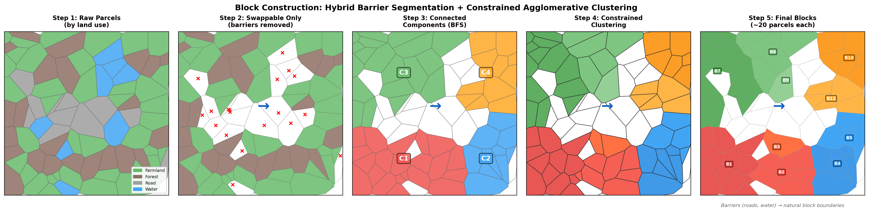
Figure: Block construction process illustrated on synthetic parcels resembling Township A. Step 1: raw parcels colored by land use (farmland=green, forest=brown, road=gray, water=blue). Step 2: barriers removed, only swappable parcels retained. Step 3: connected components identified via BFS. Step 4: large components subdivided by constrained Ward clustering. Step 5: final blocks labeled (~20 parcels each).

Table: Block construction statistics. “Both F+F” indicates the percentage of blocks containing both farmland and forest parcels (eligible for within-block swaps). “Assigned” indicates the percentage of swappable parcels successfully assigned to blocks.
Township | Blocks | Assigned (%) | Both F+F (%) | Median parcels/block | Median area (ha)
A (78 blocks) | 78 | 98 | 99 | 20 | 33
B (132 blocks) | 132 | 99 | 91 | 20 | 28
C (338 blocks) | 338 | 98 | 97 | 20 | 20

4.3 Block-level Markov Decision Process
The optimization is cast as a finite-horizon MDP (S, A, T, R, H) where the agent selects blocks to invest consolidation resources in.

4.3.1 State space
At step t, the state s_t consists of two components:
Per-block features X_t ∈ R^N_b × K_B, where N_b is the number of blocks and K_B = 17 features per block:
- Normalized mean slope, slope standard deviation, minimum slope, and maximum slope of all parcels within the block.
- Block area (normalized), farmland count, and forest count within the block.
- Farmland ratio and forest ratio within the block.
- Mean farmland slope and mean forest slope within the block.
- Contiguity index: mean proportion of same-type neighbors for farmland parcels within the block.
- Compactness: isoperimetric quotient 4\pi A / P^2 of the block’s convex hull.
- Number of adjacent blocks and mean slope of adjacent blocks.
- Budget remaining (normalized to [0, 1]).
- Step progress (t / H).
Global state vector g_t ∈ R^K_G, where K_G = 9:
- Normalized global mean farmland slope and mean forest slope.
- Global farmland contiguity index.
- Farmland count deviation from initial.
- Budget utilization ratio.
- Step progress.
- Baimu fang count (current).
- Total baimu fang area (normalized).
- Baimu fang count change from initial.
The state dimension is N_b × 17 + 9, which for the three townships evaluates to 78 × 17 + 9 = 1,335 (Township A), 2,253 (B), and 5,755 (C). Although these dimensions are large, the ParcelScoringPolicy architecture (Section sec:policy) processes each block independently through a shared scorer, so the number of learnable parameters is independent of N_b.

4.3.2 Action space
At each step, the agent selects one block a_t ∈ \1, 2, …, N_b\. An action mask m_t ∈ \0, 1\^N_b ensures that only blocks containing both farmland and forest parcels (and thus capable of supporting at least one swap) are available:
m_t(b) = 1\left[n_F^(b) > 0 \wedge n_L^(b) > 0\right]
where n_F^(b) and n_L^(b) are the remaining farmland and forest counts in block b. After swaps are executed within a block, its available parcel counts decrease; when either reaches zero, the block is masked out for all subsequent steps.

4.3.3 Transition function: connectivity-aware greedy engine
Upon selecting block b, the environment executes \kappa farmland–forest swaps within that block (\kappa = 5 by default, consuming 5 units of the total budget B_\max = 100). Each swap proceeds as follows:
Farmland removal scoring. For each farmland parcel i in block b:
score_remove(i) = s_i - \delta \cdot |\j ∈ N(i) : l_j = F\|
where \delta = 0.5 is the connectivity penalty. This score preferentially selects farmland parcels that are both steep (high s_i) and spatially isolated from other farmland (low farmland neighbor count), preserving the contiguity of the remaining farmland cluster.
Forest conversion scoring. For each forest parcel j in block b:
score_convert(j) = s_j - γ \cdot |\k ∈ N(j) : l_k = F\|
where γ = 1.0 is the connectivity bonus (note the sign: lower score is selected, so high farmland neighbor count reduces the score, making farmland-adjacent forest parcels preferred). This converts forest parcels that are both gentle-slope (low s_j) and adjacent to existing farmland, directly promoting farmland contiguity and baimu fang formation.
The asymmetry between \delta = 0.5 (removal penalty) and γ = 1.0 (conversion bonus) reflects a deliberate policy priority: building new contiguous farmland (by converting farmland-adjacent forest) is weighted more heavily than preserving existing contiguity (by avoiding removal of well-connected farmland). This design choice aligns with the consolidation objective of baimu fang formation, where expanding farmland clusters through strategic forest conversion is more valuable than merely maintaining current connectivity.
The farmland parcel with the highest score_remove and the forest parcel with the lowest score_convert are swapped, provided that the removed farmland’s slope exceeds the converted forest’s slope (otherwise the swap would worsen the mean farmland slope, and it is skipped). This process repeats \kappa times or until no improving swaps remain.
Key design property: spatial spillover. Because the baimu fang metric and the contiguity index are computed over the entire township (crossing block boundaries), swaps within one block can change the connectivity-aware scores of parcels in adjacent blocks. For example, converting a forest parcel to farmland at the boundary of block b increases the farmland neighbor count of parcels in an adjacent block b’, making those parcels more attractive for future forest-to-farmland conversion. This cross-block spatial spillover creates genuine sequential dependencies: the value of investing in block b’ at step t+1 depends on whether block b was selected at step t. This is precisely the inter-step dependency that was absent at the parcel level and that DRL can exploit through its planning horizon.

4.3.4 Reward function
The reward at step t combines four components:
r_t = w_S \cdot ΔS_t + w_C \cdot ΔC_t + w_B \cdot Δ A_B^(t) + b_B \cdot Δ n_B^(t)
where:
- ΔS_t: change in area-weighted mean farmland slope (negative = improvement). Weight w_S = 2000.
- ΔC_t: change in farmland contiguity index. Weight w_C = 500.
- Δ A_B^(t): change in total baimu fang area (hectares). Weight w_B = 500.
- Δ n_B^(t): change in baimu fang count (number of newly formed consolidated fields). Bonus b_B = 20 per new field.
The slope weight dominates (w_S = 2000), reflecting the primary policy objective of reducing farmland slope. The baimu fang area and count terms incentivize the agent to form and enlarge consolidated fields. A penalty of -1.0 is applied when a selected block yields zero completed swaps (e.g., all available swaps would worsen slope), discouraging wasteful block selections.
Note that unlike the parcel-level formulation [zhou2026transferable], no explicit farmland count penalty is needed: the connectivity-aware greedy engine guarantees that every farmland removal is paired with a forest conversion within the same step, maintaining exact farmland count conservation by construction.

4.3.5 Episode structure
Each episode consists of H = 20 steps. At each step, \kappa = 5 swaps are executed within the selected block, for a total budget of H × \kappa = 100 paired swaps per episode—identical to the budget used in the parcel-level experiments [zhou2026scaling]. The choice of \kappa = 5 balances two competing considerations: (1) sufficient within-block impact—with fewer than 3–5 swaps per block visit, the greedy engine cannot substantially alter the block’s spatial configuration, weakening the reward signal for block selection; and (2) sufficient macroscopic decisions—the agent needs enough steps (H = B_\max/\kappa) to express a meaningful sequential strategy. At \kappa = 1, the agent would make 100 near-independent selections (regressing toward parcel-level behavior); at \kappa = 20, only 5 macro-decisions would remain, insufficient for the “invest-then-recover” temporal strategies observed on Township C (Section sec:strategies). The value \kappa = 5 (H = 20) provides a practical middle ground, and the consistent convergence across three townships with different spatial structures suggests robustness to this choice. The discount factor is γ_RL = 0.99, corresponding to an effective planning horizon of ~100 steps (well beyond the 20-step episode), ensuring that the agent considers the full-episode consequences of early block selections.

4.4 Baimu fang computation
Baimu fang (百亩方) identification is performed via breadth-first search (BFS) on the farmland adjacency subgraph after each step. The algorithm operates as follows:
- Construct the subgraph of all farmland parcels using the pre-computed Queen contiguity adjacency.
- Identify connected components via BFS.
- For each component, sum the areas of all constituent parcels.
- A component qualifies as a baimu fang if its total area ≥ A_baimu = 66,700 m^2 (6.67 ha).
- Return the count and total area of qualifying components.
This computation operates on the full township farmland graph, not restricted to individual blocks. Thus, a baimu fang can span multiple blocks, and swaps in one block can contribute to forming a consolidated field in a neighboring block—reinforcing the spatial spillover mechanism described in Section sec:greedy_engine.
The BFS computation requires approximately 1.3 ms per call on the largest township (12,950 parcels), adding negligible overhead to training (which involves ~200,000 such calls).

4.5 Policy network architecture
We reuse the ParcelScoringPolicy architecture from zhou2026transferable, originally designed for parcel-level scoring, applied here to block-level scoring. The architecture consists of two sub-networks:
Scorer network. For each block b, the scorer takes as input the concatenation of its K_B = 17 local features and the K_G = 9 global features:
logit_b = Scorer\left([x_b; g]\right) ∈ R, Scorer: R^26 → R
implemented as a two-layer MLP (26 → 128 → 64 → 1) with Tanh activations. All N_b blocks share the same scorer weights. Logits are passed through a masked softmax to produce action probabilities.
Value network. The state value depends only on global features:
V(s_t) = Value(g_t) ∈ R, Value: R^9 → R
implemented as (9 → 64 → 32 → 1) with Tanh activations.
The total parameter count is 14,530—identical regardless of the number of blocks N_b. This dimension invariance means the same trained weights could, in principle, be applied to townships with different numbers of blocks, though we do not exploit this transfer capability in the current study.
Weights are initialized using orthogonal initialization [saxe2014exact] with gain 0.01 for the scorer (encouraging near-uniform initial action probabilities) and gain 1.0 for the value network.

4.6 Training
All models are trained using Maskable PPO from the sb3-contrib library [huang2022closer]. Table tab:hyperparams lists the hyperparameters.
Table: Training hyperparameters for the block-level MDP.
Hyperparameter | Value
Algorithm | Maskable PPO
Learning rate | 1 × 10^-3 (Adam)
Rollout length (n_steps) | 512
Minibatch size | 256
PPO epochs | 10
Discount factor (γ_RL) | 0.99
GAE parameter (λ) | 0.95
Clip range | 0.2
Entropy coefficient | 0.01
Total timesteps | 200,000
Episode length (H) | 20 steps
Swaps per step (\kappa) | 5
Total budget (B_\max) | 100 paired swaps

Why 200,000 timesteps suffice. The 20-step episode length means that 200,000 timesteps correspond to 10,000 episodes—comparable to the effective number of episodes in the parcel-level experiments (1,000,000 timesteps / 200 steps = 5,000 episodes). The block-level formulation’s smaller action space (78–338 blocks vs.\ 1,601–6,787 parcels) enables faster convergence, with training curves plateauing at approximately 50,000 timesteps (~2,500 episodes) across all townships.
For each of the three townships, 5 models are trained with random seeds 0–4, yielding 15 trained models total. Training was conducted on NVIDIA A100 40GB GPUs, with per-township training times of approximately 25 minutes (A), 50 minutes (B), and 2 hours (C).

4.7 Baseline methods
Four baseline methods are compared, all operating under the same block-level framework (20 steps, \kappa = 5 swaps per step, total budget 100) and using the same connectivity-aware greedy engine for within-block execution:
Greedy-Global. At each step, evaluates all N_b blocks and selects the one whose greedy execution yields the greatest slope reduction. This is the strongest single-objective baseline, analogous to the parcel-level Greedy in prior work.
Greedy-Sequential. Iterates through blocks in a fixed order (sorted by initial mean farmland slope, descending). Each block receives one step of investment before moving to the next; after cycling through all blocks, the sequence repeats.
Random-Block. At each step, selects a block uniformly at random from those with valid action masks. Averaged over 5 random seeds.
Round-Robin. Visits all blocks in sequence, allocating one step of investment to each. Blocks with more farmland and forest receive proportionally more attention over the episode.
All baselines use identical within-block execution (the connectivity-aware greedy engine with γ = 1.0, \delta = 0.5), isolating the effect of block selection strategy as the sole variable across methods.

4.8 Evaluation
Trained models are evaluated with deterministic inference: at each step, the trained policy selects the block with the highest logit score (argmax over unmasked blocks). Each evaluation produces a single deterministic trajectory. We report slope change (%), contiguity change, baimu fang count change, baimu fang area change (ha), and budget utilization across all 5 seeds.
% ============================================================================

5. Results
% ============================================================================

5.1 Training convergence
Fig. fig:training_curves shows the training dynamics for all three townships. The episodic reward exhibits clear learning progress, with convergence occurring at approximately 50,000 timesteps (~2,500 episodes) in all cases. All 15 seed–township combinations converge to positive reward plateaus, with no instances of degenerate policies or bimodal behavior.
Table tab:convergence compares convergence rates between the parcel-level approach [zhou2026scaling] and the proposed block-level approach.
Table: Convergence comparison: parcel-level DRL \citepzhou2026scaling
Township | Parcel-level convergence | Block-level convergence
A (Small, 3,607 parcels) | 2/5 (40%) | 5/5 (100%)
B (Medium, 5,500 parcels) | 1/5 (20%) | 5/5 (100%)
C (Large, 12,950 parcels) | 0/5 (0%) | 5/5 (100%)
Total | 3/15 (20%) | 15/15 (100%)

The improvement is dramatic: from 20% overall convergence at the parcel level to 100% at the block level. Most notably, Township C—where parcel-level DRL failed entirely—achieves perfect convergence with extremely low variance (reward coefficient of variation <1%).
Training dynamics also differ qualitatively. At the parcel level, training reward curves are noisy and exhibit bimodal behavior (some seeds climb while others stagnate). At the block level, all seeds follow similar trajectories with tight clustering, indicating that the optimization landscape has a single, well-defined basin of attraction.
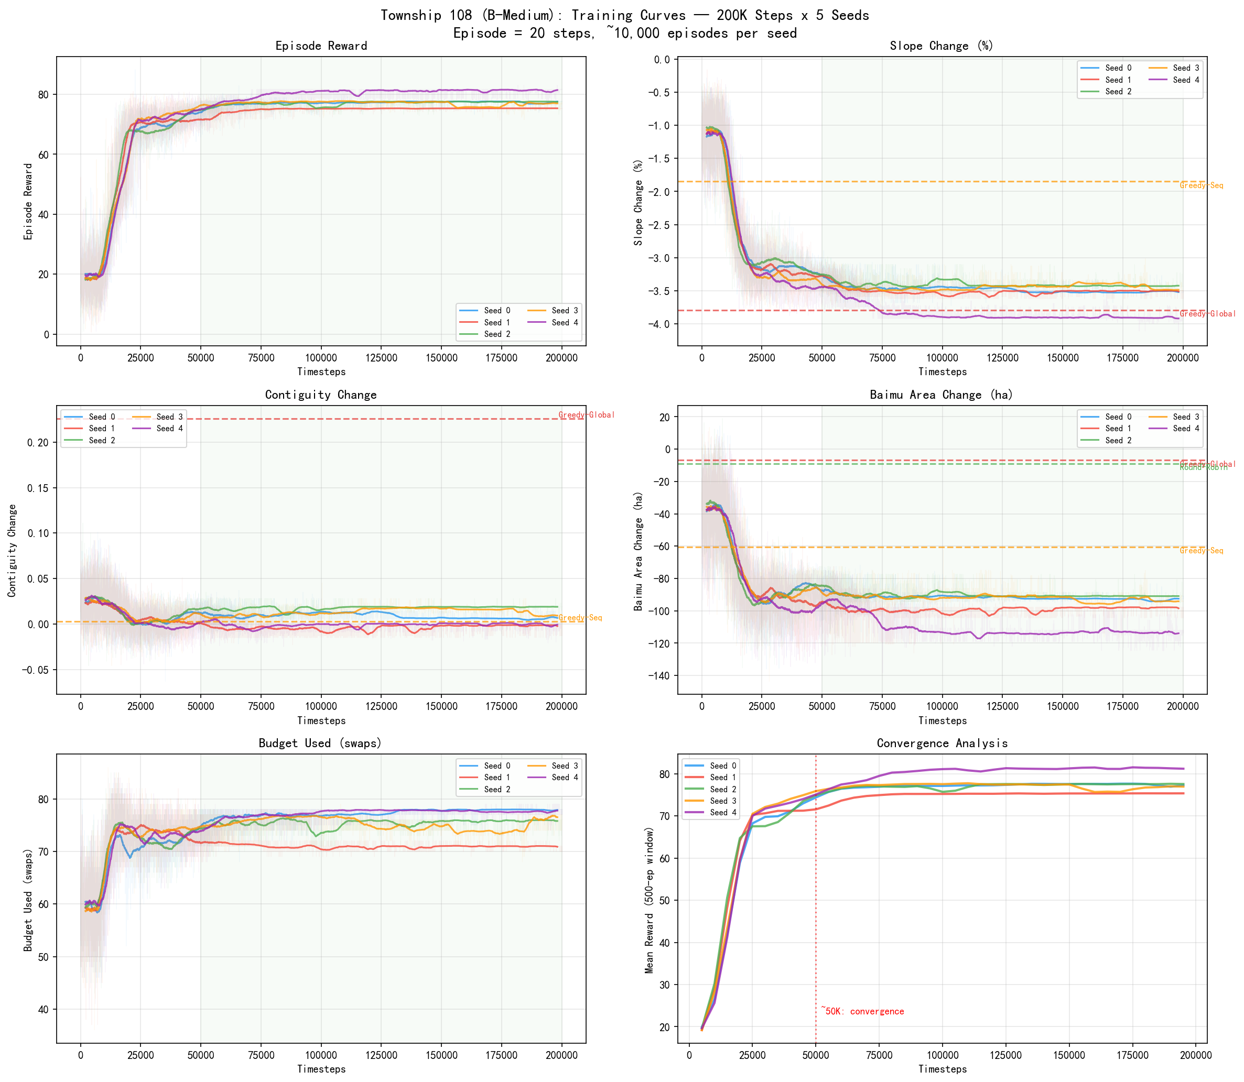
Figure: Training curves for Township B (left, 132 blocks) and Township C (right, 338 blocks), showing 5 seeds each with 200-episode moving average. All metrics (reward, slope change, contiguity, \textitbaimu fang

5.2 Cross-township comparison
Table tab:main_results presents the comprehensive results across all methods and townships.
Table: Cross-township comparison of all methods. DRL results report mean ± std across 5 seeds. Slope change: more negative is better; contiguity change: more positive is better; \textitbaimu fang
Township | Method | Slope (%) | Cont. | Baimu cnt | Baimu ha
\shortstackA
(78 blk) | Greedy-Global | -6.36 | +0.439 | -2 | -31.5
 | Greedy-Seq | -2.12 | +0.050 | -1 | -12.0
 | Random (avg) | -0.79 | +0.051 | 0 | +1.4
 | Round-Robin | -0.33 | +0.087 | -1 | +43.8
 | DRL | -2.61 ± 0.44 | +0.130 ± 0.025 | 0 | +8.8 ± 10.7
\shortstackB
(132 blk) | Greedy-Global | -3.79 | +0.226 | -1 | -6.9
 | Greedy-Seq | -1.85 | +0.003 | 0 | -60.4
 | Random (avg) | -1.31 | +0.032 | -0.6 | -38.1
 | Round-Robin | -0.28 | +0.062 | -1 | -8.9
 | DRL | -1.64 ± 0.04 | +0.115 ± 0.009 | -1 | +12.9 ± 3.2
\shortstackC
(338 blk) | Greedy-Global | -1.48 | +0.121 | -1 | +34.6
 | Greedy-Seq | -1.17 | +0.020 | 0 | -43.0
 | Random (avg) | -0.24 | +0.026 | +0.8 | +9.6
 | Round-Robin | +1.10 | +0.047 | +2 | +114.4
 | DRL | -0.33 ± 0.01 | +0.023 ± 0.003 | +5 ± 0 | +27.7 ± 1.3

Several patterns emerge:
DRL is the only method that achieves positive baimu fang area on Township B. All baseline methods show negative baimu fang area on Township B (ranging from -6.9 ha to -60.4 ha), indicating a structural tendency to destroy consolidated fields during slope optimization. DRL reverses this pattern entirely, achieving +12.9 ha—the only positive result—while simultaneously delivering the highest contiguity improvement (+0.115). On Township C, DRL forms 5 new baimu fang (count change +5), far exceeding all baselines.
DRL on Township C forms 5 new baimu fang. This is the strongest result of the study. On the largest and most complex township, where parcel-level DRL failed completely, the block-level agent consistently forms 5 new consolidated fields across all 5 seeds (standard deviation = 0). The next best method (Round-Robin) forms only 2. This demonstrates that the block-level agent has learned a strategy specifically targeted at baimu fang formation.
Greedy-Global dominates on slope. Greedy-Global achieves the best slope reduction on all three townships (-6.36%, -3.79%, -1.48%), which is expected given that it greedily selects the block yielding maximum slope improvement at each step. However, this aggressive slope optimization comes at the cost of baimu fang destruction and negligible contiguity gains.
DRL on Township B achieves a fundamentally different trade-off than all baselines. With rebalanced reward weights (equal slope and baimu fang emphasis), the DRL agent achieves -1.64% ± 0.04% slope reduction—moderate compared to Greedy-Global’s -3.79%—but with dramatically superior contiguity (+0.115 vs.\ Greedy-Global’s +0.226 being the only comparably high value) and the only positive baimu fang area change (+12.9 ha vs.\ all baselines negative). This demonstrates the DRL agent’s ability to discover Pareto-efficient trade-offs inaccessible to single-objective methods.
Fig. fig:cross_bars visualizes the cross-township comparison across all four metrics, highlighting DRL’s distinctive multi-objective profile.
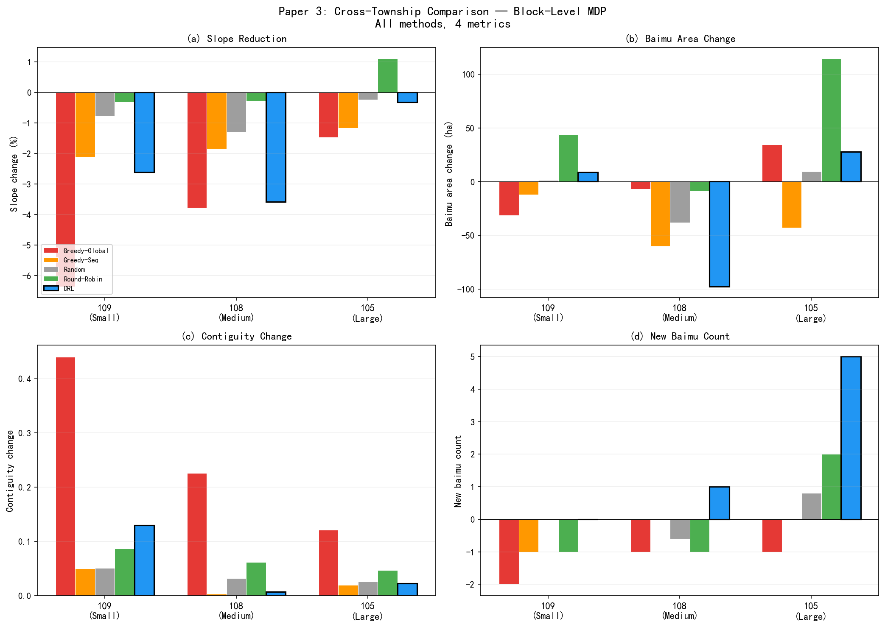
Figure: Cross-township comparison of all methods across four metrics: (a) slope reduction, (b) \textitbaimu fang

5.3 Emergent township-specific strategies
A striking finding is that the DRL agent, trained with identical hyperparameters across all three townships, develops qualitatively different optimization strategies adapted to each township’s spatial structure:
Township A (balanced strategy). The agent achieves moderate slope reduction (-2.61%), the second-best contiguity improvement (+0.130), and preserves existing baimu fang while slightly growing their area (+8.8 ha). This balanced profile places DRL on the Pareto front of the multi-objective space: no single baseline dominates DRL across all three metrics simultaneously.
Township B (contiguity-and-baimu fang area strategy). With rebalanced reward weights that equally emphasize slope reduction and baimu fang formation, the agent discovers a strategy that maximizes contiguity (+0.115, comparable to Greedy-Global) while being the only method achieving positive baimu fang area (+12.9 ha). Slope reduction is moderate (-1.64%) compared to the slope-optimal Greedy-Global (-3.79%), reflecting a deliberate trade-off. Block trajectory analysis reveals that the agent distributes selections across 20 distinct blocks, steadily increasing contiguity at every step, rather than concentrating on a few high-slope blocks. This dispersed strategy creates spatial spillover effects between adjacent blocks, enabling contiguous farmland clusters to expand above the baimu fang threshold. The extremely low seed variance (slope std = 0.04%) indicates a highly stable strategy.
Township C (baimu fang-focused strategy). The agent achieves only modest slope reduction (-0.33%) but forms 5 new consolidated fields with +27.7 ha total area. Block trajectory analysis reveals a remarkable pattern: in the first 10 steps, the agent selects blocks that actually worsen slope (slope\_pct increases), investing in blocks at the boundaries of existing near-threshold farmland clusters to push them above the 6.67 ha threshold. In the remaining 10 steps, the agent partially recovers slope by selecting high-slope blocks for greedy exchange. This “invest-then-recover” temporal strategy demonstrates sophisticated multi-step planning that greedy methods cannot replicate.
The emergence of these distinct strategies from a single set of hyperparameters is a key advantage of the DRL framework: the agent automatically adapts its behavior to the local spatial structure and opportunity landscape, without requiring manual strategy design or per-township parameter tuning.

5.4 Per-seed consistency
Table tab:per_seed reports per-seed results for all three townships.
Table: Per-seed DRL results across all three townships. Std row shows standard deviation. CV row shows coefficient of variation of total reward.
Township | Seed | Slope (%) | Cont. | Baimu cnt | Reward
A | 0 | -2.67 | +0.149 | 0 | 154.1
 | 1 | -1.78 | +0.154 | 0 | 140.3
 | 2 | -2.92 | +0.092 | 0 | 161.2
 | 3 | -2.92 | +0.140 | 0 | 159.8
 | 4 | -2.74 | +0.113 | 0 | 152.7
 | CV | 4r5.3%
B | 0 | -1.64 | +0.115 | -1 | 37.6
 | 1 | -1.56 | +0.127 | -1 | 38.7
 | 2 | -1.63 | +0.115 | -1 | 42.0
 | 3 | -1.66 | +0.115 | -1 | 40.5
 | 4 | -1.69 | +0.100 | -1 | 35.6
 | CV | 4r5.9%
C | 0 | -0.32 | +0.018 | +5 | 265.8
 | 1 | -0.35 | +0.027 | +5 | 267.0
 | 2 | -0.33 | +0.024 | +5 | 266.6
 | 3 | -0.34 | +0.021 | +5 | 265.2
 | 4 | -0.33 | +0.025 | +5 | 266.3
 | CV | 4r0.26%

Township C exhibits the most remarkable consistency: reward CV of only 0.26%, slope std of 0.01%, and baimu fang count identically +5 across all seeds. Township B also shows excellent stability with reward CV of 5.9% and slope std of 0.04%, a substantial improvement over the original slope-focused configuration (CV 12.4%). This reproducibility contrasts sharply with the bimodal behavior observed in parcel-level DRL, where Township C produced 0% convergence. The block-level optimization landscape appears to have well-defined basins of attraction across all townships.

5.5 Multi-objective Pareto analysis
Fig. fig:pareto presents the multi-objective Pareto analysis across all methods. In the slope–baimu fang count space (Fig. fig:paretoc), DRL occupies a unique position on all three townships: it achieves the highest or tied-highest baimu fang count among all methods while maintaining non-negative slope reduction. No baseline achieves this combination.
On Township A, DRL lies on the Pareto front connecting Greedy-Global (best slope, worst baimu fang) and Round-Robin (worst slope, best baimu fang area), offering a balanced trade-off unavailable from any single baseline.
On Township C, DRL dominates all baselines except Round-Robin on the baimu fang count metric (+5 vs.\ +2), while maintaining negative slope change (unlike Round-Robin’s +1.10% slope increase).
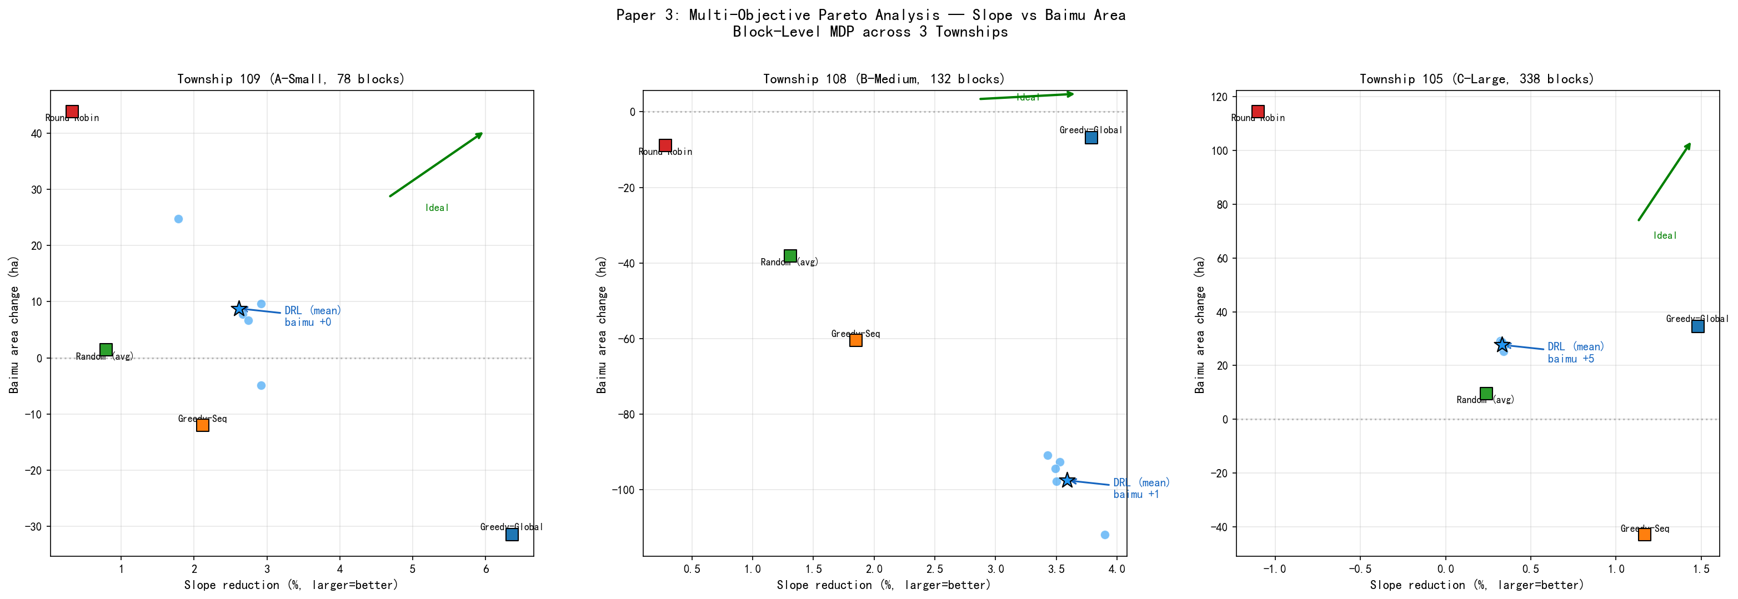
Figure: Multi-objective Pareto analysis: slope reduction vs.\ \textitbaimu fang

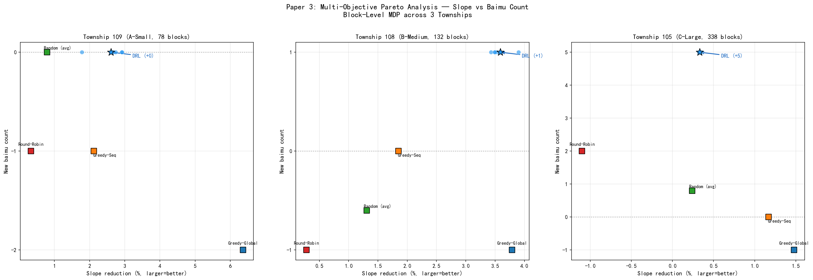
Figure: Pareto analysis: slope reduction vs.\ \textitbaimu fang

% ============================================================================

6. Discussion
% ============================================================================

6.1 Why block-level abstraction restores DRL’s advantage
The parcel-level DRL failure was attributed to swap near-independence: on irregular parcels, each exchange decision’s quality depends primarily on local attributes rather than on prior decisions [zhou2026scaling]. The block-level formulation breaks this near-independence through three mechanisms:
Resource competition. With a fixed budget of 100 swaps and \kappa = 5 swaps per step, the agent has exactly 20 block selections to make. Each selection consumes 5% of the total budget; investing in block b means not investing in block b’. This creates a genuine allocation problem where the ordering and selection of blocks affects the final outcome.
Spatial spillover. The connectivity-aware greedy engine (γ = 1.0 for forest conversion) creates cross-block dependencies: converting forest to farmland at a block boundary increases the farmland neighbor count of parcels in adjacent blocks, making them more attractive targets. This spillover effect means that investing in block b at step t changes the expected reward from block b’ at step t+1—precisely the inter-step dependency that DRL exploits.
Baimu fang threshold effects. The ≥6.67 ha threshold for baimu fang qualification creates discontinuous reward dynamics: a farmland cluster just below the threshold yields zero baimu fang reward, but one additional parcel conversion can push it above the threshold, generating a large positive signal. Strategic sequencing—investing in blocks that bring near-threshold clusters above the line—is a planning problem that greedy per-step optimization cannot solve optimally.

6.2 The “invest-then-recover” strategy on Township C
The DRL agent’s behavior on Township C merits detailed analysis. Examining the block-by-block trajectory (Fig. fig:trajectory), the agent follows a two-phase strategy:
Phase 1 (steps 1–10): Baimu fang investment. The agent selects blocks at the boundaries of existing farmland clusters, converting forest to farmland to expand these clusters toward the 6.67 ha threshold. During this phase, slope actually increases (from 0 to approximately +0.9% at step 1, gradually declining), because the agent is converting gentle-slope forest (which would reduce slope if removed as farmland) to farmland.
Phase 2 (steps 11–20): Slope recovery. Having formed the target baimu fang, the agent switches to blocks with high-slope farmland and low-slope forest, executing the classic “high-slope-out, low-slope-in” strategy to recover slope performance. By step 20, slope is reduced to approximately -0.33%.
This temporal strategy is impossible for any single-step greedy method to discover: Greedy-Global would never select a block that worsens slope in the short term, even if doing so enables superior baimu fang formation in the long term.

6.3 Policy implications
The block-level DRL framework has direct implications for China’s farmland consolidation policy:
Alignment with administrative practice. Consolidation projects are administered at the township and village level, with budgets allocated across candidate project areas (xiangmu qu). Our block-level agent performs exactly this allocation function, making its decisions directly interpretable by planners: “invest 5 swap units in Block 3, then 5 in Block 107” translates to “prioritize consolidation in the northern valley cluster, then the eastern hillside.”
Baimu fang as a decision criterion. Current practice relies on expert judgment to identify baimu fang formation opportunities. The DRL agent automates this assessment, learning from the spatial configuration which blocks offer the best consolidation potential. The fact that it forms 5 new baimu fang on Township C—where expert-designed baselines achieve at most 2—suggests that DRL can identify consolidation opportunities that human planners might overlook.
Multi-objective balancing. Different townships may have different policy priorities: some emphasize slope reduction (for erosion prevention), others prioritize block formation (for mechanization). The DRL agent’s emergent strategy adaptation demonstrates that a single framework can serve multiple policy contexts without per-township customization.
Property rights and interest coordination. A critical consideration for real-world implementation is that cadastral parcels carry complex property rights (chengbao jingyingquan, contracted management rights) attached to individual households. Farmland–forest exchange across village boundaries or farmer groups involves substantial transaction costs and requires voluntary participation. Our framework provides a spatially optimal frontier—the physical upper bound of what is achievable—while the block-level structure naturally facilitates implementation: because blocks are spatially compact units typically falling within a single village or group boundary, the social negotiation required for within-block exchanges is considerably simpler than for arbitrary cross-township parcel swaps. Future work could incorporate property boundary constraints directly into the block construction algorithm, ensuring that each block respects administrative or ownership boundaries, thereby producing optimization plans that are both physically optimal and socially implementable.

6.4 Limitations
Several limitations should be acknowledged.
Morphological simplification of baimu fang definition. The current BFS-based identification of baimu fang considers only topological connectivity and aggregate area (≥6.67 ha), without imposing shape constraints. In practice, China’s gaobiaozhun nongtian (high-standard farmland) standards require consolidated fields to support large-scale mechanized operations, which implicitly demands compact, regular shapes. A topologically connected farmland cluster that is extremely elongated (“snake-shaped”) or contains large internal perforations would fail engineering acceptance even if its total area exceeds the threshold. Future work should incorporate compactness metrics—such as the isoperimetric quotient (4\pi A / P^2), minimum bounding rectangle ratio, or convexity index—as additional baimu fang qualification criteria. This refinement would require re-integration into both the reward function and the BFS-based counting algorithm, potentially altering the agent’s strategy to favor not only large connected components but also compact, machine-accessible field shapes.
Slope–baimu fang trade-off. On Township B, the DRL agent (with rebalanced weights) trades slope performance (-1.64% vs.\ Greedy-Global’s -3.79%) for dramatically superior contiguity and baimu fang area outcomes. On Township C, the agent trades slope for baimu fang count formation. While this reflects rational multi-objective optimization, DRL does not dominate Greedy-Global on slope reduction—a metric that may be the primary concern in some policy contexts. The reward weight configuration determines the trade-off point on the Pareto front; practitioners can adjust weights to emphasize their priority objective.
Block definition sensitivity. The block construction method (barrier segmentation + agglomerative clustering) involves parameter choices (minimum block size, target parcels per block) that may affect results. We have not conducted a systematic ablation of block granularity. However, the consistency across three townships with different spatial structures suggests reasonable robustness.
Fixed connectivity parameters. The greedy engine parameters (γ = 1.0, \delta = 0.5) were set based on domain knowledge rather than optimization. These parameters control the trade-off between slope and connectivity in within-block execution; different values might produce different strategy profiles.
Swaps-per-step sensitivity. The parameter \kappa = 5 (swaps per block visit) was chosen heuristically to balance within-block impact and macroscopic decision count, as discussed in Section sec:mdp. A systematic ablation over \kappa ∈ \1, 3, 5, 10, 20\ would quantify how the macro–micro power distribution affects learning dynamics and final performance. This is an important direction for future work, as the optimal \kappa may depend on township size and block granularity.
Single district. All three townships are within Bishan District, limiting geographic generalizability. The framework should be validated on regions with different terrain, climate, and land-use patterns.
Computational cost. While dramatically more efficient than parcel-level DRL (200K vs.\ 1M timesteps, ~2h vs.\ ~4h per model on A100), the block-level approach still requires GPU training. Greedy-Global produces its result in under 0.01 seconds. The DRL approach is justified only when the multi-objective optimization capability (particularly baimu fang formation) is valued.
% ============================================================================

7. Conclusions
% ============================================================================
This paper proposed a block-level spatial abstraction for deep reinforcement learning applied to farmland consolidation planning, addressing the fundamental scalability limitation of parcel-level DRL on real cadastral data. Through extensive experiments on three townships spanning 3,607 to 12,950 parcels (78 to 338 blocks), we established the following findings:
- Spatial abstraction resolves the convergence crisis. Block-level DRL achieves 100% convergence across all 15 seed–township combinations, compared to only 20% (3/15) for parcel-level DRL. On the largest township where parcel-level DRL failed entirely (0% convergence), block-level DRL achieves perfect convergence with reward CV <1%.
- The “macroscopic planning, microscopic execution” paradigm creates genuine sequential dependencies. Resource competition between blocks, spatial spillover via the connectivity-aware greedy engine, and baimu fang threshold effects combine to create the inter-step dependencies that DRL requires to provide value over greedy selection.
- DRL discovers emergent, township-specific strategies. Under identical hyperparameters, the agent develops balanced, contiguity-focused, and baimu fang count-focused strategies on different townships, automatically adapting to local spatial structure without manual intervention.
- DRL achieves unique multi-objective performance. No single baseline method matches DRL’s combination of slope reduction, baimu fang preservation/formation, and contiguity improvement. On the large township, DRL forms 5 new baimu fang—2.5× more than the best baseline—while maintaining positive slope reduction.
- The framework aligns with consolidation policy. Block-level decision-making mirrors the administrative structure of China’s land consolidation governance, and baimu fang formation is a directly policy-relevant metric, making the framework immediately applicable as a decision support tool.
These results demonstrate that spatial abstraction—lifting the optimization from individual parcels to policy-relevant consolidation units—is a principled and effective solution to the scalability challenge of DRL for farmland spatial optimization. The three papers in this research program trace a dialectical arc: the proof-of-concept demonstrated DRL’s potential on synthetic data [zhou2026transferable]; the scaling study revealed its limits on real data [zhou2026scaling]; and this work resolves those limits through spatial abstraction, achieving both scalability and policy relevance. Future directions include block granularity ablation, cross-district validation, integration with GIS planning tools, and extension to multi-land-type consolidation scenarios involving construction land reclamation and ecological restoration.
% ============================================================================ % References % ============================================================================

References
[Aerts et al.(2003)] Aerts, J. C., Eisinger, E., Heuvelink, G. B., and Stewart, T. J. (2003). Using linear integer programming for multi-site land-use allocation. \em Geographical Analysis, 35(2):148–169.
[Barto and Mahadevan(2003)] Barto, A. G. and Mahadevan, S. (2003). Recent advances in hierarchical reinforcement learning. \em Discrete Event Dynamic Systems, 13(4):341–379.
[Cao et al.(2011)] Cao, K., Batty, M., Huang, B., Liu, Y., Yu, L., and Chen, J. (2011). Spatial multi-objective land use optimization: extensions to the non-dominated sorting genetic algorithm-II. \em International Journal of Geographical Information Science, 25(12):1949–1969.
[Cao et al.(2012)] Cao, K., Huang, B., Wang, S., and Lin, H. (2012). Sustainable land use optimization using boundary-based fast genetic algorithm. \em Computers, Environment and Urban Systems, 36(3):257–269.
[Copernicus(2021)] Copernicus (2021). Copernicus DEM GLO-30: Global 30m Digital Elevation Model. European Space Agency.
[Deb et al.(2002)] Deb, K., Pratap, A., Agarwal, S., and Meyarivan, T. (2002). A fast and elitist multiobjective genetic algorithm: NSGA-II. \em IEEE Transactions on Evolutionary Computation, 6(2):182–197.
[Equihua et al.(2024)] Equihua, J., Beckmann, M., and Seppelt, R. (2024). Connectivity conservation planning through deep reinforcement learning. \em Methods in Ecology and Evolution, 15(4):779–790.
[Huang and Onta\ n\’on(2022)] Huang, S. and Onta\ n\’on, S. (2022). A closer look at invalid action masking in policy gradient algorithms. In \em The International FLAIRS Conference Proceedings, volume 35.
[Li et al.(2011)] Li, X., Yeh, A. G., and Liu, X. (2011). Coupling cellular automata and ant colony optimization for land-use allocation. \em Environment and Planning B: Planning and Design, 38(2):234–252.
[Liu et al.(2012)] Liu, Y., Tang, W., He, J., Liu, Y., Ai, T., and Liu, D. (2012). A land-use spatial optimization model based on genetic optimization and game theory. \em Computers, Environment and Urban Systems, 36(6):508–520.
[Liu et al.(2014)] Liu, Y., Fang, F., and Li, Y. (2014). Key issues of land use in China and implications for policy making. \em Land Use Policy, 40:6–12.
[Long et al.(2018)] Long, H., Qu, Y., Tu, S., Zhang, Y., and Jiang, Y. (2018). Development of land use transitions research in China. \em Journal of Geographical Sciences, 28(10):1387–1399.
[Saxe et al.(2014)] Saxe, A. M., McClelland, J. L., and Ganguli, S. (2014). Exact solutions to the nonlinear dynamics of learning in deep linear neural networks. In \em International Conference on Learning Representations.
[Wang et al.(2021)] Wang, D., Fu, Y., Wang, P., Huang, B., and Lu, C. T. (2021). Reimagining city configuration: Automated urban planning via adversarial learning. In \em Proceedings of the 29th International Conference on Advances in Geographic Information Systems, pages 497–506.
[Wu et al.(2005)] Wu, Z., Liu, M., and Davis, J. (2005). Land consolidation and productivity in Chinese household crop production. \em China Economic Review, 16(1):28–49.
[Zheng et al.(2023)] Zheng, Y., Lin, Y., Zhao, L., Wu, T., Jin, D., and Li, Y. (2023). Spatial planning of urban communities via deep reinforcement learning. \em Nature Computational Science, 3(9):748–762.
[Zhou and Jing(2026a)] Zhou, N. and Jing, X. (2026a). A transferable deep reinforcement learning framework for farmland spatial layout optimization using parcel-level scoring policy. \em International Journal of Geographical Information Science, (submitted).
[Zhou and Jing(2026b)] Zhou, N. and Jing, X. (2026b). Scaling deep reinforcement learning for farmland layout optimization on irregular cadastral parcels: Opportunities and limits. \em Computers and Electronics in Agriculture, (submitted).

