1. 11111111111111111111111Home 页

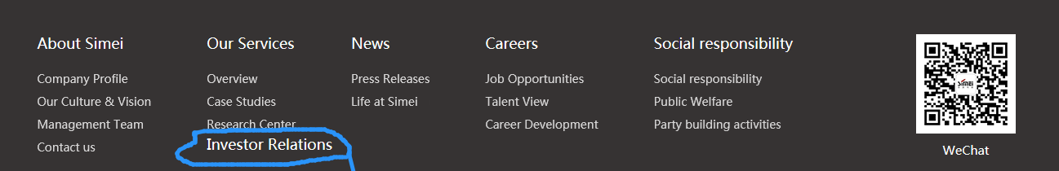

已调整

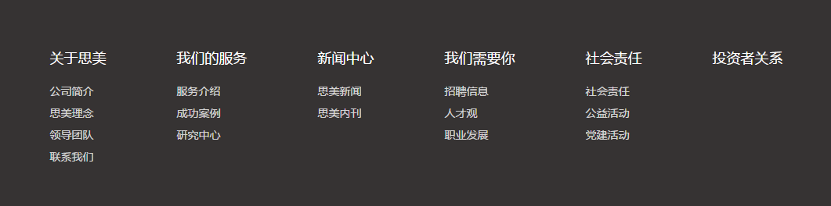

投资者关系（Investor Relations）没有和其他几个大类一行。

ABOUT SIMEI 英文简介

2、

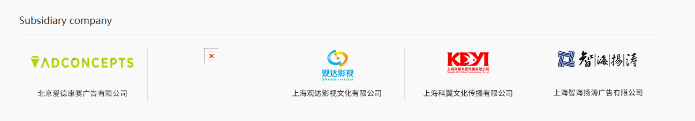掌维科技的图片没有了

3、

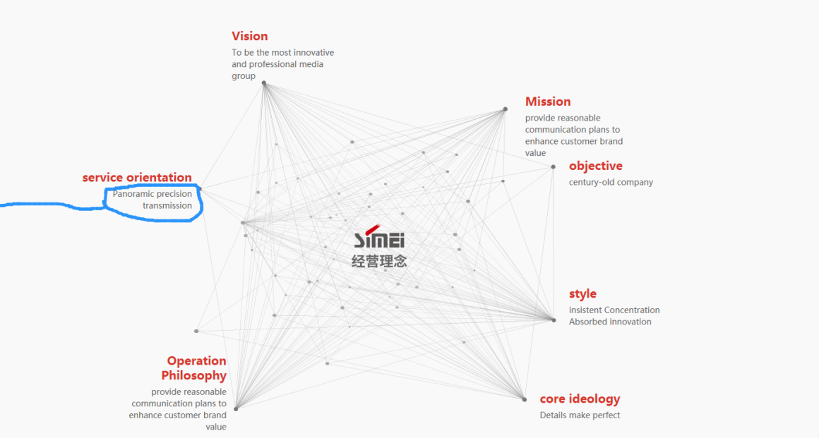

经营理念（Operation Principles） 中文没改

全景·精准·传播（Panoramic·Precision·Transmission）三个放一行，中间用点隔开

首字母记得大写

4、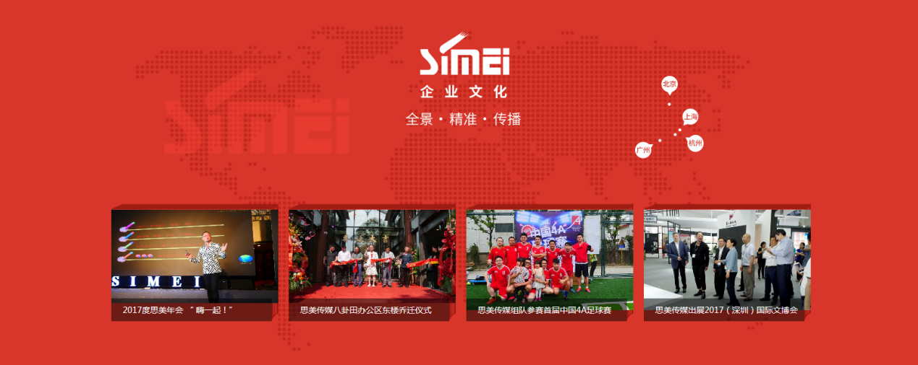

企业文化（Corporate Culture） 全景·精准·传播（Panoramic·Precision·Tansmission）

北京(Beijing) 上海（Shanghai）广州（Guangzhou）杭州（Hangzhou）

图片上的也改下。

5、

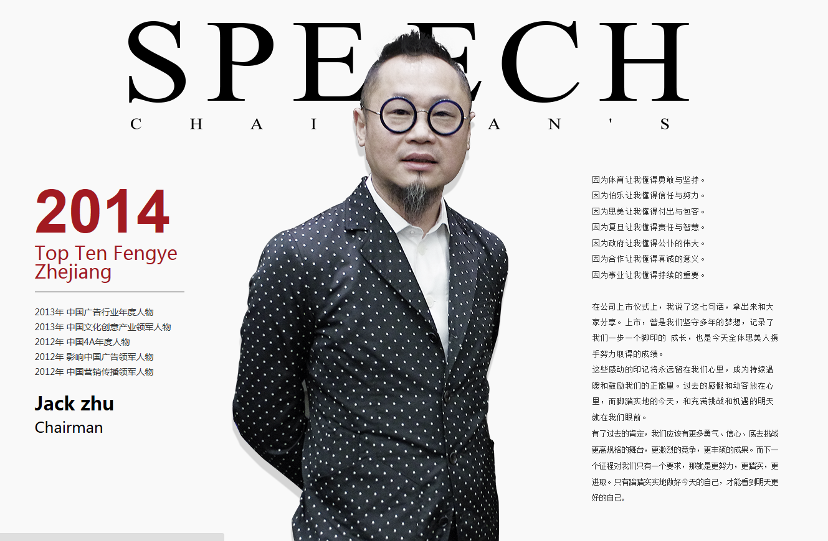

Fengyun ，不是Fengye

后台改

6、

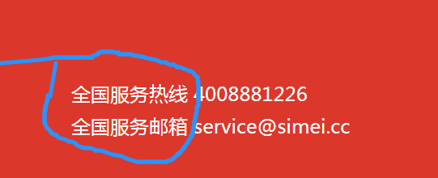



后台改

全国服务热线：TEL

全国服务邮箱：EMAIL

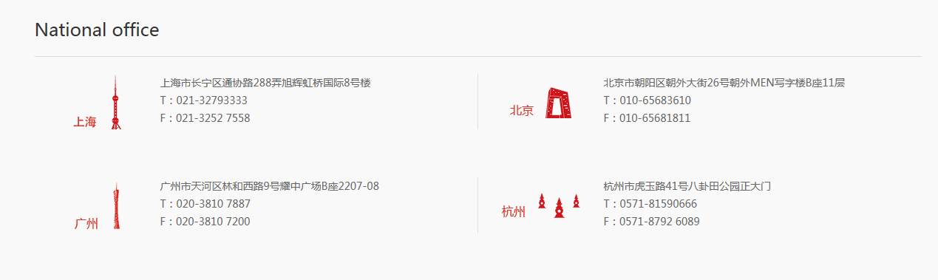

Shanghai：Block 8, CIFI Hongqiao International, Lane 288, Tongxie Road, Changning District, Shanghai

Beijing：11 F, Block B, MEN Mansion, No. 26, Chaowai Road, Chaoyang District, Beijing

Guangzhou：Room 2207-08, Block B, Yaozhong Square, No. 9, West Linhe Road, Tianhe District, Guangzhou

Hangzhou：Baguatian Park, No. 41, Huyu Road/Shijiashan, No. 41, Huyu Road, Hangzhou,

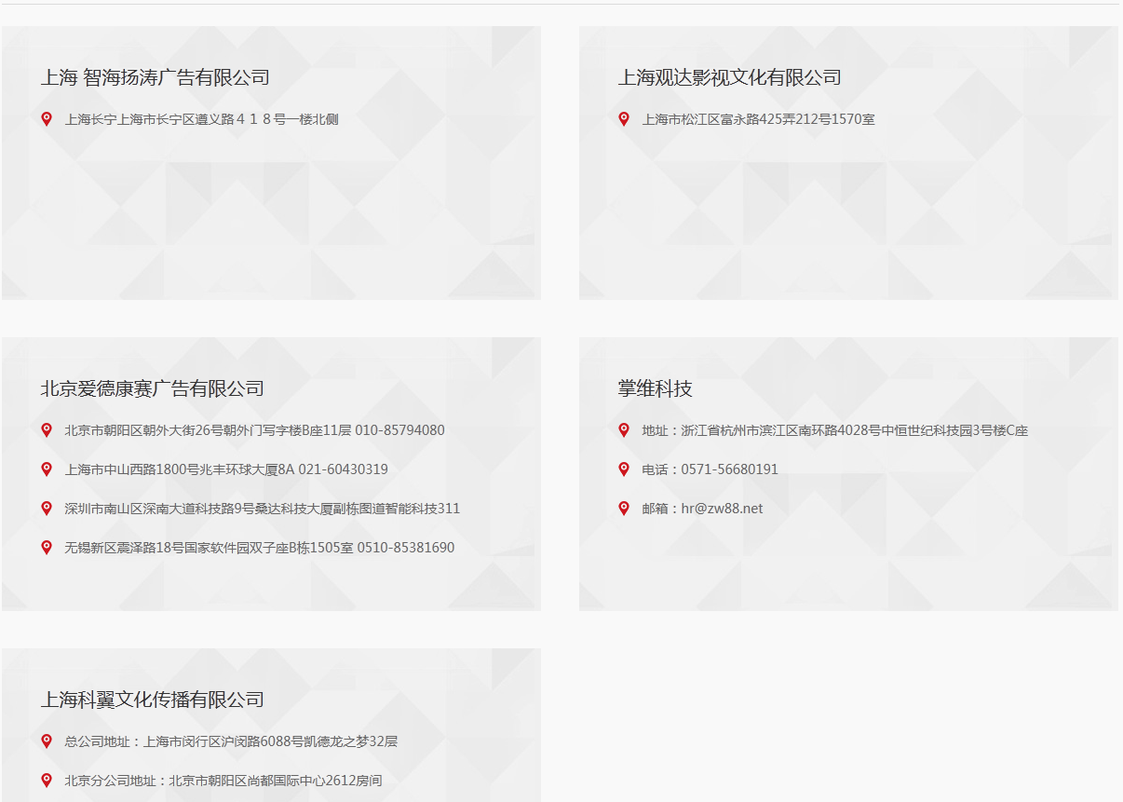

上海 智海扬涛广告有限公司

Shanghai ZhiHaiYangTao Co.,Ltd.

上海市长寿路652号景源时尚产业园9号楼

Building No. 9, Jingyuan Fashion Industry Park, No. 652 Changshou Road, Shanghai City,

上海观达影视文化有限公司

Shanghai Grand.Media Co.,Ltd.

上海市松江区富永路425弄212号1570室

Room 1570,No.212 Lane,No.425 Fuyong road,Songjiang District,Shanghai City

北京爱德康赛广告有限公司

Beijing ADCONCEPTS Co.,Ltd.

北京市朝阳区朝外大街26号朝外门写字楼B座11层 010-85794080

11 floor, Zhaowaimen Office building B , No. 26 WaidaJie Avenue, Chaoyang District,Beijing City Phone number:010-85794080

上海市中山西路1800号兆丰环球大厦8A 021-60430319

8A Zhaofeng Global Building ,No. 1800 Zhongshan Xi Road,Shanghai City

Phone number: 021-60430319

深圳市南山区深南大道科技路9号桑达科技大厦副栋图道智能科技311

Room 311,Tudao intelligent technology,Sangda technology vice building,No. 9 Shennan Road,Nanshan District,Shenzhe City

无锡新区震泽路18号国家软件园双子座B栋1505室 0510-85381690

room 1505, national software park Gemini building B,No. 18 Zhenze Road,New District,Wuxi City

Phone number: 0510-85381690

杭州掌维科技有限公司

Hangzhou Zhangwei Technology Co., Ltd.

浙江省杭州市滨江区南环路4028号中恒世纪科技园3号楼C座

No.3 building C, ZhongHeng century science park, No. 4028 South Ring Road, Binjiang District, Hangzhou City, Zhejiang Province

电话：0571-56680191

Phone number: 0571-56680191

邮箱：hr@zw88.net

Mail：hr@zw88.net

上海科翼文化传播有限公司

Shanghai Keyi Media Co., Ltd.

总公司：上海市闵行区沪闵路6088号凯德龙之梦32层

Head Office：32 floor, Cade Long Dream, No. 6088 Humin road, Minhang District, Shanghai City,

分公司：北京市朝阳区尚都国际中心2612房间

Branch Office：Room 2612, Shangdu International Center, Chaoyang District, Beijing city

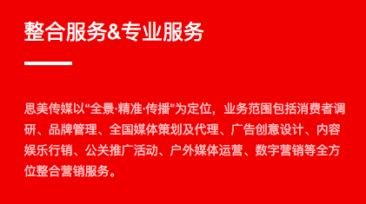

整合服务&专业服务

Integrational & Professional service

——

Simei media believe in "panorama, precision and communication", provides a wide spectrum of integrated marketing services like consumer research, brand management, media , design, content & entertainment marketing, public relations activities, outdoor media operation, digital marketing and so on.

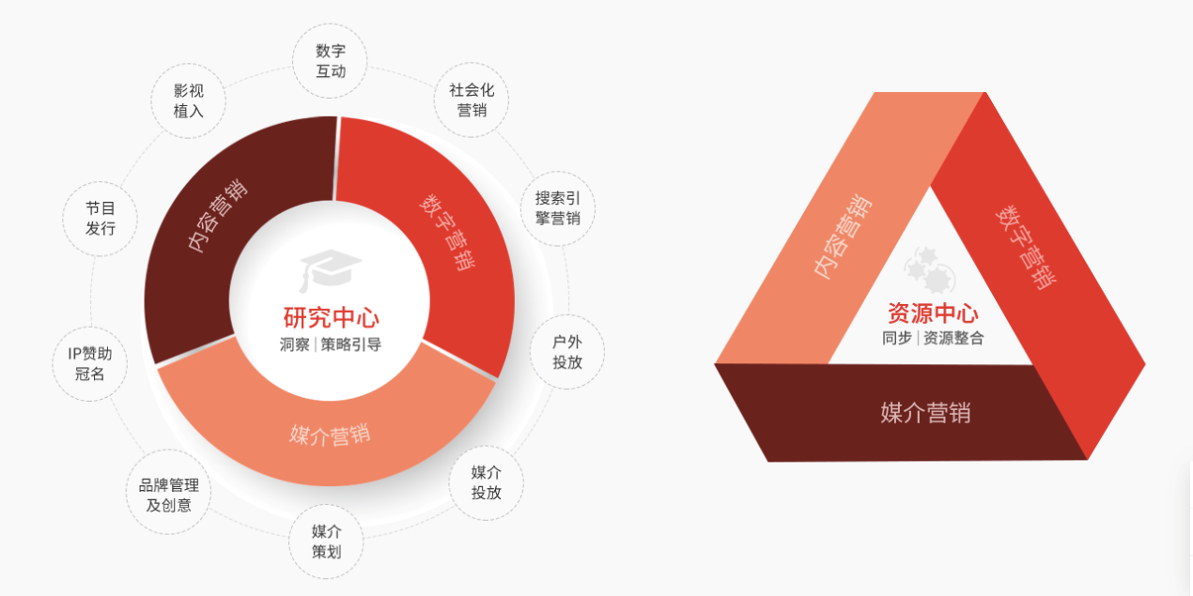

研究中心（research center）洞察|策略引导（insight| Strategy Guiding）

内容营销（content marketing）数字营销（digital marketing）媒介营销（media marketing）

数字互动（digital marketing）

社会化营销（social marketing）

搜索引擎营销（SEM）

户外投放（outdoor advertising）

媒介投放（media advertising）

媒介策划（media planning）

品牌管理及创意（brand management& creativity）

ip赞助冠名（IP Title Sponsor）

节目发行（program distribution）

影视植入（[product placement](javascript:void(0);)）

资源中心（Research Center）同步|资源整合（synchronization |resources integration）

内容营销（content marketing）数字营销（digital marketing）媒介营销（media marketing）

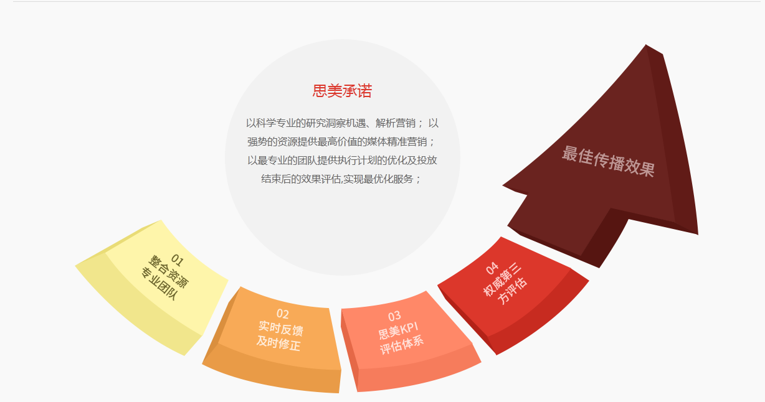

**（思美承诺）Simei Promises To**

Insight opportunity and analyze marketing with scientific and professional research

Provide the most valued media precision marketing with strong resources

Provide the optimization of execution plan and effect evaluation after delivery with the most professional team, realize the optimum services

01整合资源 专业团队

Integrate resources and professional team

02实时反馈 及时修正

Real-time feedback and correction

03思美KPI 评估系统

Simei KPI evaluation system

04权威第三方评估

Authoritative third-party assessment

最佳传播效果

Best communication effect

公司简介

思美传媒股份有限公司简介

思美传媒股份有限公司，全国文化企业三十强，中国4A副理事长单位。公司于2014年1月23日在深交所挂牌上市（股票代码：002712），中国第一家在主板上市的民营广告公司，是一家以内容为核心的传媒集团。

Simei Media Co. Ltd is a content driven intergrated marketing communication agency. We are one of China top 30 Cultural Orientated 4As agency and also the first privately listed advertising company in China, on the main board.

公司成立于2000年，在北京、上海、广州、杭州都设有分公司，现员工总人数达800余人，旗下设有思美影业、思美营销、思美科技、思美体育等多个事业部，拥有爱德康赛、掌维科技、观达影视、科翼传媒、智海扬涛等多家内容及营销领域的子公司。

Founded in 2000, currently we have more than 800 talents across our offices in Hangzhou, Shanghai, Beijing and Guangzhou. Simei Media currently has Marketing Communications, Film, Technology and Sport Marketing. We has also acquired ADCONCEPTS, ZW88 tech, grand media, Keyi media, ZhiHaiYangTao to extend our services and offering.

思美传媒以“全景·精准·传播”为定位，为客户提供从品牌管理与广告创意、娱乐内容营销、数字营销、全媒体策划及代理、公关推广到效果监测的全方位整合营销服务，全面提升客户的品牌价值。

With our vision “Panoramic, Precision , Communication” , our integrated marketing communication offering include marketing and consumer research, brand management, National media planning and Creative and design, content & entertainment , public relations ,outdoor media operation, digital marketing allowing us to better enhance our business partner communication value.

在消费升级的大趋势下，思美传媒深度关注以90后、00后为主体的9000岁和新中产群体的消费方式，深信内容已成为帮助品牌连接消费者的核心资源，而互动与体验更成为强化消费者对品牌认知的关键。基于这样的洞察，思美秉承“以需求为驱动，以内容为核心，以价值为目标”的战略理念，实施以内容为核心的产业升级，构建多层次的产品化平台，以打通上下游的产业化运营，通过资源整合和模式创新不断创造新的价值。

We put lots of attention in understanding the lifestyle and consumption behavior of China Millenial and the new middle class considering their increasing influence in the consumption strength.

Understanding their behavior and habit help us to develop a better communication strategy in reaching and engaging with this crucial target audience. Allowing our brands to connect with them across their whole consumption and entertainment journey with content as our core and value fulfillment as our goal.

公司目前已完成“IP源头+内容制作+营销宣发”的影视内容产业链闭环，并正向体育营销、内容衍生品开发、内容电商等泛娱乐领域纵深发展，不断完善产业布局，提供更加多元化的服务，帮助品牌在新的挑战中抓住先机，创造价值。

We not have developed a fully integrated communication and entertainment chain from “IP sourcing to content production and marketing” but also expand our field to sport marketing and e-commerce. We will continue to transform and enhance our offering on par with the market development and work together with our business partners to seize the opportunities in the ever evolving marketing environment.

作为行业内“国际思维，本土战术”的典范，思美传媒不仅长期服务众多的中外知名品牌，更是致力于推动成长型中小企业的发展，为提升中国品牌影响力而不断努力。思美传媒的愿景是成为最具创新能力与专业精神的传媒集团，助力中国的品牌走进世界，让世界听到中国的声音。

Thinking global, acting local, Simei Media has built a long term partnership with well-known Chinese and international brands. We are also committed to work with SME in promoting their services and products. Simei’s vision is to be the professional and innovative media conglomerate to bring Chinese brand to the world.

领导团队简介

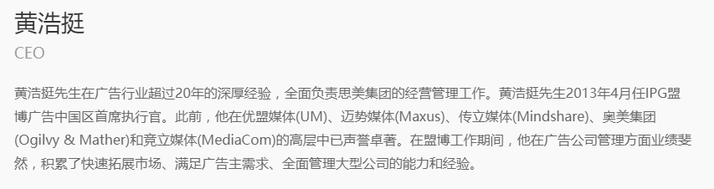

Cary Huang

CEO

Cary Huang has over 20 years experience among [advertising industry](http://dict.youdao.com/w/advertising%20industry/" \l "keyfrom=E2Ctranslation) who is responsible for the operation and management of Simei. Cary Huang was the chief executive of IPG advertising China in April 2013. Previously, he had a reputation in the senior management of Unita Media (UM), Maxus, Mindshare, Ogilvy & Mather and MediaCom. During his work at IPG, he has achieved great results in the management of advertising companies, and accumulated the ability and experience of rapidly expanding the market, meeting the needs of advertisers and comprehensively managing large companies.

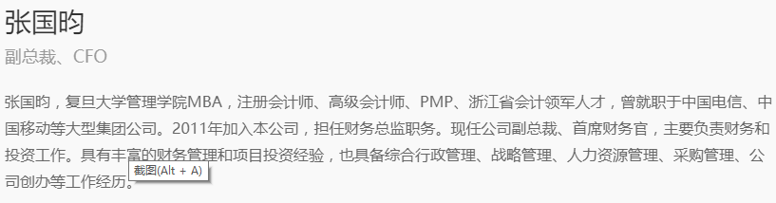

GuoYun Zhang Vice President, CFO

GuoYun Zhang, an EMBA of Fudan university of management, CPA, ICPA, PMP, accounting leader in Zhejiang, worked for CTC, CMCC and other large companies. Mr. Zhang joined the company in 2011 as chief financial officer, and he is the vice President and CFO of the company, who is responsible for financial and investment work now. With rich experience in financial management and project investment, Mr. Zhang also has experience in general administration, strategic management, human resource management, purchasing management, and company establishment.

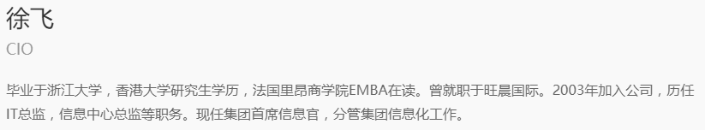

Fei Xu

CIO

Fei Xu was graduated from Zhejiang University with a postgraduate degree from the university of Hong Kong and EMBA at the Lyon business school in France. He worked in WangChen International Company. Mr. Xu joined the company in 2003, served as director of IT, director of information center, etc. He is now the CIO in Simei.

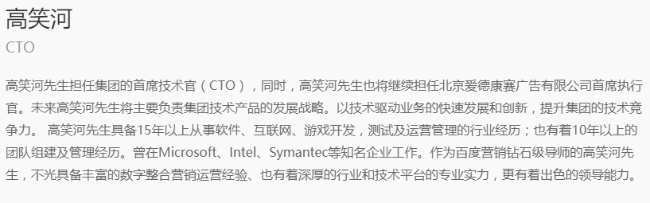

XiaoHe Gao

CTO

Mr. Gao is the CTO in Simei, and he will also continue to serve as CEO of Beijing ADKS Advertising co., LTD at the same time. In the future, Mr. Gao will be mainly responsible for the development strategy of group technology products. With the rapid development and innovation of technology-driven business, the technical competitiveness of the group is improved. Mr. Gao has more than 15 years experience in software, Internet, game development, testing and operation management. He also has more than 10 years of team building and management experience. He has worked in well-known enterprises such as Microsoft, Intel and Symantec. As a Senior marketing Instructor in Baidu, Mr. Gao not only have rich experience in digital integrated marketing operation, also has the deep industry and technology platform of professional strength, and more excellent leadership.

人才观

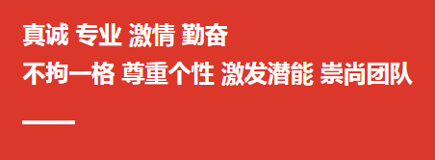

Sincere /Professional/ Passion/ Diligence

Respect /Inspire /Advocate team /Go the extra mile

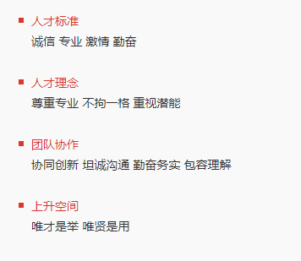

* Talent criteria : Integrity/ Professional/ Passionate/ Diligence
* Talent behavior : Respect /Inspire /Go the extra mile
* Teamwork : Collaborative innovation/ Open Communicate / Diligence and pragmatism/Understanding
* Opportunity for development : Equal / Recognition / Respect

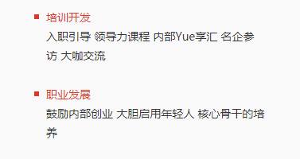

* Training and Development

Induction/Leadership Program/ Professional training /companies visiting/ communication

* [Dareer development](http://www.youdao.com/w/career%20development/" \l "keyfrom=E2Ctranslation)

Encourage internal entrepreneurship/ Be bold / train young and new talent

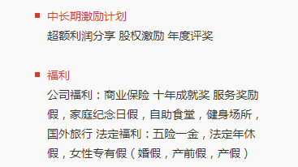

* Long-term incentive plan : Profit sharing/ Stock option incentive plan/ The annual bonus
* Welfare

Corporate welfare: The commercial insurance/ 10-year achievement award/service award/family day holiday/ cafeteria /gym/ oversea travel

Legal Welfare: Five social insurance and one housing fund (endowment insurance/medical insurance/unemployment insurance/employment injury insurance/maternity insurance/Housing Provident Fund)/statutory annual leave/women's exclusive leave (wedding leave/antenatal leave/maternity leave)

职业发展

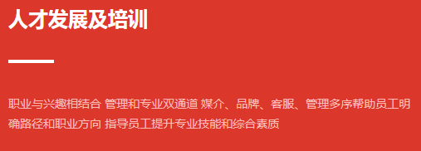

Talent training and development

Continuously enhancing the staff management and professional skill ensuring our talents provide the high value services to our business partners

A combination of career and interest/ dual channels of management and professional/Utilize media, brand, customer service and management to help employees make sure the career direction/Instruct staff to improve professional skills and comprehensive capabilities

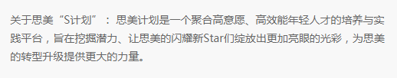

Simei S Program: Selection of young shining stars within the company, empowering them with the professional skill for adaptability in the market and upgrading Simei’s services.

“Simei S Program”: “Simei S Program” is a platform that aggregates young talents with passion and efficient which aims to tap the potential talent. “Simei S Program” let the shining stars of Simei to shine brighter, and provide more power for the transformation and upgrading of the company.

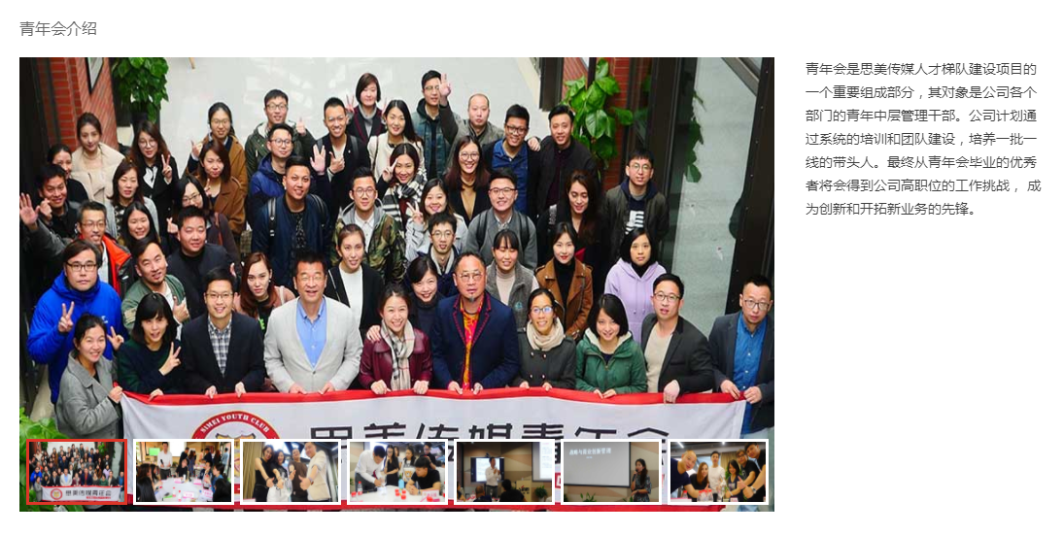

Introduction of [Young Men's Association](http://dict.youdao.com/w/Young%20Men's%20Christian%20Association/" \l "keyfrom=E2Ctranslation) of Simei

Introduction of Simei Youth Club (SYC)

SYC is an exclusive program where exclusively selected middle management talents from various division within the company in preparing them to be the new generation of Simei’s leaders. Systematic programs are developed to nurture these selected elites from professional and management skills so that they can bring fresh new innovative thinking to the company as a whole.

The [Young Men's Association](http://dict.youdao.com/w/Young%20Men's%20Christian%20Association/" \l "keyfrom=E2Ctranslation) of Simei is an important part of the construction project of the Simei media talent echelon, which is made up of the middle management cadre of youth in various departments of the company. The company plans to nurture future leaders through systematic training and team building. Ultimately, the winners will be challenged by the company's management team and become the pioneer in innovation and new business.