5.22完成smooth的优化

原函数：

/*

* naive_smooth - The naive baseline version of smooth

*/

char naive_smooth_descr[] = "naive_smooth: Naive baseline implementation";

void naive_smooth(int dim, pixel *src, pixel *dst)

{

int i, j;

for (i = 0; i < dim; i++)

for (j = 0; j < dim; j++)

dst[RIDX(i, j, dim)] = avg(dim, i, j, src);

}

这次有 尝试过循环展开，并行运算等，但是最后的结果都是和原函数的cpe极其相似，并且全是负优化。

所以考虑到可能是思路或者方法错误。

在头文件def.h中，写着#defineRIDX(i,j,n) ((i)*(n)+(j))

这是我们平时不常接触的函数型宏定义，传入i和j还有n，就计算出(i)*(n)+(j)，这是dst的地址。

一个二维的图片，一般用二维数组存储，但是二维数组在内存中依然是连续的物理地址。**可以把dst[RIDX(i,j, dim)] 直接理解为二维数组a[i][j]。**

static pixel avg(int dim, int i, int j, pixel *src)   
{  
    int ii, jj;  
    pixel_sum sum;  
    pixel current_pixel;  
  
  
    initialize_pixel_sum(&sum);  
    for(ii = max(i-1, 0); ii <= min(i+1, dim-1); ii++)   
         for(jj= max(j-1, 0); jj <= min(j+1, dim-1); jj++)   
             accumulate_sum(&sum,src[RIDX(ii, jj, dim)]);  
    assign_sum_to_pixel(&current_pixel, sum);  
    return current_pixel;  
}

这个函数循环的效率太低了，所以重点不是改原函数，而是对这个被调用的函数做出一定的修改（或者干脆放弃他，自己编写循环效率高的算法）。

**需要改写代码，不调用avg函数**

像素点平均颜色是如何计算的？

static void accumulate_sum(pixel_sum *sum, pixel p) //统计颜色数据  
{  
    sum->red += (int) p.red;  
    sum->green += (int) p.green;  
    sum->blue += (int) p.blue;  
    sum->num++;  
    return;  
}

static void assign_sum_to_pixel(pixel *current_pixel, pixel_sumsum) //计算平均值  
{  
    current_pixel->red = (unsigned short) (sum.red/sum.num);  
    current_pixel->green = (unsigned short) (sum.green/sum.num);  
    current_pixel->blue = (unsigned short) (sum.blue/sum.num);  
    return;  
}

**把相邻的像素点的RGB颜色各取平均**

首先，学习之前rotate函数的优化方法，为了减少调用max和min的时间，我们可以自定义宏定义。

/*

* smooth - Your current working version of smooth.

* IMPORTANT: This is the version you will be graded on

*/

char smooth_descr[] = "smooth: Current working version";

void smooth(int dim, pixel *src, pixel *dst)

{

int i, j;

for (i = 0; i < dim; i++)

{

int k1=max(i-1,0),k2=min(i+1,dim-1);

for (j = 0; j < dim; j++)

{

int ii, jj;

int k3=max(j-1,0),k4=min(j+1,dim-1);

pixel_sum sum;

pixel current_pixel;

//initialize_pixel_sum(&sum);

sum.red= sum.green = sum.blue = 0;

sum.num= 0;

for(ii= k1; ii <= k2; ii++)

for(jj = k3; jj <=k4; jj++)

//accumulate_sum(&sum, src[RIDX(ii,jj, dim)]);

{

pixel p=src[RIDX(ii, jj, dim)];

sum.red += (int) p.red;

sum.green+= (int) p.green;

sum.blue+= (int) p.blue;

sum.num++;

}

//assign_sum_to_pixel(&current_pixel,sum);

{

current_pixel.red = (unsigned short)(sum.red/sum.num);

current_pixel.green = (unsigned short)(sum.green/sum.num);

current_pixel.blue= (unsigned short) (sum.blue/sum.num);

dst[RIDX(i, j, dim)] = current_pixel;

}

}

}

}

第二种方式：

建立一个数组rowsum，着个数组专门保存并且计算算到的像素值，因为计算像素的平均值并保存之后，这个值附近的值值再去计算平均值的时候会被重复计算，所以用一个二维数组保存比较方便，也好调用查找。

/*

* smooth - Your current working version of smooth.

* IMPORTANT: This is the version you will be graded on

*/

char smooth_descr2[] = "smooth: Current working version";

void smooth2(int dim, pixel *src, pixel *dst)

{

pixel_sum rowsum[530][530];

int i, j, snum;

for(i=0;i<dim; i++)

{

rowsum[i][0].red = (src[RIDX(i, 0, dim)].red+src[RIDX(i, 1, dim)].red);

rowsum[i][0].blue = (src[RIDX(i, 0, dim)].blue+src[RIDX(i, 1,dim)].blue);

rowsum[i][0].green = (src[RIDX(i, 0, dim)].green+src[RIDX(i, 1,dim)].green);

rowsum[i][0].num = 2;

for(j=1;j<dim-1; j++)

{

rowsum[i][j].red = (src[RIDX(i, j-1, dim)].red+src[RIDX(i, j,dim)].red+src[RIDX(i, j+1, dim)].red);

rowsum[i][j].blue = (src[RIDX(i, j-1, dim)].blue+src[RIDX(i, j,dim)].blue+src[RIDX(i, j+1, dim)].blue);

rowsum[i][j].green = (src[RIDX(i, j-1, dim)].green+src[RIDX(i, j,dim)].green+src[RIDX(i, j+1, dim)].green);

rowsum[i][j].num = 3;

}

rowsum[i][dim-1].red = (src[RIDX(i, dim-2, dim)].red+src[RIDX(i, dim-1,dim)].red);

rowsum[i][dim-1].blue = (src[RIDX(i, dim-2, dim)].blue+src[RIDX(i,dim-1, dim)].blue);

rowsum[i][dim-1].green = (src[RIDX(i, dim-2, dim)].green+src[RIDX(i,dim-1, dim)].green);

rowsum[i][dim-1].num = 2;

}

for(j=0;j<dim; j++)

{

snum=rowsum[0][j].num+rowsum[1][j].num; dst[RIDX(0,j,dim)].red=(unsignedshort)((rowsum[0][j].red+rowsum[1][j].red)/snum);

dst[RIDX(0,j, dim)].blue = (unsigned short)((rowsum[0][j].blue+rowsum[1][j].blue)/snum);

dst[RIDX(0,j, dim)].green = (unsigned short)((rowsum[0][j].green+rowsum[1][j].green)/snum);

for(i=1;i<dim-1; i++)

{

snum =rowsum[i-1][j].num+rowsum[i][j].num+rowsum[i+1][j].num;

dst[RIDX(i, j, dim)].red = (unsigned short)((rowsum[i-1][j].red+rowsum[i][j].red+rowsum[i+1][j].red)/snum);

dst[RIDX(i, j, dim)].blue = (unsigned short)((rowsum[i-1][j].blue+rowsum[i][j].blue+rowsum[i+1][j].blue)/snum);

dst[RIDX(i, j, dim)].green = (unsigned short)((rowsum[i-1][j].green+rowsum[i][j].green+rowsum[i+1][j].green)/snum);

}

snum =rowsum[dim-1][j].num+rowsum[dim-2][j].num;

dst[RIDX(dim-1, j, dim)].red = (unsigned short)((rowsum[dim-2][j].red+rowsum[dim-1][j].red)/snum);

dst[RIDX(dim-1, j, dim)].blue = (unsigned short)((rowsum[dim-2][j].blue+rowsum[dim-1][j].blue)/snum);

dst[RIDX(dim-1, j, dim)].green = (unsigned short)((rowsum[dim-2][j].green+rowsum[dim-1][j].green)/snum);

}

}

第三种优化：

把求平均值分成了几种情况来考虑，第一组：四个顶点；第二组：四个边位置的数块；第三组：最中间的快；

这样会减少函数调用，因为每次都是直接计算。

char smooth_descr3[] = "smooth: Current working version";

void smooth3(int dim, pixel *src, pixel *dst)

{

int i,j;

int dim0=dim;

int dim1=dim-1;

int dim2=dim-2;

pixel *P1, *P2, *P3;

pixel *dst1;

P1=src;

P2=P1+dim0; //左上角像素处理

dst->red=(P1->red+(P1+1)->red+P2->red+(P2+1)->red)>>2;

dst->green=(P1->green+(P1+1)->green+P2->green+(P2+1)->green)>>2;

dst->blue=(P1->blue+(P1+1)->blue+P2->blue+(P2+1)->blue)>>2;

dst++; //上边界处理

for(i=1;i<dim1;i++) {

dst->red=(P1->red+(P1+1)->red+(P1+2)->red+P2->red+(P2+1)->red+(P2+2)->red)/6;

dst->green=(P1->green+(P1+1)->green+(P1+2)->green+P2->green+(P2+1)->green+(P2+2)->green)/6;

dst->blue=(P1->blue+(P1+1)->blue+(P1+2)->blue+P2->blue+(P2+1)->blue+(P2+2)->blue)/6;

dst++;

P1++;

P2++;

} //右上角像素处理

dst->red=(P1->red+(P1+1)->red+P2->red+(P2+1)->red)>>2;

dst->green=(P1->green+(P1+1)->green+P2->green+(P2+1)->green)>>2;

dst->blue=(P1->blue+(P1+1)->blue+P2->blue+(P2+1)->blue)>>2;

dst++;

P1=src;

P2=P1+dim0;

P3=P2+dim0; //左边界处理

for(i=1;i<dim1;i++) {

dst->red=(P1->red+(P1+1)->red+P2->red+(P2+1)->red+P3->red+(P3+1)->red)/6;

dst->green=(P1->green+(P1+1)->green+P2->green+(P2+1)->green+P3->green+(P3+1)->green)/6;

dst->blue=(P1->blue+(P1+1)->blue+P2->blue+(P2+1)->blue+P3->blue+(P3+1)->blue)/6;

dst++;

dst1=dst+1; //主体中间部分处理

for(j=1;j<dim2;j+=2) { //同时处理2个像素

dst->red=(P1->red+(P1+1)->red+(P1+2)->red+P2->red+(P2+1)->red+(P2+2)->red+P3->red+(P3+1)->red+(P3+2)->red)/9;

dst->green=(P1->green+(P1+1)->green+(P1+2)->green+P2->green+(P2+1)->green+(P2+2)->green+P3->green+(P3+1)->green+(P3+2)->green)/9;

dst->blue=(P1->blue+(P1+1)->blue+(P1+2)->blue+P2->blue+(P2+1)->blue+(P2+2)->blue+P3->blue+(P3+1)->blue+(P3+2)->blue)/9;

dst1->red=((P1+3)->red+(P1+1)->red+(P1+2)->red+(P2+3)->red+(P2+1)->red+(P2+2)->red+(P3+3)->red+(P3+1)->red+(P3+2)->red)/9;

dst1->green=((P1+3)->green+(P1+1)->green+(P1+2)->green+(P2+3)->green+(P2+1)->green+(P2+2)->green+(P3+3)->green+(P3+1)->green+(P3+2)->green)/9;

dst1->blue=((P1+3)->blue+(P1+1)->blue+(P1+2)->blue+(P2+3)->blue+(P2+1)->blue+(P2+2)->blue+(P3+3)->blue+(P3+1)->blue+(P3+2)->blue)/9;

dst+=2;dst1+=2;P1+=2;P2+=2;P3+=2;

}

for(;j<dim1;j++) {

dst->red=(P1->red+(P1+1)->red+(P1+2)->red+P2->red+(P2+1)->red+(P2+2)->red+P3->red+(P3+1)->red+(P3+2)->red)/9;

dst->green=(P1->green+(P1+1)->green+(P1+2)->green+P2->green+(P2+1)->green+(P2+2)->green+P3->green+(P3+1)->green+(P3+2)->green)/9;

dst->blue=(P1->blue+(P1+1)->blue+(P1+2)->blue+P2->blue+(P2+1)->blue+(P2+2)->blue+P3->blue+(P3+1)->blue+(P3+2)->blue)/9;

dst++; P1++;P2++;P3++;

} //右侧边界处理

dst->red=(P1->red+(P1+1)->red+P2->red+(P2+1)->red+P3->red+(P3+1)->red)/6;

dst->green=(P1->green+(P1+1)->green+P2->green+(P2+1)->green+P3->green+(P3+1)->green)/6; dst->blue=(P1->blue+(P1+1)->blue+P2->blue+(P2+1)->blue+P3->blue+(P3+1)->blue)/6;

dst++; P1+=2; P2+=2; P3+=2;

} //左下角处理

dst->red=(P1->red+(P1+1)->red+P2->red+(P2+1)->red)>>2; dst->green=(P1->green+(P1+1)->green+P2->green+(P2+1)->green)>>2;

dst->blue=(P1->blue+(P1+1)->blue+P2->blue+(P2+1)->blue)>>2;

dst++; //下边界处理

for(i=1;i<dim1;i++) {

dst->red=(P1->red+(P1+1)->red+(P1+2)->red+P2->red+(P2+1)->red+(P2+2)->red)/6;

dst->green=(P1->green+(P1+1)->green+(P1+2)->green+P2->green+(P2+1)->green+(P2+2)->green)/6;

dst->blue=(P1->blue+(P1+1)->blue+(P1+2)->blue+P2->blue+(P2+1)->blue+(P2+2)->blue)/6;

dst++; P1++; P2++;

} //右下角像素处理

dst->red=(P1->red+(P1+1)->red+P2->red+(P2+1)->red)>>2;

dst->green=(P1->green+(P1+1)->green+P2->green+(P2+1)->green)>>2;

dst->blue=(P1->blue+(P1+1)->blue+P2->blue+(P2+1)->blue)>>2;

}

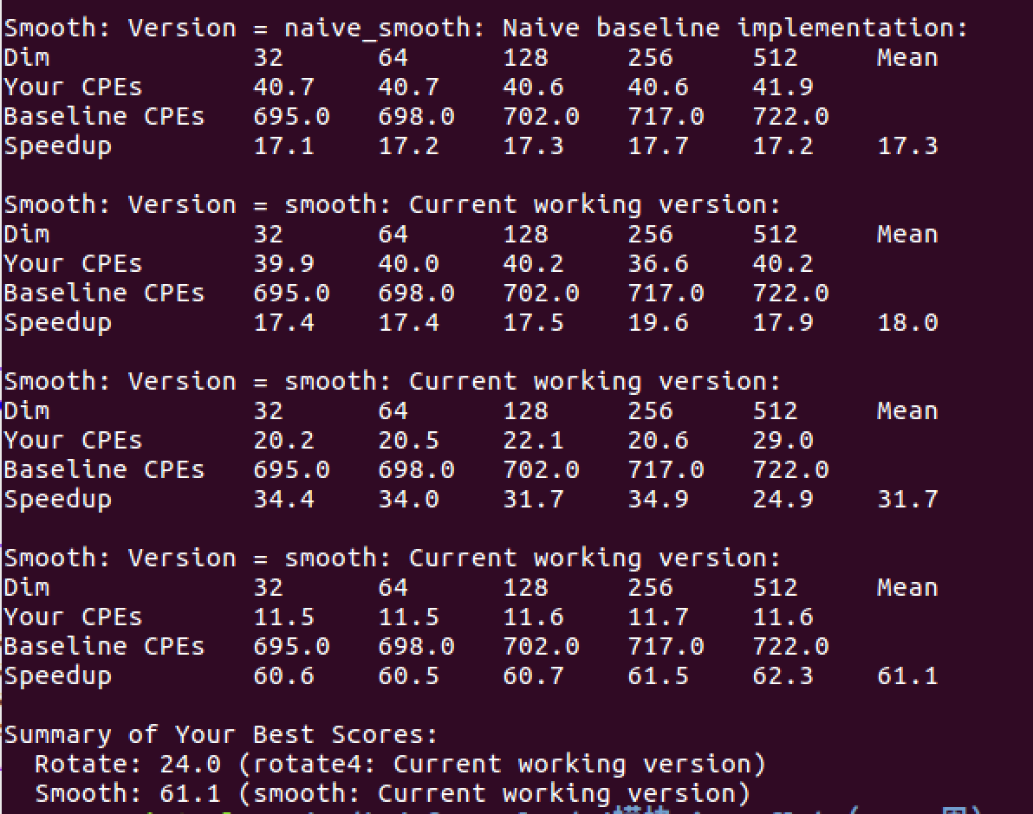

彩蛋：

