Title sheet

Contents

1. Introduction and Historical Background 3

1.1. Formula SAE Electric Background 3

1.2. Cooling System Background 3

2. Theory and Basic Equations 4

2.1. Assumptions and Constraints 5

2.2. Heat Generation 6

2.3. Heat Transfer 7

3. Concept and Analysis Plan 9

3.1. Concept Description 9

3.2. Proto-Design 9

3.3. Analysis Methods 10

4. Analysis 11

4.1. Calculation Summary 11

4.2. Design Box 12

5. Cost Estimate 12

6. Timetable 13

7. References 13

## Introduction and Historical Background

Global warming is a driving force behind engineering and innovation, resulting in an increased demand for eco-friendly products, green energy, and sustainability [1, 2]. Electric and hybrid vehicles have seen tremendous growth and popularity since the introduction of the Prius in 2003, with major automotive companies offering hybrid or electric models. Projections even estimate more that 125 million electric vehicles (EVs) will be on the road by 2030

### Formula SAE Electric Background

### Cooling System Background

There are two types of liquid cooling systems: direct and indirect. Both types are advantageous for the high specific heat and thermal conductivity of the coolant, its compact size, and better uniform temperature distribution than air. Direct liquid cooling immerses the battery in a high-resistance coolant. However, this system is more prone to electrochemical corrosion and an electrical short [[source](https://search-proquest-com.libproxy1.usc.edu/docview/2403217158/fulltextPDF/1E8EC95ADB1F4C54PQ/1?accountid=14749)]. Indirect cooling uses a system of channels to flow the liquid coolant, however, it requires a circulator pump that will draw power from the battery and reduce the vehicles travel. Additionally, both types have drawbacks, this type of system adds extra weight to the vehicle, is expensive and complex, and requires more maintenance.

The air-cooling system can be used through two methods, forced convection or natural convection. Natural convection however is less effective than forced convection because natural convection is only highly efficient for low energy density batteries. On the other hand, using fans and/or blowers helps enhance the heat transfer coefficient during forced air flow to improve heat dissipation. An air-cooling system offers different heat sink designs mainly having to do with the geometry and number of fins that could be incorporated. When the vehicle is in use, the heat generated will flow to the fins which will help heat dissipate because of the surface area increase. Comparing rectangular, circular and curved fins while changing the thickness of each fin affects the efficiency of the system [source]. Through an experiment it was found that reducing the thickness of the fin and using a curved shape fin decreased the overall weight of the system and thus improved the system’s effectiveness. Using different materials for the fins is also a factor to consider in order to increase the system’s productivity. In a comparison of aluminum alloy 6061 and magnesium alloy, aluminum alloy with a small thickness seems to be a better choice to optimize the system. Comparing the number of fins, it was found that using many fins while having small thickness was most beneficial for vehicles that would reach high speeds because it will reduce turbulence while increasing the heat transfer [source]. The challenge with the air-cooled system is that it is not as efficient as other systems, especially in vehicles where air is not fully in direct contact. Yet, the positive side of this system is that there is less weight added to the system as opposed to using the liquid system while also avoiding any unwanted leaks. The air-cooled system thus presents itself as a malleable solution because it would be possible to modify the heat sink as needed.

Table 1. Comparison of liquid cooling and air cooling. On a scale basis, 1, 2 and 3 represent great, good, okay, respectively. Table from research paper [[source](https://search-proquest-com.libproxy1.usc.edu/docview/2403217158/fulltextPDF/1E8EC95ADB1F4C54PQ/1?accountid=14749) ].

|  |  |  |  |
| --- | --- | --- | --- |
|  | Liquid Cooling |  | Air Cooling |
|  | Direct | Indirect |  |
| Cooling Efficiency | 1 | 1 | 2 |
| System Complexity | 3 | 3 | 1 |
| Energy Loss | 3 | 3 | 1 |
| Maintenance | 3 | 3 | 1 |
| Short Circuit | 3 | 3 | 1 |
| Lifespan | 3 | 3 | 1 |
| Cost | 3 | 3 | 1 |

As seen in the table above, an air-cooling system is better in mostly all aspects compared to a liquid based system. Moving forward our cooling system will be air based with some fin modifications made later in our design.

## Theory and Basic Equations

The accumulator, also known as the battery, has a watt-hour capacity of 6.3kWh. A cylindrical, lithium-ion cell, known as 18650, has been selected for the design, but the specific chemical composition has yet to be determined. Regardless of composition, the 18650 is of a standard size and average voltage, allowing the team to begin physical modelling of the accumulator. The accumulator will be composed of modules, segments of cells isolated within a casing. Within each module will be 28 groupings of 4 clustered cells in series and parallel, respectively. The accumulator will be composed of 5 modules, with each module having a charged voltage of 100.8 volts, for a total of 504 volts. Table 1 below shows calculated and estimated values from the design thus far.

Table 1: Accumulator Specification Data

|  |  |  |
| --- | --- | --- |
| **Specification** | **Value** | **Unit** |
| Cell Nominal Voltage | 3.7 | [V] |
| Cell Capacity | 3500 | [mAh] |
| Cell Internal Resistance | 20 | [mΩ] |
| Accumulator Nominal Voltage | 504 | [V] |
| Accumulator Capacity | 6.3 | [kWh] |

We will rely on basic assumptions regarding the space and behavior of the system, allowing for simplifications to calculations and modeling. These assumptions are defined as either boundary conditions of the system or as variable values within the system. Furthermore, FSAE rules and regulations define a set of design constraints that ensure and maintain safety of the vehicle, as described below in Sec. 2.1. Lastly, the design parameters for this project only reflect the demands placed on the vehicle at the FSAE competition, which takes place at Fortuna, CA every year in the month of June.

### Assumptions and Constraints

Boundary conditions (This will be a table in the final draft):

* Ambient air temperature will be assumed to be 27 ºC
* The specific geometries of the internals within the battery modules will be ignored for the proposal, replaced by a heat generating box
* Due to unknown final coverings of the vehicle, it will be assumed the accumulator container will be fully insulated, with no heating or cooling ability except for the design proposed.
* Intake air speed will be aerodynamically encouraged with the use of a scoop, but with the utility of a fan, be assumed to have a range extending from the minimum airflow due to driving and a maximum of the fan max speed.

Variable Behavior

* Air flow to the heat sink fins will be assumed to be incompressible, and further studies will be done to double check this assumption once the geometry of the air duct and heat sink has been finalized
* The exact cells to be used in the battery modules have not been chosen. Our basic heat generation calculations rely on this information, so an average resistance of 20 mΩ per cell has been chosen for this proposal

Lastly, the power demand estimate used in the calculation of heat generation within the accumulator was visually estimated using motor telemetry supplied by the Beijing Institute of Technology. This data was obtained from what is considered to be the longest and most demanding event at competition, the endurance event. The use of this data supplies us with an expected average and peak demand of power throughout the race which will be considered to be a sufficient estimate to demonstrate the feasibility of the project submitted within this proposal. Once approved, as this project progresses, research into event simulation and telemetry data will enable a more thorough analysis of the final design.

### Heat Generation

Using the average sustained power demand from the motor telemetry of 15 kW, and the nominal accumulator voltage from Table 1, the maximum sustained current was found, shown in Eqn. 1 below.

[1]

To determine the heat generated within the accumulator the maximum sustained current and internal resistance of the battery modules were considered. Using the knowledge of the internal resistance and connection sequence of the cells, Eqns. 2-3 describes the calculation of the accumulator internal resistance.

[2]

[3]

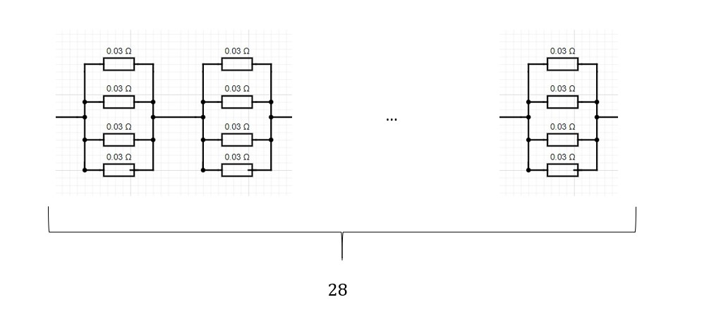

Implementing the data from Table 1 and the previous equations, the total internal resistance of the accumulator was found to be:

[4]

Combining the information from Eqns. 1-4 the maximum heat generated was found using Eqn. 5 below.

This is the working estimated heat to be dissipated by the thermal management system design proposed.

### Heat Transfer

The heat transfer system of the accumulator consists of the heat generated by the accumulator system components, the heat dissipated through conduction via heat sinks, and the convection of heat via the forced air through the heat sink channel. The radiator and hoses function as the primary disposal of heat generated by the motor and motor controller. Additionally, all wiring, sensors, and other high-voltage electrical components will be assumed to produce negligible heat transfer through either conduction or convection for the purposed of this proposal but will be considered throughout the remainder of this study.

The first law of thermodynamics dictates that the rate of heat transfer leaving the heated fluid within system must be equal to the rate of heat transfer to the cooling element. Similarly, this rate of heat transfer must also be equal to the amount of heat generated by the system.

[5]

The heat transfer rates shown in Eqn. 5 can be expanded as follows:

[6]

[7]

Where K in Eqn. 6 is the thermal conductivity of the heat sink material and h in Eqn. 7 is the convection heat coefficient specific to the design. Using Eqn.5, the mass air flow speed of the system can be determined using the following equation.

[8]

Air flow across the heat sink requires fluid dynamic calculations, taking into account the Reynolds number, Nusselt number, hydraulic diameter, and velocity. These calculations are essential in finding the optimal number of fins, as well as fin composition and spacing for the heat sink.

As previously mentioned, the air flow system includes a sucking fan housed within a scoop. The fan is required because while the vehicle may travel at many speeds, the faster the vehicle travels, the more likely radial outflow of incoming air is to occur as the vehicle passes through space. Suction from the fan will ensure consistent flow across the heat sinks.

(7)

(6)

(5)

Considering the air flow evaluated by equations 5-7, as well as the Bernoulli equation, the entrance region, passage across the radiator, and flow through and exiting the fan can be calculated. Beginning with the airflow across the radiator, this flow, the flow movement generated by the fan, and the exit of the flow will be treated as one system with a volumetric flow constant. Once the range of thermal cooling needs has been determined, a range of cooling ability can be established and actualized by controlling the volumetric flow by a variable speed suction fan.

## Concept and Analysis Plan

This section highlights the design concepts and plan of analysis for the design of a thermal management system. The design for heat dissipation will be an air-cooled system which uses the assistance of fans and a heat sink. The design will consider the physical design, placement within the existing accumulator design, build material selection, air flow properties within the system, and optimization of heat dissipation within the budget constraints set out in SECTION XX.

### Concept Description

Our design goal is to create an accumulator thermal management system capable of maintaining the optimal temperature range of a lithium-ion battery pack and its subsequent components in an electric race vehicle while performing at a competition. The battery pack is a part of a larger subassembly also known as the accumulator. The accumulator consists of the packaging of individual battery cells, various high-voltage (HV) components, wiring, and a controller (not housed within the accumulator container). A breakdown of the current accumulator design is shown below in FIGURE XX.

[figure]

The main components shown above are five battery sub containers (modules), the Accumulator Isolation Relays (AIRs), HV fuses and wiring, and the housing (accumulator container). (more here)

### Proto-Design

Our thermal management system will include the [connection of] multiple components. FIGURE XX below outlines the strategy to be employed.

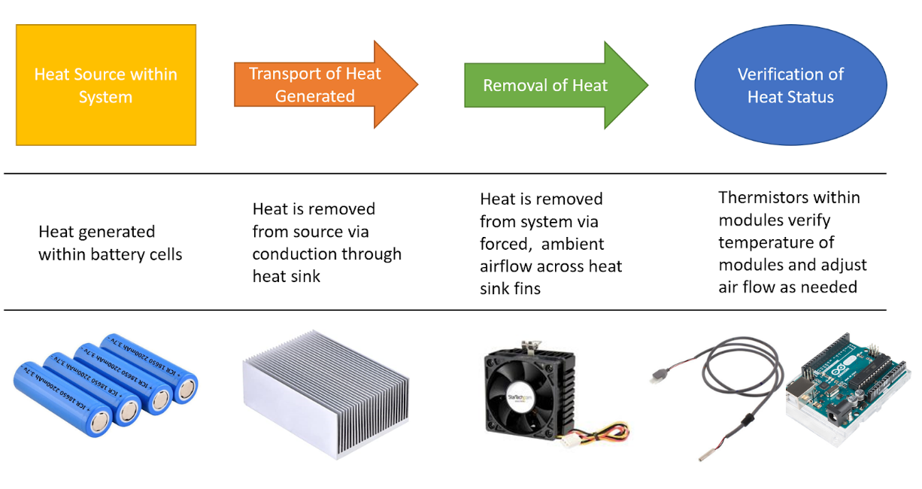

Figure 1: A TITLE PLEASE

The immediate heat dissipation of XX W is expected to begin with the heat sink pulling heat from the module. The current module model shows the ends of the cells sharing a common wall.

The heat sink goes there and draws the heat.

Air flow is required to remove the heat from the system. Using a hood scoop and PWM fan, air is drawn in from above the .... and directed into (describe the layout)

The Accumulator Management System (AMS) is a controller which allows for safe operation of the HV cells. This controller monitors the temperature of every cluster of 4 battery cells. In addition, the main controller of the vehicle (MC) monitors the temp as well. Talk about how the fam might work.

## Analysis Methods

Our analysis addresses these 3 questions:

* Is the accumulator running at the optimal temperature range for the input heat?
* Is the model robust and physically capable of handling the conditions of the competition?
* Does the design meet the criteria for the budget?

By using the results from the CFD analysis, we will figure out amount of heat dissipated using our air-cooled system. From the heat profile, we can easily calculate max and minimum temperature of the battery pack.

## Analysis

A preliminary analysis was completed to determine the feasibility of this project. This section will walk through the calculations and assumptions introduced in Section 2 and provide additional supporting information to justify feasibility of the air-cooled heat dissipation as well as support for the basic assumptions.

### Calculation Summary

Using a common internal resistance of the 18650 cells and the nominal voltage of the accumulator, the heat generated was determined to be 620 W. Using EQN XX the heat sink

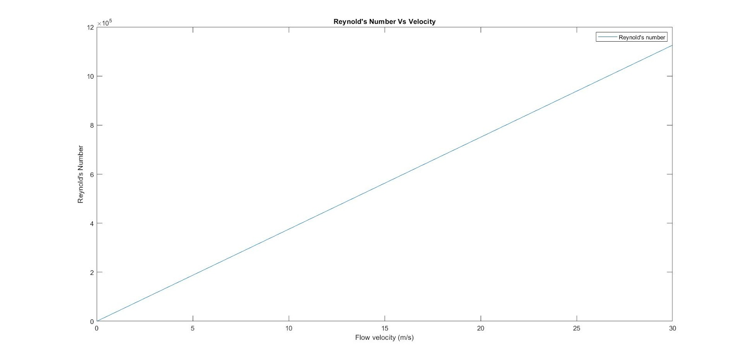

Using equation 4 and boundary conditions at 27 Celsius, we computed Reynold’s number VS. Velocity graph. As we can see, the flow will always be turbulent. The maximum flow speed that air can remain incompressible is 102 m/s, which can satisfy our assumption that air is incompressible.

For air-cooled battery pack, first we will calculate the optimal wind speed v using MATLAB. By varying v from CFD analysis, we will compare v with an amount of heat dissipated (using equation 3), using assumed boundary conditions. Further we are assuming the shape of the battery pack acts as a box. For a water-cooled battery pack, the core concept is to equate equation 6 to equation 7 and find the optimal mass flow rate. However, we will vary the material and therefore varying terms h, cin the above equations. A graph will be shown comparing mass flow rate vs temperature change, together with their cost comparison.

### Design Box

The vehicle will experience a myriad of thermal conditions during competition as there are different events within which the vehicle will be used. Designing around a worst- or best-case scenario is limiting within this process, as it may result in a product which undercools when placed under strenuous conditions or becomes over-engineered, resulting in an accumulator that performs well under stress, but otherwise runs at suboptimal temperatures. The solution to this design problem is to design around a frequent condition to be experienced within the race. The endurance event is a multi-lap scenario with an approximate 80% power utility of the vehicle. An average lap within this event will define the draw on the accumulator we design around, in addition to the constraints introduced in SECTION XX.

The analysis begins by finding the amount of heat generated within

Something important to mention: although our design is optimizing for a specific moment in time around the competition, we also want to test our system for it’s max cooling ability, to see the limits it may have.

## Cost Estimate

## Timetable

Beautiful timetable here. Include screen sheet and refer reader to appendix to view full spreadsheet.

## References