Scripts:

**CollectHistoricalData.m**

Gets historical data from yahoo, within some time range.

Outputs:

rawPrice, a structure, with fields being *ticker* and *content*

tickers, array of stock tickers

**UpdateData.m**

Update data from previously update to latest businessday

Outputs:

rawPrice

tickers

currentDay

**addRVol.m**

adds log return and standard deviation of return to the data

Outputs:

workPrice, content column 1=Date,2=Open,3=High,4=Low,5=Close,6=Volume,7=AdjClose,8=lnRetrun,9=return

std

numOfTickers

daysOfRV (default is 10)

Functions:

Category 1: big move day

There are 6 special cases of a OHLC bar, here O is not same day Open, but

previous Close

1a H>=C>O>=L;1b H>O=C=L; 1c H>O>C=L

2a H>=O>C>=L;2b H=O=C>L; 2c H=C>O>L

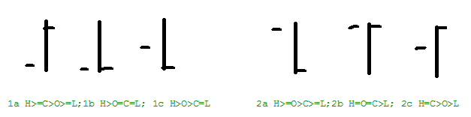

The Open here is not open, but previous close.

To filter big moves, we use number of standard deviations, noStd, call it N, default in code is 3, std is 10 day realized vol

1a,

Function name a1Filter:

H>exp(Nσ)O, H/C< exp (σ), check later O-L<σ

1b and 1c, they are more or less the same, **reversal**

H> exp(Nσ)O, O>C, later we can check C-σ<O

2a,

L<exp(-Nσ) O, C-L< σ, check later H-O< σ

2b and 2c, **reversal**

L<exp(-Nσ) O, C>O, later can check C>O+ σ