SmartDorm EnergyGuard: An IoT-Cloud Based Real-Time Dormitory Electricity Monitoring System

1. Problem Identification and Research

1.1 Problem Definition and Objectives
In university dormitories, especially in countries like New Zealand where students live in shared accommodations, excessive and unmanaged electricity consumption is a common issue. Many students are unaware of their real-time power usage, leading to frequent overloads on individual circuits, unexpected high electricity bills, potential fire hazards from overloaded sockets, and overall energy waste that contradicts sustainability goals of modern educational institutions.
Key problems include：
- Lack of real-time visibility into power consumption (power, current, cumulative energy).
- Difficulty in detecting abnormal usage patterns or overload situations promptly.
- No effective alerting mechanism when usage exceeds safe thresholds.
- Inefficient energy management at the individual room level, contributing to higher institutional operational costs.。
Core Objectives of the Current Solution：
- Develop an IoT-based dormitory electricity monitoring system that collects real-time simulated power data using a Raspberry Pi.
- Transmit data periodically to the cloud for storage and processing.
- Implement cloud-based logic with AWS Lambda to detect overloads and abnormal usage patterns..
- Provide a secure web dashboard with real-time curves, historical records, and instant alerts.
- Promote energy awareness, prevent electrical hazards, and support sustainable campus living.

1.2 Research on Existing IoT Architectures and Cloud Computing Methodologies
The following are three relevant existing IoT + cloud solutions that were searched for based on the objectives of this project.：
- ITERA Smart Campus Energy Monitoring System This IoT-based system uses microcontrollers to measure voltage, current, and power in campus buildings, sending data to a cloud server. It provides real-time web-based visualization and achieves high accuracy. The architecture emphasizes scalability through IoT and cloud integration. Reference: Energy Monitoring System Based on Internet of Things Toward Smart Campus
- MongoDB Atlas + MQTT Smart Meter Solutions Modern smart meter architectures use MQTT protocol for lightweight data ingestion and MongoDB Atlas with Time Series Collections for storage and real-time analytics. MongoDB Realm/Atlas Functions enable serverless rule-based processing . This is highly relevant to our project. Reference: Saving Energy, Smarter: MongoDB And Cedalo For Smart Meter Systems
- Design and Implementation of a Cloud-IoT-Based Home Energy Management System This paper adopt a layered architecture: IoT devices → MQTT/HTTP → Cloud Ingestion (AWS IoT Core) → Serverless processing → NoSQL storage (DynamoDB) → Web dashboard. Reference: Design and Implementation of a Cloud-IoT-Based Home Energy Management System
These solutions generally employ the MQTT protocol for efficient communication and rely on the cloud platform to achieve scalable storage and processing. This has verified the feasibility of the technical route of this project.

1.3 Why an IoT + Cloud Solution is Appropriate
An IoT-cloud architecture based on AWS IoT Core + Lambda + DynamoDB is the optimal solution to address the identified problems, with unique advantages that cannot be achieved with local-only systems:
- Scalability : The system can seamlessly scale from a single dormitory room to an entire campus without hardware upgrades. AWS DynamoDB automatically scales storage and throughput capacity as the number of monitored rooms or data volume grows. AWS IoT Core supports up to millions of concurrent device connections, making it ideal for large-scale campus deployments.
- Serverless Computing: Using AWS Lambda , we can implement overload detection and alert logic in a fully serverless manner. This eliminates the need to manage servers, reduces operational overhead, and only charges for actual execution time.
- Cost-Efficiency: Pay-as-you-go pricing model is ideal for a small-to-medium deployment. There is no upfront infrastructure cost, and idle periods cost almost nothing. AWS offers a generous free tier suitable for prototypes.
- Reliability and Accessibility: Cloud services provide high availability, automatic backups, and accessible from any location. Students and administrators can monitor usage anytime via web from anywhere.
- Real-time Processing and Analytics: Cloud enables powerful real-time rule processing, historical data analysis, and future extension to anomaly detection.

2. System Design

2.1 Overall Architecture
The system adopts a three-layer IoT-cloud architecture:

- Device Layer: Raspberry Pi simulates sensor data collection (voltage, current, power, cumulative energy) and publishes via MQTT to AWS IoT Core every 30 seconds. The device simultaneously subscribes to IoT Device Shadow delta events to receive power cutoff commands.
- Cloud Layer: AWS IoT Core acts as the MQTT broker and device shadow manager. An IoT Rule routes incoming MQTT messages to an AWS Lambda function for processing. API Gateway exposes four REST endpoints for the frontend. DynamoDB stores all persistent data. Cognito handles OAuth 2.0 authentication. SNS delivers email alerts. CloudWatch collects custom metrics for analytics.
- Application Layer: A React SPA served as a static website provides the user dashboard with real-time charts, remote threshold control, simulation tools, and alert history.

2.2 System Block Diagram
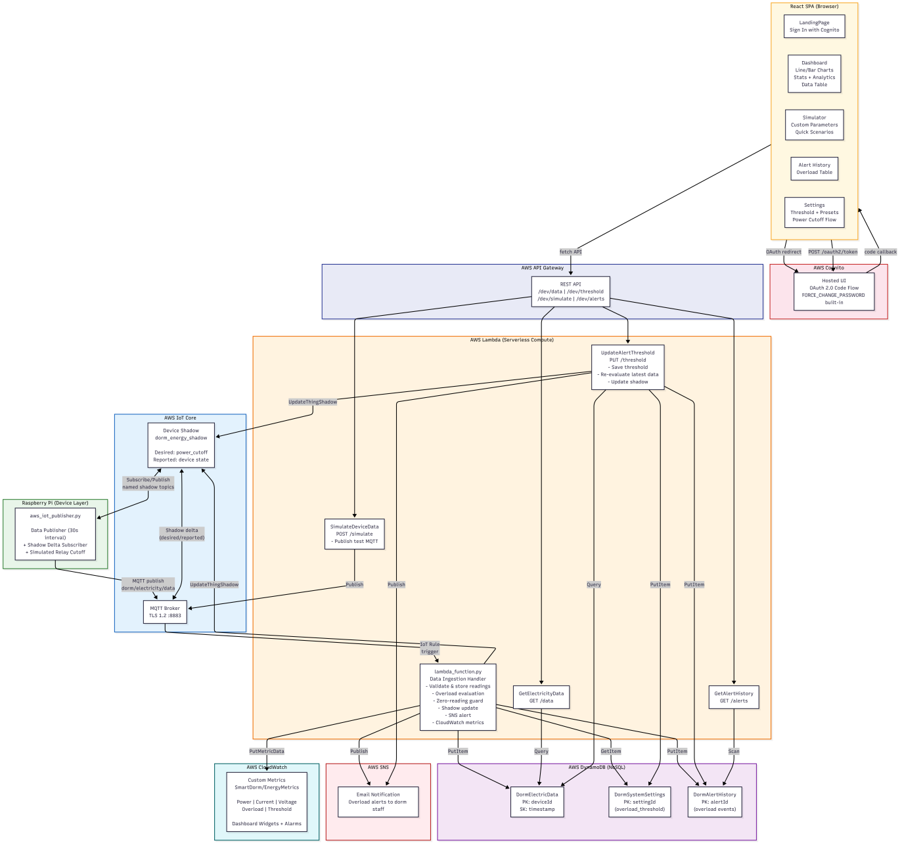

2.3 Hardware and Service Selection

Component | Selection | Rationale
IoT Hardware | Raspberry Pi | Widely available, Python SDK, GPIO for future relay integration
MQTT Broker | AWS IoT Core | Fully managed, supports millions of concurrent devices, built-in device shadow for bidirectional communication
API Layer | AWS API Gateway | Serverless REST endpoints, auto-scaling, CORS support, integrates directly with Lambda
Compute | AWS Lambda (Python 3.14) | Serverless — no server management, pay-per-execution, auto-scales from 0 to thousands of concurrent invocations
Authentication | AWS Cognito Hosted UI | Fully managed OAuth 2.0 provider, built-in FORCE_CHANGE_PASSWORD, zero frontend SDK dependency
Database | AWS DynamoDB | NoSQL key-value store with single-digit millisecond latency, auto-scaling, fully managed — ideal for time-series IoT data
Notifications | AWS SNS | Push email notifications to dormitory staff on overload events
Monitoring | AWS CloudWatch | Custom metrics, dashboards, log aggregation — enables data analytics without external tools
Frontend | React 18 + Vite + Tailwind CSS + Chart.js | Fast dev server, small bundle, responsive design, no additional SDK for auth

2.4 Communication Protocols and Data Flow
MQTT was chosen for device-to-cloud communication because:
- Lightweight binary protocol ideal for constrained devices
- Persistent connection reduces overhead compared to HTTP polling
- QoS levels (we use QoS 1 — at least once delivery)
- Built-in TLS 1.2 encryption
- AWS IoT Core natively supports MQTT

HTTPS/REST was chosen for frontend-to-cloud communication because:
- Standard protocol supported by all browsers
- API Gateway provides request validation and throttling
- No persistent connection needed for user-facing requests

Data Flow:
1. Raspberry Pi → MQTT publish dorm/electricity/data → AWS IoT Core → IoT Rule triggers Lambda
2. Lambda validates, reads threshold from DynamoDB, checks overload, writes to DynamoDB, updates device shadow, publishes CloudWatch metrics, sends SNS if overloaded
3. Shadow delta (power_cutoff) → MQTT → Raspberry Pi receives command, simulates relay action
4. Frontend → HTTPS → API Gateway → Lambda → DynamoDB → Response
5. Cognito Hosted UI → OAuth code → Frontend exchanges code for tokens at oauth2/token endpoint

3. Prototype Implementation

3.1 Cloud Backend Implementation

3.1.1 Data Ingestion Channel
Data reaches the cloud through two paths:

Path A — Device MQTT (Primary):
The Raspberry Pi publishes JSON payloads to MQTT topic dorm/electricity/data. AWS IoT Core receives the message. An IoT Rule with SQL SELECT * FROM 'dorm/electricity/data' triggers lambda_function.py.

Path B — API Gateway (Simulator):
The frontend Simulator page sends POST requests to /simulate. API Gateway routes this to SimulateDeviceData.py, which publishes test data to the same MQTT topic.

Both paths demonstrate the system's flexibility: real devices use MQTT directly, while user-facing tools use REST via API Gateway.

[INSERT_IMAGE: AWS IoT Core Console — MQTT test client showing incoming messages on topic dorm/electricity/data]

3.1.2 Data Storage Design
Three DynamoDB tables were chosen for their distinct access patterns:

Table | Partition Key | Sort Key | Access Pattern | Why DynamoDB
DormElectricData | deviceId | timestamp | Query by device, sorted by time (newest first) | Time-series data — high write throughput, query by partition key
DormSystemSettings | settingId | — | Single-item read/write (the threshold) | Small config table — GetItem/PutItem with low latency
DormAlertHistory | alertId | — | Scan with limit (recent alerts) | Event log — infrequent reads, simple structure

DynamoDB was selected over RDS because:
- IoT data is semi-structured (variable fields possible in future)
- No complex JOIN queries needed — all queries are by primary key
- Auto-scaling handles sudden bursts of device data without provisioning
- Free tier includes 25 GB of storage — sufficient for the prototype

[INSERT_IMAGE: AWS DynamoDB Console — Show DormElectricData table items with columns visible]

3.1.3 Data Processing Logic
The core processing Lambda (lambda_function.py) implements a multi-step pipeline:

1. Validation: Check for required fields (voltage, current, power, cumulative_energy)
2. Threshold Resolution: Read current threshold from DormSystemSettings (falls back to 3000W default)
3. Zero-Reading Guard: If the device is publishing zero readings (indicating it has already cut power), read the current shadow state. If power_cutoff = true, maintain cutoff — do not evaluate overload again. This prevents a rapid on/off cycle.
4. Overload Evaluation: For normal readings, compare power against threshold
5. Persistence: Convert floats to Decimal (DynamoDB requirement) and write to DormElectricData
6. Shadow Update: Write desired.power_cutoff to IoT Device Shadow
7. Alert & Logging: If overloaded, send SNS email and write to DormAlertHistory
8. Metrics: Publish 5 custom metrics to CloudWatch (Power, Current, Voltage, Overload, Threshold)

Exception handling is implemented at every step — each external service call (DynamoDB, IoT, SNS, CloudWatch) is wrapped in try/except with log output, ensuring a failure in one subsystem does not cascade.

[INSERT_IMAGE: AWS Lambda Console — lambda_function.py code editor or CloudWatch Logs showing successful execution]

3.1.4 Security and Access Control

Security Layer | Implementation
Device Authentication | X.509 certificate (TLS 1.2 mutual authentication) registered to IoT Core Thing
API Authorization | Cognito Hosted UI OAuth 2.0 authorization code flow — all tokens verified by Cognito
IAM Roles | Lambda execution roles with least-privilege policies: dynamodb:PutItem/GetItem/Query, iot:UpdateThingShadow/GetThingShadow, sns:Publish, cloudwatch:PutMetricData
Data Encryption | TLS 1.2 for all MQTT and HTTPS traffic; DynamoDB server-side encryption at rest
CORS | API Gateway configured with Access-Control-Allow-Origin: * for development (restrict in production)

[INSERT_IMAGE: AWS IAM Console — Lambda execution role policy JSON]

3.1.5 Data Analytics (Bonus)
CloudWatch custom metrics are published every 30 seconds to namespace SmartDorm/EnergyMetrics with five metrics: Power, Current, Voltage, Overload (count), Threshold. A CloudWatch Dashboard with four widgets visualizes these metrics. Additionally, two Metric Math expressions compute overload rate and power headroom.

[INSERT_IMAGE: AWS CloudWatch Dashboard — All 4-6 widgets visible on one screen]

3.2 Web Frontend Implementation

3.2.1 Real-Time Data Visualization
The Dashboard page fetches data from GET /data every 15 seconds and renders:
- Three Chart.js charts (single Y-axis each to avoid rendering bugs): Power Trend line chart with threshold reference line, Current bar chart, Voltage area chart
- Four real-time stat cards: Power, Current, Voltage, Total Energy — dynamically change color when overload is detected
- Four analytics cards (computed client-side): Maximum Power, Average Power, Overload Event Count & Percentage, Power Margin (threshold headroom)
- Data table: 20 most recent records with overload status badges

[INSERT_IMAGE: Dashboard page — Full screen showing charts, stats, analytics cards, and data table]

3.2.2 Remote Control
Two interactive control features are provided:

Threshold Management (Settings page):
- Four preset buttons (1.5kW, 2.0kW, 3.0kW, 5.0kW) for quick selection
- Custom numeric input with validation
- On save: API call to PUT /threshold → Lambda re-evaluates latest data → updates device shadow → shadow delta sent to device → device simulates power cutoff if overloaded
- Red warning banner with "Power Cutoff Triggered" message displays if cutoff was activated
- Step-by-step flow diagram explaining the cutoff mechanism

Device Simulator (Simulator page):
- Quick scenario buttons: Normal Load (800W), Mild Overload (3500W), Heavy Overload (5500W)
- Custom parameter mode toggle: "By Power" or "By Current + Voltage"
- All inputs accept arbitrary decimal values (no step constraints)
- Result display shows the exact published values

[INSERT_IMAGE: Settings page — Showing overload warning banner and power cutoff flow diagram]

3.2.3 Authentication
Cognito Hosted UI provides the complete OAuth 2.0 flow:
1. User clicks "Sign In with AWS Cognito" on LandingPage
2. Browser redirects to Cognito login page (/login?client_id=...&redirect_uri=...)
3. Cognito handles: email/password validation, FORCE_CHANGE_PASSWORD flow, MFA (if configured)
4. After successful login, Cognito redirects to http://localhost:5173?code=xxxx
5. Frontend detects ?code= in URL, exchanges it for tokens via POST to /oauth2/token
6. Tokens (id_token, access_token, refresh_token) stored in localStorage
7. Auto-refresh when token nears expiry; redirect to Cognito /logout on sign-out

Zero AWS SDK dependencies — all OAuth interactions use native fetch().

[INSERT_IMAGE: Cognito Hosted UI login page in browser]

[INSERT_IMAGE: LandingPage with "Sign In with AWS Cognito" button]

3.2.4 Alert Notification (Bonus)
SNS Email Alerts: When an overload is detected, the Lambda sends an SNS email containing device ID, timestamp, voltage, current, power, threshold, and cumulative energy. The Lambda also logs the event to DormAlertHistory table.

Alert History Page: A dedicated page queries GET /alerts and displays all overload events in a table with columns: Time, Power, Threshold, Excess amount, Current, Voltage.

Dashboard Overload Banner: A red pulsing banner with warning icon and power details appears at the top of the Dashboard when the latest reading exceeds the threshold.

[INSERT_IMAGE: Alert History page — Table with overload records visible]

[INSERT_IMAGE: Email inbox showing SNS overload alert email]

3.3 Code Quality
All source code follows these practices:
- Module separation: config.js, api.js, auth.js are independently testable modules
- JSDoc comments: Every file has a header block explaining its role and design decisions
- Defensive coding: All data access uses optional chaining (?.) and nullish coalescing (??)
- Error boundaries: React ErrorBoundary wrapping every page ensures no blank screens
- Static imports: No dynamic import() to prevent Vite module-fetch failures
- Single-axis charts: Each Chart.js chart uses one Y-axis to avoid rendering conflicts

4. Cloud Integration Value Analysis
This section analyzes how cloud services provide unique advantages over a traditional local-deployment approach.

4.1 Elastic Scalability
Without cloud: Adding 100 more dormitory rooms would require provisioning new servers, expanding local databases, and configuring load balancers — a process taking days and requiring upfront hardware investment.

With AWS cloud: DynamoDB's on-demand capacity mode automatically scales read/write throughput as data volume grows. IoT Core handles millions of concurrent device connections without configuration changes. Lambda scales from zero to thousands of concurrent function instances instantly — no server provisioning needed. Adding 100 rooms is transparent to the architecture.

4.2 Serverless Computing
All backend logic runs on AWS Lambda with zero server management. The Lambda functions:
- Scale down to zero when idle (no cost for unused capacity)
- Automatically scale up during peak usage (e.g., all rooms reporting simultaneously)
- Charge only for actual execution time (first 1 million requests per month are free)

This contrasts with traditional EC2-based solutions where a server must run 24/7 regardless of utilization, incurring costs even during idle periods.

4.3 Cost Efficiency

Resource | Monthly Cost (Prototype) | Monthly Cost (100-Room Campus)
IoT Core | Free tier: 2.25M messages/month | ~$2-5/month for additional messages
Lambda | Free tier: 1M requests, 400K GB-seconds | ~$5-10/month for compute
DynamoDB | Free tier: 25 GB storage | ~$3-5/month for additional storage + throughput
Cognito | Free tier: 50K MAU | Remains free under 50K users
API Gateway | Free tier: 1M requests/month | ~$3-5/month for additional requests
SNS | Free tier: 1K email notifications | ~$2/month for additional emails
CloudWatch | Free tier: 10 custom metrics | ~$5-10/month for dashboard + additional metrics
Total | $0/month | ~$20-37/month

A traditional hosted solution (EC2 t3.medium 24/7) would cost approximately $30\text{/}monthevenfortheprototype,plusRDScosts($15+/month). The serverless approach is cost-free during development and scales linearly with usage.

4.4 High Availability and Reliability
- DynamoDB replicates data across three availability zones automatically
- Lambda functions are inherently fault-tolerant — AWS routes around failed instances
- IoT Core maintains persistent MQTT connections with automatic reconnection
- Cognito ensures authentication availability without hosting an auth server
- SNS guarantee message delivery with retry logic

4.5 Built-in Analytics
CloudWatch custom metrics and dashboards provide analytics capabilities without deploying additional tools like Grafana or QuickSight. The data retention policy (15 months for custom metrics) enables long-term trend analysis at no extra cost.

5. Source Code Analysis

5.1 OAuth Authentication Flow
The authentication module (src/auth.js) implements Cognito Hosted UI OAuth with zero dependencies:

User clicks Sign In → redirect to Cognito /login
→ Cognito handles login + FORCE_CHANGE_PASSWORD
→ redirect back with ?code=
→ exchangeCodeForTokens(code):
POST https://domain/oauth2/token
Body: grant_type=authorization_code, client_id, code, redirect_uri
Response: id_token, access_token, refresh_token
→ Store tokens in localStorage
→ Parse JWT to extract user identity (email)

Key design decision: Using the authorization code flow (not implicit) means tokens are never exposed in the URL — they are fetched via a secure POST exchange.

5.2 Zero-Reading Guard (Overload Cycle Prevention)
The data processing Lambda (Lambda/lambda_function.py) implements a zero-reading guard that prevents the following cycle:

High power → overload → cutoff → device publishes 0W
→ Lambda sees 0W < threshold → sets cutoff=false
→ device restores → power still high → overload → cutoff again
(infinite rapid on/off cycle)

The guard detects voltage < 1 && current < 1 && power < 1 (device in cutoff), reads the current shadow state, and if power_cutoff = true, maintains the cutoff without re-evaluating overload. Cutoff is only lifted when the user manually raises the threshold via the web UI.

5.3 Device Shadow Ownership Separation
A key architectural decision was to separate shadow section ownership:
- Lambda writes ONLY to `desired` (the command)
- Device writes ONLY to `reported` (the confirmation)

If the Lambda also wrote to reported, it would overwrite the device's confirmation, breaking shadow delta delivery. This separation ensures clean delta calculation by IoT Core.

6. Deployment Guide

6.1 Prerequisites
- AWS account with Administrator access
- Node.js 18+ and npm
- Python 3.9+ and pip

6.2 AWS Resources Deployment Order
1. DynamoDB Tables: Create using AWS Console or let Lambda auto-create on first invocation
2. IAM Role: Create a role for Lambda with policies for DynamoDB, IoT Core, SNS, CloudWatch
3. Lambda Functions: Deploy each .py file from the Lambda/ directory in AWS Console
4. IoT Core: Create Thing DormRaspberryPi, generate certificates, attach IoT policy with shadow permissions
5. API Gateway: Create REST API with four routes, enable CORS, deploy to /dev stage
6. Cognito: Create User Pool, configure Hosted UI with callback URL http://localhost:5173
7. SNS: Create topic DormEnergyAlerts, add email subscription

6.3 Local Frontend Setup
cd dorm-energy-frontend
npm install
npm run dev

6.4 Device Simulator Setup
cd app
pip install paho-mqtt
# Copy certificate files to the same directory
python aws_iot_publisher.py

7. Troubleshooting Guide

Symptom | Probable Cause | Solution
Frontend blank page | Vite module cache corruption | rm -rf node_modules/.vite && npm run dev
"Invalid request" on Cognito Login | Callback URL not registered in App Client | Add http://localhost:5173 to Allowed Callback URLs in Cognito Console
Device does not receive shadow delta | Named shadow topic path incorrect | Verify MQTT topic uses /shadow/name/dorm_energy_shadow/ segment, not just /shadow/
"Failed to publish CloudWatch metrics" in Lambda logs | IAM role missing cloudwatch:PutMetricData | Add inline IAM policy with PutMetricData permission
"Failed to update device shadow" in Lambda logs | IAM role missing iot:UpdateThingShadow | Add inline IAM policy with UpdateThingShadow permission
CloudWatch metrics not appearing in Dashboard | Unit value was invalid (Watts/Amps/Volts) | Ensure Lambda code uses Unit: 'None' — deploy latest code
Simulator shows random values instead of input | Lambda doesn't read current/voltage from request | Deploy latest SimulateDeviceData.py that handles custom_current and custom_voltage
MQTT connection refused | Certificate path wrong or certificate not registered | Verify file paths in aws_iot_publisher.py; check IoT Core Thing certificate status
Dashboard threshold line not updating | Threshold not synced to localStorage | Ensure latest Settings.jsx code is deployed (calls localStorage.setItem)

8. User Manual

8.1 Logging In
1. Open http://localhost:5173 in a browser
2. Click "Sign In with AWS Cognito"
3. Enter your email and password on the Cognito login page
4. If this is your first login, Cognito will prompt you to set a new password
5. After successful login, you will be redirected to the Dashboard

8.2 Viewing Real-Time Data
The Dashboard displays:
- Top cards: Current power, current, voltage, cumulative energy
- Analytics: Max power, average power, overload count, power margin
- Charts: Power trend (with red threshold line), current bar chart, voltage curve
- Table: Most recent 20 readings with overload status

Data refreshes automatically every 15 seconds.

8.3 Testing Overload Detection
1. Navigate to Simulator
2. Click "Mild Overload" (3500W) to send a data point above the default 3000W threshold
3. Return to Dashboard — a red overload banner should appear
4. Check email for SNS overload notification

8.4 Changing the Threshold
1. Navigate to Settings
2. Click a preset button or enter a custom watt value
3. Click "Save"
4. If the current power exceeds the new threshold, a red "Power Cutoff Triggered" banner appears and the device will be commanded to cut power

8.5 Viewing Alert History
Navigate to Alert History to see all past overload events with timestamps, power values, and excess amounts.

8.6 Logging Out
Click the user icon in the top-right corner → "Sign Out". This clears your local session and signs you out of Cognito.

9. AI Tool Usage Declaration
In accordance with the course requirement, the following generative AI tools were used in this project:

Tool | Usage | Scope
Claude (Anthropic) | Code generation for Lambda functions, React frontend components, device-side scripts; debugging MQTT shadow topic paths; fixing Vite module compatibility; generating README and architecture diagrams | Full-stack development assistance
Claude (Anthropic) | Report drafting — generating Section 2–9 content based on project code and architecture | Report writing assistance

All AI-generated code was reviewed, tested, and modified as needed. The student takes full responsibility for the final submission.

[INSERT_IMAGE: Full system running — Side-by-side showing (1) device simulator terminal, (2) web dashboard, (3) CloudWatch dashboard, (4) Cognito login page]

