**CS673 Software Engineering** 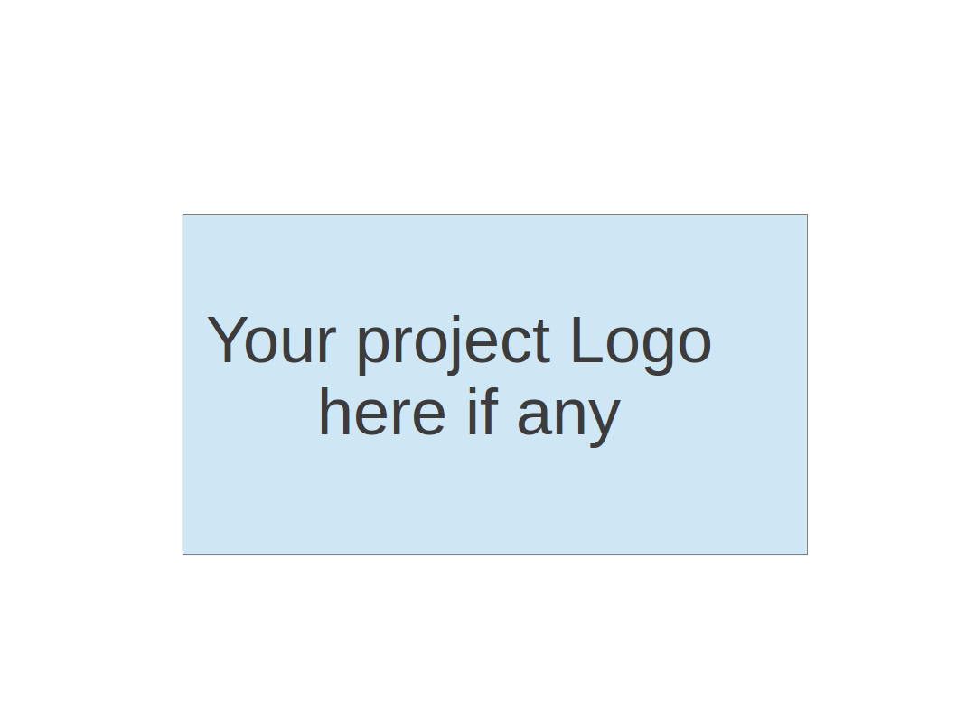

**Team 5 - MEAL it**

**Software Test Document**

| Team Member | Role(s) | Signature | Date |
| --- | --- | --- | --- |
| David Vanderschaaf | Team Lead | *David Vanderschaaf* | 10/19/2022 |
| Fahmida Jyoti | Configuration Lead | [Fahmida Joyti](mailto:fsjoyti@bu.edu) | 10/20/2022 |
| Wenxiao Zhou | Design & Implementation leader | *Wenxiao Zhou* | 10/20/2022 |
| Xiaohang Lin | QA Lead | *Xiaohang Lin* | 10/20/2022 |
| Alaap Bharadwaj | Requirements Lead | *Alaap Bharadwaj* | 10/20/2022 |
| Jintong Song | Security Lead | *Jintong Song* | 10/20/2022 |
|  |  |  |  |
|  |  |  |  |

**Revision history**

| **Version** | **Author** | **Date** | **Change** |
| --- | --- | --- | --- |
| 1.0 | Whole Team | 10/19/2022 | Initial Version |
|  |  |  |  |

Testing Summary

Manuel Tests Reports

Automated Testing Reports

Testing Metrics

References

Glossary

# Testing Summary

So far for our project we have implemented a few unit tests that verify entity and repository functionality is operating as expected. Additionally, we have performed manual user testing that verifies that the appropriate responses are triggered when a user interacts with the web application.

# Manual Testing Report

So far a majority of the testing we have performed has been manual interactive testing. We have walked through verified the following functionality:

* + Opening the webpage
  + Registering a user
  + Using the validation link
  + Logging in
  + Logging out
  + Trying to log in with unregistered user
  + Trying to access the list of users when not logged in
  + Deleting a user
  + Using the wrong username
  + Using the wrong password
  + Trying to view the recipe display without signing in

# Automated Testing Report

Describe briefly the automated testing you have done, including where the test code resides in your code repository, what test frameworks are used, and the screen shots or generated testing report.

Using Junit testing framework, we have begun to set up automated testing for our repository classes:

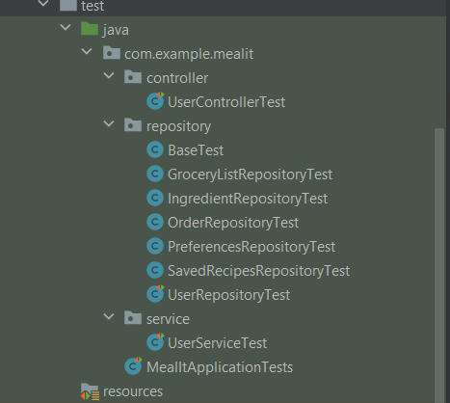

These tests can be run manually and also run when Pull Request is created for the dev or main branches. Below are the results of running the tests that have been created so far (100% pass).

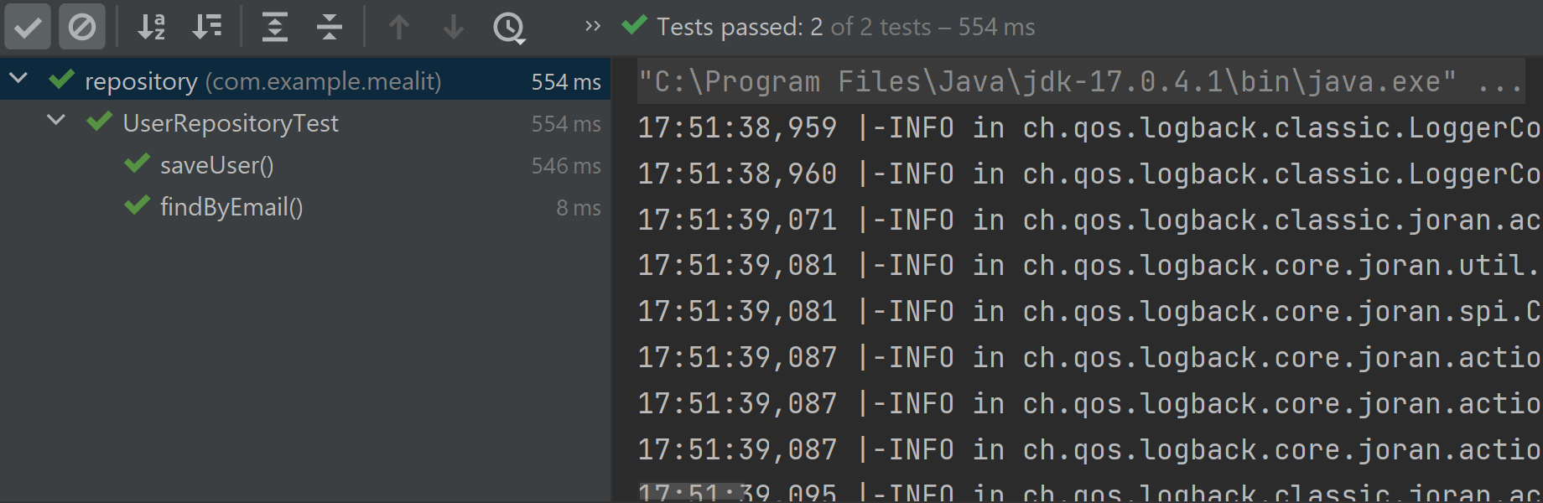

We are using junit and mockito for testing the service layer.

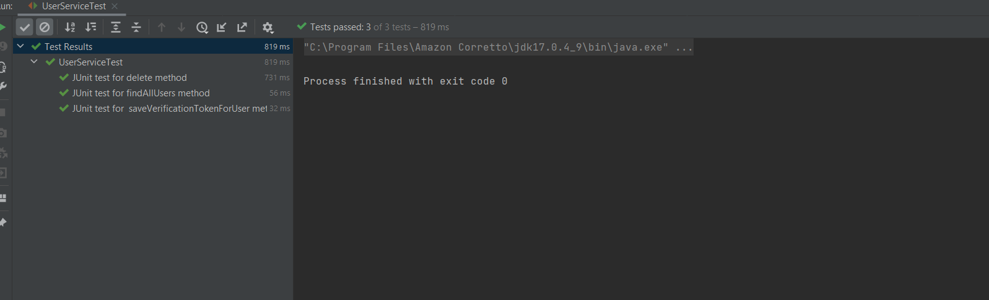

We are using mockmvc to make requests to the endpoints in usercontroller and verify that the endpoints return the expected response.

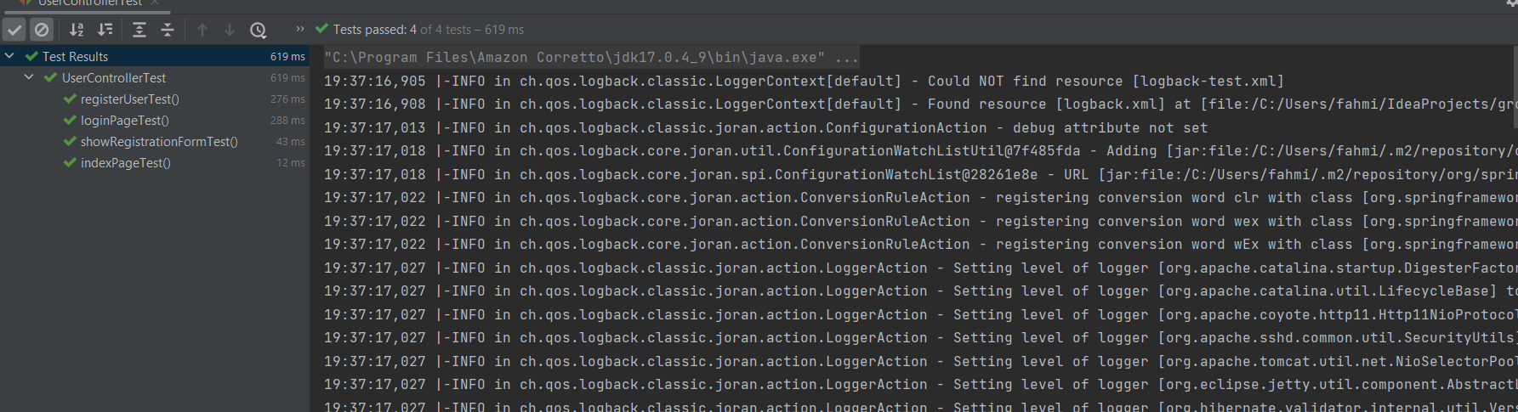

# Testing Metrics

In this section, you shall report any metrics used for the evaluation, e.g. # of test cases, test coverage, defects rate, etc.

# References

# Glossary