**LAB1 REPORT**

Xiaoxin Zhou

For Lab 1, I tested three different settings for the Elegoo Owl robot. The test site is composed of wooden slats, which means the ground is not smooth as the DEMO video. The Elegoo Owl robot consists of two wheels and a bead. It makes the result different from the DEMO video. From the video LAB1_please_lookthisone, I have set the robot analogWrite pulse width modulated signal to 200. However, when I set the two motors at the same level, the robot will not run in a straight line. For this phenomenon, it is difficult for me to make a conclusion. Maybe the performance of the two motors is different, or maybe my uneven ground caused this result. In order to solve the vibration caused by the uneven road, I tried to reduce the robot's moving speed, and the result was much better. I reduced the robot analogWrite for motor from 200 to 100. The robot will be much closer to the original point. The result video is Lab1_right/left. Both testing video are using the same structure:

Go forward,

Turn

Go forward

Turn

Go forward

Turn

Go forward

Turn

Because there is no additional sensor to support the robot in localization and mapping, it is difficult for the robot to correct its pose. The robot does not know where it is, so returning to the original point is impossible.

Improve the performance:

Here are two solutions that can improve and correct robot drift. 1) Remote control from humans. 2) Requite a laser or Camera.

1. To use the Bluetooth

To use the software that Elegoo Owl provided, we can remotely control the robot. All we need is a smartphone, and the smartphone price might be different. 9.99.



1. To use the laser

We can buy a laser and use the package called GMAPPING, the gmapping package provides laser-based SLAM (Simultaneous Localization and Mapping), which can give the robot an ability to understand his location. 37.88.

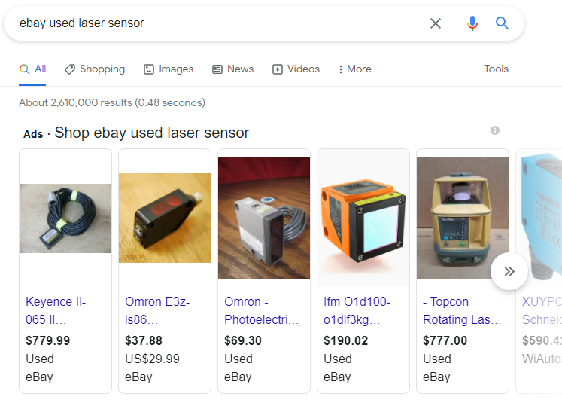

By consider the camera sensor:

There is a system call Visual SLAM (stereo); by reading the image from the camera, we can have detected the feature from the image. To use the feature point that we just extracted and compare with the next image. This action can give the robot the ability to calculate how far did it go. But this may still produce errors and drift, and we can apply the loop closure to make sure the robot will back to the original point as close as possible. 22.04.

