Answers:

User credential:
“customer3”, “mercury”
“driver4”, “mercury”

2.1 Driver should be able to login to the system and input / create new delivery once the food is ready for delivery.

DeliveryStatus.id auto increments on insert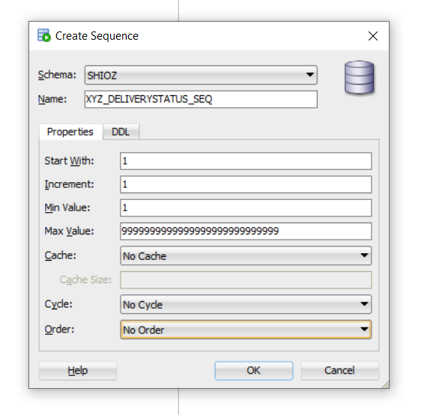

Using GET method for easier debugging:
http://localhost:8080/deliverystatus/create?orderid=100&driverid=001&comments=samplecomments
http://localhost:8080/deliverystatus/create?orderid=101&driverid=001&comments=samplecomments

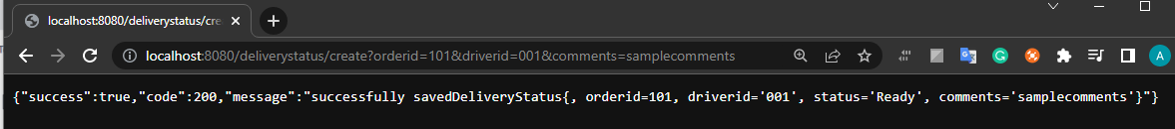

Row added with incrementing id:
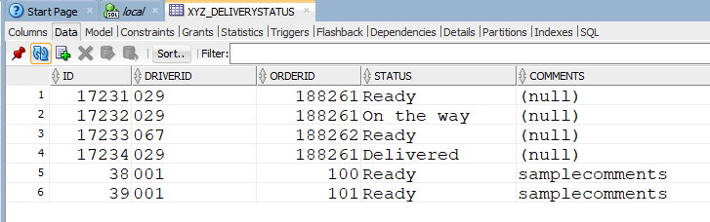

Requirement:
Driver need to specify a valid orderid, a valid driverid, a valid status input. Type must not mismatch.

2.2 Driver should be able to update the delivery status of a particular order, from "Ready" -> "On the Way" -> "Delivered" / "Failed", each update should be recorded into database.

Db was 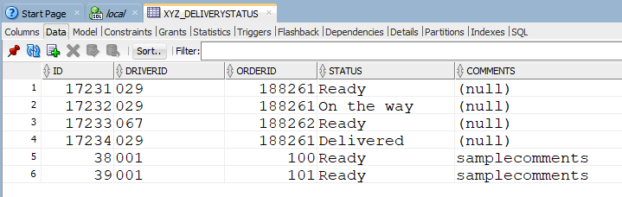

http://localhost:8080/deliverystatus/update/101/Failed
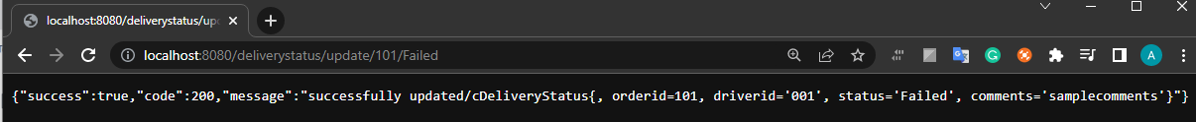
http://localhost:8080/deliverystatus/update/100/On%20the%20Way
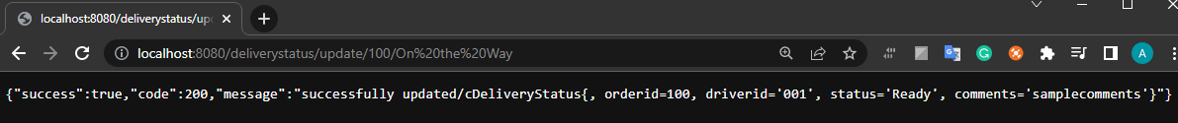
http://localhost:8080/deliverystatus/update/100/Delivered
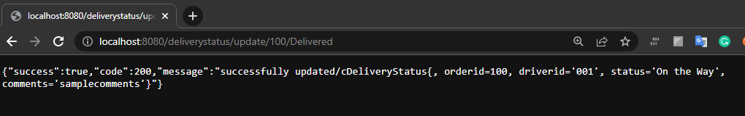
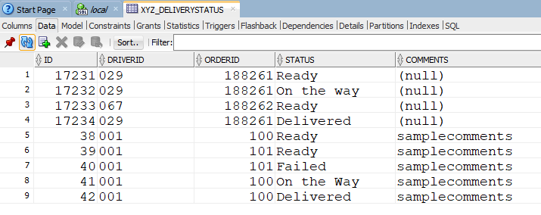

Requirement: the orderid must be a valid one and exist in the table.

3.1 Customer should be able to login to the system and search the order delivery status by inputting order Id. Customer should only get the current delivery status of this order.

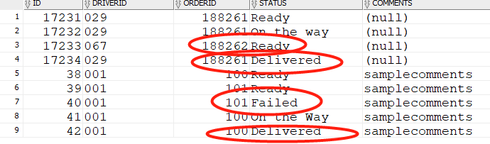
Red arrow points to this order’s latest DeliverStatus.id

http://localhost:8080/deliverystatus/latest/188262
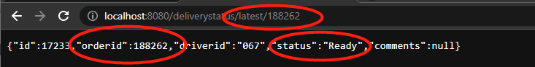

http://localhost:8080/deliverystatus/latest/188261
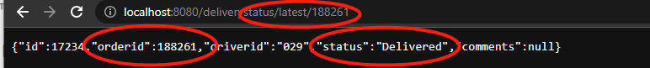
http://localhost:8080/deliverystatus/latest/101
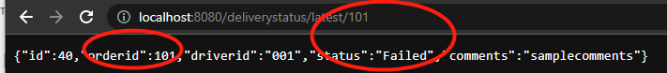
http://localhost:8080/deliverystatus/latest/100
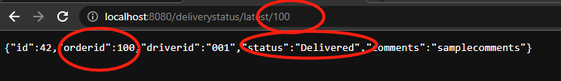

Requirement: the orderid must be a valid one and exist in the table.
Security part:

Logined as customer:
using
“customer3”, “mercury”

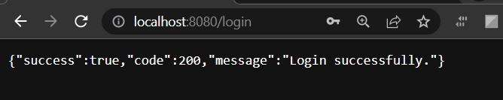
Cutomer can check the latest order/delivery status
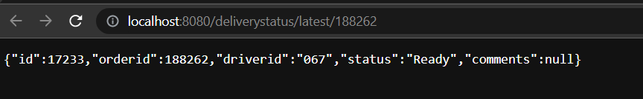
Log out
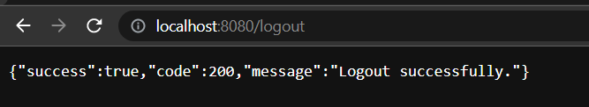
Logined as driver:
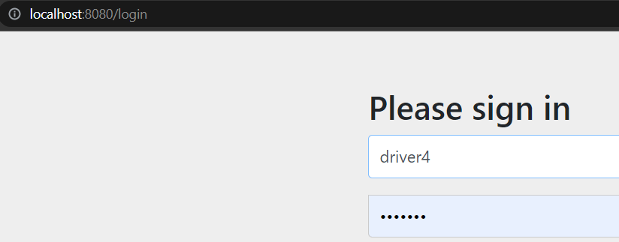

“driver4”, “mercury”
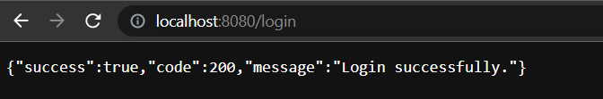
Driver can create status

Driver can also update status

But driver does not have power to check latest status
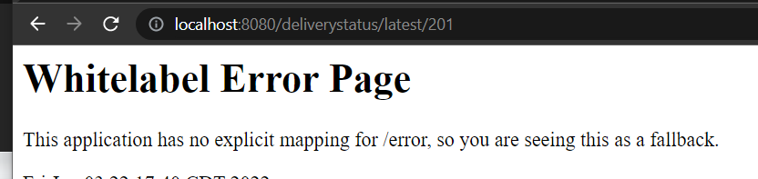

Tables created:
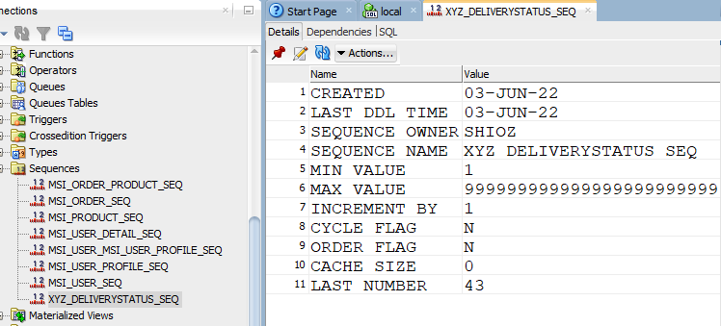

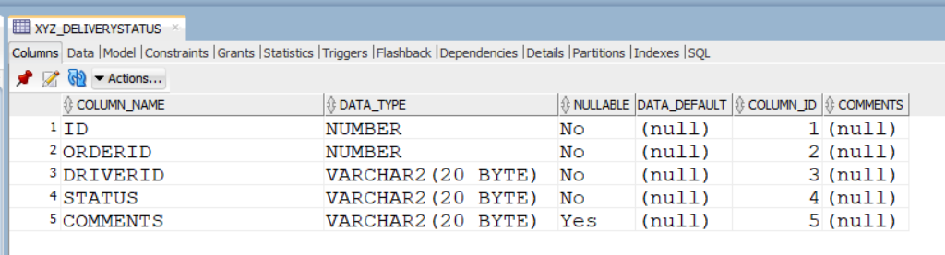

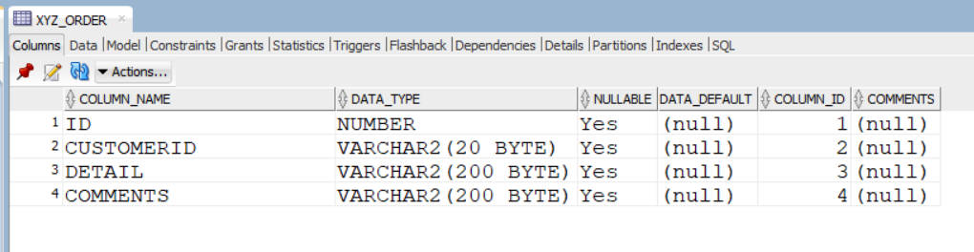
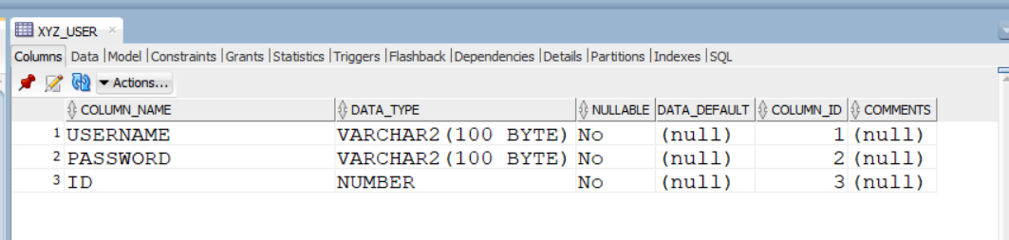

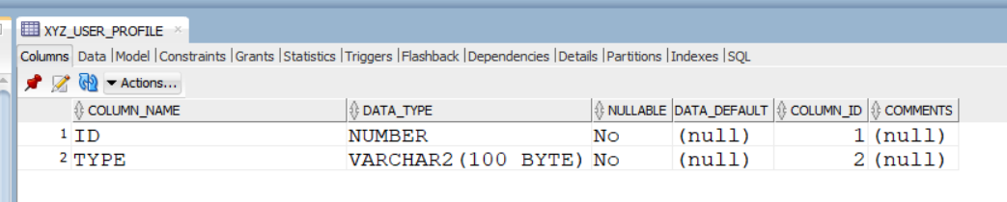
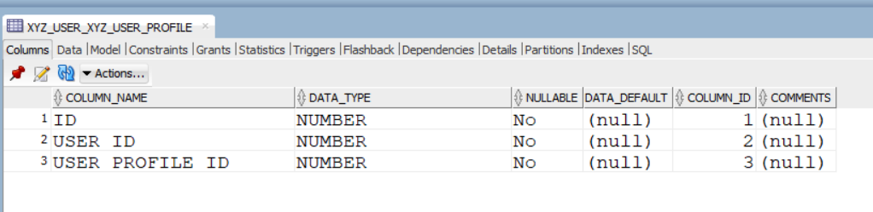

@PreAuthorize("permitAll()")
Other requests that work for debugging():

http://localhost:8080/orders/188261
http://localhost:8080/orders/
http://localhost:8080/deliverystatus
http://localhost:8080/deliverystatus/17234
http://localhost:8080/deliverystatus/orderid/188261
http://localhost:8080/deliverystatus/orderid/188262
http://localhost:8080/deliverystatus/deliveredorderid/188261
empty:
http://localhost:8080/deliverystatus/deliveredorderid/188262

