Projekt name: python3 with simpler grammar.

Motivation: some syntax is not English-like enough. When I learned python3 for the first time, I personally had problem with understanding these syntax.

Target: including certain keyword, grammar, syntax in the python3 code. The “compiler/interpreter” will parse that into standard python3 code.

Note: in terms of the difference between one “tab”and four “whitespaces”, my editors(pycharm and sublime3) both could not tell the difference, and my python code always read a fresh tab as four “whitespaces”. thus, in this project, i assume python has no tab.

1. New Keyword: UNLESS

Logic: pretty much like ‘if’, but the condition will be opposite. It has to be noted that, if an ‘unless’ statement is inside of a ‘while’ or ‘for’ loop, it needs to break the loop, since ‘unless’ condition is not met.

Example:

“if I won the lottery, I would buy a house.”

is the same as:

“I would NOT by a house, unless I won the lottery”

1. New keyword: but

Logic: logically, ‘but’ is the same as ‘and’, both conditions needs to co-exist.

Example:

“I passed this class, but I failed that one”

Is the same as:

“I passed this class, and I failed that one”

1. New keyword: before/until

Logic: somewhat like ‘while’, but the condition is opposite.

Example:

“while the train has NOT arrived, I will have another coffee”

Is the same as:

“i will have another coffee before/until the train arrives”

Test:

I am using two codes: the classic quicksort.py(from geeksforgeeks) and the classic #1 question at Leetcode:

Quicksort original: Quicksort written in special grammar:

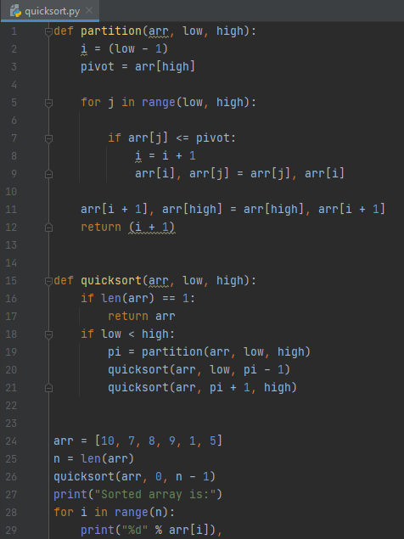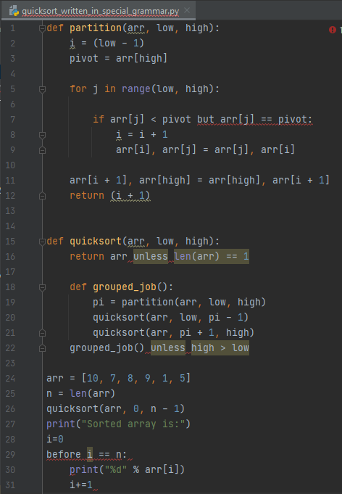

And it is parsed to:

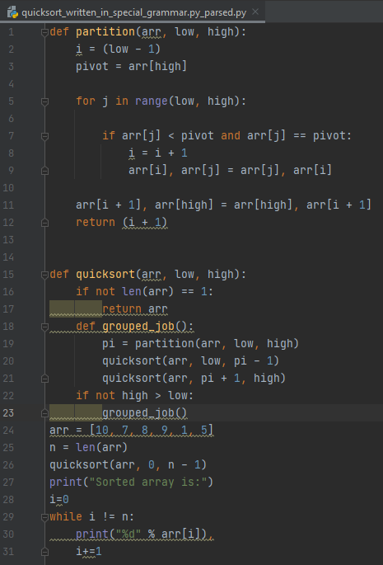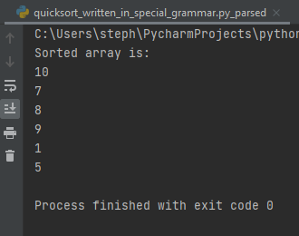

And runs!

Two sum question:

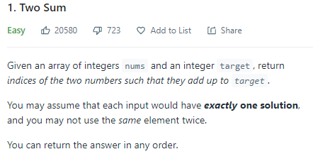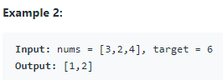

My code:

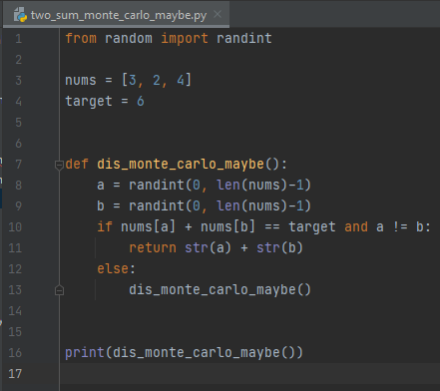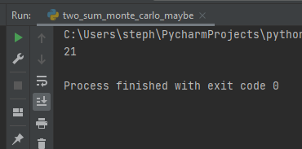

My code written in special grammar:

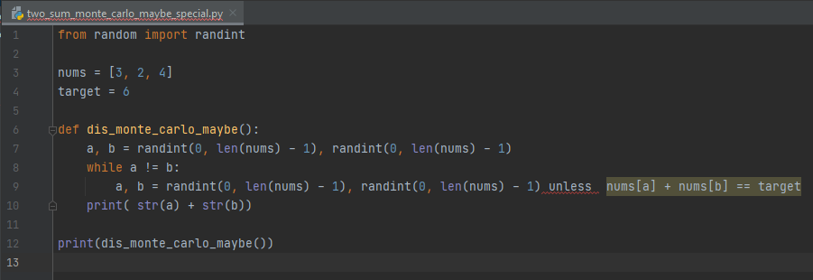

Seems easier to code for beginners, right?

It got ’translated’ to:

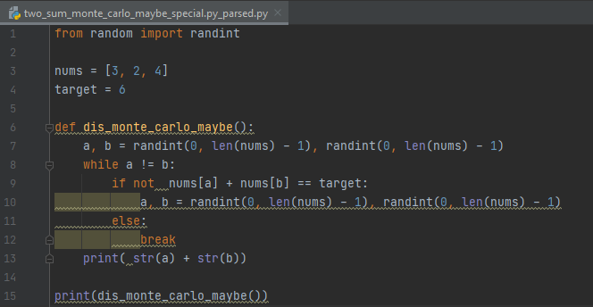

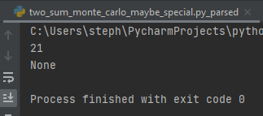

Oh sick..