The files which managed by git have three status

* + Modified: indicate this file have been modified(red color word)
  + Staged: indicate this file have been added to stage
  + Committed : indicate this file have been committed to repository

Three trees

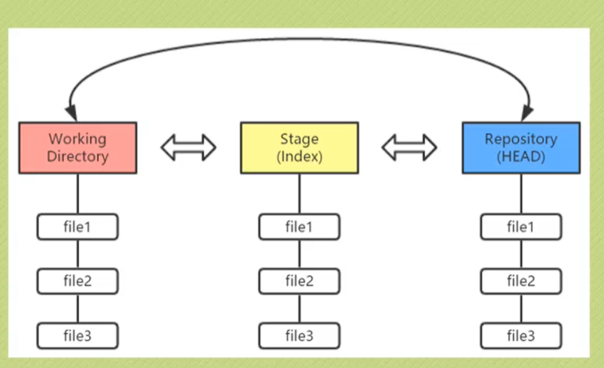

HAED point the latest version

* + config the user name and email address:
    - git config --global user.name "USERNAME"
    - git config --global user.email "EMAIL ADDRESS"
  + Create a new repository
    - git init
  + Add a file to stage
    - git add FILENAME
  + Commit the files which in the stage to the Repository
    - git commit -m "comment"

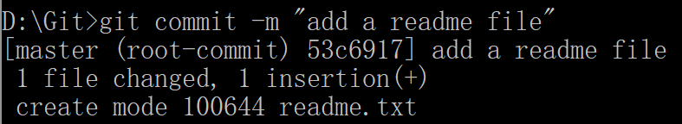

* + Quire the status
    - git status

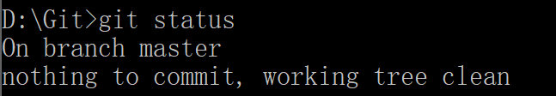

Branch master is the default branch

Nothing to commit means stage tree is empty

Working tree clean means files and data that in the workspace folder no updated

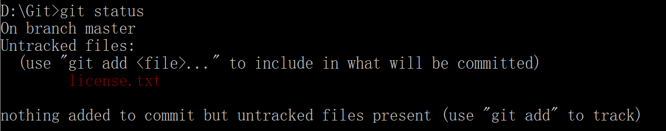

Untracked files means this file is new added and have not been add to stage.

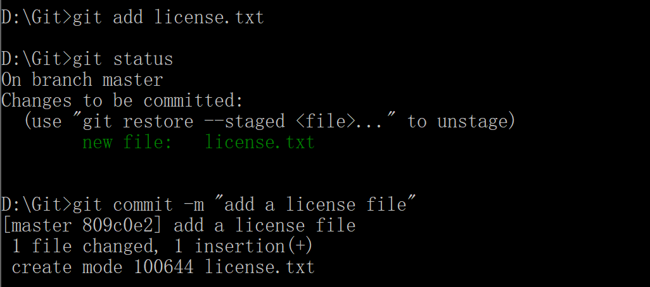



* + If you modify the license.txt file in workspace, the status will change.

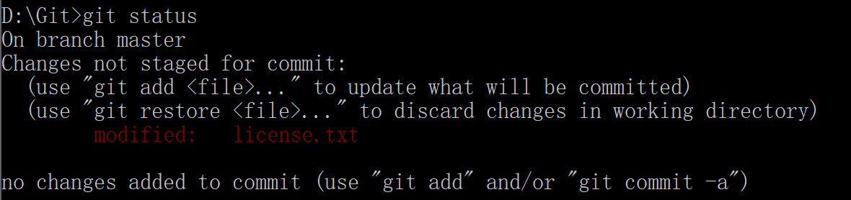

If use command git restore <file>, it will use the file which store in stage to cover the modified file.

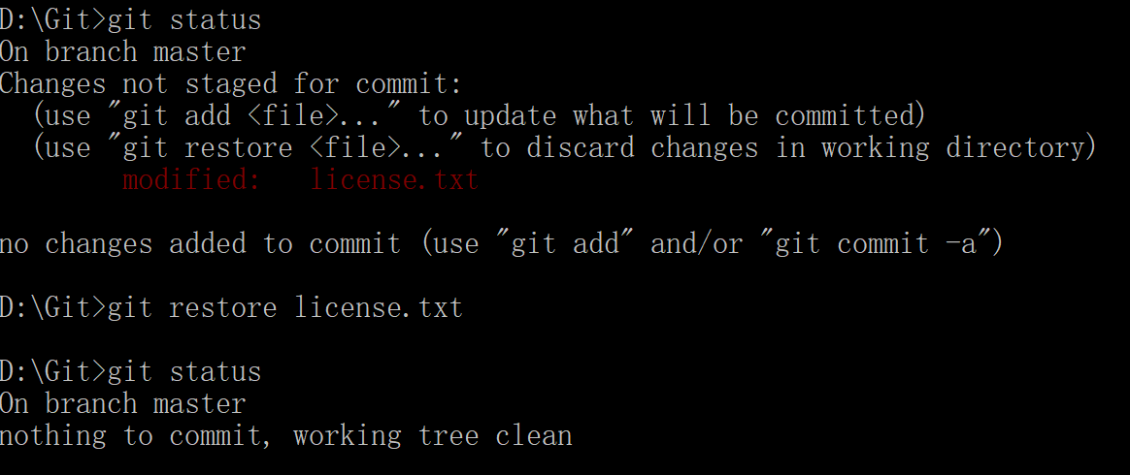

* + If we add modified file(version1) to stage then we modified this file(version2) again what will happen?

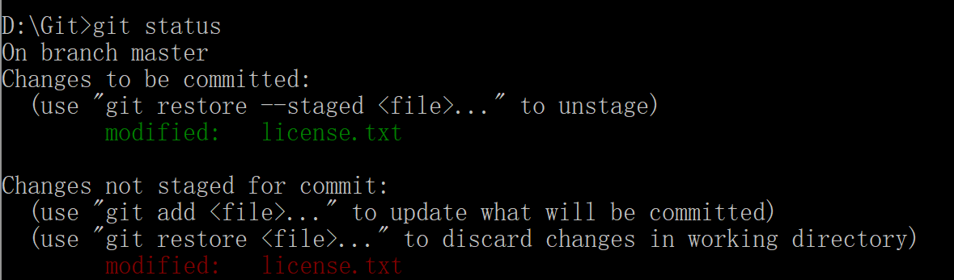

The green words part indicates the version1 file which store in stage

The red words part indicates the version2 file which store in workspace

We can use git commit -m "XXXX" command to upload the version1 file

We can also use git add [FILENAME] to add version2 file to stage and then use commit command to upload the version2 file.

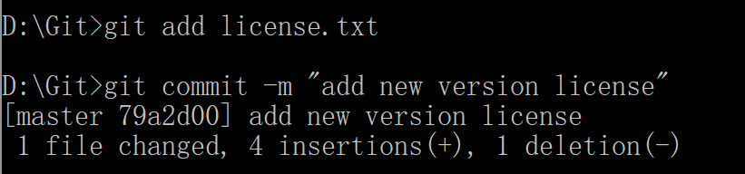

* + If you want to undo the operation that track the file you just add, you can use git restore --staged <file>
    - git reset --staged <file>

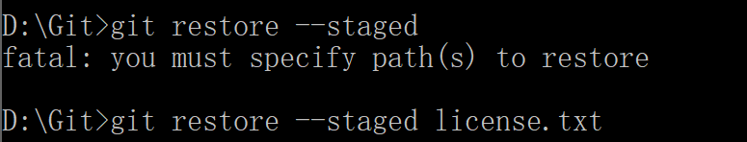

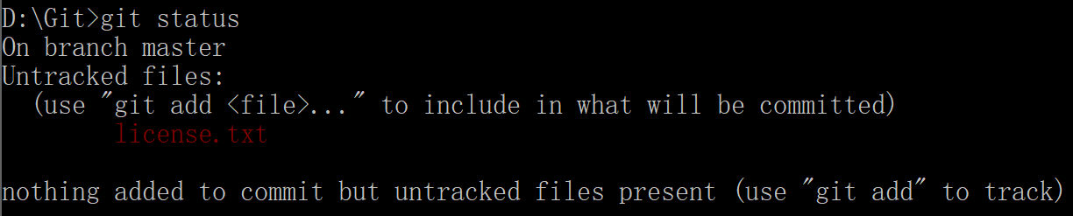

* 1. Using git log command to quire the history committed record.
     + git log

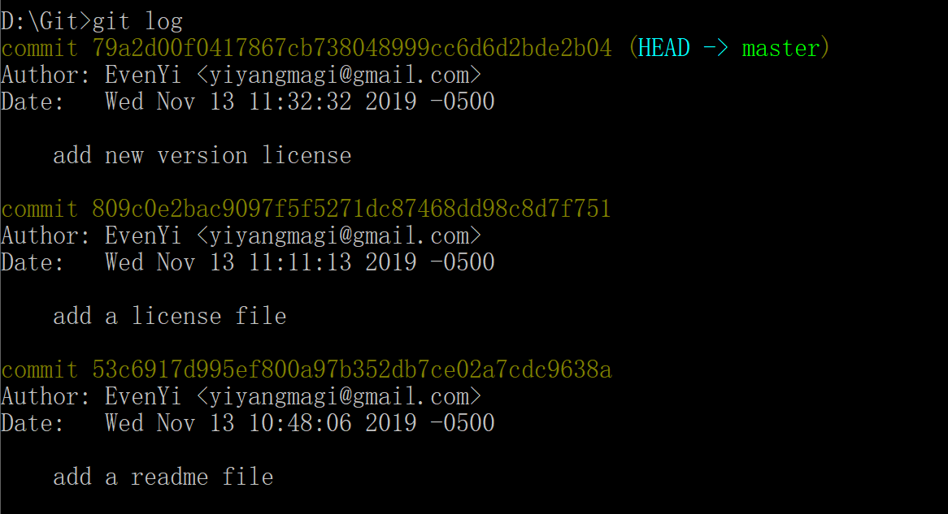

We have three record means we have committed three times.

This commit code is generated (SHA) by git and this code is the id for each commit version. From the id we can find the unique version

C:\Users\Sphinx\AppData\Local\Packages\Microsoft.Office.OneNote_8wekyb3d8bbwe\TempState\msohtmlclip\clip_image014.png

This is head point to indicate the latest version

