**Assignment 6**

**Xiaofei Zhou**

**Andrew ID: xiaofei2**

1. Low & High-Fidelity Prototypes:
   1. Low-Fidelity prototypes:
      1. 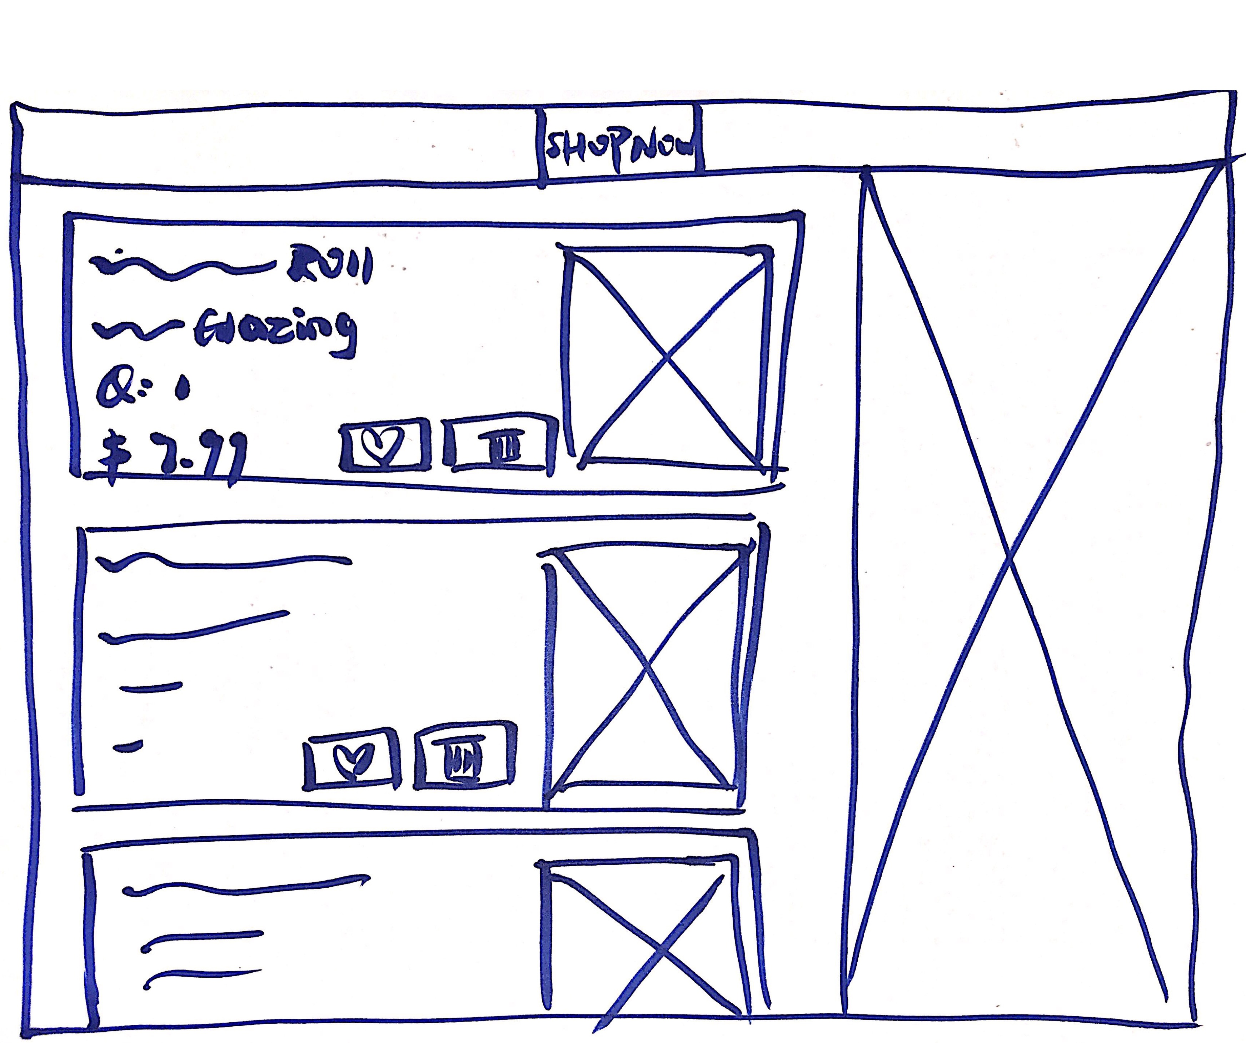
      2. The shopping cart page is basically spitted into two parts and the two information flows are clearly organized. One is for items added in the shopping cart and the other one is for other information display, including promotions, VIP and new comings. And the information for the items added in the shopping cart is concise and minimized. Besides, the header is consistent with all the other headers in the rest pages.
   2. High-Fidelity prototype
      1. 
      2. High-Fidelity prototype is pretty much the same design as the low-fidelity prototype, with more design detailed in color patterns, fonts, font size, icons, images and so on. The quantity of items in the shopping cart can be changed in this page, for the convenience of customers. And customers can move the items that they don’t want to buy immediately into their wish list as a reminder of shopping list. And more detailed design of tabs is shown in the header, which is a quick navigation to those most important web pages for this website, including browsing all the products, most popular products, products for VIP, new comings, products promotions.
2. Web Prototype w/JavaScript:
3. Reflection