ESP32-S3-WROOM-1-N8芯片编译配置
- idf.py clean
清除所有编译产物

- idf.py menuconfig
Serial flasher config -> Flash szie (8MB)
Flash 配置为8M
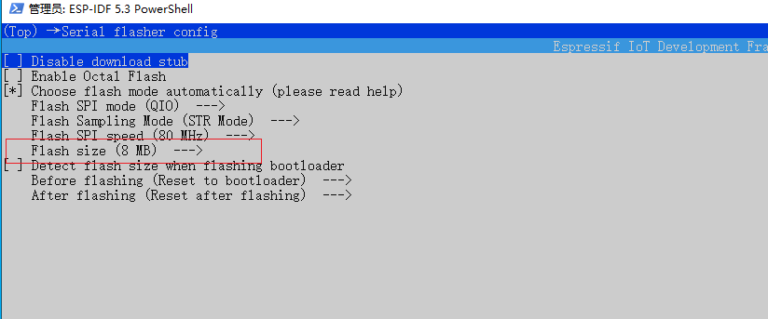

分区表配置
Partition Table -> Custom partition CSV file
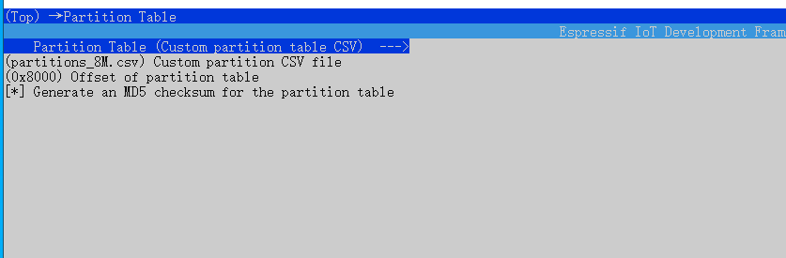

板子配置为Sparkbot
Xiaozhi Assistant -> Board Type -> Esp-SparkBot
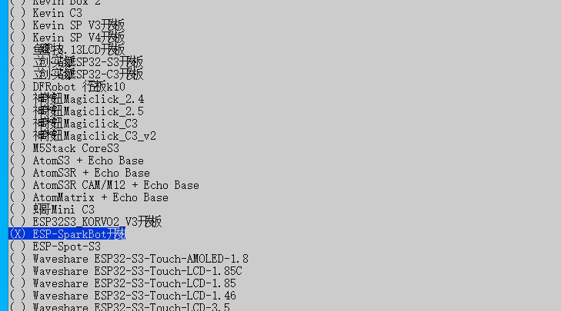

PSRAM关闭
Component config -> ESP PSRAM -> Support for external SPI-connected RAM
