Homework #1 CS638 Xiaojue Zhou

Problem 1

Q1.

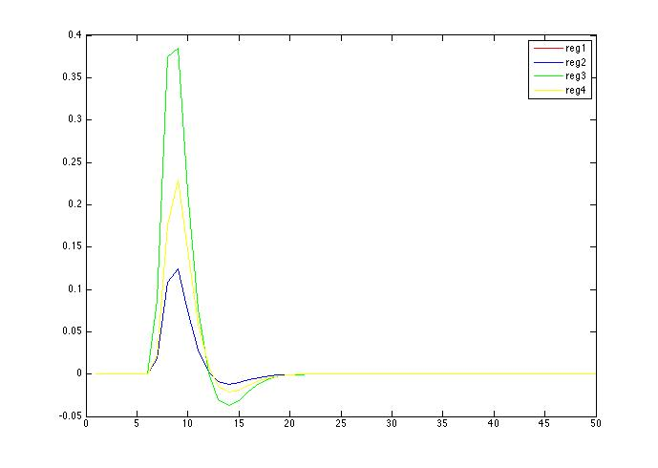

Q2

From above we can see the first and third regressors are the same but the second and the fourth are different. Since reg1 and reg3 have different duration, the regressors are still the same since the time resolution is low.

Problem 2

I tried but cannot figure it out how to figure out the matrix arrays of regressors.

Q3