<V8 on Xeon/VOX>

# High-Level Technical Design

Version 1.0

03/28/2019

Table 1-1. Revision History

|  |  |  |  |
| --- | --- | --- | --- |
| **Revision No.** | **Draft/Changes** | **Date** | **Author** |
| 0.1 | Initial Draft | 2019-01-22 | - |
| 0.2 | Schedule Run Driver | 2019-03-28 | Zhou, Yang |
|  |  |  |  |
|  |  |  |  |
|  |  |  |  |
|  |  |  |  |

## Introduction

Instructions: Provide identifying information for the existing and/or proposed automated system or situation for which the High Level Technical Design applies (e.g., the full names and acronyms for the development project, the existing system or situation, and the proposed system or situation, as applicable). Summarize the purpose of the document, the scope of activities that resulted in its development, its relationship to other relevant documents, the intended audience for the document, and expected evolution of the document. Emphasize that the High Level Technical Design is completed during the Concept Phase of the Investment Lifecycle and is intended to describe the conceptual design of the proposed system. This document provides a framework for more detailed requirements and design activities in later phases of the project.

## Automation Framework

Instructions: Identify and describe the technical architecture of the current system. If available, include a high-level diagram that highlights major sub systems and components. An example:

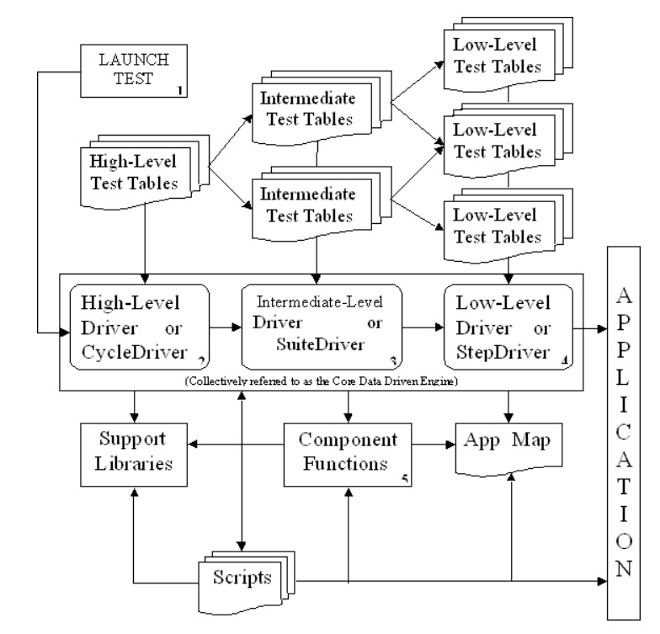

## System Configuration

## Detailed Design

### Test system

### Data system

### Post system