1. 提交订单接口错误 code：500 /pdaapi/SubmitOrder
   1. {"head":{"F_AirfieldFloor":"T1","F_AirfieldId":null,"F_AirfieldName":"首都国际机场","F_StartStation":"广州白云国际机场T2","F_Longitude":116.335754,"F_Latitude":39.616219,"F_CustomerAddress":"北京市大兴区总部基地","F_CustomerName":"曹媛媛","F_CustomerPhone":"13533599485","F_FareName":"张哈哈","F_FarePhone":"13533599485","F_CustomerRemarks":"","F_FlightCompany":"南方航空","F_FlightNumber":"HG6230","F_IsUrgent":"普通","F_OpenId":"oRsOH5CMNpdpU3Be7n4THJ1PLoZI","F_State":0,"F_Stype":"港内配送"},"OrderDetails":[{"F_ConsignmentNumber":"543646","F_Weight":20,"F_Distance":100,"F_Price":10,"F_Qty":1}]}
2. 用户下单的时候地址去重 /pdaapi/SubmitOrder
   1. {"head":{"F_AirfieldFloor":"T1","F_AirfieldId":null,"F_AirfieldName":"首都国际机场","F_StartStation":"广州白云国际机场T2","F_Longitude":116.335754,"F_Latitude":39.616219,"F_CustomerAddress":"北京市大兴区总部基地","F_CustomerName":"曹媛媛","F_CustomerPhone":"13533599485","F_FareName":"张哈哈","F_FarePhone":"13533599485","F_CustomerRemarks":"","F_FlightCompany":"南方航空","F_FlightNumber":"HG6230","F_IsUrgent":"普通","F_OpenId":"oRsOH5CMNpdpU3Be7n4THJ1PLoZI","F_State":0,"F_Stype":"港内配送"},"OrderDetails":[{"F_ConsignmentNumber":"543646","F_Weight":20,"F_Distance":100,"F_Price":10,"F_Qty":1}]}
3. 查看所有订单按最近时间排序 /pdaapi/GetOrderList
   1. {"openId":"oRsOH5CMNpdpU3Be7n4THJ1PLoZI","status":""}
4. 订单状态返回正确状态 -1、-2、0、1（2）、3、4、5 /pdaapi/GetOrderList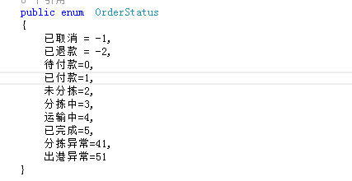
   1. {"openId":"oRsOH5CMNpdpU3Be7n4THJ1PLoZI","status":""}
5. 缺少加急件接口
6. 订单详情缺少是否加急标识 /pdaapi/GetOrderDetailByNo
   1. {"OrderNo":"PEK201905250002"}
7. 获取操作记录（时间节点信息）