# 一.centos Redis集群搭建与简单使用

1.[redis3.0.3集群搭建](https://www.cnblogs.com/zhongkaijun/p/4728334.html)

<https://www.cnblogs.com/zhongkaijun/p/4728334.html> (亲测)

https://blog.csdn.net/nuli888/article/details/52134117

注意:文档中 appendonly on 应改为appendonly yes

2.redis 本地集群配置目录：

192.168.47.128(master) /home/zhouyc/softwares/redis-3.0.3/redis_cluster

192.168.47.134(slave1) /home/zhouyc/softwares/redis-3.0.3/redis_cluster

3.redis 集群启动各个节点命令:

切换到redis安装目录下:

src/./redis-server redis_cluster/7000/redis.conf

src/./redis-server redis_cluster/7001/redis.conf

src/./redis-server redis_cluster/7002/redis.conf

src/./redis-server redis_cluster/7003/redis.conf

src/./redis-server redis_cluster/7004/redis.conf

src/./redis-server redis_cluster/7005/redis.conf

或者进入：

/home/zhouyc/softwares/redis-3.0.3/redis_cluster/7005

执行:

../../src/./redis-server redis.conf

../../src/./redis-cli -p 7005

成功截图

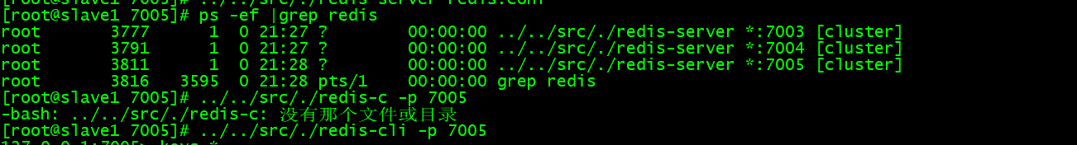

创建集群命令:

src/./redis-trib.rb create --replicas 1 192.168.47.128:7000 192.168.47.128:7001 192.168.47.128:7002 192.168.47.134:7003 192.168.47.134:7004 192.168.47.134:7005

4. 检查 redis 启动情况

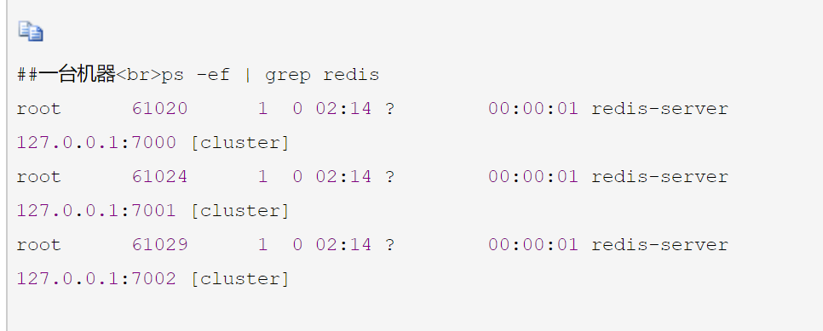

5.进入redis客服端

src/./redis-cli -h 192.168.47.128 -c -p 7000

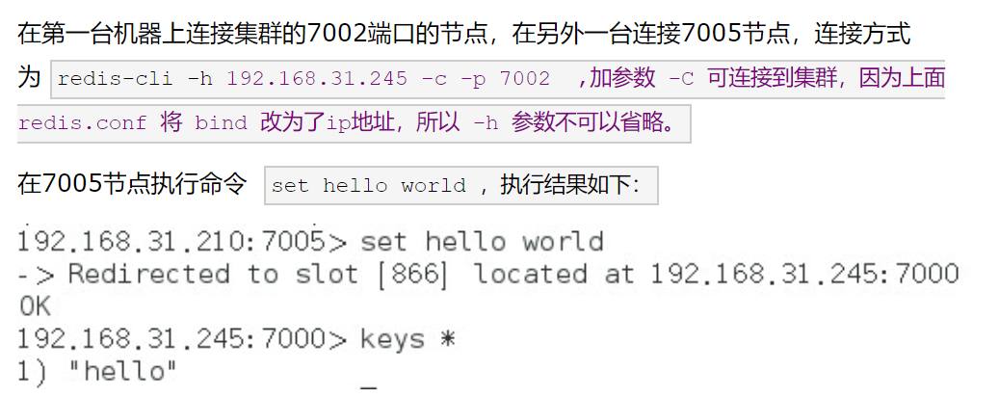

# 二.centos redis 单机版搭建

<https://blog.csdn.net/liaomin416100569/article/details/53432963>

1. 配置目录:

192.168.47.130(slave2) /home/zhouyc/softwares/redis-3.2.5

2.idea 安装可视界面

<https://blog.csdn.net/qq_15071263/article/details/77680355>

三. 更改在redis里面查看key和value编码问题

RedisSerializer redisSerializer =new StringRedisSerializer();

redisTemplate.setKeySerializer(redisSerializer);

redisTemplate.setValueSerializer(redisSerializer);

redisTemplate.opsForValue().set("women","test");

redisTemplate.opsForValue().set("dianying","yingdu");

四.springboot 连接redis集群(jediscluster方式)

https://www.cnblogs.com/baizhanshi/p/7503417.html

# 三.报错

1．ERR Slot 741 is already busy (Redis::CommandError)

<https://blog.csdn.net/qiushisoftware/article/details/78837855>

1. (error) CLUSTERDOWN The cluster is down

<https://blog.csdn.net/eagleuniversityeye/article/details/80023077>

1. [ERR] Node 192.168.47.128:7001 is not empty. Either the node already knows other nodes (check with C

<https://blog.csdn.net/zhangxiaomo_java/article/details/71189293>

# 四．Redis 高级应用

<https://www.cnblogs.com/hjwublog/p/5660578.html>

# 五．[SpringBoot系列十：SpringBoot整合Redis](https://www.cnblogs.com/leeSmall/p/8728231.html)

<https://www.cnblogs.com/leeSmall/p/8728231.html>

<https://blog.csdn.net/zhulier1124/article/details/82193182>

<https://www.cnblogs.com/skyessay/p/6485187.html>

<https://blog.csdn.net/oppo5630/article/details/80403111>