1. Open “ccipdWSIAnnotation.exe”.
2. Click “File->Open” to select the whole slide image.
3. The image will display in the main window.

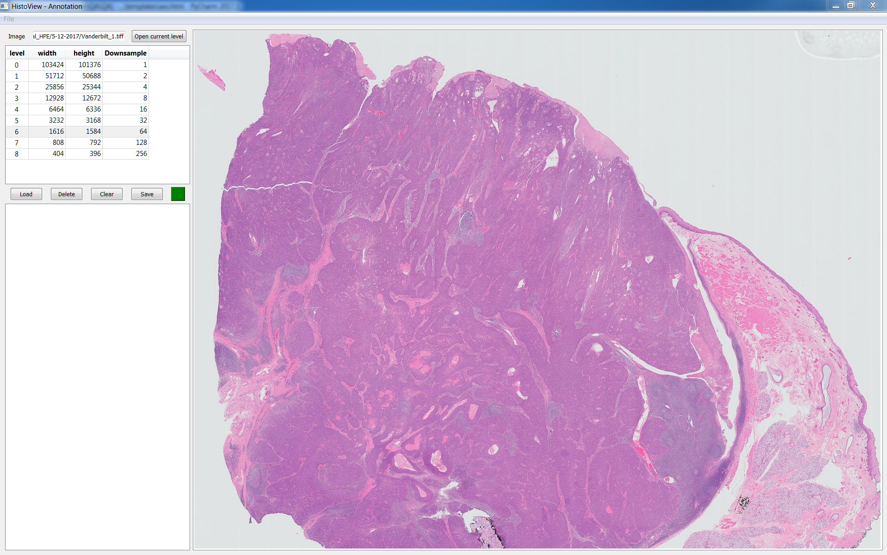

* 1. Use mouse wheel to zoom in and out
  2. Use right mouse button to move the slide
  3. Use left mouse button to annotate

1. When finish annotating, please double click on the last annotated point to close the shape and make sure there’s new item added to the list left to the main window.

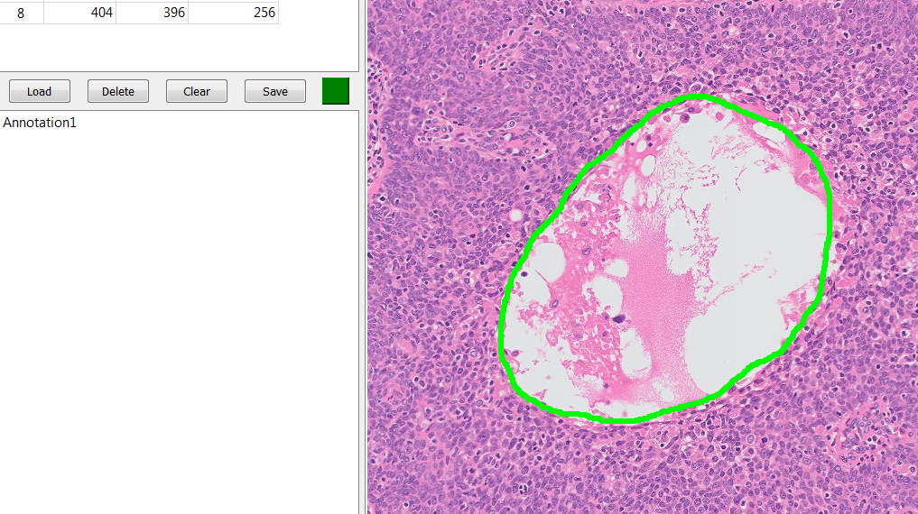

New item added here!

1. Click “Load” button to open an existing annotation file (xml format).

Click “Delete” button to delete the selected annotation.

Click “Clear” button to clear all the annotation.

Click “Save” button to save the annotation (xml format) to the disk.

