**Peer Evaluation Form– Semester Project**

Your name ___________________Yufei Zhou_________________________________ Team name (if any)__________________________________________________

Write down the names of each team member in the following table and follow the instructions to distribute the points:

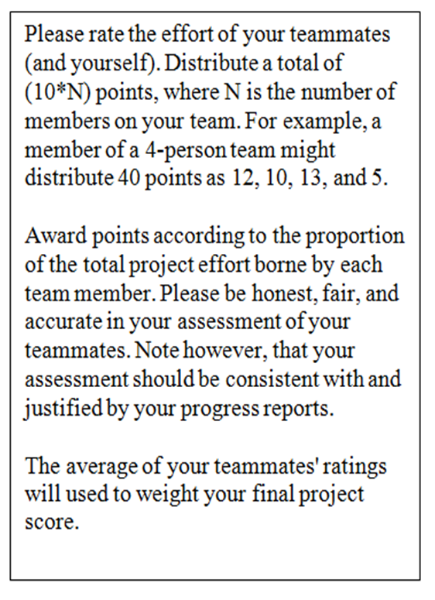

|  |  |
| --- | --- |
| **Team member names** | **Rating** |
| **You: Yufei Zhou** | **10** |
| **#1: Leo Zhao** | **10** |
| **#2: Harry You** | **10** |
| **#3: Zhenli Min** | **10** |
| **#4:** |  |
| **#5:** |  |
| **TOTAL ( = # members * 10)** |  |

**Other information or comments regarding to your Peer Evaluation:**