1. Provide a current version of your ER Model as per Project Checkpoint 01. If you were instructed to change the model for Project Checkpoint 01, make sure you use the revised version of your ER Model.

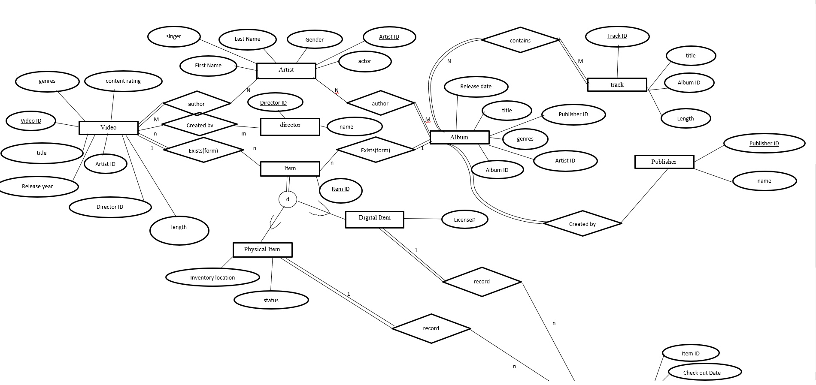

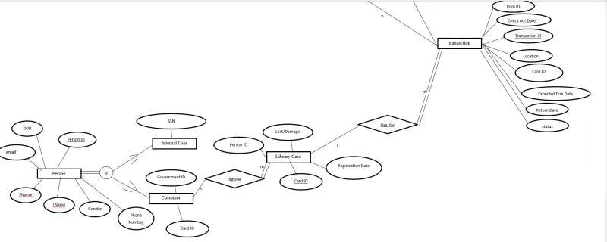

1. Map your ER model to a relational schema. Indicate all primary and foreign keys with different indicators. Each foreign key should point to the attribute it references. Your schema should look similar to those in the power points.

Artist

(Fname, Lname, Gender, ArtistID, Actor, Singer)

Author

(ArtistID, VideoID)

Video

(content rating, genres, VideoID, title, Release year, DirectorID, length)

Created by

(VideoID, DirectorID)

Director

(DirectorID, name)

Item

(ItemID, VideoID(FK), AlbumID(FK))

Physical item

(itemID, Inventory location, status, available numbers of item)

Digital item

(ItemID, license)

Author

(ArtistID, AlbumID)

Album

(Release date, title, PublisherID(FK), AlbumID, genres, Artist ID)

Publisher

(PublisherID, name)

Contains

(AlbumID, TrackID)

Track

(TrackID, title, AlbumID, Length)

Transactions

(itemID(FK), check out date, TransactionID, location, CardID(FK), Expected due date, return Date, status)

Library card

(PersonID, lost/damage, CardID, registration date)

Register

(governmentID, cardID)

Customer

(personID, governmentID)

Internal user

(SSN,personID)

Person

(PersonID, DOB, fname, lname, gender, email, numbers of movie checked out)

1. Given your relational schema, provide the relational algebra to perform the following queries. If your schema cannot provide answers to these queries, revise your ER Model and your relational schema to contain the appropriate information for these queries
2. Find the titles of all songs by ARTIST released before YEAR
3. Give all the movies and their date of their checkout from a single patron (you choose how to designate the patron)
4. List all the albums and their unique identifiers with less than 5 copies held by the library.

Result 1 σ available number of items < 5(physical item)

Result2 Album \* Result1

Result Π title, albumID(Album)

1. Give all the patrons who checked out a movie/video by ACTOR and the movie they checked out.

Result 1 --- σ Video ID ≠ Null(Item)

Result 2 --- Result1 \* Transaction

Result 3 --- Result2 CardID = CardID Library card

Π PersonID(Result 3)

Π Title(Result 1)

1. Find the total number of albums checked out by a single patron (you choose how to designate the patron)

f.Find the patron who has checked out the most movies and the total number of movies they have checked out.

Result1 --- F MAX numbers of movies checked out(Person)

Πlname, fname( numbers of movies checked out = Result 1(Person))