1. Develop two use scenarios for it.

Use Scenario 1:

1. User searches for a particular product category.
2. User browses through many products’ pictures and prices.
3. User click one product to see the detail of product information.
4. User put the product in the shopping cart.
5. User goes to the shopping cart and purchase the product.

Use Scenario 2:

1. User search for a specific product name.
2. User click the product to see the detail to make sure it is what he wants.
3. User put the product in the shopping cart.
4. User goes to the shopping cart and purchase the product.
5. Design an ISD that shows how a user would navigate among the screens.

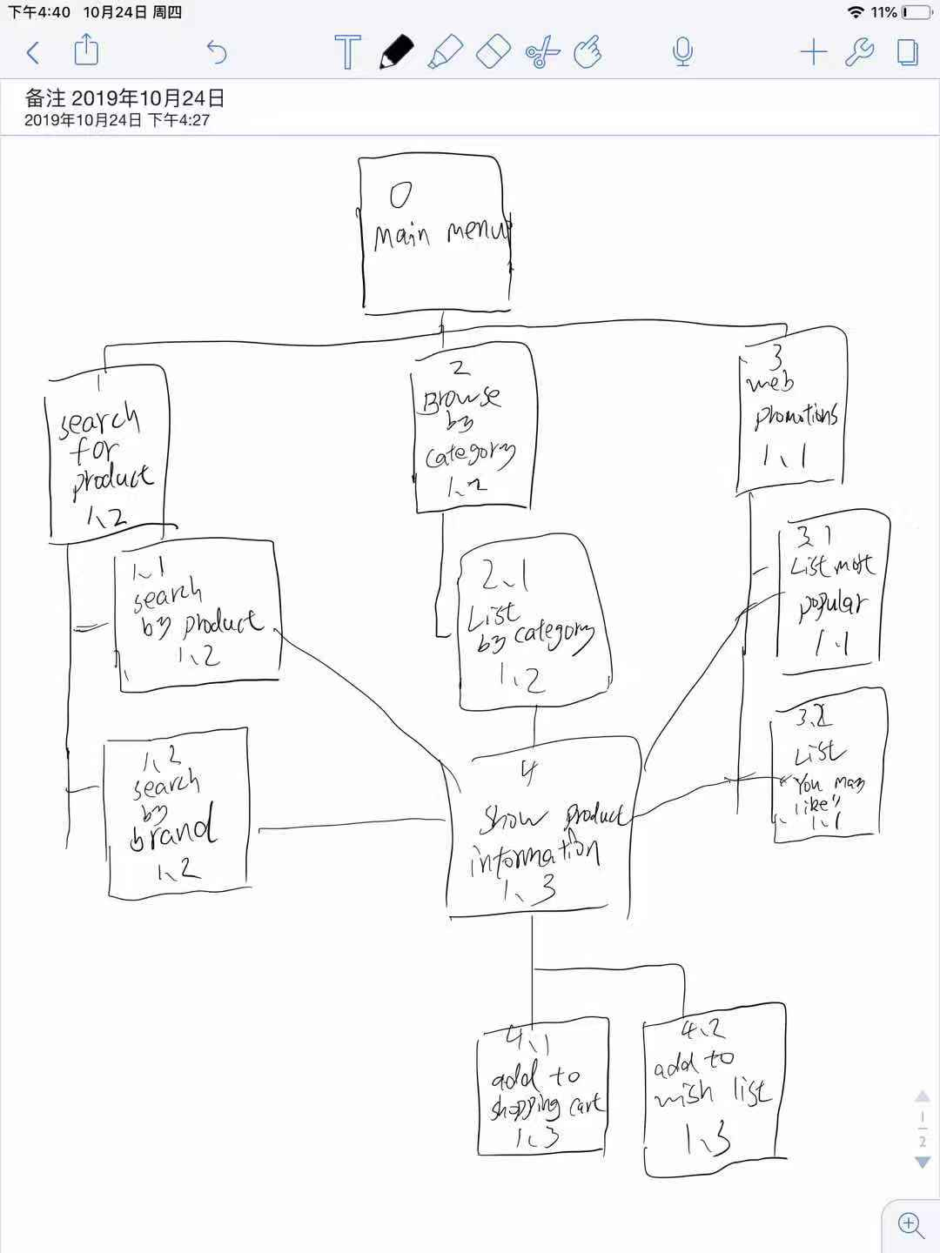

1. Develop an interface standard that includes metaphors, objects, actions, icons, and a template.

Shopping cart is an interface metaphor.

I will use “find” instead of “search” in the “search product box”.

The icon of “add in to shopping cart” will be a shopping cart. “Delete from shopping cart” will be a trashcan.

The icon of “add in to shopping cart” will be big and the color will be bright to attract users to click

1. Develop a storyboard

