- Set up your subversion account.
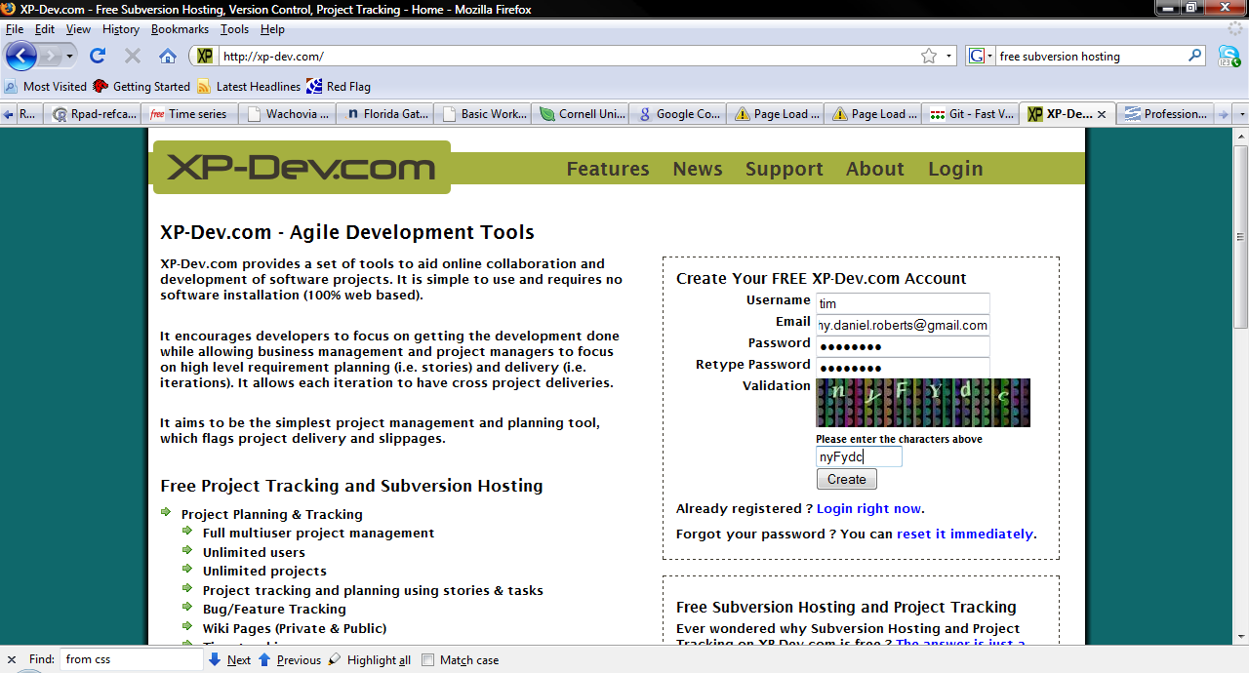
r
- Download and install Tortoise SVN.
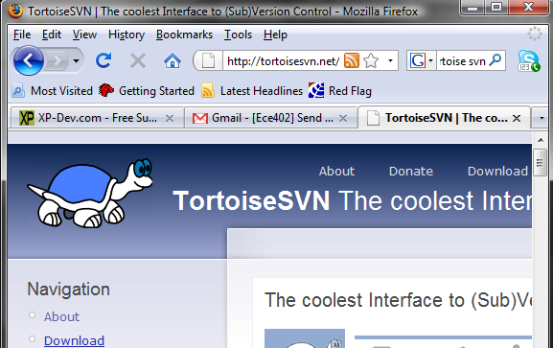

- Start a new folder in your project directory called SVNRepository
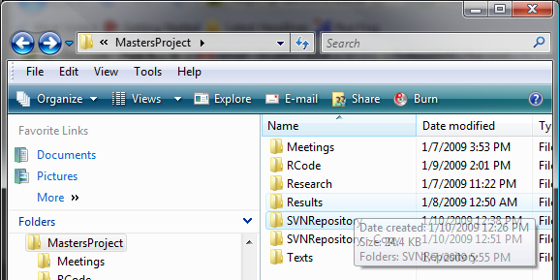

- Perform an SVN checkout (downloads the subversion server folders to your PC) By right clicking on SVNRepository and Right Click -> SVN Checkout

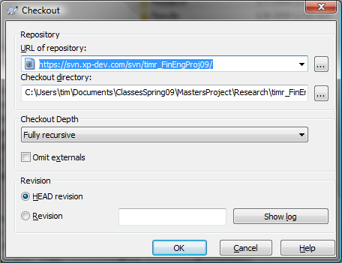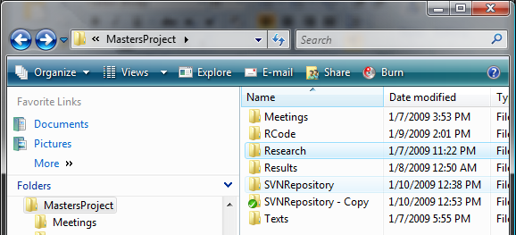

- Make some changes, add files, whatever. 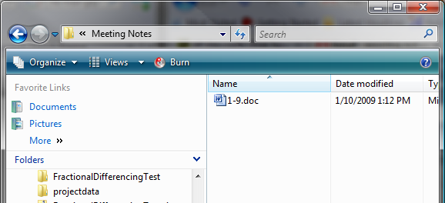

- Do an SVN commit (right click on head folder and click SVN Commit)



